INTERNATIONAL ORGANISATION FOR STANDARDISATION
ORGANISATION INTERNATIONALE DE NORMALISATION
ISO/IEC JTC 1/SC 29/WG 4
CODING OF MOVING PICTURES AND AUDIO

ISO/IEC JTC 1/SC 29/WG 4 m 55709
Online – January 2021

Title: Proposal for an optimized input format for MPI
Authors: J. Fleureau, F. Thudor, R. Doré, B. Chupeau, G. Briand, T. Tapie (Interdigital)

Abstract

In this contribution we propose an efficient input format to describe an MPI input that significantly reduces the memory footprint and the encoding time of the associated content.

- Introduction

During the previous meeting, it was demonstrated how Multiplane Image (a.k.a. MPI) could be described by the current MIV specification at the cost of few changes (mainly the activation of an additional transparency attribute) and the definition of possibly new / extended dedicated profile (see M55089). The idea of defining a MPI profile was supported by the group provided that an example of MPI content was shared as well as an associated updated version of the TMIV implementing the coding and decoding parts.

- Raw Storage (RS)

An example of MPI content and the associated software have been effectively delivered to the group (see TMIV 7.1). The provided MPI (content “M”) is related to the 17 first frames of Fan (content “O”) which were subjectively better handled by a MPI approach at the time of the first contribution.

As a reminder, an MPI is a set of S layers generated along the x-axis of a reference camera. Each layer is a regular frame which pixels embed the color + transparency information of the scene at this specific depth. Each layer of one MPI has the same size / resolution than the reference camera (W x H) so that each layer sample of a same pixel captures the same angular information from the reference camera center (see Figure 1).

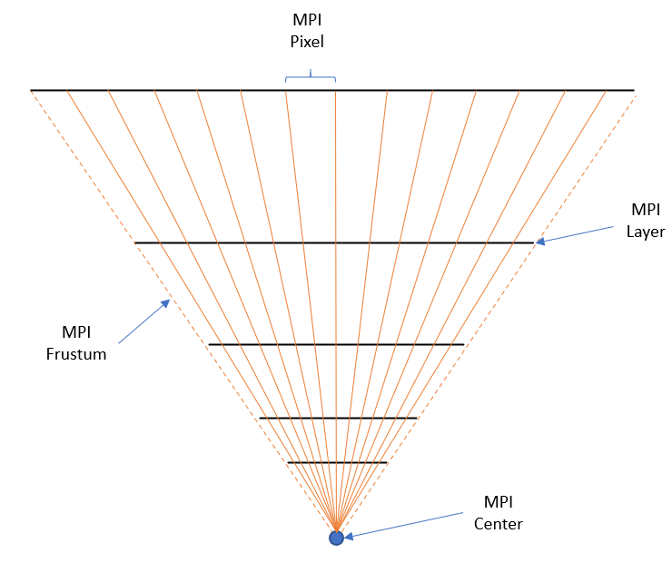
Figure 1: MPI layers and pixels

A first format was chosen to distribute the input MPI as a pair of 2 raw video files and a JSON configuration file. The first video file contains the color information of the MPI whereas as the second video file contains the transparency one. Both video files contain a temporal concatenation of the stacked layers of the MPI (see Figure 2). Each color layer is stored as a YUV420P10LE frame and each transparency layer is stored as a YUV420P8 frame. To read a full MPI temporal frame, one has then to successively read the associated color and transparency layers in the corresponding files.
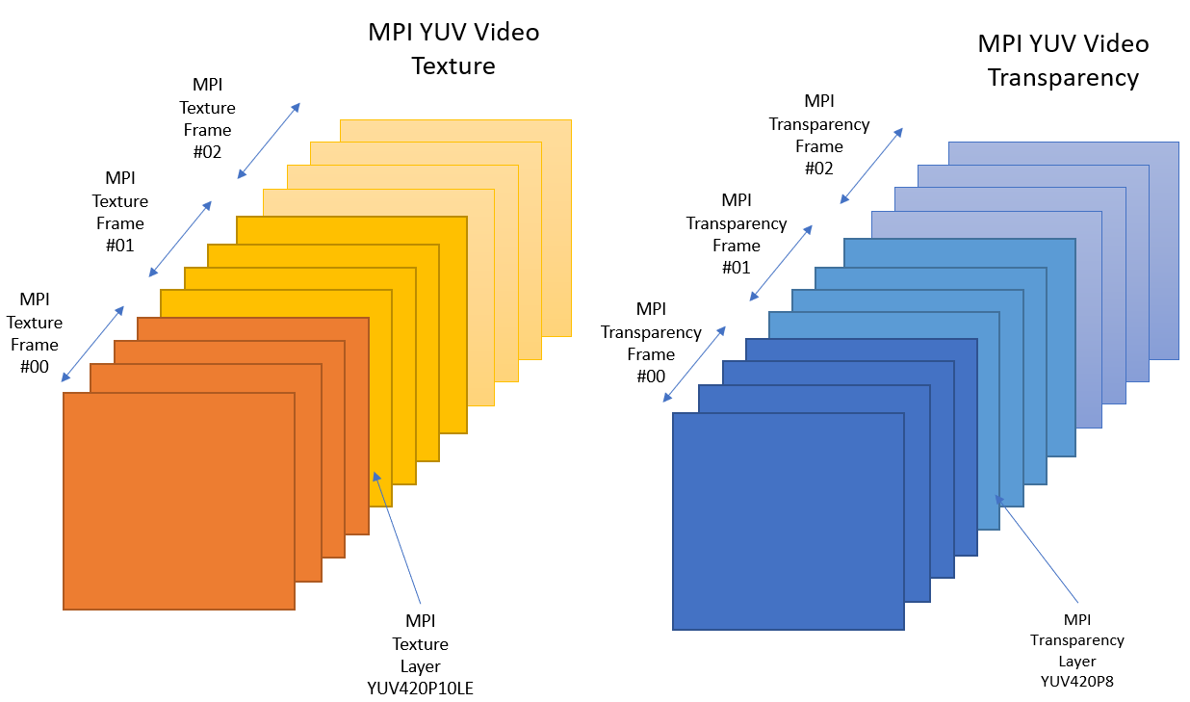

Figure 2: Raw Storage

If such a format is quite convenient to read and understand, it suffers from 2 important drawbacks: i) the memory footprint is huge (when not compressed) and ii) the encoding time is significantly high because of the implied disk I/O.

- Compressed Storage

In this contribution, a more efficient format to store and provide an MPI is proposed. It takes advantage of the high sparsity of an MPI. It is inspired by deep images and classical schemes to store sparse matrices. The key idea comes from the fact that only few layers are “active” along an MPI ray. In other word, for a given pixel of the reference camera, a lot of layers are empty (fully transparent). It is therefore advantageous to store the list of non-empty attributes per pixel rather than explicitly storing the whole set of very sparse layers. Each attribute contains then the color, transparency and quantized depth information of the associated non fully transparent sample.

- Deep Image (OpenEXR)

Such a representation is very related to deep images which are images where each pixel may have a varying number of attributes (possibly different per pixel). As mentioned in the previous meeting, an existing EXR format has been originally defined by ILM (Industrial Light & Magic) and permits to store such kind of deep images. It is implemented in the reference implementation OpenEXR (https://www.openexr.com/index.html). It could be used as an alternative to store MPIs, but it is a still image format only and the internal representation is more adapted to studio and post-production tools than to video distribution standards.

Indeed, each attribute may be only encoded using 16-bits floating points values, 32-bits floating point values or 32-bits integral values which are clearly excessive in the MIV context (it mainly offers the possibility to access to very high dynamic color range). It leads to useless important memory footprints which are mitigated by the possibility to use compression algorithms (RLE, zip, …) at the cost of increased I/O times (compression / decompression required for each access).

Moreover, using such a format would induce the need of implementing the EXR format in TMIV or relying on external libraries which is not necessary desirable.

- Interleaved Compressed Storage (ICS)

As an alternative, we first propose to make use of a format exploiting a structure similar to the one of a deep image but with less overhead and an internal sample representation better aligned with the MIV needs.

In that perspective, the MPIs are temporally concatenated in a unique binary file (see Figure 3). Each single MPI is stored as a set of W x H pixels, each pixel having as many attributes as “active” layers. The pixels are stored one after the other, in a scanline format (no padding) and with the classic image convention (the first pixel corresponds to the upper-left one).

For each pixel:

- The two first bytes represents a 16-bits little-endian unsigned integer containing the number N of attributes associated to the pixel (i.e., the number of active layers for this pixel),

- The following bytes contains the direct concatenation of the N attributes (no padding), each attribute being coded as follows:

  - Color as a YUV444P10LE sample (6 bytes)
  - Quantized Depth as a YUV400P16LE sample (2 bytes)
  - Transparency as a YUV400P8 sample (1 byte)

This list of attributes is sorted in ascending order of quantized depth in order to allow for a faster access on the client-side (fast search algorithm – logarithmic complexity instead of linear).

Such a format is clearly lighter that the raw input one as soon as the number of active layers per pixel is low. In comparison to the raw format, there is a an overhead due to i) the use of YUV444P10LE instead of YUV420P10LE for the color coding and ii) the explicit depth per pixel storage. However, this overhead is easily compensated by the layer sparsity.

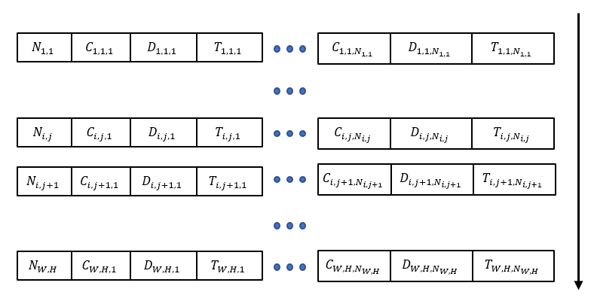
For an average number of active layers per pixel Ñ, then the ICS memory footprint (in bytes) is (2 + Ñ x (6 + 2 + 1)) x W x H = (2 + 9Ñ) x W x H to be compared to the (3 + 1.5) x S x W x H = 4.5 x S x W x H bytes required for RS. The memory footprint ratio is then equal to (2 + 9Ñ) / (4.5 x S). For Ñ = 3 and S = 100, this ratio is approximatively equal to 6.44%, that is to say a storage gain close to 15.5 times.

Figure 3: Interleaved Compressed Storage layout

- Packed Compressed Storage (PCS)

The beforementioned storage strategy is quite effective in terms of memory saving, however, to read each pixel of an MPI, one must successively read the number of active layers per pixel before reading the attributes. It therefore induces many “small” disks accesses which may reduce the I/O efficiency.

To mitigate that issue a packed version of the former ICS format may be envisioned. In that additional flavor, the W x H number of attributes per pixels are first provided as a regular YUV400P16LE frame in the bitstream, and the concatenated list of all attributes is immediately stacked after (see Figure 4).
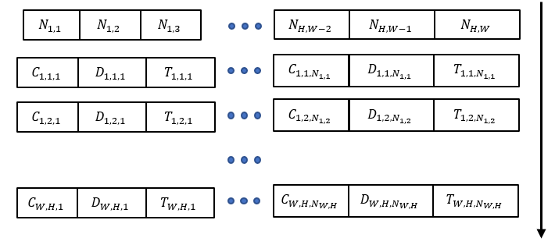
Figure 4: Packed Compressed Storage layout

When reading an MPI temporal frame, one first read the W x H YUV400P16LE frame containing the number of attributes per pixel. The total number of attributes may be then easily derived which then makes possible to read the whole attribute list at once which results in only 2 disk “accesses”.

Once in memory, this packed structure of the attribute may be kept as it and accessed by the means of a dedicated table / index derived from the number of attributes per pixels.

- Objective evaluation

An objective evaluation of this latter format has been performed on the provided content “M”. The TMIV has been modified (v7.1-dev, commit bdbca740, 8 dec 2020) to accept MPI formatted in the PCS way and a comparative study has been conducted with RS as a baseline. The following table sums up the main properties of the provided MPI.

Number of frames | 17
Number of layers | 423
Width | 4176
Height | 2024
Table 1: MPI of “M” properties

- Memory footprint

The memory impact of this alternative format has been first quantified. To do so the number of non-empty pixels per MPI over the time for “M” has been computed and presented in Figure 5. On average, only 0.58 slices are active per pixel for the provided MPI, that is to say Ñ = 0.58 if we use the previous notation again. This number is very low because the frustum of the MPI reference camera was over-estimated (too wide) and, consequently, a significant number of pixels have no active layers (and makes the overall figure lesser than 1).

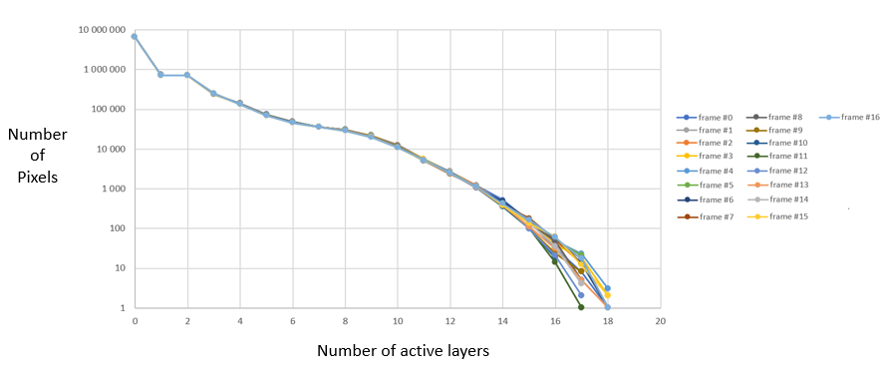
Figure 5: Histogram of number of active layers per pixel on “M”

The following table compares the overall size (17 frames) of the MPI of “M” in its Raw Storage shape (uncompressed and zipped) with respect to the PCS one. A comparison with the “equivalent” MVD content O is also provided as a baseline.

 | Overall Size (GB)
M - RS | 273.51
M - RS (zipped) | 0.57
M - PCS | 1.05
M - PCS (zipped) | 0.33
O | 2.65
Table 2: Memory footprint comparison

As excepted, the PCS overall size is very lower than the RS one (x 260) and it is even competitive with the zipped RS one without suffering from compression / decompression requirements.

- Encoding time

As a second study, the encoding time making use of the PCS storage has been evaluated to investigate for possible gain due to lower I/O solicitations.

The following table sums up the obtained results for the encoding of 17 frames of M with a RS and a PCS input on the same reference machine (average of 5 independent runs). As an additional comparison the encoding time of A17 / O is also provided on the same machine.

 | Encoding time (s)
M17 / M - RS | 1415
M17 / M - PCS | 109
A17 / O | 1000
Table 3: Encoding time comparison

The very lighter weight of the PCS input as well as its sparse structure allows for buffering as well as multi-threading and algorithmic optimization in the TMIV encoding process which is not possible with a RS input. It therefore considerably lowers the requirement of disks I/O which then also significantly reduces the encoding time (almost divided by 14).

- Content repository

The Fan content originally proposed in MVD format [1], then under the form of an MPI [2] is now also available in mpeg content server at adress

Mpegcontent/MPEG-I/Interdigital/m55709_Mpi_Fan_Pcs

This directory contains the licence and zipped .pcs file including the data, md5, and json,

- Conclusion & Recommendations

An alternative format to provide MPI input for test and evaluation purposes in the context of MIV has been proposed. It allows for very smaller files manipulation as well as significant gain in computation times.

Consequently, we recommend
- adopting the PCS format as the preferred format for future possible MPI content proposals
- integrating the change into the future version of TMIV reference software with the possibility to input MPIs as either YUV or PCS format
- keeping both MPI format YUV and PCS available on mpeg content server at least for the content Fan for convenience

- Reference

[1] Renaud Doré, Gérard Briand, Franck Thudor, Interdigital, Fan content for MIV, ISO/IEC JTC1/SC29/WG11 MPEG131/M54732, June 2020

[2] J. Fleureau, R. Doré, B. Chupeau, F. Thudor, G. Briand, T. Tapie, MIV CE1-Related - Activation of a transparency attribute and application to MPI encoding, ISO/IEC JTC1/SC29/WG11 MPEG132/M55089, October 2020

