INTERNATIONAL ORGANISATION FOR STANDARDISATION
ORGANISATION INTERNATIONALE DE NORMALISATION
ISO/IEC JTC 1/SC 29/WG 4
CODING OF MOVING PICTURES AND AUDIO

ISO/IEC JTC 1/SC 29/WG 4 m 55710
Online – January 2021

Title: Interdigital Mirror content proposal for advanced MIV investigations on reflection
Author: Renaud Doré, Gérard Briand (Interdigital)

It has been mentioned several times in previous meetings that current MPEGs contents were missing pure reflection aspects.
The same way that we proposed the synthetic Fan content dedicated to fine geometry [1], we propose here a new content focused on pure reflection aspect.
Same as Fan, Mirror content is synthetic and has no pretention to be photorealistic and therefore not so much destinated to outside communications but is claimed to be both technically relevant and realistic, in line with what can be met in real life.

While Fan has been accepted by MPEG MIV group as mandatory content, Mirror content is only here proposed as optional content since there may be no short-term solution to address the technical issue of reflection.

Description of Mirror content

The scene is indoor, rendered with Blender 2.8 and is shot with perspective cameras. A man holds a flat mirror and slightly rotates it. Another man with a cap reflects into this mirror. Another smaller static convex mirror also reflects the man with the cap. The flat mirror itself presents some traces of corrosion, like in an old mirror. The geometry of the scene is made more complex by adding furniture like table, chairs and paintings. The environment is constituted by the rough shape of the room, without any details, rendered as an emissive shader.

We made such that there is no other issue in this content but those related to reflection: no fine geometry, not too much specularity, no refraction, no depth of field, ..

The rig is made of 5x3 spaced by 20cm horizontally and 20cm vertically, leading to a visualization box of 80cm x 40 cm.

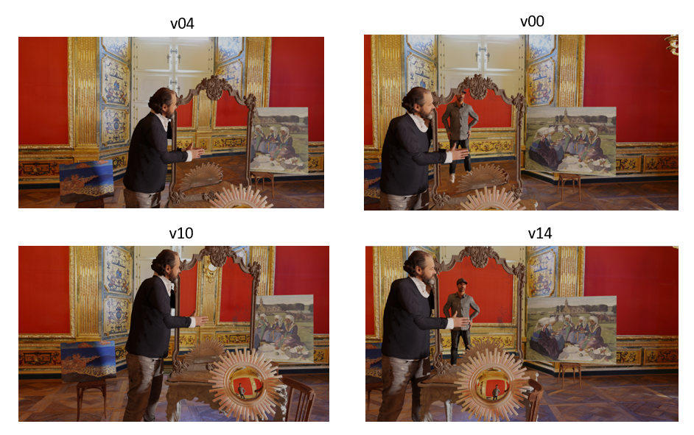
Figure 1: texture of the four corner cameras for frame 1

The depth generated by Blender only captures the surface of the mirror, as expected.

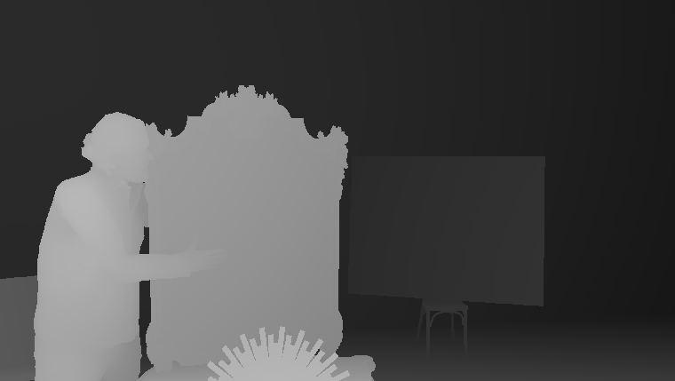

Figure 2: depth of v0 frame 1

The content on 97 frames, 3 pose files (Yp01.csv, Yp02.csv, Yp03.csv), the 3 related R97 pose traces, this contribution, the excel file and copyright license are to be found in:

- MPEG server MPEG-I/Interdigital/Interdigital_Mirror_Content/

Quick test with TMIV

A very quick trial has been made with TMIV6

As expected, current TMIV is not able to handle pure reflection and this shows up with severe artefacts on the surface of the mirror where patterns are typically repeated, because put at the wrong depth.

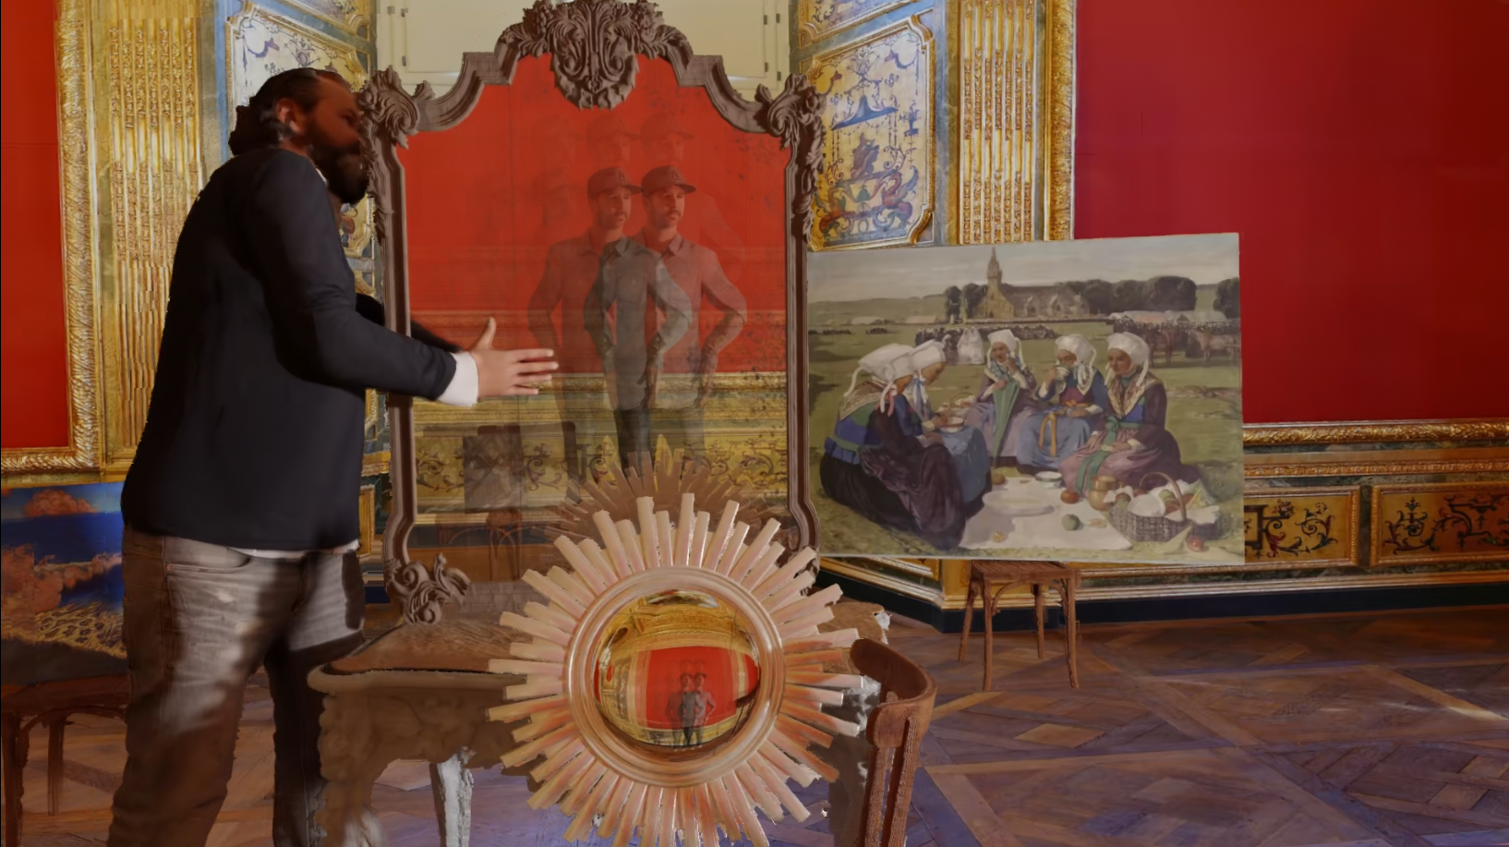

Figure 3: snampshot of p01 pose traces with severe artefacts on mirror surface

We did not find useful to draft the Excel template results since the BD rate degradation would be just depending of the angular size of the mirror.

Recommandations

Although the content is not photorealistic and not meant for outside communications, we recommend accepting this Mirror content as optional contents in the next version of CTC [2], since it will help addressing advanced topics in coming MIV investigations.

Copyright

Cf Annex. Also to be found in MPEG site content

Credits

Three relatively famous paintings are present in this content, represented with exact dimensions, all viewable in Rennes Art Museum (cf the list of most famous paintings here):

- Marine Bleue, Effet de Vague/ Georges Lacombe (1868-1916) / © RMN - Grand Palais/ Photographer Jean-Manuel Salingue / Musée des Beaux-Arts de Rennes
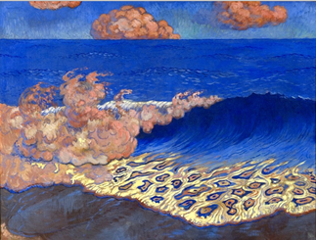
- Le Pont de l’Europe / Caillebotte Gustave (1848-1894) / © RMN - Grand Palais/ Photographer Adélaïde Beaudoin / Musée des Beaux-Arts de Rennes
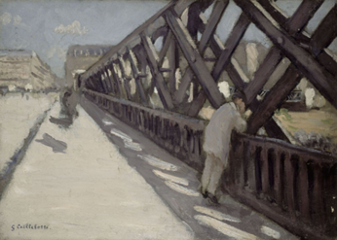
- Femmes de Plougastel au Pardon de Sainte-Anne-La-Palud / Cottet Charles (1863-1925)) / © RMN - Grand Palais/ Photographer Adélaïde Beaudoin / Musée des Beaux-Arts de Rennes
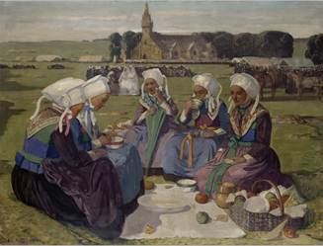

For curious people, the scene is shot in a so-called “salle du Conseil de la Grand-Chambre “ room in the same building than the one used for Museum content, which is Rennes Parlement dedicated to Justice and currently in activity (info in French here).

Reference

[1] m54732 “Fan content proposal for MIV”, July 2020, Renaud Doré, Gérard Briand, Julien Fleureau
[2] WG04N0006 Common Test Conditions, October 2020

Annex: Copyright Interdigital Mirror content

WARNING: DO NOT REMOVE THIS NOTICE - AUTHORIZATION SUBJECT TO RESTRICTIONS
This copyright document relates to the following image contents:
All files included in the content directory with the names ####.yuv or ####.json
with #### indicating a field of any number of letters or numbers

This video content (“Content”) may only be used for the purpose of developing, testing and promulgating technology standards developed by the MPEG, JPEG, VCEG, JVET standardization groups and for academic research without any commercial use or intent (a commercial use including without limitation the creation of any intellectual property right)(“Purpose”), under InterDigital R&D France (“InterDigital”) owned or controlled copyrights, by individual(s) or organization(s) that participates, contributes or is part of such standardization groups (“User(s)”).

RESTRICTIONS: No license whatsoever is implied except from this expressed limited personal, non-sublicensable, non-transferrable authorization. In particular no right under any patent of InterDigital or its affiliates is granted. Any other use is strictly prohibited. This Content cannot be distributed or otherwise disposed of or made available (via internet or otherwise), broadcasted, , used for providing any services to third parties or for any commercial use, nor copied (except as technically necessary for the Purpose), modified, adapted, translated, exchanged, integrated, without limitation. This Content and all intellectual property rights, titles and interests therein, are and remain the exclusive property of InterDigital or its affiliates.
The Content may be disclosed to third Parties or publicly performed for the Purpose only. In no circumstances the Content may be delivered to any third Party. In any demonstration of the content, the following publication must be mentioned:
R. Doré, G. Briand, T. Tapie, Interdigital Mirror Content Proposal for MIV advanced investigations on reflection ISO/IEC JTC1/SC29/WG11 MPEG133/M55710, January 2021

NO WARRANTY: This Content is supplied "as is" and without any warranty of any kind, expressed or implied, including but not limited to any warranty for accuracy or performance, fitness for a general or particular purpose, or any warranty arising by statute or by law, or non-infringement of any third parties’ rights. In no event will InterDigital be liable for damages of any kind, including without limitation, any special, indirect, incidental, or consequential damages even if InterDigital has been advised of the possibility of such damages. This authorization is effective as of the date of use of the Content. InterDigital may nevertheless terminate it at any time for any reason upon notice to User(s). It is governed by the laws of France without regard to conflict of laws. It shall be exclusively submitted to the first instance civil court of Paris, France in the event of a dispute not settled amicably.

BY USING THIS CONTENT USER(S) AGREES AND ACCEPTS THE ABOVE MENTIONNED TERMS AND CONDITIONS. IF USER(S) DOES NOT AGREE TO THESE TERMS AND CONDITIONS, IT SHALL NOT ACCESS OR OTHERWISE USE THIS CONTENT. DO NOT REMOVE OR MODIFY INTERDIGITAL OR ITS AFFILIATES’ NAMES, SIGNS, LOGOS, NOTICES OF/IN THE CONTENT.

Any use (including citation) of the Content must explicitly contain the following sentence "copyright: InterDigital. All rights reserved"
Copyright © 2017-2018 – InterDigital
All Rights Reserved “

