INTERNATIONAL ORGANISATION FOR STANDARDISATION
ORGANISATION INTERNATIONALE DE NORMALISATION
ISO/IEC JTC 1/SC 29/WG 7
CODING OF MOVING PICTURES AND AUDIO

ISO/IEC JTC 1/SC 29/WG 7 m58167
Online – Oct 2021

Title: [AI-3DGC] Point cloud geometry compression using learned
octree entropy coding
Authors: Muhammad Asad Lodhi, Jiahao Pang, Dong Tian (InterDigital)

Introduction
This “for information” document describes another branch of learning based point cloud compression via entropy coding of its octree representation. This is in contrast to the learning based architectures that have been recently discussed in MPEG; see m57453 [1] and m57301 [2] for more details. The work being focused on in this document is related to the publications [3, 4]. As we will show in this document, the learning based octree coding is a standalone compression scheme and also acts complementary to the existing learning based architectures.

Placement in current discussion at MPEG
Current explorations at MPEG looking at learning based method are looking at methods primarily concerned with dense point cloud data up to 11bits. Moreover, these methods only concern themselves with the last few bits and the remaining earlier bits are compressed via simple arithmetic coding or using the GPCC codec. This scheme is unsuitable for high bit-depth data like LiDAR.
In contrast, in this document we want to present another set of methods that focus on high bit-depth point clouds like LiDAR or HD maps, namely learning based octree coding methods. These coding methods can be paired with the other methods (for dense point clouds) to work for high bit depth data. For example, when working with HD maps the last few levels can be compressed via the dense point cloud methods while the octree coding methods can compress all the remaining earlier levels.

Octree entropy coding
Octree coding is a well-known method and is also one coding modes available in GPCC codec. In the simplest terms, the idea is based on the fact that a point cloud can be represented via an octree decomposition tree. A root node encompasses the full space of the point cloud in a bounding box. The space is then equally split in every direction, i.e., x-, y-, and z- directions, leading to eight (8) voxels/children nodes. For each voxel, if there is at least one point, the voxel is marked to be occupied, represented by ‘1’; otherwise, it is marked to be empty, represented by ‘0’. The root voxel node is then described by an occupancy constituting an 8-bit value corresponding to the eight voxels.
For each occupied voxel, its space is further split into eight (8) child voxels; and one then moves to the next level of octree. Based on the occupancy of the child voxels, the current voxel is further represented by a 8-bit value. This splitting of occupied voxels continues until the last octree depth level. The (locations of the) leaves of the octree finally represent the points of the point cloud.
On encoder side, the octree nodes (node values) are typically sent to an entropy coder to generate a bitstream. A decoder then uses the decoded octree node values to reconstruct the octree structure, and finally reconstruct a point cloud based on the leaf nodes of the octree structure. To efficiently entropy code the octree nodes, a probability distribution model is typically utilized to allocate a shorter symbol for octree node values with appearing with higher probability. Context dependent entropy coder can also be used to achieve even better compression performance.

Learning based octree entropy coding
Deep entropy models refer to a category of learning-based approaches that attempt to formulate a context-aware conditional model using a neural network module to predict an underlying probability distribution. Recently, some deep entropy models have been proposed for octree coding [3, 4, 5] which can be categorized under two heads: point based deep entropy models, and voxel based deep entropy models.
Figure 1. Prior art: OctSqueeze (figure taken from the paper)

Point based deep entropy model
One deep entropy model is known as OctSqueeze [3] in Fig. 1. It utilizes hierarchical information by using features from the ancestor nodes including a parent node, a grandparent node, etc. The model consists of three MLP-based modules. A first MLP module takes the context of the current node as input, and generate an output feature. The context of the node includes its location, octant, level, and the occupancy of its parent. A second MLP module generates an output feature by taking the outputted feature of two such first MLP modules; one from the current octree level and the other from the previous octree level. A last third MLP module takes the outputted feature of two such second MLP modules, one from the current octree depth level and the other from the previous octree depth level. Finally, the third MLP module generates a predicted probability distribution.
Figure 2. Prior art: VoxelContextNet. Figure taken from the paper.

Voxel based deep entropy model
The OctSqueeze model suffers some drawbacks: (1) they only exploit context information from ancestor nodes ignoring strong prior information between spatially neighbouring nodes at the same depth level. (2) their work does not consider the distortion introduced in the octree construction procedure. To overcome these Another deep entropy model is known as VoxelContextNet [21] in Fig. 2. Different from OctSqueeze that uses ancestor nodes, VoxelContextNet employs an approach using spatial neighbor voxels to first analyze the local surface shape then predict the probability distribution.
The OctSqueeze model suffers some drawbacks: (1) they only exploit context information from ancestor nodes ignoring strong prior information between spatially neighboring nodes at the same depth level, (2) due to dependence on ancestral features the computational graph is very complex, (3) their work does not consider the distortion introduced in the octree construction procedure. To overcome these shortcomings, another deep entropy model known as VoxelContextNet (VCN) [4] was proposed as shown in Fig. 2. In contrast to OctSqueeze, VCN employs voxelized representation of the point cloud at each level. For each node at each level, VCN extracts the local neighborhood around each node from the voxelized version of the point cloud at that level. This voxelized representation is more efficient at using spatial neighbor voxels and is also amenable to 3D convolutions which can be used to analyze the local neighborhood surface to predict the probability distribution. The network used by VCN for prediction of probability distribution is shown in Fig. 3a and is trained via the cross-entropy loss.
In addition to utilizing the voxel context, VCN also proposes a method to refine the coordinates after the octree has been decoded, dubbed the coordinate refinement module (CRM). The CRM module aims to learn an additive offset/displacement for each decoded point depending on its context. This module is trained using the MSE loss between the ground truth point and the displaced point. The architecture is very similar to probability prediction network with the only major difference being the network outputting an offset instead of a probability distribution.
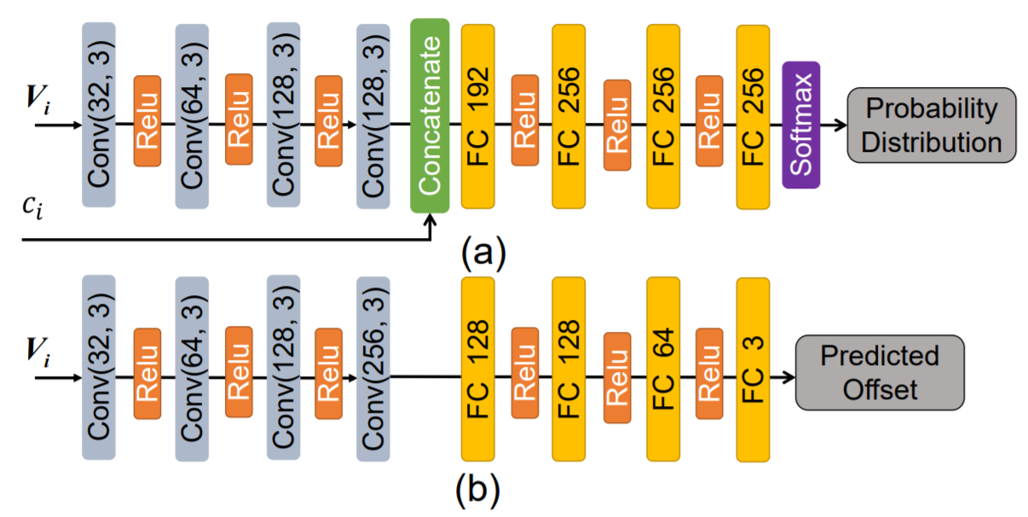
Figure 3. VCN network architecture for (a) probability prediction and (b) CRM. Figure taken from the paper.

A new point based deep entropy model: PointContextNet
The advantage of VCN comes from constructing the local neighborhood but it is apparent that the local voxelized neighborhood is sparse and mostly empty; specially at deeper levels. This means that the voxelized neighborhood has high memory complexity, which gets worse as the size of the neighborhood increases. To this end, we propose a new point based entropy model, PointContextNet (PCN), which enjoys the best of both worlds; low computational and memory complexity. It has also been observed in the literature that 3D convolution based architecture is good for repeatable patterns in the 3D space but it misses the intricate details within the scene [6, 7].
We construct a local normalized point neighborhood by using the normalized locations of the points in the local neighborhood (rather than the voxelized representation). We normalize the points in the local neighborhood by the node size at that level. This point locations in the normalized point neighborhood correspond exactly to the locations of only the occupied voxels in the voxel context from VCN. The work in the earlier point based deep entropy model (OctSqueeze) used MLP modules as building blocks of their network. However, we recognize that just using MLPs is too naïve and thus propose a network architecture based on PointNet++ [8]; see Fig. 4 for an example.
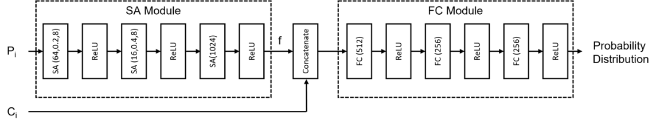
Figure 4. Network architecture for proposed PointContextNet

Experimental evaluation
We now present results from the VCN and from some of our own experiments. We mainly focus on two LiDAR datasets: Kitti dataset and Ford sequences from MPEG CTC.
First, let us look at the results reported in [4] comparing VCN, Octsqueeze and GPCC evaluated for Kitti dataset. The train and test split is specified by the dataset specifications. One can see that the VCN method provides gains on both OctSqueeze and GPCC codec.
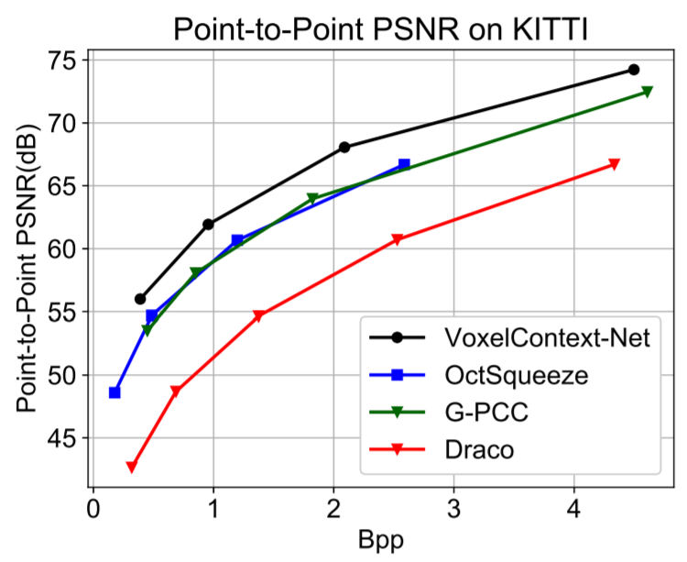
Figure 5. Performance evaluation from VCN paper.
For our own experiments, we try to reproduce the results of VCN and add our own proposed method to the experiments, as shown in Fig. 6.

Bibliography

[1] | J. Wang, Z. Ma, H. Wei, Y. Yu, V. Zakharchenko and D. Wang, A Geometry Compression Framework for AI-based PCC via Sparse Convolution, Online: MPEG m57453, Jul 2021.
[2] | A. Zaghetto, D. Graziosi and A. Tabatabai, Discussion on Point Cloud Geometry Compression Using Machine Learning, Online: MPEG m57301, Jul 2021.
[3] | L. Huang, S. Wang and e. , "OctSqueeze: Octree-Structured Entropy Model for LiDAR Compression," in CVPR, 2020.
[4] | G. L. a. D. X. Zizheng Que, "VoxelContext-Net: An Octree based Framework for Point Cloud Compression," in Proceedings of the IEEE/CVF Conference on Computer Vision and Pattern Recognition, 2021.
[5] | S. Biswas, J. Liu and et.al., "MuSCLE: Multi Sweep Compression of LiDAR using Deep Entropy Models," in NeurIPS, 2020.
[6] | C. G. L. J. Z. W. J. S. X. W. H. L. Shaoshuai Shi, "PV-RCNN: Point-voxel feature set abstraction for 3d object detection," in Proceedings of the IEEE/CVF Conference on Computer Vision and Pattern Recognition, 2020.
[7] | H. T. Y. L. S. H. Zhijian Liu, "Point-Voxel CNN for efficient 3d deep learning," in Proceedings of the IEEE/CVF Conference on Computer Vision and Pattern Recognition, 2019.
[8] | L. Y. H. S. L. G. Charles Qi, "PointNet++: Deep hierarchical feature learning on point sets in a metric space," in Advances in Neural Information Processing Systems, 2017.
[9] | G. Martin-Cocher and D. Tian, Discussion Around G-PCC Version 2, Online: MPEG m56008, Jan 2021.
[10] | G. E. Hinton and R. S. Zemel, "Autoencoders, Minimum Description Length and Helmholtz Free Energy," in Advances in neural information processing systems 6, 1994.
[11] | Audi, "Driving Dataset," [Online]. Available: https://www.a2d2.audi/a2d2/en.html.
[12] | KITTI, "The KITTI Vision Benchmark Suite," [Online]. Available: http://www.cvlibs.net/datasets/kitti/.
[13] | A. X. Chang, T. Funkhouse and et.al., "ShapeNet: An Information-Rich 3D Model Repository," in ICCV, 2017.
[14] | M. Quach, G. Valenzise and F. Dufaux, "Improved Deep Point Cloud Geometry Compression," in MMSP, Tampere, Finland, 2020.
[15] | J. Pang, M. A. Lodhi, G. Martin-Cocher and D. Tian, "[PCC] AI-based Point Cloud Compression for New PCC," in MPEG m56776, Online, 2021.
[16] | Y. Yang, "FoldingNet: Point cloud auto-encoder via deep grid deformation," in Proceedings of the IEEE Conference on Computer Vision and Pattern Recognition, 2018.
[17] | J. Begaint, F. Racape, S. Feltman and A. Pushparaja, "CompressAI: a PyTorch library and evaluation platform forend-to-end compression research," in arXiv 2020.03029, 2020.
[18] | J. Pang and et.al., "TearingNet: Point Cloud Autoencoder to Learn Topology-Friendly Representations," in Yang, Yaoqing, et al. "Foldingnet: Point cloud auto-encoder via deep grid deformation." Proceedings of the IEEE Conference on Computer Vision and Pattern Recognition, 2021.
[19] | C. R. Qi and et.al., "PointNet: Deep learning on point sets for 3D classification and segmentation," in Proceedings of the IEEE conference on computer vision and pattern recognition, 2017.
[20] | J. Balle, D. Minnen and et.al., "Variational Image Compression with a Scale Hyperprior," in ICLR, 2018.

