INTERNATIONAL ORGANISATION FOR STANDARDISATION
ORGANISATION INTERNATIONALE DE NORMALISATION
ISO/IEC JTC 1/SC 29/WG 4
CODING OF MOVING PICTURES AND AUDIO

ISO/IEC JTC 1/SC 29/WG 4 m 55091
Online – October 2020

Title: MIV CTC modification proposal
Author: Renaud Doré, Franck Thudor, Bertrand Chupeau (Interdigital)

The purpose of m55089 is to justify the possible activation of the transparency information in an extended profile. This profile would be used when some contents require it. Interdigital claims that this requirement happens even before the content includes truly transparent material like glass– which is by the way almost absent in the current CTC contents – and for example when the contours are either very sensitive to any artefact because of sharp contrast of foreground versus background or in presence of fine geometry. m55089 also explains that MPI is a means to bring and render this transparency information.

m55089 only recommends opening a new extended profile. This contribution aims discussing about the introduction of content with transparency component in the CTC.

MPI as a possible input for test material

It has been mentioned in m55089 [1] that the creation of an MPI is extremely long and requires GPU processing, preventing in practice the computation in the TMIV software as done so far.
Instead, it would be natural to allow a content provider to propose as an alternative method his content for CTC integration directly under the form of an MPI. A few remarks:

- MPI input would be a parallel with MVD inputs, as an alternative input. It would use the last update of Call for Visual Test Material [2] allowing transparency as complementary input as YUV file.

- The TMIV would have to accept this alternative inputs as well but could mutualize a number of blocks in the encoder. An exception to this is the pruning which does not longer exist with MPI.

- TMIV Renderer would be of course different but blocks in the decoder could be mutualized as well like metadata parsing, etc.

OpenEXR 2.0 as a possible input format

MPI is just a set of texture and transparency planes. We see 2 options as an input format:
- One first option would be to create a view per planes. It would lead to more than one hundred of views, which may be not manageable in terms of input pixel rates.
- The 2nd option is OpenEXR 2.0 and this has our preference.

Originally, “OpenEXR is a high dynamic range raster file format, released as an open standard along with a set of software tools created by Industrial Light & Magic (ILM), under a free software license similar to the BSD license”.

In April 2013, ILM introduced a major release OpenEXR2.0 (cf [4]) with depth support:

Deep Data support - Pixels can now store a variable-length list of samples. The main rationale behind deep images is to enable the storage of multiple values at different depths for each pixel. OpenEXR 2.0 supports both hard-surface and volumetric representations for Deep Compositing workflows

There are different method for lossless or lossy compression as listed in OpenEXR Wikipedia page.

Also, the use of OpenEXR2.0 as input format would open the door to other information like material ID, etc. and to advanced investigations but this is beyond the current specification version.

Required Changes in the methodology related to objective performances

A recent contribution “On quality evaluation for MIV activity” [3] has listed the issues with the objective performance method based on source views, among which :
“
- Issue 1: most of the displayed views, for which the quality should be assessed, don’t have a ground truth reference.

As a consequence, for objective evaluation, only the intermediate views estimated at position and orientation of captured source views are considered.

- Issue 2: full-reference objective metrics can only be used on a limited amount of view positions and orientations.”

No more source views to compare with, and PSNR computed on pose traces, as mentioned by the contribution on how to improve metrics for immersive content

.. The group has limited confidence in the metrics [ currently used in the CTC ], in this specific context.
”
The use of a MPI changes a little bit the game:

- There is no more “source views”, preventing the comparison to original images.
- but on another hand, the renderer is straightforward, allowing to render the generation of any position with very little, if any, ambiguity.

Therefore, would the group decide to investigate more the MPI in the framework of TMIV, objective metrics computation would consist in using the same metrics as in current CTC, but applying them on very diverse source positions, typically integrated through the pose trace paths as illustrated below.
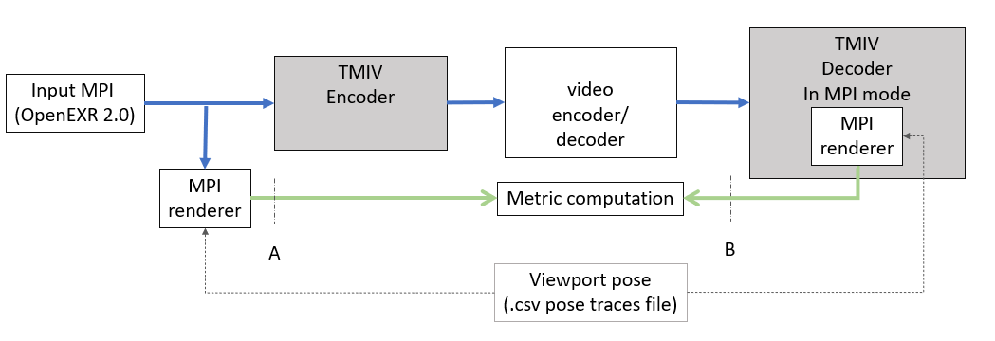
Figure 1: metrics computation along pose trace paths
The introduction of MPI as a content input raises anyway the question of the viewing quality of this content. The group could decide the acceptance of a new content by viewing the content from the MPI renderer (cf A above) and assess whether the visual quality is good enough.

Recommandations

We therefore recommend to open the CTC and allow:

- to accept content under the form of OpenEXR format with texture, depth and transparency informations
- to determine the process of acceptance of a content in such a format, typically with the use of qualified MPI renderer
- to precise the methodology for objective performances, typically along the pose trace paths

Reference

[1] m55089 “MIV CE1 related: activation of transparency attribute based on MIV”, October 2020, Julien Fleureau, Franck Thudor, Bertrand Chupeau, Renaud Doré
[2] N19490 Call for MPEG-I Visual Test Materials, July 2020
[3] m54361 “On quality evaluation for MIV (MPEG Immersive Video) ”, Joël Jung & All (Tencent), Vinod Kumar Malamal Vadakital (Nokia)
[4] OpenEXR: https://www.openexr.com/

