INTERNATIONAL ORGANISATION FOR STANDARDISATION
ORGANISATION INTERNATIONALE DE NORMALISATION
ISO/IEC JTC 1/SC 29/WG 2
MPEG TECHNICAL REQUIREMENTS

ISO/IEC JTC 1/SC 29/WG 2 m55986
Online – January 2021

Source | InterDigital
Status | Input contribution
Title | Kinesthetic reference setup for the AHG MPEG-haptics
Authors | Fabien Danieau (fabien.danieau@interdigital.com)  Quentin Galvane (quentin.galvane@interdigital.com)  Philippe Guillotel (philippe.guillotel@interdigital.com)

Contents
Abstract 1
1. Introduction 2
2. Hardware 2
3. Workflow 2
3.1. Touch device 2
3.2. Virtual Audio Cable 3
3.3. Kinesthetic driver 4
3.3.1. Portaudio 4
3.3.2. Chai3d 4
3.3.3. Kinesthetic driver 4
3.4. mushra STEP 5
4. Technical details 6
5. Conclusions 6
6. Copyright and information(s) 6

Abstract
At the 131 MPEG meeting, an AhG was setup with the mandate to prepare a Call for Proposals for the coded representation of Haptics. Among its mandates, the group had to i) collect test material for use with the CfP and subsequent specification development and ii) study and propose methods to evaluate CfP responses.
This contribution proposes a piece of software that allows to use mushra STEP with kinesthetic content. This content is playback on a force-feedback device.

Introduction
Encoded contents submitted by the proponents will be evaluated with a MUSHRA protocol in a way similar audio signals are evaluated. The software STEP (https://www.audioresearchlabs.com/arl-step/) already used by the MPEG audio group will serve as a platform for handling these tests. Indeed, vibratory signals are similar to audio signals and could be used as is by the test software (they are encoded in a .wav file). The vibrating device is connected to the audio speaker. However, in the context of kinesthetic content, the force-feedback device is connected through USB and it is not designed to receive audio signals. Thus, a piece of software is required to render signals from STEP with the force feedback device. The scheme bellow describes the workflow for connecting STEP to the force-feedback device. The proposed software is the “Kinesthetic Driver”.

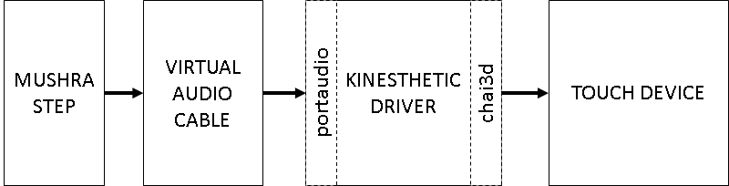

Hardware
The platform is based on a 3D System Touch, and fully described in the CfP (m55829). It is a 3DoF force-feedback device able to apply 3.3N along each axis. It relies on a USB 2.0 connection.

Workflow
This section describes each step of the workflow, and how to install each component.

Touch device
The official driver for the Touch device must be downloaded and installed. Use the Touch Device Driver v2020.7.9 and OpenHaptics v3.5, available here https://support.3dsystems.com/s/article/Haptic-Device-Drivers
If successfully installed Touch Smart Setup should be available on the desktop. The detection of the device can be tested (see screenshot below).

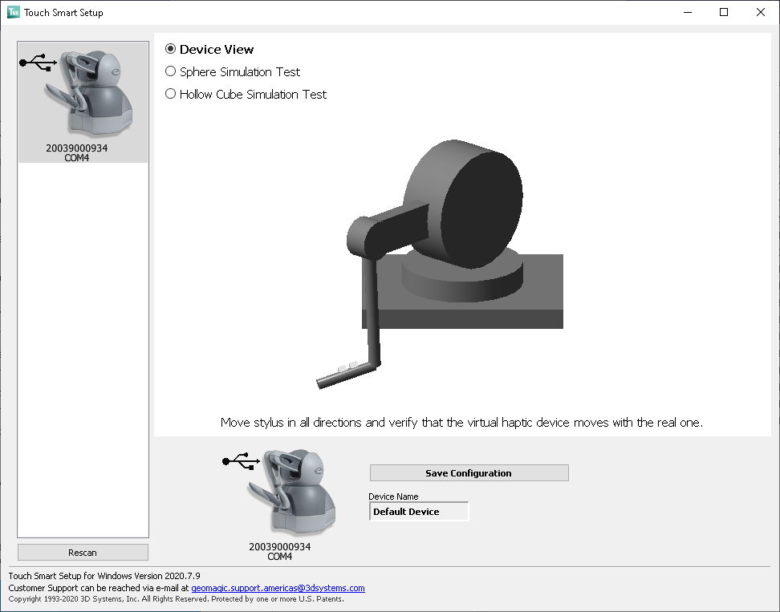

Examples located in C:\OpenHaptics\Developer\3.5.0\examples\bin\x64 should also work.

Virtual Audio Cable
Virtual Audio Cable (VAC) is a virtual audio card that allows an audio software to output a signal on that device which is also available as an input. Thus, another audio software can get this signal. VAC is then used to connect STEP to the kinesthetic driver.

Download and install Virtual Audio Control Cable https://vac.muzychenko.net/en/download.htm
If successfully installed, ‘Line 1’ should be visible in the audio devices panel.

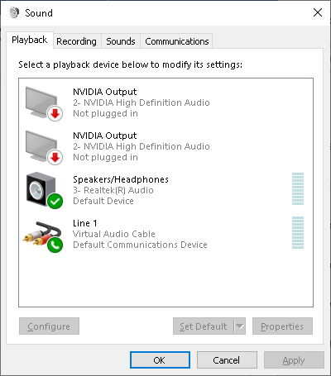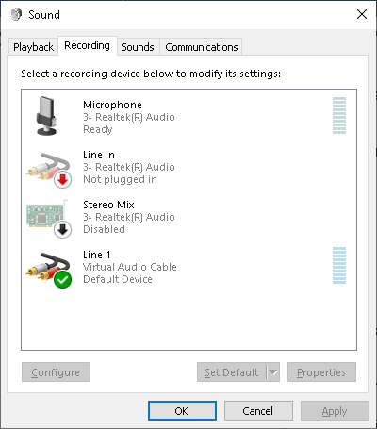

Virtual Audio Cable Control Panel should also be available. When sound is sent to the virtual cable, the signals levels are activated.

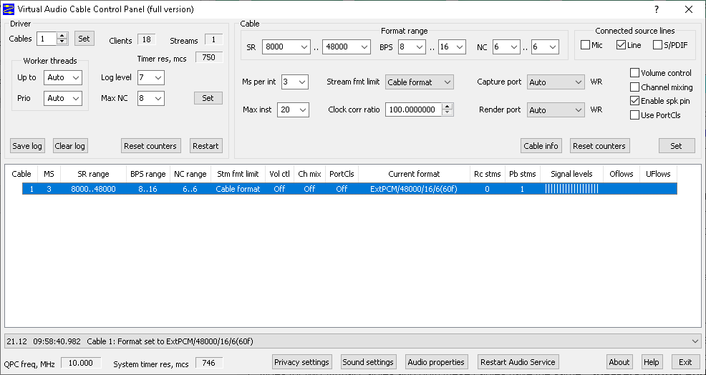

Number of channels (NC) should be specified at 6 (input and output). ‘Channel mixing’ should be deactivated and ‘Enable spk pin’ activated.

Kinesthetic driver
This piece of software is the heart of the proposal. It has been developed to convert the audio signal from VAC into forces rendered by the Touch. It requires Windows 10 and should be compiled with Visual Studio 2019. It also requires cmake, git, and two libraries: portaudio for capturing audio data and chai3d for rendering forces on the Touch device.

Portaudio
Follow instructions to git clone and compile https://github.com/Microsoft/vcpkg. Use the release version 2020.11-1. Then install portaudio library using vcpkg:

vcpkg install portaudio

Chai3d
Follow instructions to git clone and compile https://github.com/chai3d/chai3d.git Use version 3.2.0. If succeeded, chai3d examples can be tested with the Touch.

Kinesthetic driver
Git clone https://github.com/InterDigitalInc/MPEG_Haptics
Step by step instruction to compile the code are list in the file README.md, in the kinesthetic_RefSetup folder.
Basically, use cmake to build the visual c++ project file.

cmake .. -DCMAKE_TOOLCHAIN_FILE=D:\vcpkg\scripts\buildsystems\vcpkg.cmake
Then open the visual studio project KINE_STEP_TEST.sln and build all (Release 64bits). It should build kine_step.exe

mushra STEP
Run Mushra STEP and select the provided *.asi file. Select Virtual audio cable as Audio Device.
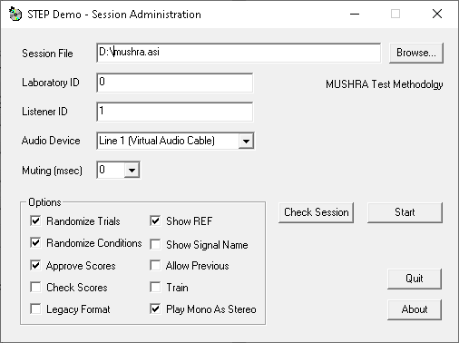

Plug the Touch device and run kine_step.exe. Select interface Line 1 (Virtual Audio Cable) max input:6 max output:0 by entering its id number and press enter (number 2 in this example).

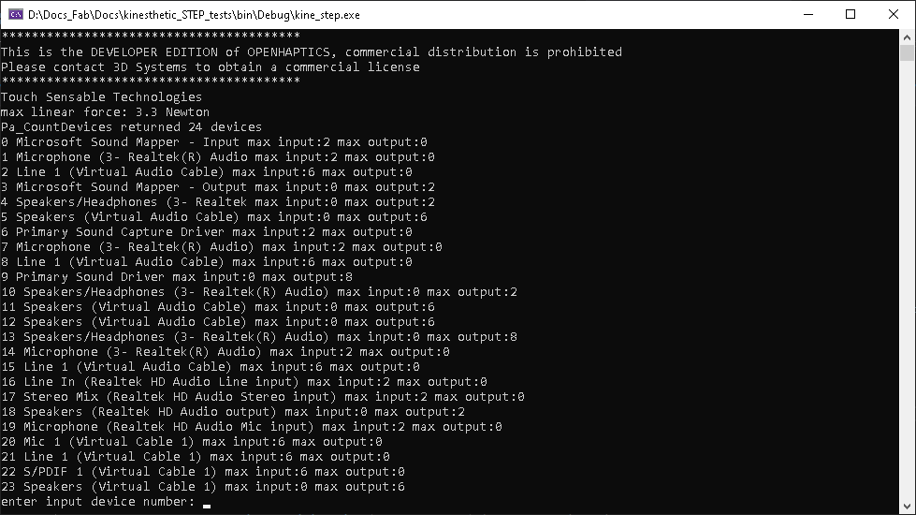

kine_step.exe is now running and listening to audio input from STEP. Stimulus are rendered on the Touch device.

The test is ready to be performed. Start the session from the mushra step interface. Pressing Play button would activate the Touch device.

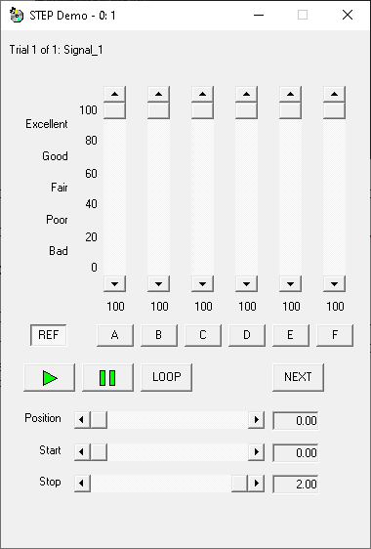

Technical details
The kinesthetic driver (kine_step.exe) relies on the portaudio library to collect data from the selected audio input. The sample rate (8KHz) and sample type (16bit) are defined in the source code AudioCapture.h and AudioCapture.cpp. The capture of data is performed in a callback fonction (recordCallback) and stored in a ring buffer.
A thread reads this buffer (processing_thread), unpack the data as 3D forces and send them to the force-feedback device. The device is a chai3d object. Any force feedback device compatible with this library is usable. This thread runs as fast as possible and relies on a clock to make sure that the correct frames are played at the right time. Any frame received too late is dropped.
Step 3.3.3 also builds kine_player.exe. It is used to directly render a wav file on the force-feedback device for test purposes. The path of the file should be specified in main_player.cpp directly.

Conclusions
The proposed piece of software allows to connect the mursha STEP platform to a force-feedback device. The robust Mursha protocol can be then used for evaluating kinesthetic content in the context of the MPEG Haptics CfP.

Copyright and information(s)
The associated TERMS AND CONDITIONS are provided with the software.

