INTERNATIONAL ORGANISATION FOR STANDARDISATION
ORGANISATION INTERNATIONALE DE NORMALISATION
ISO/IEC JTC 1/SC 29/WG 2
MPEG TECHNICAL REQUIREMENTS

ISO/IEC JTC 1/SC 29/WG 2 m55985
Online – January 2021

Source | InterDigital
Status | Input contribution
Title | OHM file format for haptic data description
Authors | Philippe Guillotel (philippe.guillotel@interdigital.com)  Quentin Galvane (quentin.galvane@interdigital.com)  Fabien Danieau (fabien.danieau@interdigital.com)

Contents
Abstract 1
1. Introduction 1
2. Object Haptic Metadata (OHM) file format 2
3. Example of OHM description 5
4. Software tool to generate the OHM binary file 6
5. Conclusions 7
6. Patent rights declaration(s) 8

Abstract
At the 131 MPEG meeting, an AhG was setup with the mandate to prepare a Call for Proposals for the coded representation of Haptics. Among its mandates, the group had to i) collect test material for use with the CfP and subsequent specification development and ii) study and propose methods to evaluate CfP responses.
This contribution proposes a syntax to describe the various haptic input data that will be considered for the coming CfP, together with the associated software tool to generate the binary file corresponding to a proposed description.

Introduction
Three types of data format are planned for the MPEG-Haptics CfP, based on either JSON descriptors (i.e., AHAP file format), XML parametric effects descriptors (i.e., IVS file format) and PCM signals encoded using WAV. However, there is no description of the haptic content and configuration associated to each stream, such as the type of haptic data, the number of channels, or how to play the signals regarding the user. This contribution proposes such a description syntax and the associated software tool to generate the corresponding binary file. The description is inspired from the audio OAM (Object Audio Metadata) file format, and has been adapted for haptic data, thus the name OHM (Object Haptic Metadata).
The Call for Proposals for the Coded Representation of Haptics has been drafted at the 132 MPEG meeting (m55194) and includes this proposed description file format that will have to be provided with the haptic test streams.

Object Haptic Metadata (OHM) file format
This metadata file contains a description of the haptic system and setup. In particular, it provides the name of each associated file along with a description of the signals. It also provides a mapping between each channel of the signals and the targeted body parts on the user body. To perform this mapping, each body part of a user is associated with a binary mask as shown in Figure 1 and Table 1. These masks can be combined to define larger body surfaces as illustrated in Table 2.
The syntax of the OHM metadata file is given below.

Syntax | No. of bytes | Data format
file_description () {  format_id_string  format_version  number_of_haptic_elements  description_string  for (i=0; i<number_of_haptic_elements; i++) {  haptic_element_file_name  element_description_string  number_of_haptic_channels  for (i=0; i<number_of_haptic_channels; i++) {  channel_description_string  channel_gain  body_part_mask  }  }  } | 4  2  2  32  64  32  2  32  4  4 | char  unsigned int  unsigned int  char  char  char  unsigned int  char  single float  unsigned int

format_id_string – unique character identifier “OHM”
format_version – version number of the file format: 1.
number_of_haptic_elements – number of haptic elements compiling the content. An element typically maps to an end-user haptic device.
description_string – description string containing a human readable content description. If shorter than 32 bytes, it is followed by padding null characters. If the string is 32 bytes long, the string is terminated without a null character.
haptic_element_file_name – description string containing the file name of the according haptic element file (.wav, .ivs, .ahap). If shorter than 64 bytes, it is followed by padding null characters. If the string is 64 bytes long, the string is terminated without a null character. Note that an element might include more than one channel. This file is assumed to be located in the same directory as the ohm file (i.e. same path).
element_description_string – description string containing a human readable content description. If shorter than 32 bytes, it is followed by padding null characters. If the string is 32 bytes long, the string is terminated without a null character.
number_of_haptic_channels – number of simultaneous channels for each haptic element (up to 65535).
channel_description_string – description string containing a human readable content description. If shorter than 32 bytes, it is followed by padding null characters. If the string is 32 bytes long, the string is terminated without a null character.
body_part_mask – binary mask specifying the body part(s) on which to apply the effect.
channel_gain – a single precision float value that describes the amplitude gain for the haptic track. A value of 1.0 indicates that the track should be rendered at nominal voltage. Higher values indicate an overdrive state for the actuator.

Table 1: Body Part Masks
body part ID | Name | body_part_mask | Hexa
0 | Unspecified | 00000000000000000000000000000000 | 0x00000000
1 | Head front | 00000000000000000000000000000001 | 0x00000001
2 | Head back | 00000000000000000000000000000010 | 0x00000002
3 | Head right | 00000000000000000000000000000100 | 0x00000004
4 | Head left | 00000000000000000000000000001000 | 0x00000008
5 | Right upper chest | 00000000000000000000000000010000 | 0x00000010
6 | Left upper chest | 00000000000000000000000000100000 | 0x00000020
7 | Abdomen | 00000000000000000000000001000000 | 0x00000040
8 | Waist | 00000000000000000000000010000000 | 0x00000080
9 | Upper back | 00000000000000000000000100000000 | 0x00000100
10 | Lower back | 00000000000000000000001000000000 | 0x00000200
11 | Right upper arm | 00000000000000000000010000000000 | 0x00000400
12 | Left upper arm | 00000000000000000000100000000000 | 0x00000800
13 | Right forearm | 00000000000000000001000000000000 | 0x00001000
14 | Left forearm | 00000000000000000010000000000000 | 0x00002000
15 | Right wrist | 00000000000000000100000000000000 | 0x00004000
16 | Left wrist | 00000000000000001000000000000000 | 0x00008000
17 | Right hand palm | 00000000000000010000000000000000 | 0x00010000
18 | Left hand palm | 00000000000000100000000000000000 | 0x00020000
19 | Right hand dorsum | 00000000000001000000000000000000 | 0x00040000
20 | Left hand dorsum | 00000000000010000000000000000000 | 0x00080000
21 | Right hand fingers | 00000000000100000000000000000000 | 0x00100000
22 | Left hand fingers | 00000000001000000000000000000000 | 0x00200000
23 | Right thigh | 00000000010000000000000000000000 | 0x00400000
24 | Left thigh | 00000000100000000000000000000000 | 0x00800000
25 | Right calf | 00000001000000000000000000000000 | 0x01000000
26 | Left calf | 00000010000000000000000000000000 | 0x02000000
27 | Right foot palm | 00000100000000000000000000000000 | 0x04000000
28 | Left foot palm | 00001000000000000000000000000000 | 0x08000000
29 | Right foot dorsum | 00010000000000000000000000000000 | 0x10000000
30 | Left foot dorsum | 00100000000000000000000000000000 | 0x20000000
31 | Right foot fingers | 01000000000000000000000000000000 | 0x40000000
32 | Left foot fingers | 10000000000000000000000000000000 | 0x80000000

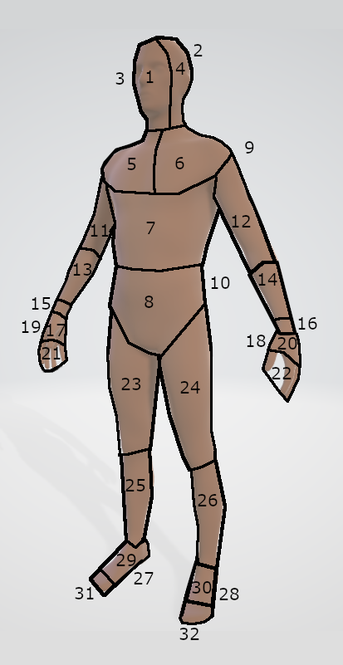
Figure 1: Body Part Segmentation

Table 2: Body Parts Combinations
body part ID | body_part_mask | Hexa
Right arm | 00000000000101010101010000000000 | 0x00015540
Left arm | 00000000001010101010100000000000 | 0x002AA800
Right leg | 01010101010000000000000000000000 | 0x55400000
Left leg | 10101010100000000000000000000000 | 0xAA800000
Upper body | 00000000001111111111111111111111 | 0x003FFFFF
Lower body | 11111111110000000000000000000000 | 0xFFC00000
Full body | 11111111111111111111111111111111 | 0xFFFFFFFF

Example of OHM description
This example corresponds to a “rain” like effect. It includes 4 channels corresponding to 4 actuators put on the red areas on the user described in Figure 2. For each channel a random discrete series of pulse is simulated according to Figure 3.

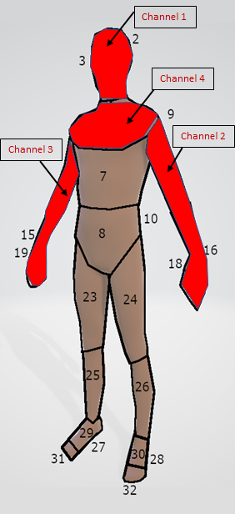
Figure 2: Body parts for the rain example
The corresponding OHM syntax is the following. It includes the name of the effect (rain effect), the name of the associated PCM file (rain.wav), and the description of each channel 1 to 4 (name, gain, body parts).

format version: 1
number_of_haptic_elements: 1
description string: rain effect
haptic_object #: 1
haptic_object_file_name: rain.wav
element description string: Vibration effect
number_of_haptic_channels: 4
haptic channel #: 1
channel description string: head
channel gain: 1.0
body_part_mask: 0b1111
body parts: ['Head front', 'Head back', 'Head right', 'Head left']
haptic channel #: 2
channel description string: left arm
channel gain: 1.0
body_part_mask: 0b1010101010100000000000
body parts: ['Left upper arm', 'Left forearm', 'Left wrist', 'Left hand palm', 'Left hand dorsum', 'Left hand fingers']
haptic channel #: 3
channel description string: right arm
channel gain: 1.0
body_part_mask: 0b101010101010000000000
body parts: ['Right upper arm', 'Right forearm', 'Right wrist', 'Right hand palm', 'Right hand dorsum', 'Right hand fingers']
haptic channel #: 4
channel description string: upper chest
channel gain: 1.0
body_part_mask: 0b110000
body parts: ['Right upper chest', 'Left upper chest']

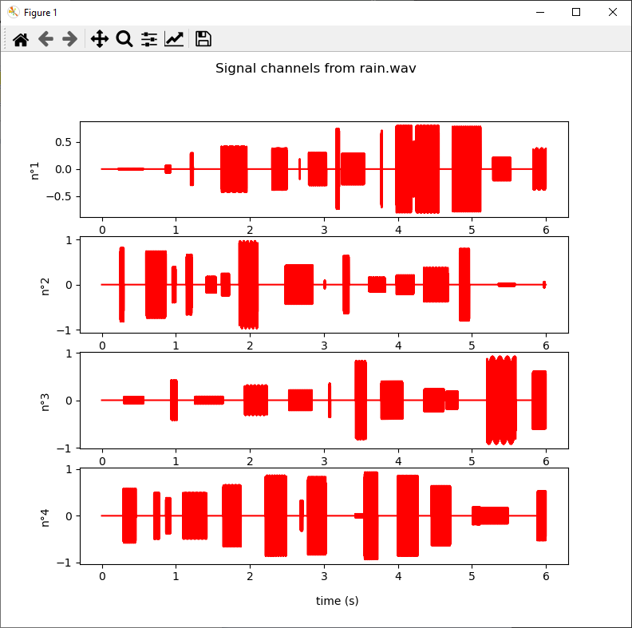
Figure 3: PCM signals for the rain example

Software tool to generate the OHM binary file
This chapter contains instructions to download and run the OHM description file.

The code is located on a git repo: https://github.com/InterDigitalInc/MPEG_Haptics
It contains two python files: generate_ohm.py and parse_ohm.py. It requires python 3 (tested with python 3.8.5). Parse_ohm.py requires the optional libraries soundfile and matplotlib in order to display the signals.

Simply run ‘python generate_ohm.py’ to generate an ohm file. Parameter should be modified within the python file in the main function. Several examples are provided such as:
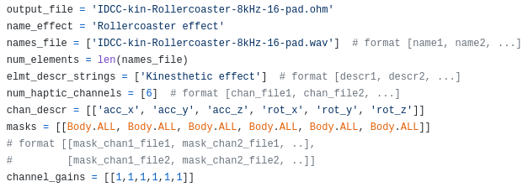

To parse an ohm file run ‘python parse.ohm <file_name>’. <file_name> being the path to the file. For instance:
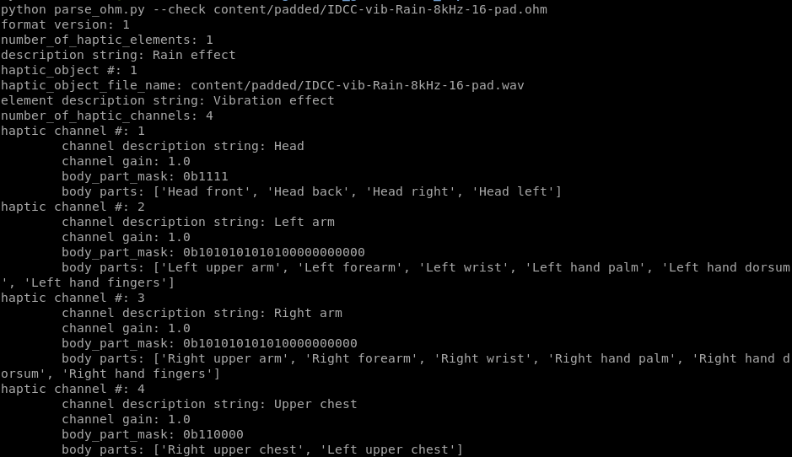Adding the option –check will display a figure with the signal, such as in Figure 3.

Conclusions
The proposed syntax allows to describe the content of any haptic input data format, in order to describe the type of content and location on the user body. It applies for AHAP, IVS and WAV haptic formats, but cannot also be used for any other formats. It has to be associated to the raw data file for a correct use for the MPEG Haptics CfP.

This format will be documented as part of the Encoder Input Format for Haptics (currently draft document m55196), and the software to generate and parse the binary file will be made available to the test streams proponents to generate the appropriate files.

Patent rights declaration(s)
InterDigital may have current or pending patent rights relating to the technology described in this contribution and, conditioned on reciprocity, is prepared to grant licenses under reasonable and non-discriminatory terms as necessary for implementation of the resulting ITU-T Recommendation | ISO/IEC International Standard (per box 2 of the ITU-T/ITU-R/ISO/IEC patent statement and licensing declaration form).

