INTERNATIONAL ORGANISATION FOR STANDARDISATION
ORGANISATION INTERNATIONALE DE NORMALISATION
ISO/IEC JTC1/SC29/WG11
CODING OF MOVING PICTURES AND AUDIO

ISO/IEC JTC1/SC29/WG11 MPEG2020/m54467
July 2020, Online

Source: | InterDigital Communications, Inc.
Status: | Input contribution
Title: | [DNNVC] CompressAI: A PyTorch library and evaluation platform for end-to-end compression research
Authors: | Jean Bégaint, Fabien Racapé, Simon Feltman, Akshay Pushparaja

Introduction
This contribution presents CompressAI, a platform that provides custom operations, layers, models and tools to research, develop and evaluate end-to-end image and video compression codecs. In particular, CompressAI includes pre-trained models and evaluation tools to compare learned methods to classical codecs. Multiple models from the state-of-the-art on learned end-to-end compression have thus been reimplemented in PyTorch[1] and trained from scratch using the Vimeo90K training dataset [2].
The contribution also reports objective comparison results using PSNR and MS-SSIM metrics vs. bitrate, using the Kodak [3] image dataset as test set. Although this framework currently implements models for still-picture compression, it is intended to be extended to the video compression domain.

CompressAI

CompressAI is an open source library, available under the Apache license version 2.0. It is publicly accessible on GitHub: https://github.com/InterDigitalInc/CompressAI.

Motivation

At the 130th MPEG meeting, an Ad hoc Group was created on DNN-based video coding (DNNVC) with the following mandates:
            - Evaluate and quantify performance improvement potential of DNN based video coding technologies (including hybrid video coding system with DNN modules and end-to-end DNN coding systems) compared to existing MPEG standards such as HEVC and VVC, considering various quality metrics;
            - Study quality metrics for DNN based video coding;
            - Solicit input contributions on DNN based video coding technologies;
            - Analyze the encoding and decoding complexity of NN based video coding technologies by considering software and hardware implementations, including impact on power consumption;
            - Investigate technical aspects specific to NN-based video coding, such as design network representation, operation, tensor, on-the-fly network adaption (e.g. updating during encoding) etc.
In response to several of these mandates, CompressAI is made available to MPEG DNNVC experts.

The current deep learning ecosystem is mostly dominated by two frameworks: PyTorch and TensorFlow. Discussing the merits, advantages and particulars of one framework over the other is beyond the scope of this document. However, there is evidence that PyTorch has seen a major growth in the academic and industrial research circles over the last years. On the other hand, building end-to-end architectures for image and video compression from scratch in PyTorch requires a lot of re-implementation work, as PyTorch does not ship with any custom operations required for compression (such as entropy bottleneck and estimation tools). These required tools are also mostly absent from the current PyTorch ecosystem, whereas the tensorflow framework has a compression library.

CompressAI aims to implement the most common operations to build deep neural network architectures for data compression in PyTorch, and to provide evaluation tools to compare learned methods against classical codecs. CompressAI also pre-defines model architectures from the state-of-the-art on learned image compression with pre-trained weights achieving similar performances as reported in the original papers.

CompressAI features
CompressAI is built on top of PyTorch and implements custom operations, layers and modules for end-to-end data compression. In particular, CompressAI re-implements the most critical modules from the Tensorflow compression library by Ballé et al.

The following is a non-exhaustive list of the current tools implemented in CompressAI:
- Layers
  - Non-linear activation functions
    - GDN (Generalized Division Normalization) layer
    - 1-GDN: simplified GDN
  - Masked Convolution: can be used during training to simulate an auto-regressive component at the decoder side
- Entropy models
  - Entropy Bottleneck: learned per-channel probability density estimation functions. Useful to approximate the Shannon entropies of a tensor elements during training.
  - Gaussian Conditional: evaluates the Shannon entropies of the tensor elements via a conditional Gaussian probability density model. (The associated Gaussian distribution parameters need to be provided with the tensors)
- Operations
  - Straight-Through-Estimator (STE) rounding operator with non-zero gradients
  - lower bound: max operator with non-zero/useful gradients
- Models
  - Factorized Prior
  - Scale Hyperprior
  - Mean Scale Hyperprior
  - Joint Autoregressive Hierarchical Priors

Note: All the implemented models fully support end-to-end compression/decompression with a bit-stream representation, including the auto-regressive encoders/decoders.

- Entropy coders:
  - Range Asymmetric Numeral Systems (Python bindings with C++ backend)
The following models from the state of the art have been implemented and are available in a “model zoo” with pre-trained weights and can be automatically downloaded:
- bmshj2018-factorized [4]: 8 quality parameters, trained for MSE
- bmsh2018-hyperprior [4]: 8 quality parameters, trained for MSE
- mbt2018-mean [5]: 8 quality parameters, trained for MSE
- mbt2018 [5]: 8 quality parameters, trained for MSE
The following models are implemented, and pre-trained weights will be made available soon:
- Anchor model from [6]
- Self-attention variant model from [6]
CompressAI documentation is available online: https://interdigitalinc.github.io/CompressAI.

In addition, we are also working on making CompressAI fully compatible with TorchScript, so that the models can be easily exported and optimized for different platforms or standalone programs. In the meantime, we can report that we have been able to export the models to the ONNX and CoreML formats.

Benchmarking with traditional compression methods
The following hybrid codecs can be used for evaluation with CompressAI:
- JPEG: libjpeg http://ijg.org/
- JPEG2000: openjpeg http://www.openjpeg.org/
- WebP: libwebp https://chromium.googlesource.com/webm/libwebp
- BPG: https://bellard.org/bpg
- HEVC HM reference software: https://hevc.hhi.fraunhofer.de
- AV1 (aomenc): https://aomedia.googlesource.com/aom/
- VVC VTM test model: https://vcgit.hhi.fraunhofer.de/jvet/VVCSoftware_VTM
CompressAI does not ship the binaries of theses codecs but rather provides a common Python interface over the executables, with the exceptions of JPEG and WebP which are linked by default to the Python Pillow Image library.

Results
This section first demonstrates similar results obtained with the CompressAI re-implementation compared to reported in the original publications. The objective performances of above mentioned DNNVC methods against traditional video compression standards are then compared.

Comparison against originally published results
This section exposes the equivalence between the results produced using CompressAI by retraining state-of-the-art methods from scratch, and the originally published results.
The following models have been re-implemented in CompressAI:
- factorized and hyperprior models from [4],
- hyperprior with non-zero gaussian means and auto-regressive models from [5].
The pre-trained weights, optimized for MSE (Mean-Square-Error), can be directly accessed from the CompressAI API.

The following figures show that similar have been measured as reported in the original publications. Note that these are actual bitrates counted on the produced bit-streams, not entropy estimation values provided by the networks. The full encoding/decoding pipeline is implemented in CompressAI. However, due to floating points operations (at the auto-encoder networks and probabilities estimation networks level), reproducibility across different systems or platforms is not yet achieved. Some publications on the subjects have already proposed solutions (e.g.: integer models in [7]), and will be considered in a future version.

The performance, measured as PSNR (RGB) vs. bit-rate on the Kodak dataset [3], are plotted on the following figures. In each case, the blue curve corresponds to the results obtained with CompressAI and the orange curve corresponds to the “official” results from the authors.

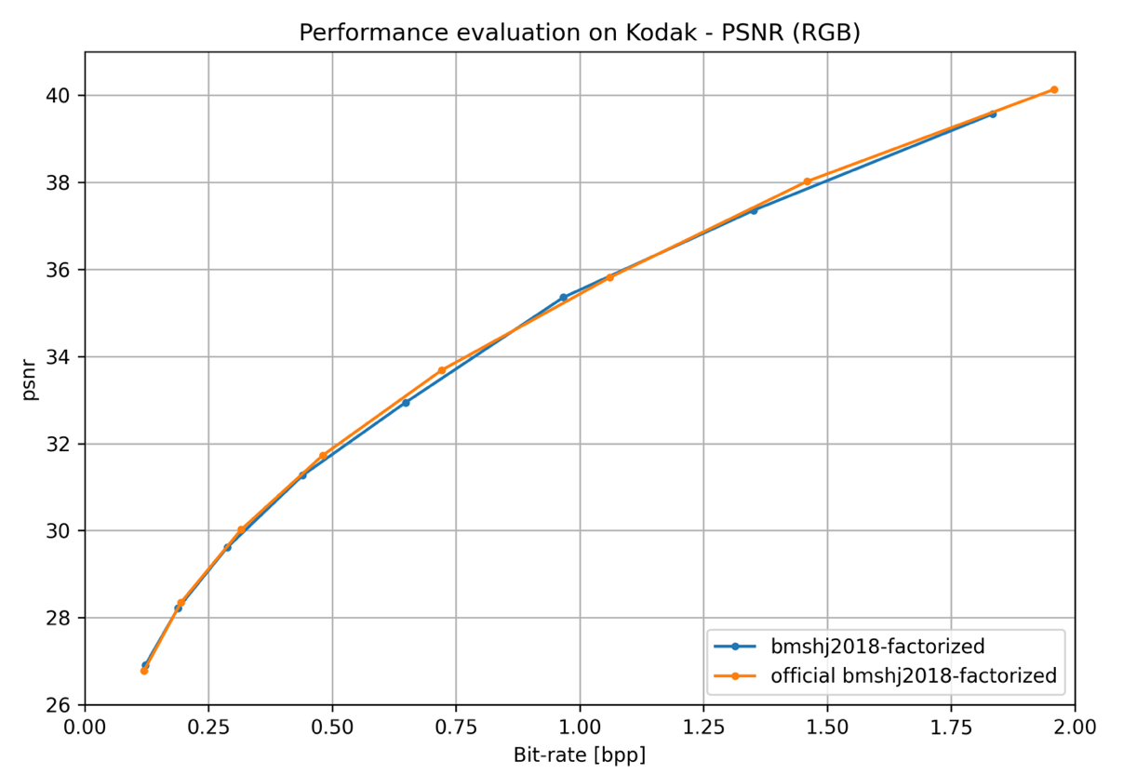
Figure 1: Factorized prior architecture
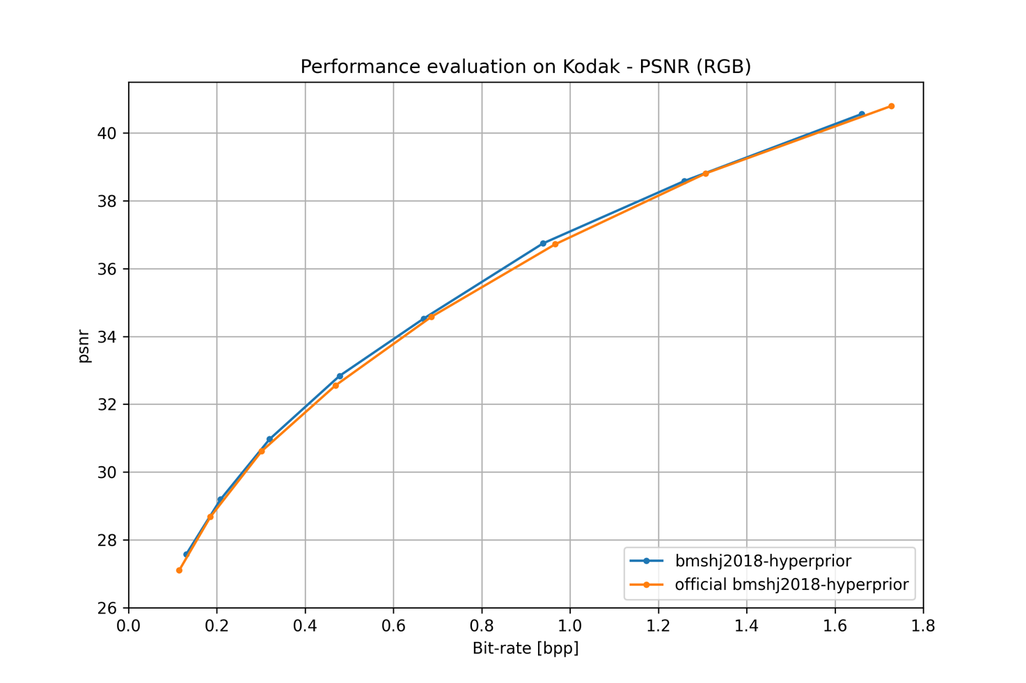
Figure 2: Hyperprior architecture

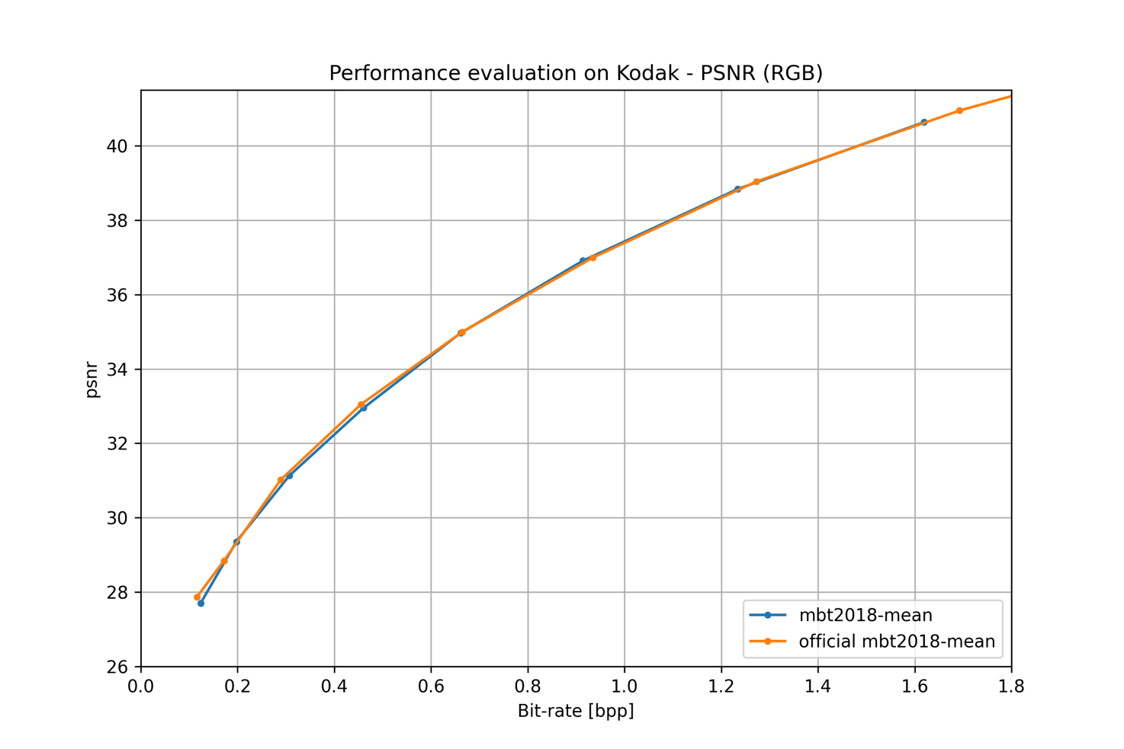
Figure 3: Hyperprior with non-zero gaussian means architecture
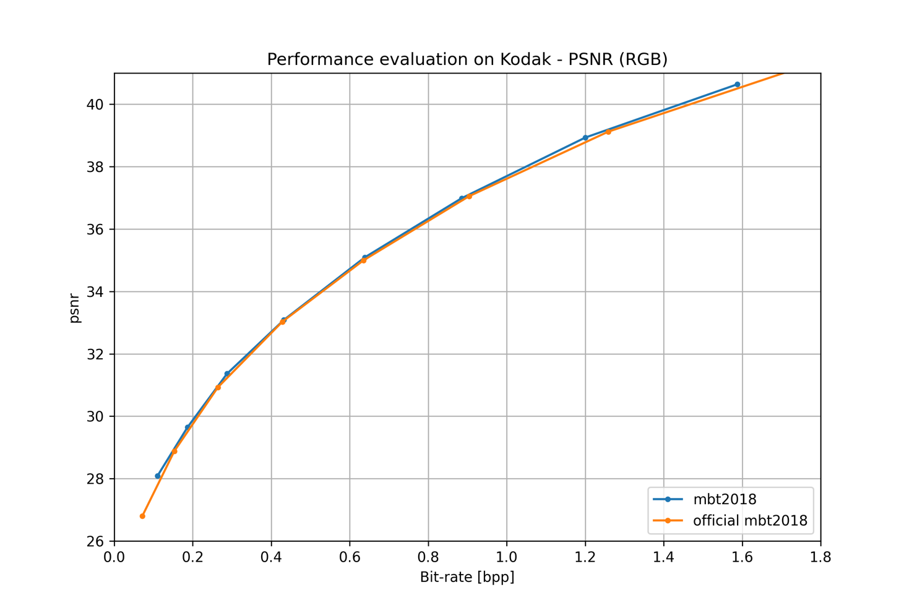
Figure 4: Joint auto-regressive and hyperprior architecture
All the numerical compression results are available as text files in the “results” directory in the CompressAI repository.

Note: As the curves intersects, we cannot effectively compute the usual Bjøntegaard BD-rate values. Training a neural network to reach a specific bitrate at inference is an active research topic.

Comparison of DNN-based and traditional video codecs
Figure 5 shows PSNR curves as a function of the bitrate for all the above-mentioned codecs.
HEVC (HM version 16.20), VVC (VTM version 9.1) and AV1 (version 2.0) have been configured in intra mode with 8-bit YUV 4:4:4 inputs/outputs.

As can be seen, although recent works compare favorably with already published standards such as H.265/HEVC (HM v16.20) and AV1, the VTM v9.1 still outperforms learned still picture codecs in terms of PSNR. However, learned compression framework can be directly optimized for complex objective metrics as long as the metric is differentiable or has a differentiable approximation. This constitutes a major asset compared to traditional hybrid codecs where it is difficult to define good strategies for block-based encoder decisions. CompressAI will soon support different metrics for training and evaluating the performances.

Besides, learned image and video compression codecs have only started to achieve competitive results these last 5 years. Considering the success of learned methods in other image processing and computer visions domains, significant improvements in compression performances and inference speeds can be expected as more research will be performed on the subject.
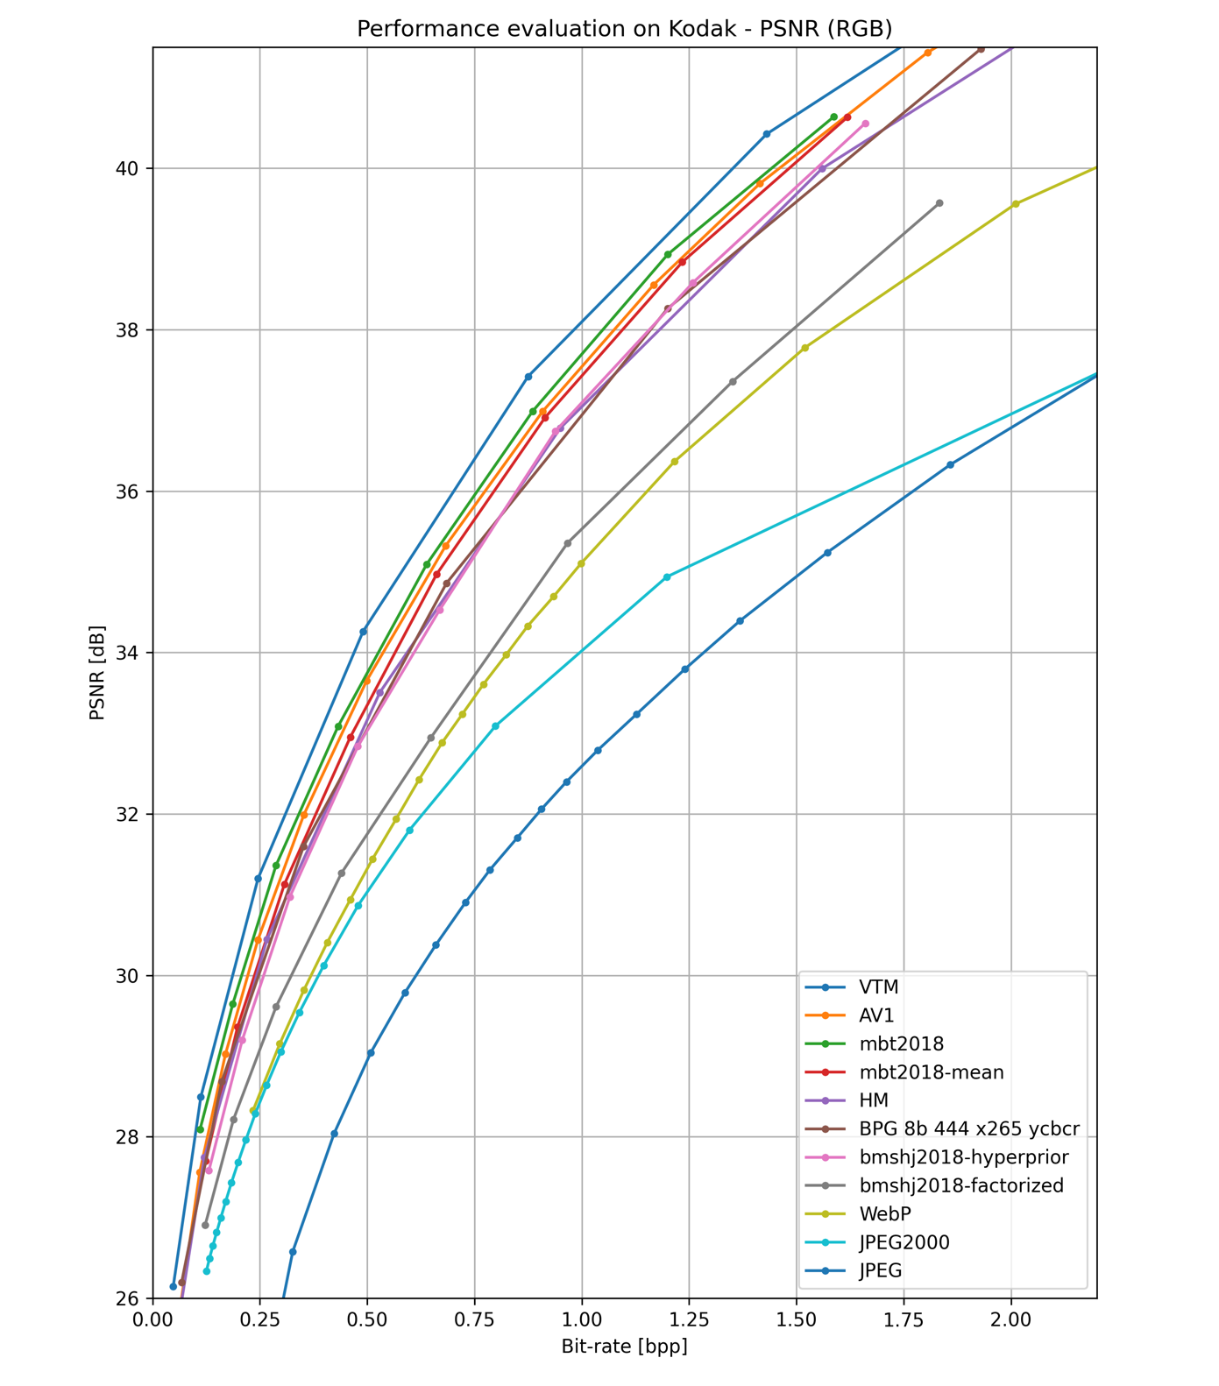
Figure 5: PSNR curves of SOTA DNN-based approaches implemented in CompressAI and traditional codecs

Note: At this time, runtime comparisons between traditional methods and DNN-based methods cannot be reported in an accurate and fair manner. Measuring the inference efficiency of a neural network-based codec is an active research topic. Neural networks are effectively designed to run on massively parallel architectures whereas traditional codecs are typically designed with a single CPU core in mind.

Test frameworks and platform

The presented results were obtained under the following test conditions:
- Operating System: Ubuntu 18.04 LTS
- Programming Language: Python 3.6+
- Additional Libraries: PyTorch 1.4+, CUDA 10.2, CUDNN 7.6.5.
- The hardware configuration:
  - Inference: 1 CPU thread: Intel(R) Core (TM) i9-9980XE CPU @ 3.00GHz
  - Training: Nvidia TITAN Xp/X/V or RTX 2080 TI

Conclusion and future work
CompressAI currently implements networks for still picture coding and provide pre-trained weights and tools to compare state-of-the-art models against traditional image codecs.
Several extensions to CompressAI are planned. In the next releases, CompressAI will include additional models from the state-of-the-art on learned image compression, and new pre-trained weights for perceptual metrics (e.g.: MS-SSIM). One critical extension in the works is to add support for video compression. Evaluation for low-delay and random-access video coding with traditional codecs, and end-to-end networks with compressible motion information modules will be introduced in the next releases.
The platform is made available to the MPEG and research community. We plan to continue supporting and extending CompressAI publicly on GitHub, and we welcome feedback, questions and contributions.

References
[1] A. Paszke et al., ‘PyTorch: An Imperative Style, High-Performance Deep Learning Library’, p. 12.
[2] T. Xue, B. Chen, J. Wu, D. Wei, and W. T. Freeman, ‘Video Enhancement with Task-Oriented Flow’, International Journal of Computer Vision, Feb. 2019, doi: 10.1007/s11263-018-01144-2.
[3] Eastman Kodak, ‘Kodak Lossless True Color Image Suite (PhotoCD PCD0992)’. [Online]. Available: http://r0k.us/graphics/kodak.
[4] J. Ballé, D. Minnen, S. Singh, S. J. Hwang, and N. Johnston, ‘Variational image compression with a scale hyperprior’, arXiv:1802.01436 [cs, eess, math], Jan. 2018, Accessed: May 25, 2018. [Online]. Available: http://arxiv.org/abs/1802.01436.
[5] D. Minnen, J. Ballé, and G. Toderici, ‘Joint Autoregressive and Hierarchical Priors for Learned Image Compression’, arXiv:1809.02736 [cs], Sep. 2018, Accessed: Feb. 10, 2020. [Online]. Available: http://arxiv.org/abs/1809.02736.
[6] Z. Cheng, H. Sun, M. Takeuchi, and J. Katto, ‘Learned Image Compression with Discretized Gaussian Mixture Likelihoods and Attention Modules’, arXiv:2001.01568 [eess], Jan. 2020, Accessed: Jan. 13, 2020. [Online]. Available: http://arxiv.org/abs/2001.01568.
[7] J. Ballé, N. Johnston, and D. Minnen, ‘Integer Networks For Data Compression With Latent-Variable Models’, p. 10, 2019.

http://toflow.csail.mit.edu/
http://r0k.us/graphics/kodak
https://thegradient.pub/state-of-ml-frameworks-2019-pytorch-dominates-research-tensorflow-dominates-industry/
https://github.com/tensorflow/compression/
https://pytorch.org/docs/stable/jit.html
https://onnx.ai/
https://coremltools.readme.io/docs
http://www.compression.cc/
https://github.com/InterDigitalInc/CompressAI

