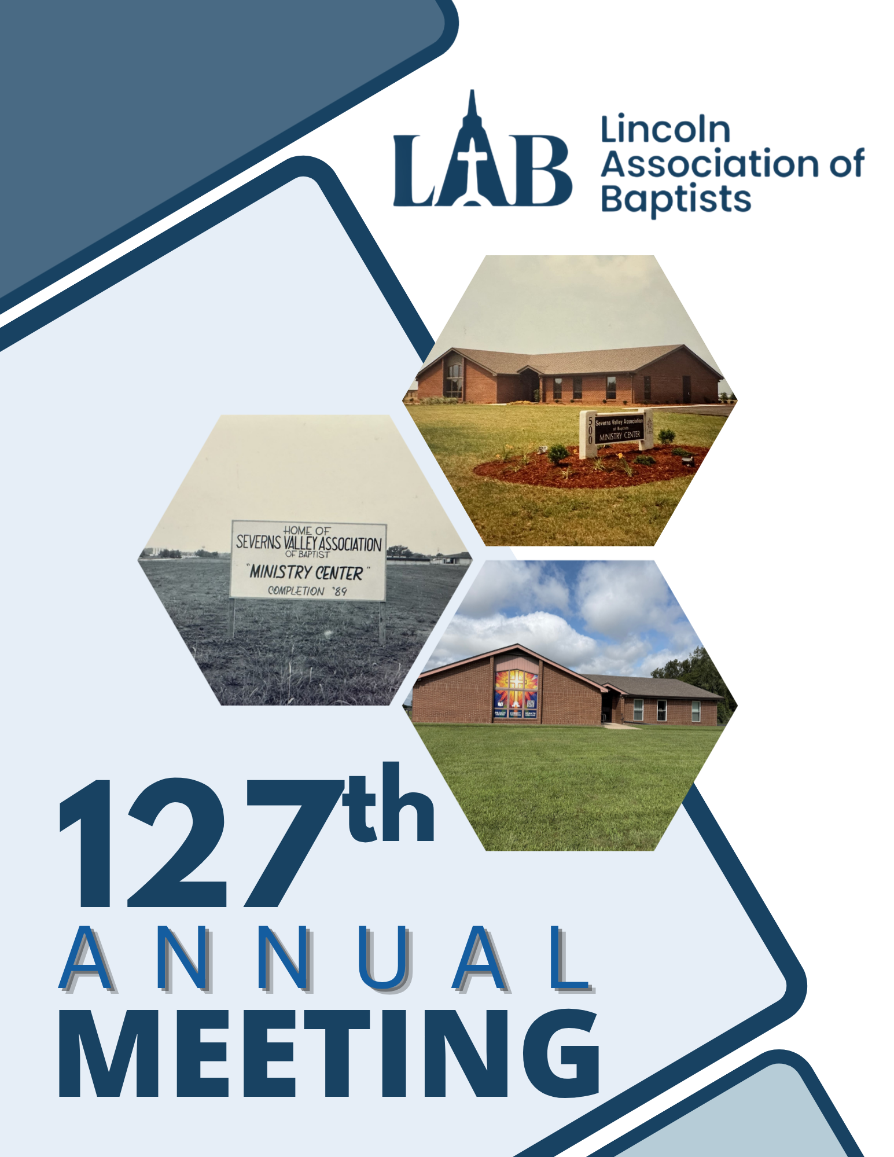

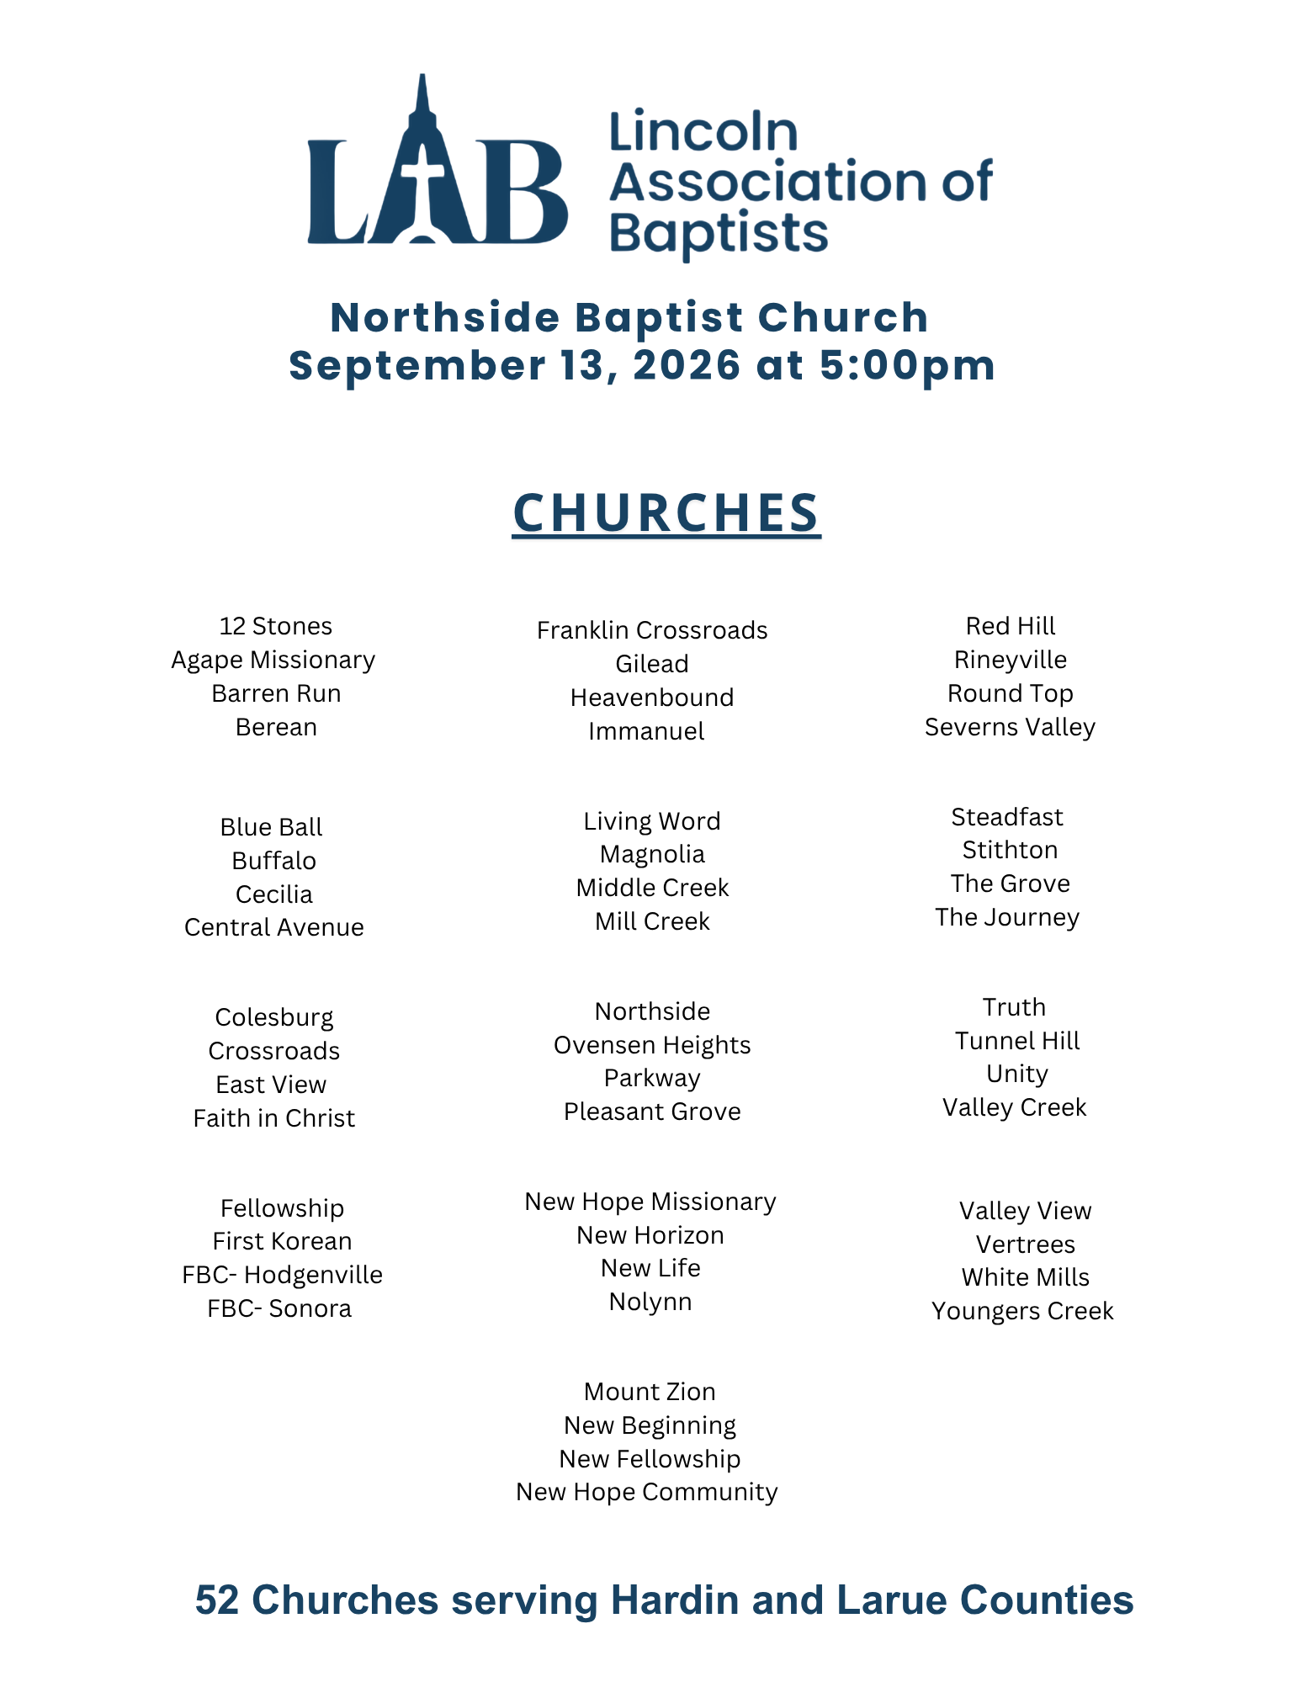
Table of Contents
Page
Schedule of Events 4
Constitution and Bylaws 5-8

Team reports
AMS Report 9
KBC Mission Board 11
ECTC Baptist Campus Ministry report 13
Camp Shafer Report- Youth and Children 14
Gateway Seminary 15
Recovery Ministry Report 16
Oneida Report 17
Mission Team 19
Personnel Team 19
Credentials Team 20
Nominating Team Recommendations 22
Appendices
Proposed budget 2026-2027
Profit and loss Summary
ACP Summary

Schedule of Events

5:00-5:05: Welcome, Pastor Hagan York, Northside Baptist Church

5:05-5:15: Congregational Singing, Northside Worship team

5:15 -5:25: Scripture and Prayer, Mitch Whidden, AMS

5:25-5:30: Call to Order, Seating Messengers, Recognition of Guests, and Adoption of Program, Pastor Faron Knopp, Moderator, Mill Creek Baptist Church

5:30-5:50: Recognition of New Church Staff, AMS Report, Mitch Whidden, AMS

5:50-6:00: Congregational Singing, Northside Worship team

6:00-6:10: Written Reports, Pastor Faron Knopp, Moderator, Mill Creek Baptist Church

6:10-6:55:

Proposed Budget, 2026-2027, Billy Cann, Mt. Zion Baptist

Nominating Team Recommendation: Pastor Jerry Shacklett, Rineyville Baptist

Old Business and New Business:

6:55-7:05 ***Intermission to review booths***

7:05-7:20: Inspirational Music, Northside Worship team

7:20-7:50: Message, Dr. Rob Sumrall, Crossroads Baptist

7:50 Adjournment of Meeting, Pastor Faron Knopp, Moderator, Mill Creek Baptist Church

Closing Prayer

Lincoln Association of Baptists
Constitution
(Revised September 26, 2022)

The Association is a fellowship of New Testament Southern Baptist churches which voluntarily associate themselves with each other as one way to express their covenant relationship as the people of God, to advance the work of His kingdom under the leadership of the Holy Spirit.

ARTICLE I - NAME
This body shall be known as the Lincoln Association of Baptists.

ARTICLE II - MEMBERSHIP
Section 1: The membership of this Association shall be composed of messengers representing cooperating Baptist churches whose doctrinal beliefs and practices conform to the recent BAPTIST FAITH AND MESSAGE adopted by the Southern Baptist Convention. These churches’ pastors shall be Southern Baptist in theology and practice.
Section 2: A cooperating church shall continue to be defined as a church which is a bona fide (sincere) financial contributor to the work and ministry of the association. Additionally, a cooperating church will endeavor to complete and return the Annual Church Profile to the association. Any church that fails to fulfill these two defining characteristics for two consecutive years will be considered inactive. If an inactive church begins cooperating again within the third year (within the year of being considered inactive), that church will be considered active and cooperating. If, after being considered inactive for a year (a total of three years being uncooperative), there has been no cooperation, that church shall not be considered a part of the association any longer.
Section 3: Each church shall be entitled to send two messengers and one additional messenger for each fifty (50) members or major fraction thereof, and no church shall be entitled to more than fifteen (15) messengers.
Section 4: Any church desiring to unite with this body shall petition the Association for recognition and shall present the Annual Church Profile (ACP). The Missions Development Team shall investigate and make appropriate recommendation to the Association.
Section 5: This Association reserves the right to reject messengers from any church which shows itself to be unorthodox in faith or practice according to ARTICLE II, SECTION 1, or which willfully and persistently creates discord by refusing to comply with this Constitution.

ARTICLE III - OBJECTIVE
Section 1: The purpose of this Association shall be to assist the churches to implement the Great Commission by:
1. Promoting inter-church fellowship.
2. Strengthening our oneness in faith and practice.
3. Disseminating information in an effort to inspire our churches regarding the work within the Association and within the whole denomination.
4. Helping the churches do together those things which they cannot do effectively themselves.
Section 2: This body shall exercise no legislative or judicial authority over any church, nor shall it have ecclesiastical power over the internal affairs of any church.

ARTICLE IV - OFFICERS
Section 1: The officers of this Association shall be moderator, vice moderator, and clerk. These officers shall serve on the Executive Board in the same capacity. They shall be elected annually at the annual meeting and begin serving thereafter. The term of office for the moderator and vice-moderator is limited to two consecutive years, and a person shall not be eligible for re-election until at least one year has elapsed from the time a successor is named. The clerk shall serve until the clerk’s successor is duly installed.
Section 2: Their duties shall be such as are common to the same officers in similar organizations, and as defined by the Association.

ARTICLE V - EXECUTIVE BOARD AND TEAMS
Section 1: There shall be an Executive Board of this Association which shall have charge of the work of the Association between annual sessions. This Board shall be composed of the pastor of each church, or pastor's designee, and one lay member duly elected by each church, the pastor of any mission of a cooperating church, the associational officers listed in Section 1 of Article IV, the DOM, and the chief officer of each organization of the Association.
Section 2: The Association shall elect a three-member Board of Trustees, according to the Articles of Incorporation on file with the Secretary of State of the Commonwealth of Kentucky.
Section 3: The Association and the Executive Board shall have such regular and special teams as needed in executing their work.
Section 4: Team leaders shall have voting privilege at Executive Board Meetings. Team members are invited to attend as non-voting members.

ARTICLE VI - ANNUAL REPORTS
Section 1: The affiliated churches shall furnish annually to the Association the information requested by the Annual Church Profile (ACP.)
Section 2: The AMS and each team and organization of the Association shall submit an annual report.

ARTICLE VII - ANNUAL MEETING
Section 1: The Association shall meet annually at such place and time as selected by majority vote of the messengers.
Section 2: In case of an emergency requiring a special session, or a change of date or place of the annual meeting, the Executive Board may take such action.

ARTICLE VIII - ANNUAL MINUTES
The minutes of the annual meeting of this Association, together with such information as may be useful, shall be published and distributed annually among the churches of the Association.

ARTICLE IX - BY-LAWS AND JOB DESCRIPTION
This Constitution allows for By-Laws and Job Descriptions of all employees, officers, teams, and organizations.

ARTICLE X - CHANGE OF CONSTITUTION
The Constitution may be amended by a two-thirds majority of messengers present and voting at any regular annual meeting, provided that such proposed amendments have been submitted in writing at the preceding annual meeting.

BY-LAWS

ARTICLE I
All meetings of the Association shall be conducted in accordance with the Bible and Robert's Rules of order (latest edition). A simple majority of those voting in any regularly announced meeting shall be valid.

ARTICLE II
The Nominating team shall nominate to the Association or the Executive Board the members of existing teams and leaders. The Nominating Team shall be named by the Moderator.

ARTICLE III
Between annual sessions of the Association, vacancies in the office of moderator, vice-moderator, or paid full time personnel and ministerial staff shall be filled by the Executive Board. Part-time personnel may be filled by either the Association Mission Strategist, and/or the Personnel Team.

Election of officers shall be conducted during the annual session. The Nominating Team shall nominate other offices and team members. Upon a majority vote, they will take office following the annual meeting. If two or more candidates for any position are proposed, voting shall be conducted by secret ballot. Should there be more than two (2) candidates and none received a majority, there will be a run-off to determine the winner. The run-off would be between the two (2) candidates receiving the largest number of votes in the first ballot. Only the one(s) receiving the greatest number of votes will be announced (or run-off candidates) to the annual meeting. A team will be appointed for the purpose of counting and recording the votes. The persons receiving a majority of votes shall be declared elected.

ARTICLE IV
The Trustees are authorized to hold, purchase, and receive title to real estate and other property by devise, gift, grant or other conveyance, with power to mortgage and to borrow money, sell or convey the same or any part, parcel or portion thereof, when so directed by the Association, except in an emergency the Stewardship Team shall recommend to the Executive Board that trustees be authorized to borrow money to cover previously approved budget authorization.

ARTICLE V
The Association and Executive Board shall have regular and special teams as needed to execute their work.

ARTICLE VI - CHANGE OF BY-LAWS
These By-Laws may be amended by a majority vote of the Executive Board of the Association present and voting providing the membership of the Executive Board has been notified in writing of such suggested change thirty (30) days prior to the vote.

AMS Report
“The Lincoln Association of Baptists exists for the purpose of supporting the fellowship, missional engagement, equipping, and strengthening of local churches.”
God has been at work in the Lincoln Association. After much discussion with our pastors and a vote from the Executive Board, we have decided to adopt the above purpose statement and organize our ministries around it. We are currently engaged in each of the four priorities listed in our purpose statement. These are some of the current ministries, as well as some future ministry prospects for our association.
- Our monthly Fuel for the Faithful meetings accomplish the purpose of fellowship and equipping as pastors gather on the first Monday of every month to be encouraged and strengthened in the like-minded company of other pastors. We have had several speakers from the KBC so far this year and look forward to a great lineup for the rest of the year, including some of our local pastors who will be speaking in their given areas of expertise.
- The Advance Institute from Gateway Seminary will help us equip local leaders.
- Our weekly prayer gathering on Thursdays in the office helps strengthen the fellowship and encouragement of our pastors. In August, we had our prayer meeting on the road and met in four different locations around our association as we prayed with local churches.
- Our new podcast and website are helping us be effective in the digital age and promote our churches and their mission projects through creative media.
- Pastors and representatives from eight different churches accompanied me on a trip to the Northeast Indiana Association to investigate mission opportunities that are close to home. These mission opportunities will be perfect for those churches who want to involve themselves in missions but may not be ready for an overseas mission trip. Many of these churches already have plans to go back and serve on the field in Northeast Indiana.
- I continue to meet with pastors weekly to ensure we are on the right track as an association and to hear from our pastors about how we can partner together for the Gospel and move forward as an association.
We have also been working hard to upgrade and update your association office. When I say “your associational office,” I mean it. Any association pastor who would like a key to our offices to use for study or meetings when they are in town, please let me know and a key will be provided. This is your association office building. Consequently, we would like it to be upgraded and updated.
We have already sealed and striped the parking lot and are in the process of changing the lighting to LEDs to save on electricity. You may also notice the beautiful mural on our window with a QR code to our new website.
A special shout-out to Faith in Christ and Pastor Pino for helping with the physical work and helping to pay for the parking lot and lighting. Rineyville Baptist and Pastor Jerry Shacklette have graciously paid for the window tinting and mural in the large room. Meanwhile, Cecilia Baptist has been hard at work with our landscaping and power washing of our sidewalks. Thank you to all these churches and others who have shown interest in helping us keep up the property.
From a missional perspective, we are looking forward to designing creative ways to promote the missional efforts of our churches, both locally and internationally. This will highlight mission opportunities that already exist and promote partnerships between churches. Stay tuned for more information on these upcoming opportunities.
Thank you for your prayers and support. Please know I am available to all our churches. If you would like for me to come and speak to your church about any of these mission efforts, or simply come in for a Q&A, please let me know.
Mitch Whidden, AMS
270-734-3737
Whidden.ams@gmail.com
www.labaptists.org

LAB Annual Meeting KBC Report

Broadly and Consistently
- Spreading the Gospel through our IMB Missionaries: Your churches are helping
support 3600 missionaries in 155 countries, who combined see an average of
500 people a day come to faith in Jesus.
- Spreading the Gospel through Church Planting: Through our combined efforts we
have planted more than 12,000 new Southern Baptist Gospel preaching
churches in North America since 2010.
- Spreading the Gospel through training Leaders: As we cooperate together we
are helping 25,000 men and women prepare for a life of Christian ministry
leadership through our six seminaries and their respective colleges.
- Care for more than 1,200 of Kentucky’s most vulnerable children through Sunrise Children’s Services, which has facilitated 735 adoptions since 2006.
- Provide disaster relief across Kentucky, Tennessee, and beyond. Earlier this year, you helped prepare more than 4,600 hot meals for ice-impacted communities and helped keep more than 2,600 KBC Disaster Relief volunteers trained and ready to respond.
- Support retired ministry leaders and their widows through Mission Dignity. This past year, 66 Kentucky Baptist ministry couples or widows received financial assistance. Across the nation, Mission Dignity provided monthly support to 2,600 retired workers or widows, distributed more than $10.3 million in assistance, and provided an additional $3 million in one-time grants. In Kentucky, recipients also received a thirteenth check totaling approximately $24,000.
- Help more than 260,000 Kentucky college students gain gospel access through KBC Campus Ministry.
- Enable well over 20,000 students to attend Crossings Camps.
- Provide scholarships for 180 Kentucky Baptist ministry students through the Calling Out The Called Scholarship, helping students attend Clear Creek, Boyce College, or Southern Seminary by covering half of their tuition costs.

KBC Annual Ministry Priorities
2026 – 2027

- Pastoral Wellness: The purpose of this priority is to cultivate healthy, resilient, and spiritually vibrant pastors who are able to serve faithfully for the long haul—resulting in healthier churches, stronger leadership, and more sustainable gospel ministry across Kentucky.
- Championing KY Baptist Campus Ministry: The purpose of this priority is to elevate the understanding and appreciation for Baptist Campus Ministry, so it becomes a household name among Kentucky Baptists.
- Crossover 2026 - Hope for Richmond: The purpose of this priority is to bring glory to God through cooperative evangelistic events designed to impact the region with the Good News of Jesus Christ.
- KY Baptist Sent Ones: The purpose of this priority is to develop a weekly prayer and connection initiative designed to support missionaries with Kentucky roots serving through the IMB, NAMB, or MSC. Resources are provided to help churches actively pray for and connect with these missionaries, fostering a stronger partnership between sending churches and those on the field.
- Every Church On Mission – Partnership Missions: This priority represents a 3-year goal to connect KBC churches to the work of our IMB and NAMB missionaries in hopes of developing long-term relationships and partnerships.
- Calling Out the Called - Practical Preaching Workshops: This priority represents a revised goal to equip current and future Kentucky Baptist pastors and other church leaders on the basics of sermon preparation and delivery.
- Mission: Dignity: The purpose of this priority is to partner with GuideStone Services in promoting the good work of Mission: Dignity in Kentucky and to help more retired Kentucky Baptist ministry leaders or their widow receive monthly benefits.


____________________________________________________________________________________
The VISION of BCM is to be a place of refuge and Biblical truth and fellowship for students at ECTC. We desire to be God’s hands and feet on campus and to extend the reach of our churches in the area onto campus and into the lives and homes of the students we encounter. Our MISSION is to enable the next generation of pastors, missionaries, evangelists, and church members to do Kingdom work here on Earth.
LOOKING AT THIS SEMESTER
Fall 2026 is underway! We are SO thankful for the cooperation and support of the churches within our association to do Kingdom work on the campus of ECTC. We can truly be the hands and feet of Christ on the campus of ECTC and watch as students lives are changed and they impact our community and beyond!
The schedule for the Fall semester of BCM is FULL, but we haven’t begun scheduling for the spring yet. If you want to be added to that schedule please reach out to me. This is a great way to gain access to the community college right here in our city. If you haven't signed up I'd encourage you to prayerfully consider.

We are looking to not only get our students connected in churches in our community, but we are also hoping to get them serving within those churches and other para-church organizations. With that I mind if you have a young adult or college age ministry have the person in charge reach out to me so we can share info and I can get them connected!

I am thankful for each of you, and want you to know that we could not minister to the students and campus without each of you and your respective churches.
WANT TO GET INVOLVED?
Sign-ups always fill up quickly. SO… those who are wanting to get involved in the future should reach out to me ASAP to get added to the next scheduling opportunity. With our limited meeting schedule (once per week) we only have so many speaking slots available. You are always welcome to come by on any Tuesday to assist, encourage, and pray!
Tanner Royalty
Tanner.NHCC@gmail.com

Camp Reports

KIDS CAMP

Kids Camp at Camp Schafer was a wonderful success this year. We were blessed to host 66 campers who came together for a week full of fun, fellowship, and spiritual growth.

Our theme, “Assembled,” focused on the importance of the Church, grounded in Hebrews 10:19–25. Throughout the week, campers engaged in meaningful worship services and Bible studies that helped them better understand what it means to gather together as the body of Christ. Alongside this, the weather was great, allowing us to fully enjoy games, cabin wars, and all the activities that make camp such a special experience.

Most importantly, we rejoice that 13 campers made decisions for salvation during the week. We give all praise and glory to God for the work He did in the hearts of these children.

My wife and I want to sincerely thank every church that sent campers, counselors, and financial support. Your partnership made this week possible, and we are incredibly grateful for the opportunity to serve as your Kids Camp Co-Directors. Thank you for investing in the next generation and for trusting us with such an important ministry.

Austin and Brooklynne Stillwell

YOUTH CAMP

It was another hot one at youth camp! We faced the 115-degree heat index and still had an amazing camp!

This year we wanted to show our campers how the Lord has ASSEMBLED us together as the Church! Our hope was that campers would learn to love the Church and cultivate a desire to serve in their local churches.

We were blessed with some amazing leaders at camp this year who guided our teens through the book of Acts. We also had studies in apologetics, missions, and having a personal quiet time just to name a few.

Every night, we worshipped together through song and through the Word. Our praise team was amazing, taking our youth to the throne of God every night, even leading a special celebration night of worship on Tuesday. Our speakers at chapel did a phenomenal job proclaiming God's Word and helping our youth understand their role in the church today.

While at camp, we saw 12 people make a decision for Christ! We know that several others made a decision and plan to follow through with baptism when they return to their home churches. My hope and prayer is that many more will answer the call to serve in their local church as well as on the mission field.

Plans are already underway for 2027. If your church is not involved in our associational camp ministry, there is no better time than RIGHT NOW!!! Put Camp Schafer in your calendar for 2027!

Thank you again for allowing us to serve your churches.

Faithfully submitted,

Josh Looten
Gateway Seminary Report

Your Lincoln Association of Baptists is starting a new program to equip our area pastors, staff members, small group leaders, and even future ministers who may not have had access to theological education. The program is called ADVANCE and is sponsored by Gateway Seminary in California. Gateway is one of our six Southern Baptist seminaries.
The ADVANCE program provides pre-baccalaureate theological education at a minimal cost. The courses are taught in-person at the Associational Office by qualified instructors. The only basic requirements are that students must be 18 years of age and be recommended by their local church. The first two courses will be offered starting this next week and will run for ten weeks:
- Principles and Approaches to Bible Teaching, Tuesday evenings at 6pm, starts 9/15, led by Pastor Louie Williams
- New Testament Survey, Sunday evenings at 5:30pm, starts 9/20, led by Pastor Faron Knopp

If you need information or registration assistance, please contact:
Ed Scott
334-258-0723
edscott206@gmail.com

Recovery Ministry Report

This past year, we sent informative posts and emails to association churches. We planned an informative event which will be led by Campbellsville Marriage and Family Therapy program at Truth Baptist Church on Sep 17, at 630pm. They will share information regarding suicide prevention, mental health and substance abuse. We started back ministering to recovery houses through food donations, words of encouragement, prayer, and transportation to church. On Oct 5, we will present helpful information regarding suicide prevention to available attendees. On September 30, there is a free Lunch and Learn event regarding Lethal Means Safety in Louisville Kentucky. See flier for details or contact me.

Here is our current focus:
We will resume sharing information via email and Facebook as soon as we can. We will continue to share information via email and Facebook and minister to recovery houses.
We plan to execute more informative events regarding mental health, substance abuse and suicide prevention. If you would like contacts or can share contact info of experts and organizations to assist with recovery/ mental health/suicide prevention, please let me know.

Here are ways you can assist:
Give recommendations for our recovery/ mental health/suicide prevention emails, post, and the website.

Inform me of what your church is doing regarding recovery, mental health, and or suicide prevention. I would like to attend to learn and share. I would love to share what churches are doing.

Blessings,
Pastor Silas Session, D.Ed.Min
Truth Baptist Church
LAB Recovery Ministry

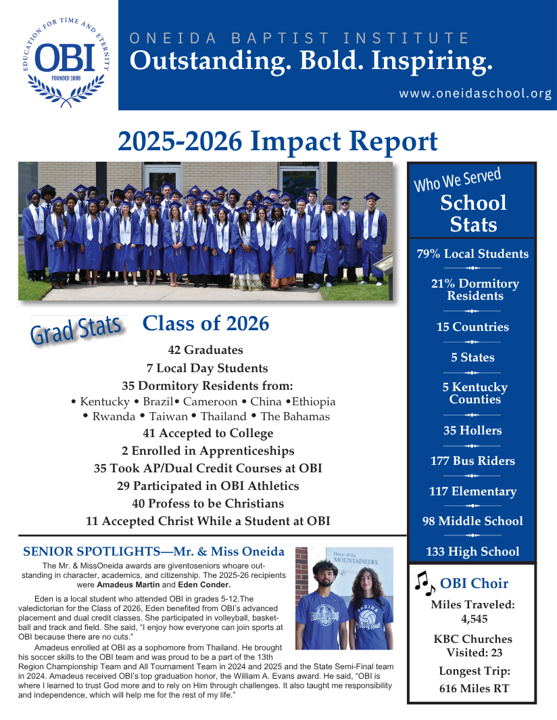



Mission Team Report:
Mission Scholarships
The Mission Team met and approved three applications for mission scholarships. The team also discussed how we can streamline the scholarship approval process to vet applicants and provide timely responses.
Promoting Church Missions
We are in the process of gathering information about LAB churches’ mission trips. We hope to promote these on the LAB website and help make churches more aware of opportunities to serve.
Local Mission Partnerships
Bro. Mitch and Bro. Merrill met with a representative from Room In The Inn to discuss how LAB churches can engage in local missions by supporting this ministry.
We have also reached out to Warm Blessings to explore potential partnership opportunities.

Personnel Team Report:

We are still working on forming a performance evaluation for Bro. Mitch in his role as AMS for LAB. Our goal is to have two parts to the evaluation:
- Pastor Questionnaire: A simple questionnaire that will be sent to all LAB church pastors to gather feedback on Bro. Mitch’s work and ministry with the association.
- Personnel Team Evaluation: A more comprehensive evaluation that the Personnel Team will work through with Bro. Mitch.
Our goal is to send out the pastors' questionnaire at the beginning of January and then use those responses when we meet with Bro. Mitch near his 1 year anniversary for the comprehensive performance review with the Personnel team.

Credentials Committee Report

Motion: That the Lincoln Association of Baptists add the following paragraph to the responsibilities of the Credentialing Team:
The Credentialing Team shall assist the Association in matters related to church affiliation, fellowship, and cooperation. The Team shall work with churches participating in Watch Care, helping guide them through the Watch Care process and evaluating their progress toward meeting the requirements established in the Association’s Constitution and By-Laws. Upon completion of the Watch Care period, the Credentialing Team shall make appropriate recommendations concerning the church’s reception into the Association as a cooperating member. The Team shall also address concerns involving member churches that may have fallen out of fellowship with the Association, ceased to cooperate with the Association, or whose doctrine or practice may no longer be consistent with the doctrinal standards and requirements established in the Association’s Constitution and By-Laws. In such matters, the Team shall seek to promote biblical restoration, unity, and cooperation and shall make recommendations to the appropriate body of the Association when action is necessary. The Credentialing Team shall also develop and maintain an approved list of pastors and ministers available for pulpit supply and other temporary ministry needs within the churches of the Association.

Watch Care Policy
Lincoln Association of Baptists
Watch Care is intended to provide a period of fellowship, cooperation, and mutual discernment for a church seeking to become a cooperating member of the Lincoln Association of Baptists.
A church admitted into Watch Care will:
- Be approved for Watch Care by the Executive Board during a regularly scheduled Executive Board meeting.
- Be partnered with a sister church within the Association for the purpose of fellowship, encouragement, relationship-building, and support during the Watch Care period.
- Demonstrate a spirit of cooperation by contributing missionally through the Association and participating in associational missional endeavors when applicable.
- Be encouraged to attend Executive Board meetings and the Annual Meeting of the Association in order to become familiar with the work, fellowship, and ministry of the Association.
- Strive to build a spirit of unity and cooperation within the Association and develop healthy relationships with its member churches and leaders.
- Strive during the Watch Care period to meet the requirements established in the Association’s Constitution and By-Laws necessary to become a cooperating member of the Association.
- Remain under Watch Care for a minimum of one year. During this period, the church will strive to meet the requirements established in the Association’s Constitution and By-Laws necessary to become a cooperating member of the Association. At the conclusion of the minimum one-year Watch Care period, and upon satisfactory demonstration of fellowship, cooperation, and alignment with those requirements, the Credentialing Team will present the church to the Association for consideration as a cooperating member church.
Administration of the Watch Care Policy
Changes or revisions to this Watch Care Policy shall be made through the Credentialing Team of the Association and, when necessary, shall be ratified by the Executive Board at a regularly scheduled meeting.

Nominating Team Recommendation 2026-2027
Moderator: Chris Workman, Immanuel Baptist

Assistant Moderator: Connor Anderson, Gilead Baptist

Clerk: Jessi Ashley, LAB

Assistant Clerk: Denise Hawkins, LAB

Audit Team: Cindy Gibson, Parkway Baptist
Scott Kisselbaugh, Northside Baptist
Peggy Larue, The Grove
Blake Williams, Valley Creek

Baptist Campus Ministries: Tanner Royalty, New Hope Community
Herb Williams, New Hope Community
Josh Looten, Tunnel Hill Baptist
Joe Galloway, Tunnel Hill Baptist

Bible Drill Team: Ramona Jeffries, Gilead Baptist

Bylaws Team: Wanda Walker, Cecilia Baptist
Lamar Black, Rineyville Baptist
Terry Richardson, White Mills Baptist

Camp Shafer Team: Josh Looten, Tunnel Hill Baptist
Austin Sitllwell, Cecilia Baptist
Brooklynne Stillwell, Cecilia Baptist

Credentials Team: Kenny Rager, 12 Stones Baptist
Faron Knopp, Mill Creek Baptist
Josh Looten, Tunnel Hill Baptist
Dewayne Gibson, Parkway Baptist

Feasibility Study Team: Jerry Shacklett, Rineyville Baptist
Denver Copeland, Stithton Baptist
Debbie Duda, Northside Baptist

Missions Team: Merrill Kurtz, Ovesen Heights
Emmett Holly, Severns Valley Baptist
Silas Sessions, Truth Baptist
JT Sutherland, Crossroads Baptist
Denver Copeland, Stithton Baptist

Nominating Team: Jerry Shacklett, Rineyville Baptist
Donna Coffey, Parkway Baptist
Diane Booker, Blueball Baptist
Randy Logsdon, Berean Baptist
Terry Spencer, White Mills Baptist

Personnel Team: Henry Ray, First Baptist Hodgenville
Merrill Kurtz, Ovesen Heights
Don Flannigan, First Baptist Sonora
Don Warren, Berean Baptist

Parliamentarian Team: Jerry Shacklett, Rineyville Baptist
Glen Chasteen, Steadfast Baptist

Stewardship Team: Billy Cann, Mt. Zion Baptist
Mike Harris, Crossroads Baptist
Jerry Hignite, Severns Valley
Denver Copeland, Stithton Baptist

Trustees: Elnoah Gragson, First Baptist Eastview

VBS Team: Ruth Ann Shacklett, Rineyville Baptist
Stephanie Breeding, Rineyville Baptist
Donna Clark, Parkway Baptist

