Global Fund for Coral Reefs (GFCR)
Stakeholder Engagement Policy
(Draft – 24 September 2024)
Table of Contents
1. Introduction 1
2. Purpose and scope 2
Who are stakeholders? 2
What is meaningful engagement? 2
Significance of Stakeholder Involvement 3
Applicability of the Policy 3
3. Principles 3
4. Promoting Gender Equality and Women’s Empowerment 4
5. Culturally Sensitive Engagement with Indigenous Peoples 5
6. The Stakeholder Engagement Process 5
7. Engagement during Design Stages 7
Step 1: Identify stakeholders 7
Step 2: Initial consultations 7
Step 3: Stakeholder analysis 7
Step 4: Stakeholder mapping 7
8. Engagement during Preparation Stages 8
Step 5: Develop Stakeholder Engagement Plan (SEP) 8
Step 6: Communication strategies 8
Step 7: Grievance Redress Mechanism 9
Step 8: Allocate resources 9
9. Engagement during Implementation Stages 9
Step 9: Continued engagement and SEP implementation 9
Step 10: Respond to concerns / grievances 9
Step 11: Monitor and report back 10
10. Considerations for challenging environments 10
11. Monitoring, Compliance, and Reporting 10
12. Organisational Commitment and Capacity 10

1. Introduction
The Global Fund for Coral Reefs (GFCR) is committed to preserving and restoring coral reef ecosystems through collaborative efforts with diverse stakeholders. This Stakeholder Engagement Policy establishes GFCR’s commitment to fostering meaningful and inclusive participation in all stages of its initiatives, recognising that effective engagement is crucial for the environmental and social sustainability of its programmes and projects.
By emphasising open and transparent engagement between Convening Agents and stakeholders, GFCR aims to align with international best practices for conservation funds and blended finance mechanisms. This approach is designed to enhance programme and project acceptance, improve design, preparation and implementation, and ultimately advance GFCR's mission of mobilising resources for coral reef conservation.
The Policy underscores GFCR's commitment to improving the well-being of vulnerable populations affected by its activities, with a particular focus on marginalised groups, women and girls, indigenous peoples, and local communities. By engaging early and often with stakeholders, GFCR seeks to develop interactive and constructive processes that ensure stakeholders are well-informed, their ideas are advanced, and their concerns are addressed.
This Policy outlines the GFCR's expectations for Convening Agents in conducting stakeholder engagement processes. It details: the purpose and scope of stakeholder engagement; the principles guiding engagement practices; specific considerations for including women and indigenous peoples; requirements and steps for effective engagement at different stages; monitoring and reporting procedures; and the organisational commitment and capacity required to support these efforts.

2. Purpose and scope
The GFCR requires Convening Agents to develop and implement plans for meaningful consultation and engagement with stakeholders throughout the lifecycle of its programmes and projects.

Who are stakeholders?
Stakeholders refer to individuals or groups who:
- Are affected or likely to be affected by a programme or project (affected parties).
- May have an interest in the programme or project (other interested parties).

What is meaningful engagement?
Meaningful stakeholder engagement encompasses both consultation and active participation (engagement):
- Consultation involves seeking input from diverse affected or interested parties, particularly women and traditionally marginalised or underrepresented communities, to understand their perspectives on proposed activities.
- Engagement provides stakeholders with a more substantial role in actively participating in discussions to then make consequential contributions to decisions related to the design, preparation and implementation of programmes and projects. It goes beyond superficial consultation to enable deeper participation and co-creation.
Meaningful stakeholder engagement prioritises culturally appropriate, two-way communication that fosters genuine exchange of views and ensures inclusive participation. Special attention is given to women's involvement and diverse group perspectives. The process is designed to be free from coercion, thoroughly documented, and includes clear mechanisms for timely reporting and follow-up actions. Rather than a one-time event, meaningful stakeholder engagement is an ongoing cycle of interaction, co-creation, and feedback.

Significance of Stakeholder Involvement
Effective and meaningful stakeholder engagement can contribute to:
- Enhancing the design, preparation, implementation, and acceptance of programmes and projects.
- Improving the environmental and social sustainability of initiatives.
- Identifying stakeholder priorities, potential constraints, and conflicts.
- Incorporating local knowledge to mitigate risks and impacts associated with programmes and projects.
- Providing feedback and monitoring mechanisms to ensure initiatives achieve intended results.
- Upholding the rights of citizens to participate in decisions that may affect them.

Applicability of the Policy
This Policy applies to all programmes, projects and activities supported by GFCR and its Convening Agents, with the intensity and scale of engagement varying based on the initiative’s complexity, potential risks, and impacts.

3. Principles
Key principles that should guide stakeholder engagement processes across GFCR governance, and the operations of its Convening Agents include:
- Human rights-based approach: Ensure all engagement processes respect, protect, and fulfil the fundamental rights and freedoms of all stakeholders, empowering rights-holders to claim their rights and enabling duty-bearers to meet their obligations.
- Inclusivity and non-discrimination: Actively include diverse stakeholders, particularly marginalised groups, women, and indigenous peoples, ensuring equal opportunities for participation.
- Transparency and accessibility: Share relevant information in accessible formats to enable informed participation.
- Two-way dialogue: Foster genuine communication and encourage active stakeholder participation.
- Cultural sensitivity: Respect local customs, languages, and communication preferences of different stakeholder groups.
- 'Do no harm': Ensure engagement processes and outcomes do not negatively impact stakeholders or exacerbate existing vulnerabilities.
- Integration of input: Demonstrate how stakeholder perspectives are considered and incorporated into decision-making processes.
- Accountability: Establish clear mechanisms for responsibility and follow-through on commitments made during engagement.
- Adaptive learning: Maintain flexibility to adjust processes based on feedback and lessons learned.
- Adequate resourcing: Dedicate sufficient time, budget, and expertise to enable meaningful engagement.
These principles aim to ensure GFCR can foster more meaningful and inclusive stakeholder engagement processes across its governance and the operations of its Convening Agents.

4. Promoting Gender Equality and Women’s Empowerment
The GFCR Gender Policy recognises gender equality and women’s empowerment as both a strategic and operational imperative. A gender responsive approach is essential in stakeholder engagement, acknowledging that women and men possess unique skills, knowledge, and experiences as primary users and stewards of many natural resources, including coral reefs.
BOX 1: A GENDER RESPONSIVE APPROACH

A gender responsive approach recognises and acknowledges gender norms and inequalities and responds to them through the creation of actions, policies and initiatives to address the different needs, constraints and opportunities of women and men. A gender responsive approach ensures that the differential needs of women and men are addressed; that participation of women and men is equitable; and that distribution of benefits, resources, status and rights are equitably addressed.

Convening Agents, in their work with co-implementers, are responsible for meaningfully including women and men in stakeholder consultations. This involves engaging with women/gender-focused groups, associations, or gender units in partner organisations throughout each programme.
Gender-responsive consultations should consider cultural contexts, potential barriers to participation, and employ inclusive methods such as:
- Women-only interviews.
- Gender-specific focus groups and group consultations.
- Separate meetings with women’s cooperatives or associations.
- Reserved seating in steering committees, decision-making and monitoring bodies for females.
- Choosing consultation times and places that will increase gender inclusiveness.
- Providing childcare during consultations.
- Offering tailored capacity-building sessions.
By implementing these practices, the GFCR aims to empower women in decision-making processes that affect them. This gender-focused engagement enhances community capacity and ensures that the unique perspectives and needs of all genders are recognised in coral reef conservation and restoration efforts.

5. Culturally Sensitive Engagement with Indigenous Peoples
The rights and interests of indigenous peoples are increasingly recognised in climate change policies and actions, as highlighted by the United Nations Framework Convention on Climate Change, Paris Agreement, and, most recently, Kunming-Montreal Global Biodiversity Framework, adopted by the parties to the Convention on Biological Diversity in 2022. These frameworks emphasise the importance of respecting and considering the rights of indigenous peoples when addressing climate change and conservation. International instruments such as the UN Declaration on the Rights of Indigenous Peoples (UNDRIP), International Labour Organization (ILO) Indigenous and Tribal Peoples Convention 169, and others, affirm their rights to lands, territories, and resources they have traditionally owned or occupied, as well as their right to Free, Prior, and Informed Consent (FPIC) regarding programmes and projects affecting these areas.
In programmes and projects involving or potentially affecting indigenous peoples, it is crucial to adopt a culturally sensitive engagement approach that respects their unique social, cultural, and economic contexts. The GFCR emphasises the importance of conducting culturally appropriate consultations to ensure that indigenous peoples receive equitable benefits and opportunities from GFCR supported initiatives.
This approach involves engaging indigenous communities in meaningful dialogue, recognising their traditional knowledge, and ensuring their active participation in decision-making processes.
Convening Agents are encouraged to utilise specialised expertise to implement best-practice consultations. Through this meaningful and inclusive engagement, GFCR aims to support indigenous peoples in safeguarding their rights and enhancing their contributions to sustainable development and coral reef conservation.

6. The Stakeholder Engagement Process
GFCR Convening Agents, in their work with co-implementers, are required to implement a comprehensive stakeholder engagement process spanning the entire lifecycle of programmes and projects. This process is iterative and continuous, beginning in the earliest stages of design and continuing through implementation and beyond.
Requirements of Convening Agents in this process include:
- Initiating and maintaining meaningful stakeholder engagement throughout the entire lifecycle of programmes and projects, commencing as early as possible in the design phase.
- Implementing stakeholder analysis and engagement processes that are gender-responsive, culturally sensitive, non-discriminatory, and inclusive. This includes paying particular attention to vulnerable and marginalised groups and ensuring FPIC for initiatives that may affect indigenous peoples' rights, lands, resources, or territories.
- Disseminating information to stakeholders in a timely, comprehensible, and accessible manner, tailored to cultural contexts. All engagement activities must be conducted free from manipulation, interference, coercion, discrimination, or intimidation.
- Developing appropriately scaled stakeholder engagement plans, with the scale and frequency of engagement reflecting the initiative’s nature, potential risks, and stakeholder concerns.
- Establishing accessible grievance mechanisms for affected stakeholders to communicate concerns.
- Maintaining and disclosing a documented record of stakeholder engagement, including a description of stakeholders consulted, feedback received, and how this input was incorporated or, if not, the reasons for its exclusion.
To effectively implement these requirements, the stakeholder engagement process can be structured according to the three main stages of programme or project development: Design, Preparation, and Implementation. While specific procedures may vary based on individual cases, key steps and activities within each stage include:

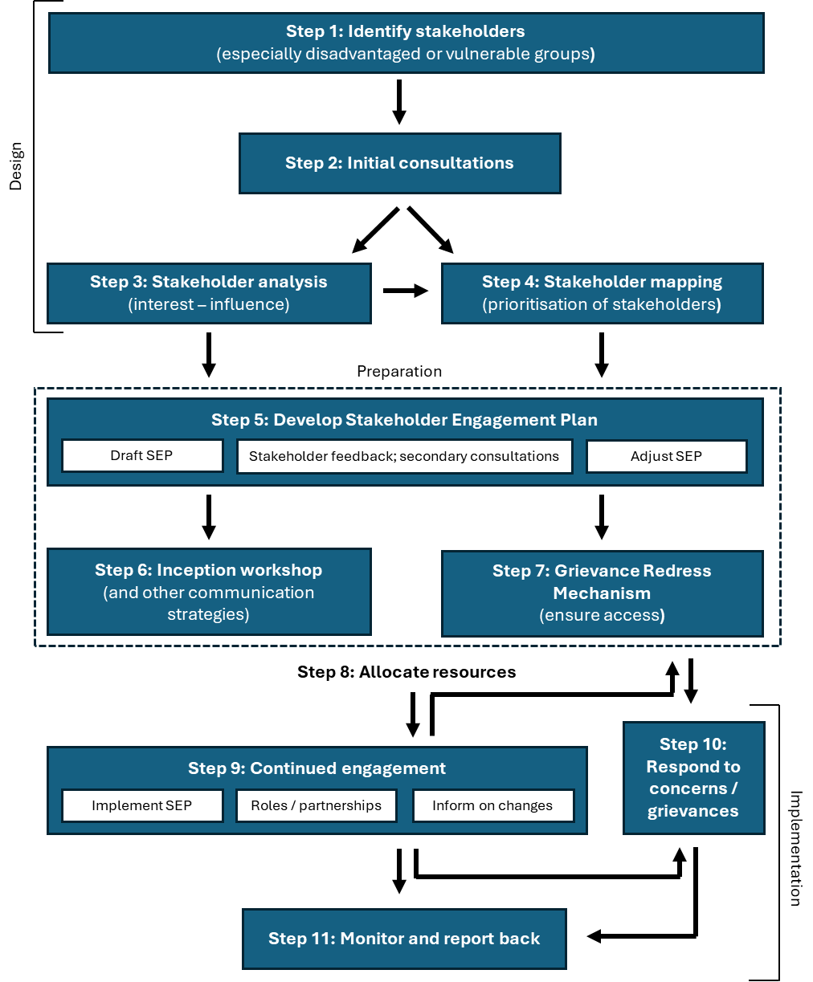

7. Engagement during Design Stages
During the design stage, the focus is on developing the programme or project concept and laying the foundation for ongoing collaboration.

Step 1: Identify stakeholders
Conduct a comprehensive stakeholder identification process, encompassing, among others:
- Local communities.
- Indigenous Peoples.
- Government agencies at various levels.
- Civil society organisations.
- Private sector entities.
Special attention should be paid to identifying disadvantaged or vulnerable groups who may be disproportionately affected by a GFCR-funded initiative.

Step 2: Initial consultations
Conduct preliminary consultations to:
- Introduce the programme or project concept.
- Gather initial feedback and concerns.
- Identify key issues and potential risks.
- Inform subsequent stakeholder analysis and mapping.
These consultations should be inclusive, culturally appropriate, and free from coercion or intimidation. Consultations should be carried out with both affected parties (those likely to be impacted by the programme or project) and other interested parties.

Step 3: Stakeholder analysis
Perform a detailed stakeholder analysis to:
- Assess stakeholders' interests, influence, and potential impacts.
- Consider gender dynamics and power imbalances.
- Identify potential barriers to participation, especially for disadvantaged or vulnerable groups.
Barriers may include sociopolitical factors, societal conflicts, educational limitations, and/or practical constraints (e.g., mobility issues, language barriers), among others. At this stage, develop strategies to mitigate these barriers, focusing on accessibility, effective communication, empowerment, and confidentiality.

Step 4: Stakeholder mapping
Based on the analysis, conduct stakeholder mapping to:
- Prioritise stakeholders based on their level of influence and potential impact.
- Identify stakeholders with different concerns and priorities regarding project impacts, mitigation mechanisms, and benefits.
- Determine which stakeholders may require different or separate forms of engagement.
To aid prioritisation, it is good practice to categorise stakeholders into:
- Key stakeholders (those with a direct role).
- Primary stakeholders (directly affected parties).
- Secondary stakeholders (interested parties).
- And other implementing partners (indirectly affected groups).
For projects with potentially significant environmental and social risks, it is worth considering engaging independent third-party specialists to assist in stakeholder identification, analysis, and designing an inclusive engagement process. This external expertise may be valuable not only during the design stage but also throughout the preparation and implementation stages and beyond.

8. Engagement during Preparation Stages
During the preparation phase, engagement becomes more focused and detailed.

Step 5: Develop Stakeholder Engagement Plan
The Stakeholder Engagement Plan (SEP) is a crucial document that guides stakeholder engagement activities throughout the programme or project lifecycle, beyond the design phase. It should be developed collaboratively, with feedback sought from relevant stakeholders on the draft version, and then revised and finalised based on this input.
The SEP should include:
- Comprehensive stakeholder identification and analysis, including a detailed list with stakeholders' interests and reasons for inclusion.
- Engagement objectives, methods, and frequency of activities.
- Steps for achieving meaningful consultation and inclusive participation, including details on forums for meaningful engagement.
- Clear delineation of roles and responsibilities for plan implementation.
- Timeline and budget for engagement activities, including related to capacity-building.
- Key indicators for monitoring stakeholder engagement.
- Information disclosure and feedback gathering mechanisms.
- Details of the grievance redress mechanism.

Step 6: Communication strategies
Tailored communication approaches should be developed for different stakeholder groups, considering any analysed barriers to participation (sociopolitical factors, societal conflicts, educational limitations, mobility issues, language barriers, etc.). This may include:
- Organising an inception workshop to formally introduce the programme or project.
- Establishing regular communication channels (e.g., newsletters, community meetings).
- Facilitating engagement sessions across various levels and sectors in a culturally sensitive, accessible, and gender-responsive way.
- Ensuring flexibility for stakeholders to join the engagement process at any time.

Step 7: Grievance Redress Mechanism
Design a Grievance Redress Mechanism to provide an accessible, gender-responsive and culturally appropriate system for stakeholders to raise concerns, ensuring fairness, impartiality, transparency, and responsiveness.
The mechanism should provide multiple channels for stakeholders to raise concerns and should be designed to address issues promptly and effectively. If concerns remain unresolved, stakeholders have the option to escalate their grievances to the United Nations Development Programme's (UNDP) Social and Environmental Compliance Unit (SECU) for further review.

Step 8: Allocate resources
Ensure adequate resources are allocated for effective stakeholder engagement, including:
- Budget for engagement activities.
- Skilled personnel to facilitate engagement.
- Time for meaningful consultation and feedback incorporation.
- Resources for capacity-building of both programme/project staff and stakeholders.
Consider potential capacity-building needs to enhance the effectiveness of engagement, such as training on participatory methods, conflict resolution, or cultural sensitivity.

9. Engagement during Implementation Stages
During the implementation phase, the focus shifts to ongoing dialogue, adaptive management, and responsive engagement.

Step 9: Continued engagement and SEP implementation
Execute the SEP, maintaining regular communication with all stakeholder groups. Build upon and strengthen the channels of communication and engagement established during earlier stages.
Engagement strategies should be adapted as needed, based on any programme or project developments, changing contexts, and stakeholder feedback. Engagement activities should remain inclusive, culturally appropriate, and gender-responsive throughout implementation.
If necessary, review and update stakeholder lists and analysis to capture any changes in the stakeholder landscape.

Step 10: Respond to concerns / grievances
Actively monitor and address concerns raised through the grievance mechanism. All complaints, actions taken, and resolutions should be documented in a transparent and accessible manner.
Use feedback from grievances to inform and improve programme and project implementation and stakeholder engagement strategies. Regularly review the effectiveness of the grievance mechanism and adjust as necessary to ensure its accessibility and responsiveness.

Step 11: Monitor and report back
Continuously track engagement activities and their effectiveness using the key indicators established in the SEP.
It is good practice to conduct regular evaluations of stakeholder engagement processes, involving stakeholders in the evaluation where possible, as well as provide frequent updates to stakeholders on project progress, including how their input has been incorporated into decision-making and implementation. Develop and disseminate stakeholder-friendly reports on engagement activities, project outcomes, and lessons learned.

10. Considerations for challenging environments
GFCR-funded initiatives may sometimes operate in challenging environments, such as areas experiencing natural disasters, conflict, or where human rights violations are prevalent. In these contexts, engage stakeholder engagement specialists with up-to-date knowledge of local contexts or problem-specific expertise to devise and manage appropriate engagement processes. Develop flexible, context-specific strategies that prioritise stakeholder safety and well-being while still striving for meaningful engagement. Be prepared to adjust engagement strategies rapidly in response to changing conditions. Maintain heightened awareness of potential power imbalances and vulnerabilities among stakeholders, ensuring that engagement processes do not exacerbate existing tensions or put stakeholders at risk.

11. Monitoring, Compliance, and Reporting
Convening Agents are required to report annually to the GFCR on the outcomes of their stakeholder engagement processes. These reports should include:
- A comprehensive log of engagement activities, detailing dates, locations, and stakeholder notifications.
- The purpose of each engagement event.
- Methods of engagement employed (e.g., workshops, focus groups, online consultations).
- Participant demographics and numbers.
- A list of documents shared with stakeholders.
- Key points and concerns raised by stakeholders.
- How stakeholder input was addressed and incorporated into decision-making.
- Outstanding issues, follow-up actions, and plans for keeping stakeholders informed.
Stakeholder engagement reporting should be integrated into broader reporting mechanisms, such as programme annual narrative reports, to maintain its priority status throughout implementation.

12. Organisational Commitment and Capacity
The GFCR is committed to effective stakeholder engagement, with the Convening Agents responsible for defining clear roles, responsibilities, and authority for these activities. They will designate qualified personnel to implement and monitor stakeholder engagement efforts, ensuring they have the necessary expertise. When appropriate, Convening Agents should supplement their internal capacity with external expertise. Additionally, resources must be allocated in proportion to the project's nature, risks, and anticipated impacts, ensuring that stakeholder engagement is effectively integrated into the GFCR's operational structure.

For grievance redress, refer to the GFCR Grievance Redress Mechanism Policy (2024).
The principles were drafted taking into consideration the policies, strategies and best practices of UN agencies, other donors, and private philanthropies, in particular the stakeholder engagement approaches of GCF, GEF, UNDP, World Bank and WWF.
Human rights norms and standards that apply to the GFCR, its Convening Agents and co-implementers include those found in the International Bill of Rights, International Covenant on Economic, Social and Cultural Rights, International Convention on the Elimination of All Forms of Racial Discrimination, International Covenant on Civil and Political Rights, Guiding Principles on Business and Human Rights, United Nations Declaration on Human Rights Defenders, United Nations Declaration on the Rights of Peasants and Other People Working in Rural Areas, United Nations Convention on the Elimination of All Forms of Discrimination against Women, and United Nations Core Human Rights Principles for Private Conservation Organizations and Funders.
In line with the GFCR Gender Policy (2022), the term “women and men” in this policy document is a short version of “women and men from different ages and backgrounds including sexual orientation and gender identity, ethnicity, religion, ability, etc.”
According to the GFCR Gender Policy (2022).
Reference: UNDP Social and Environmental Standards Guidance Note on Stakeholder Engagement (2017), p. 12.
Including the International Bill of Rights, International Covenant on Economic, Social and Cultural Rights, International Convention on the Elimination of All Forms of Racial Discrimination, International Covenant on Civil and Political Rights, Guiding Principles on Business and Human Rights, United Nations Declaration on Human Rights Defenders, United Nations Declaration on the Rights of Peasants and Other People Working in Rural Areas, United Nations Convention on the Elimination of All Forms of Discrimination against Women, and United Nations Core Human Rights Principles for Private Conservation Organizations and Funders.
For details on FPIC, refer to the GFCR Indigenous Peoples Policy (2024).
For guidance on the process for handling grievances and designing an efficient Grievance Redress Mechanism, refer to the GFCR Grievance Redress Mechanism Policy (2024).

