Global Fund for Coral Reefs (GFCR)
Grievance Redress Mechanism Policy
(Draft version 2 – 16 October, 2024)
Table of Contents
1. Introduction 1
Background 1
Levels of Responsibility for Grievance Handling 2
2. Purpose and Scope 2
What is a grievance? 2
What is a GRM? 3
Importance of GRMs 3
3. Principles 4
4. Eligibility 4
Who can submit a grievance? 4
Types of grievances covered 4
5. Establishing accessible channels to submit grievances 5
6. Handling Grievances 5
Step 1: Receive, acknowledge and register grievance 6
Step 2: Assess and assign 6
Step 3: Propose response 7
Step 4: Seek agreement on response 7
Step 5. Implement agreed response and close 8
Step 6. Handle appeals 8
7. Escalation Procedure 8
8. Maintaining Records and Monitoring Actions 9

1. Introduction

Background
The Global Fund for Coral Reefs (GFCR) is committed to addressing stakeholder concerns in a proactive and transparent manner. This Grievance Redress Mechanism (GRM) Policy establishes a formal process for handling grievances, ensuring that individuals, institutions, organisations, or communities potentially affected by GFCR initiatives are provided with appropriate channels through which to voice their concerns and receive timely assistance.
The Policy outlines principles and procedures for implementing an effective and accessible GRM across all GFCR-grant funded initiatives. It aims to ensure accountability and transparency in operations, facilitate early identification and resolution of issues, and promote compliance with environmental and social safeguards. By providing a channel for complainants to voice concerns, the GRM supports GFCR’s commitment to sustainable livelihoods and community engagement in coral reef conservation efforts.
Through this process, GFCR aims to continuously improve its operations, align with international best practices for conservation funds and blended finance mechanisms, and ultimately advance its mission of mobilising resources and action for coral reef conservation while respecting the rights and interests of affected communities and stakeholders.

Levels of Responsibility for Grievance Handling
This Policy is based on an understanding that stakeholder grievances could be dealt with at each and all of the following:
- at the level of project delivery by the Co-Implementing Partner;
- at the level of project overview and management by the Convening Agent; and,
- at a final level of complaint escalation and appeal.
The majority of stakeholder complaints will eventuate during the design or implementation of “on-the-ground” programmes implemented by Co-Implementing Partners. The ultimate responsibility for overseeing and managing programmes lies with Convening Agents. As a consequence, the central focus of this Policy is the Convening Agent. The GFCR GRM is built on an understanding that each Convening Agent has its own organisational GRM in place, the purpose of which is to deal effectively with complaints held by stakeholders affected by specific GFCR programmes.
This Policy outlines the requirements that the GFCR has for the GRMs held by Convening Agents. It establishes: the purpose and scope of GRMs; the principles which should underlie the design of effective Convening Agent GRMs; eligibility criteria; establishing accessibility channels and complaint handling procedures; and escalation procedures when complainants are not satisfied with the outcomes of Convening Agent GRMs.
The Policy recognizes that Convening Agents may either have their own GRM policies in place, or be considering the introduction of a grievance redress approach. In the former case, this Policy provides guidance for Convening Agents to enable them to consider whether their GRM approach has gaps and, if so, how those gaps might be addressed. In the latter case, this Policy provides a structure for the design of an organisational GRM.

2. Purpose and Scope

What is a grievance?
A grievance can be defined as an issue, concern, problem or claim expressed by an individual or group who feels they have been or will be negatively affected by someone else's activities. It represents a situation that the affected party wants to have addressed and resolved and can often mark the beginning of a dispute between the parties involved. Grievances can be based on both real and perceived impacts and reflect the perspective of the party raising the concern.

What is a GRM?
A GRM is a formalised system designed to accept, assess, and resolve stakeholder issues, complaints or concerns related to the design, implementation, or assessment of policies, programmes, projects, and operations. These mechanisms serve as a structured, accessible, and predictable process for addressing grievances, complementing but not replacing formal legal channels.

Importance of GRMs
All GFCR programmes should involve proactive stakeholder engagement during the design and implementation phases. Despite this, there are sometimes situations where stakeholders feel that their concerns have not been taken account of. It is these instances where GRMs can be particularly important.
GRMs can play a crucial role in:
- Ensuring accountability and safeguarding policies.
- Protecting human rights.
- Supporting just transitions to sustainable practices.
- Serving as an early warning system for potential issues.
- Identifying systemic problems.
- Combating corruption by providing secure channels for whistleblowers.
While GRMs can range from simple spreadsheets to complex web-based systems, their core purpose is to offer a first line of response to stakeholder concerns. GRMs are meant to supplement, not replace, formal legal remedies, and so stakeholders maintain their right to seek alternative forms of redress.
GRMs are designed for collaborative problem-solving and are not suitable for all types of complaints. Issues involving allegations of corruption, coercion, or significant and widespread violations of rights or policies are typically directed to organisational accountability mechanisms or legal bodies for formal investigation.
BOX 1. DISTINCTION BETWEEN FEEDBACK AND GRIEVANCES

It is important to make a distinction between “feedback” and “grievances”.

- Feedback: No specific response or resolution expected; part of regular stakeholder engagement.
- Grievances: Complainant seeks direct response or redress; handled through separate mechanisms.
Note: Unaddressed feedback may escalate into grievances.

3. Principles
Key principles that should guide the design of an effective Convening Agent GRM include:
- Legitimacy: The GRM should be trustworthy and accountable, ensuring fair conduct of grievance processes without interference.
- Accessibility: It should be known to all intended stakeholders and provide adequate assistance for those who may face barriers to access (e.g., lack of awareness, language, literacy, costs, physical location or fears of reprisal).
- Predictability: The GRM should have a clear, known procedure with timeframes and clarity on available processes and outcomes.
- Equity: Aggrieved parties should have reasonable access to information and expertise to engage fairly in the process.
- Transparency: Parties should be kept informed about progress, while maintaining necessary confidentiality.
- Rights compatibility: Outcomes should align with applicable national and international rights standards and should not restrict access to other redress mechanisms.
- Continuous learning: The GRM should draw lessons from grievances to improve and prevent future issues and harm (including by analysing the frequency, patterns, and causes of grievances, the strategies and processes used for grievance resolution, and the effectiveness of those strategies and processes).
- Engagement and dialogue: The design should be based on stakeholder consultation and focus on dialogue for resolution.
These principles aim to ensure the GRM is effective, trusted, and capable of providing fair resolutions to stakeholder concerns.

4. Eligibility

Who can submit a grievance?
Any individual, community, organisation, project stakeholder, or affected group (two or more individuals) affected by a GFCR-supported Programme should be able to submit a grievance through a Convening Agent’s GRM. Additionally, representatives acting on behalf of affected parties are also eligible to submit complaints.

Types of grievances covered
A Convening Agent’s GRM should address grievances related to GFCR-supported activities and their impact on coral reef ecosystems. This includes, but is not limited to environmental impacts on coral reefts and marine ecosystems, and social impacts on individuals, institutions, organisations, or local communities.

5. Establishing accessible channels to submit grievances
Convening Agent GRMs should provide multiple, easily accessible channels for stakeholders to submit grievances. These could include phone, letter, email, website, or in-person meetings.
To ensure effectiveness and accessibility, a GRM should:
- Be publicised to all relevant project stakeholders, especially vulnerable groups, explaining its purpose and submission processes.
- Provide information in local languages and culturally appropriate forms.
- Ensure confidentiality and protection from retaliation for complainants.
- Be communicated to relevant project stakeholders during project design or early implementation phases.
Required information for grievance submission:
- Complainant's name and contact details (unless anonymity is requested).
- Description of the issue or harm resulting from the GFCR programme.
- Relevant GFCR policy or safeguard violated (if known).
- Any supporting documentation.
- Proposed solution (if any).
In addition to Convening Agent GRMs, the GFCR has its own GRM in place, and complainants may use it to address their concerns, if they believe that the Convening Agent GRM is ineffective, or in some way compromised. Stakeholder access to the corporate level GFCR GRM is outlined in Section 7.

6. Handling Grievances
Grievance handling should follow a systematic process guided by the principles outlined in Section 3. While specific procedures may vary based on individual cases, the core steps should include:
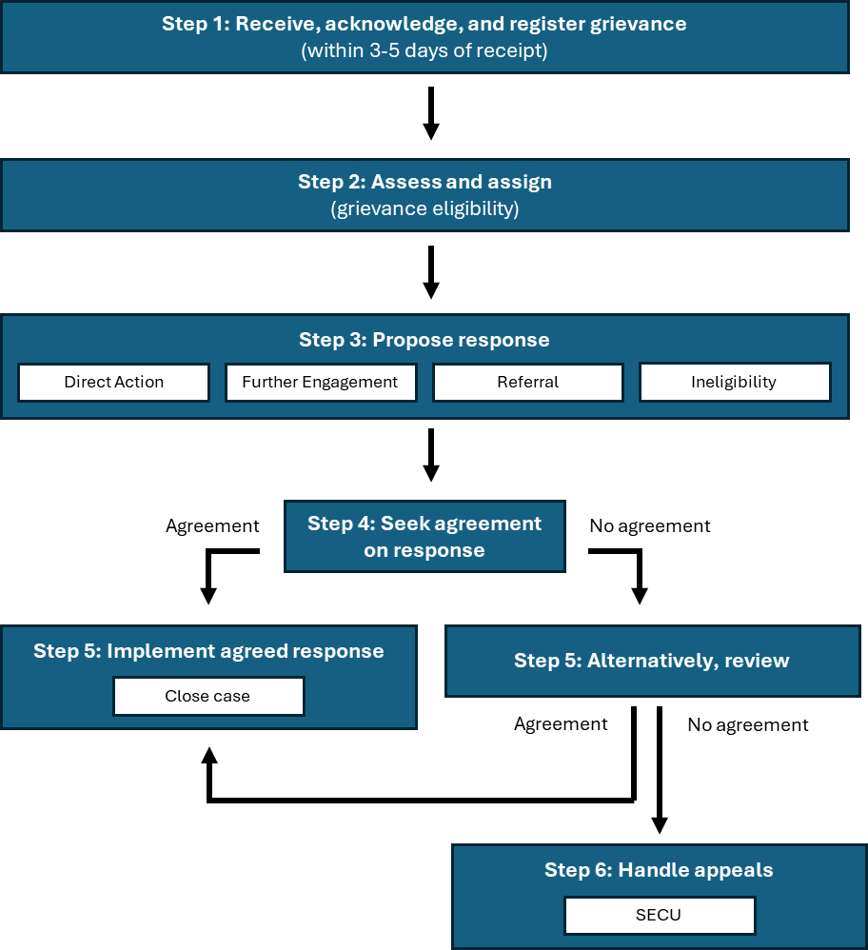

Step 1: Receive, acknowledge and register grievance
Upon receiving a grievance through any established channel, the Convening Agent should log it in a grievance data management system and send an acknowledgment to the complainant. Normally, complaints should be acknowledged within 3-5 days of receipt. Provide information on potential follow-up actions and timeline. Even where a grievance is minor or can be directly resolved, record the details in the centralised system for monitoring and evaluation purposes.

Step 2: Assess and assign
Assess grievance eligibility using established, publicly available criteria. If ineligible, clearly communicate this to the complainant with reasoning. If eligible, proceed to review and respond. Maintaining an accessible process with swift initial responses, rather than imposing strict entry criteria that might discourage stakeholders from raising legitimate concerns, is recommended.
Eligibility assessment doesn't imply fault or promise specific redress but triggers initial review. Staff should follow clear guidelines on eligible issues, referrals to other mechanisms, and cases needing clarification.
Eligibility is often determined based on four broad criteria: (1) indication of actual or potential negative impact caused by a GFCR initiative, (2) specific description of the impact and its link to a GFCR initiative, (3) confirmation that complainants are affected parties or their authorised representatives, and (4) sufficient information is provided to evaluate the grievance.
Assessors may need to redirect complaints to appropriate departments or external bodies, including escalating to the UNDP Social and Environmental Compliance Unit (SECU) as necessary (Section 7).

Step 3: Propose response
Conduct an impartial, objective review of the submitted information. The GRM should offer flexible resolution approaches based on case complexity:
- Direct Action: For straightforward issues, implement simple, agreed-upon solutions promptly.
- Further Assessment and Engagement: In complex cases, conduct additional investigation and stakeholder consultation to jointly determine the best resolution approach.
- Referral or Ineligibility: If the grievance doesn't meet eligibility criteria or falls outside the GRM's scope, communicate this and redirect to appropriate mechanisms if applicable.
A successful GRM adapts to diverse issues by offering multiple resolution strategies. It’s essential to involve complainants in selecting the most appropriate approach, ensuring flexibility and effectiveness in addressing a wide range of grievances.
For serious allegations, collaborate with law enforcement as needed. Maintain systematic records of all actions and findings, providing regular updates to the complainant.

Step 4: Seek agreement on response
Communicate the proposed response to the complainant within 14-21 days of receiving the grievance, using accessible language and methods. The communication should explain the rationale, detail actions to be taken, and outline the complainant's options.
The complainant may or may not agree with the proposed response. If there is agreement, then the proposed response can proceed, whether direct action, further assessment, or referral. If there is disagreement, options include:
- Requesting a review of the decision.
- Engaging in further dialogue.
- Participation in a proposed assessment and engagement process.
- Pursuing the complaint through alternative channels.
If the complainant disagrees with the proposed response, GRM staff should:
- Seek to understand the reasons for disagreement.
- Offer additional information or clarification.
- Revise the approach if feasible.
Preference should be given to in-person meetings with dissatisfied complainants to discuss concerns and explore solutions, rather than relying solely on written correspondence.
For sensitive cases, the GRM may consider independent assessments, mediation, or adjudication to seek appropriate resolution of the case. Ensure the complainant understands all available recourse options, including through judicial or administrative channels. Document all interactions and decisions thoroughly.

Step 5. Implement agreed response and close
Once agreed, implement the response and collect evidence of corrective actions taken (e.g. photos or documents, a record of resolution, an agreement with the complainant, a confirmation from the complainant). Close the case.

Step 6. Handle appeals
If the complainant remains unsatisfied, they can appeal to the United Nations Development Programme’s (UNDP) Social and Environmental Compliance Unit (SECU). SECU serves as an independent panel to:
- Conduct higher-level reviews.
- Perform independent investigations.
- Provide expertise on social and environmental issues.
- Offer a final internal appeal option.
Throughout the process, maintain flexibility, document all interactions, and ensure the complainant understands all available options, including external channels.

7. Escalation Procedure
If complainant believes that the Conventing Agent GRM is ineffective or compromised, a grievance may be channeled directly to the GFCR’s corporate-level GRM. UNDP’s Social and Environmental Compliance Unit serves as the final escalation point for GFCR's GRM, providing an independent review mechanism. This escalation procedure provides an additional layer of oversight and resolution for GFCR grievances.
To submit an appeal to SECU, complainants may use various channels:
- Email: project.concerns@undp.org and secuhotline@undp.org
- Messaging apps: WhatsApp, Viber, Signal (001-917-207-4285), or WeChat (@SECUSRM)
- Mail: SECU/SRM, OAI, UNDP, 1 U.N. Plaza, 4th Floor, New York, NY USA 10017
- Phone: 001-917-207-4285 (caller incurs costs; Skype recommended for affordability)
SECU requests complainant include the following information in their requests:
- Name, address, telephone number, and other contact information.
- Whether the Complainant(s) wish to keep their identity confidential, and if so, why.
- Name, location, and nature of the UNDP project or programme (if known).
- How the Complainants believe they have been, or are likely to be, adversely affected by the UNDP-supported project or programme.
- If a third party, such as a civil society organization, is filing a complaint on behalf of an affected individual or community, the complaint should include evidence the third party is working on behalf of the individual or community.
- Although helpful, it is not necessary to cite to specific UNDP standards or policies (such as the UNDP's Social and Environmental Standards).
The SECU acts as the GFCR’s own GRM. In addition to acting as a final appeal/escalation point, as indicated in Section 5, complainants can decide to route their complaint directly to the SECU.

8. Maintaining Records and Monitoring Actions
- Convening Agents should report the outcomes of their GRM procedures to GFCR on a yearly basis. In turn, the GFCR will implement a centralised database managed by a dedicated team to log all grievances using a standardised protocol. This system is essential for accountability and continuous improvement. Basic complaint information, such as the date received, eligibility status, main concerns, response status, and final resolution, should be made publicly available while respecting confidentiality requests.
- Informal resolutions should also be recorded to track responsiveness and identify recurring issues. Detailed records in a data management system will help monitor common trends that may indicate systemic problems and evaluate a GRM’s performance in fairness, impartiality, accessibility, and responsiveness.

This Policy is built on, and references, Grievance Redress Mechanisms in place in the following conservation trusts: Central African Forests Initiative Multi-Partner Trust Fund; Blue Nature Alliance; Blue Action Fund; Blue Alliance Marine Protected Areas; Blue Planet Fund; World Bank Problue.
Based on UN Human Rights Council, 2011. “Protect, Respect and Remedy: A Framework for Business and Human Rights”. A/HRC/17/31, 21 March.
https://www.undp.org/accountability/audit/secu-srm/social-and-environmental-compliance-review

