Global Fund for Coral Reefs (GFCR)
Indigenous People and Local Communities Policy
(Draft – October 16, 2024)
Table of Contents
1. Introduction 1
2. Purpose and Scope 2
Who are indigenous peoples? 2
Why engage with indigenous peoples? 2
Rights and interests of indigenous peoples 3
Applicability of the Policy 4
3. Principles 4
4. Requirements 5
Step 1: Identification of indigenous peoples 6
Step 2: Meaningful Engagement 7
Step 3: Free, Prior, and Informed Consent (FPIC) 8
Step 4: Indigenous Peoples Plans and Planning Frameworks 9
Step 5: Grievance Redress Mechanism 10
5. Specialised Expertise 10
6. Monitoring and Evaluation 11
7. Adaptive Management 11

1. Introduction
The Global Fund for Coral Reefs (GFCR) is committed to protecting and restoring coral reef ecosystems while respecting the rights, knowledge, and practices of indigenous peoples. This Indigenous People and Local Communities Policy establishes a framework for meaningful engagement with indigenous peoples in GFCR’s coral reef conservation efforts.
The Policy aims to integrate indigenous perspectives and traditional ecological knowledge into coral reef protection strategies, acknowledging the intricate relationships between indigenous cultures and their environments. It supports the GFCR’s commitment to transforming the livelihoods of coral reef-dependent communities and ensuring their resilience to major shocks.
By implementing this Policy, the GFCR seeks to enhance the effectiveness and sustainability of its coral reef conservation initiatives while safeguarding the rights and interests of indigenous peoples who have been stewards of these ecosystems for generations. The Policy ensures GFCR-supported programmes and projects create opportunities for indigenous peoples to participate in and benefit from activities without compromising their cultural identities and well-being.
This Policy outlines GFCR's expectations for Convening Agents to fully respect the human rights, cultural heritage, and traditional knowledge of indigenous peoples. It details: its purpose and scope; principles for engagement; requirements for effective collaboration – including identification, meaningful engagement, free, prior, and informed consent (FPIC), grievance redress mechanisms, and Indigenous Peoples Plans and Planning Frameworks – monitoring and reporting procedures; and specialised expertise and adaptative management statements.
The Policy addresses the GFCR’s Investment Principle 8 (Equitable Outcomes), which states that: “the GFCR supports interventions with positive and equitable outcomes and that protect the rights of stakeholders particularly indigenous peoples and local communities and regardless of gender, ethnicity, culture, political or socio-economic status”.

2. Purpose and Scope

Who are indigenous peoples?
Indigenous peoples are distinct social and cultural groups characterised by several key attributes, to varying degrees:
- Self-identification: Members identify as part of a unique indigenous social and cultural group and are recognised as such by others.
- Collective attachment: There is a strong connection to geographically distinct habitats, ancestral territories, or areas of seasonal use, along with an attachment to the natural resources found there.
- Distinct systems: They maintain customary cultural, economic, social, or political systems that differ from those of mainstream society.
- Language: Indigenous peoples often speak a distinct language or dialect, which may be different from the official language(s) of their country or region.
While these characteristics are common, there is no universally accepted definition that fully captures the diversity of indigenous peoples. Terminology varies globally, reflecting national contexts. Terms may include “indigenous peoples and local communities”, “local communities”, “sub-Saharan African historically underserved traditional local communities”, “indigenous ethnic minorities”, “Afro-descendent communities of South America and the Caribbean”, “ethnic groups”, “aboriginals”, “hill tribes”, “vulnerable and marginalized groups”, “minority nationalities”, “scheduled tribes”, “first nations”, “tribal groups”, “pastoralists”, “hunter-gatherers”, “nomadic groups” or “forest dwellers”, among others.
GFCR considers self-identification as the fundamental criterion for definition. This Policy applies to all groups meeting the defining criteria, regardless of the specific term used. Convening Agents may request the use of alternative terms that align with the national context relevant to their programmes and projects.

Why engage with indigenous peoples?
Indigenous peoples are unique and distinct stakeholders of the GFCR, with invaluable contributions to make in coral reef conservation and climate change adaptation. Their traditional ecological knowledge and sustainable practices offer critical insights that can enhance conservation strategies. Engaging with indigenous peoples allows the GFCR to integrate this knowledge into its conservation efforts, enhancing the resilience of both coral reefs and coastal communities.
Indigenous peoples, however, face serious threats to their rights and livelihoods from climate change actions and development projects that overlook their perspectives and needs.
This Policy recognises that indigenous peoples have distinct identities and aspirations, frequently experiencing disadvantages due to traditional development models. Many are among the most economically marginalised and vulnerable populations, with limited capacity to defend their rights to land and resources. Consequently, they may not receive equitable or culturally appropriate benefits from programmes or projects. The Policy also acknowledges that gender roles in indigenous cultures often differ from mainstream societies, with women and children facing potential marginalisation both within their communities and because of external developments.
Engaging with indigenous peoples is essential for recognising their rights and ensuring effective, equitable conservation efforts. The GFCR is committed to making special efforts to respect, protect, and comply with the collective and individual rights of indigenous peoples, including their customary and resource rights.

Rights and interests of indigenous peoples
The rights and interests of indigenous peoples are increasingly recognised in climate change policies and actions, as highlighted by the United Nations Framework Convention on Climate Change, Paris Agreement, and, most recently, Kunming-Montreal Global Biodiversity Framework, adopted by the parties to the Convention on Biological Diversity in 2022, which commits to a human rights-based approach in achieving its goals, including conserving 30% of the planet by 2030. These frameworks emphasise the importance of respecting and considering the rights of indigenous peoples when addressing climate change and conservation. International instruments such as the UN Declaration on the Rights of Indigenous Peoples (UNDRIP) and International Labour Organization (ILO) Indigenous and Tribal Peoples Convention 169 affirm their rights to lands, territories, and resources they have traditionally owned or occupied, as well as their right to FPIC regarding programmes and projects affecting these areas.
The GFCR recognises indigenous peoples as rightful partners in conservation efforts, committed to respecting their collective rights and ensuring that their voices are heard. This includes acknowledging their distinct cultural and social needs, the importance of their cultural heritage, and traditional practices. In developing this Policy, the GFCR has been guided by the human rights norms and standards of various internationally recognised instruments, including those in the International Bill of Rights, UNDRIP, ILO Indigenous and Tribal Peoples Convention 169, International Covenant on Economic, Social and Cultural Rights, International Convention on the Elimination of All Forms of Racial Discrimination, International Covenant on Civil and Political Rights, Guiding Principles on Business and Human Rights, United Nations Declaration on Human Rights Defenders, United Nations Declaration on the Rights of Peasants and Other People Working in Rural Areas, United Nations Convention on the Elimination of All Forms of Discrimination against Women, and United Nations Core Human Rights Principles for Private Conservation Organizations and Funders.
Importantly, the GFCR recognises indigenous peoples’ right to remain on their territories. Any relocation, considered only as an exceptional measure, must occur with their FPIC and in full compliance with relevant laws and conventions. The GFCR also respects the rights of indigenous peoples living in voluntary isolation to maintain their chosen lifestyle and decide if and how they wish to engage with the mainstream world.

Applicability of the Policy
This Policy applies to all situations where indigenous peoples are present in, have, or had a collective attachment or right to areas where GFCR-financed activities will be implemented. This includes groups who, within living memory, have been disconnected from their traditional lands due to circumstances such as involuntary relocation, conflict, government-mandated resettlement, land dispossession, natural disasters, or urbanisation of their ancestral territories.
The application of this Policy is not contingent on the legal recognition of indigenous peoples by a state, nor on the legal status of their lands and resources. It applies regardless of whether the impacts on indigenous peoples are positive or negative, and irrespective of the significance of these impacts.
Furthermore, the Policy applies regardless of the presence or absence of discernible vulnerabilities among indigenous peoples, although the nature and extent of vulnerability will inform the design of plans to promote equitable access to benefits or mitigate adverse impacts.
In cases of mixed communities or where indigenous peoples coexist closely with other social or ethnic groups, this Policy will be applied to benefit both indigenous peoples and neighbouring communities.

3. Principles
Key principles that should guide GFCR-financed activities involving indigenous peoples, including where they live, have collective attachment, or historically held rights, include:
- Free, prior, and informed consent (FPIC): Requiring Convening Agents to conduct meaningful consultations and obtain FPIC for any initiatives that impact indigenous peoples' lands, territories, resources, livelihoods, cultures, or that necessitate relocation.
- Meaningful and culturally appropriate engagement: Ensuring all interactions and processes are culturally appropriate, respectful of indigenous peoples' customs and traditions, and foster genuine communication using preferred languages and communication methods.
- Recognition and respect of indigenous and community rights: Acknowledging and respecting the rights of indigenous peoples, local communities, and vulnerable groups to their lands, resources, cultural heritage, and traditional knowledge, in accordance with UNDRIP and other international human rights standards, while considering the specific needs and risks of marginalised populations.
- Equitable benefit-sharing: Ensuring the fair distribution of benefits from programmes and projects among indigenous peoples, facilitating meaningful consultations and negotiations regarding benefit sharing, financial or otherwise.
- Participation in decision-making: Actively involving indigenous peoples in decision-making processes related to programmes and projects that affect their communities, respecting their systems of self-government.
- Indigenous leadership: Promoting and supporting indigenous-led initiatives and decision-making processes in coral reef conservation efforts, recognising the value of traditional governance structures and knowledge systems.
- Protection of traditional knowledge: Recognising and safeguarding the traditional knowledge and cultural heritage of indigenous peoples, including indigenous ways of ownership and knowledge transmission, promoting the participation and leadership of traditional knowledge holders in GFCR-financed activities.
- Support for indigenous livelihoods: Supporting and improving the quality of life and livelihoods of indigenous peoples in coastal communities through GFCR's coral reef conservation programmes, projects, and promotion of sustainable resource use.
- Gender responsiveness: Prioritising the empowerment of indigenous women within communities by meaningfully engaging, enhancing their access to resources, strengthening their decision-making roles, and recognising their contributions as stewards of natural resources and traditional knowledge.
- Empowerment: Providing resources for capacity-building to empower indigenous peoples in coastal communities to effectively interact and negotiate with local and national governments and other stakeholders, addressing inequalities and supporting indigenous youth.
- Respect for voluntary isolation: Respecting the rights of indigenous peoples living in voluntary isolation, ensuring their choice to remain isolated and live according to their cultural practices is honoured.
- Grievance redress: Establishing accessible and culturally appropriate grievance redress mechanisms for indigenous peoples affected by GFCR-financed activities.
- Prevention of human rights violations and abuses: Preventing and addressing human rights abuses by ceasing any adverse impacts they cause and ensuring that relationships with governments and other entities do not lead to violations, taking decisive action, including restricting or terminating support, when necessary.
These principles aim to ensure that GFCR-financed activities respect and uphold the rights, cultures, and livelihoods of indigenous peoples, fostering meaningful engagement, equitable benefit-sharing, and sustainable development in coastal communities.

4. Requirements
The GFCR has established essential requirements to ensure the rights of indigenous peoples are effectively considered in its financed activities. These requirements are designed to guide GFCR Convening Agents, co-implementers, and other stakeholders through the process of engaging with indigenous peoples across all stages of programme and project design, preparation, and implementation.
These requirements should be applied in conjunction with other relevant GFCR policies and guidelines, as well as applicable national laws and international agreements concerning the rights of indigenous peoples.
Key steps and activities include:
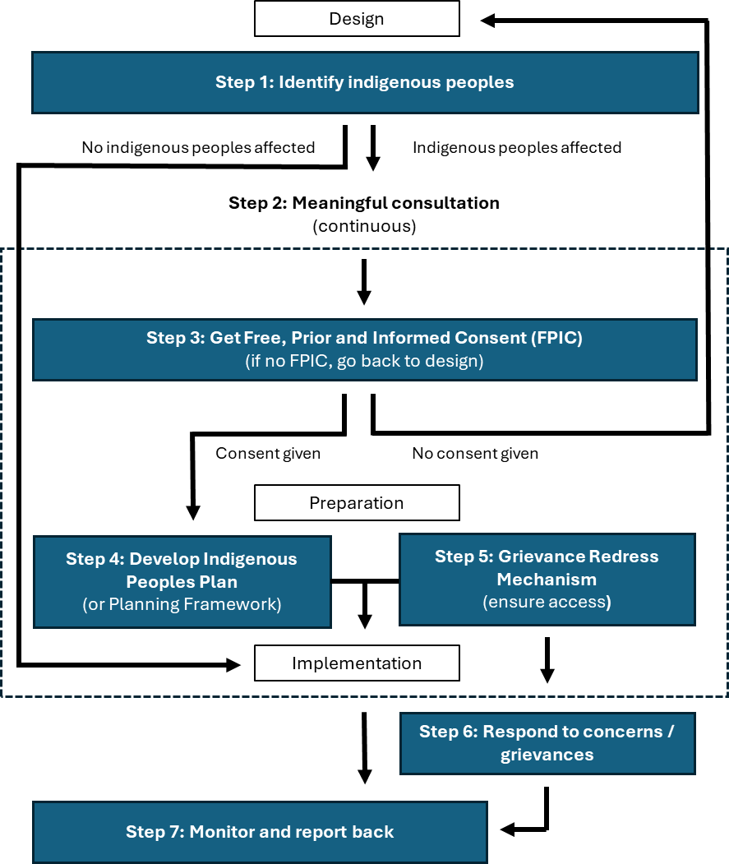

Step 1: Identification of indigenous peoples
The GFCR emphasises the need for early and accurate identification of indigenous peoples potentially impacted by its financed activities. This identification stage lays the groundwork for meaningful consultation, FPIC, and the development of Indigenous Peoples Plans and Planning Frameworks in subsequent steps. It also informs the establishment of appropriate grievance redress mechanisms and monitoring processes.
Key requirements for Convening Agents include:
- Screening and mapping: Conducting thorough social and environmental screening to identify indigenous peoples in or with collective attachment to a programme or project area. Performing comprehensive stakeholder mapping to identify all relevant indigenous peoples’ groups, formal and informal leadership structures, community organisations or representation bodies, and vulnerable sub-groups within communities.
- Identification criteria and process: Utilising the key attributes outlined in Section 2.1 as a guide for identifying indigenous peoples, including self-identification, collective attachment to lands and resources, distinct cultural systems, and language. Respecting the principle of self-identification as the fundamental criterion for defining indigenous peoples. Initiating identification at the earliest stages of programme and project design, ensuring the process is culturally appropriate and involves affected indigenous peoples and host governments.
- Preliminary impact assessment: Conducting an initial targeted social assessment to understand the relative vulnerabilities of affected indigenous peoples and potential programme or project impacts. Identifying any particularly vulnerable groups within the indigenous peoples and consider differentiated gender impacts.
- Reporting: Clearly documenting the identification process, criteria used, and findings. Including information on identified indigenous groups, their characteristics, and potential programme and project impacts in proposals and planning documents.

Step 2: Meaningful Engagement
The GFCR acknowledges that meaningful engagement with indigenous peoples is crucial for the success and sustainability of its financed activities. This engagement ensures programme and project support, ownership, and reduced risk of delays or grievances. It aims to make indigenous peoples active participants in the decision-making processes that affect their lives and territories.
The engagement process should begin as soon as is feasible, prior to the commencement of any activities that may impact indigenous peoples, their rights or their interests and should continue throughout the life of the programme or project.
The process includes stakeholder analysis, mapping and engagement planning following initial consultations, as well as the development of communication strategies for effective information disclosure and ongoing, meaningful consultation. All consultations should be conducted in local languages and in a culturally appropriate manner, with sensitivity to gender and intergenerational inclusivity, while respecting the customs, norms, and values of the affected communities through their chosen representatives.
Meaningful engagement with indigenous peoples requires additional considerations. Key requirements Convening Agents should adhere to include:
- Representation: Involving indigenous peoples' representative bodies and organisations (e.g., councils of elders, village councils, chieftains) identified in previously conducted stakeholder mapping processes.
- Inclusive participation: Ensuring engagement of women, youth, elderly, and persons with disabilities. Create spaces for direct participation of marginalised groups within the community.
- Capacity-building: Assessing and enhancing indigenous peoples' capacity to engage effectively. Implement communication and capacity-building programmes as needed.
- Adequate time: Allowing sufficient time for community-level internal deliberations and decision-making, acknowledging that these processes may be collective in nature and require extensive discussion, particularly when there are differing opinions or challenges within the community.
- Freedom from interference: Ensuring the consultation process is free from external manipulation, interference, coercion, and intimidation.
- Documentation: Recording all engagement processes and outcomes, including how indigenous concerns and preferences are addressed in programme and project design, preparation, and implementation stages.

Step 3: Free, Prior, and Informed Consent (FPIC)
The GFCR recognises FPIC as a right of indigenous peoples and a fundamental principle in its engagement process. FPIC is required when GFCR-financed activities may impact the lands, resources, livelihoods, or cultural heritage of indigenous peoples. This process is not a one-time event but an ongoing dialogue that fosters mutual understanding and respect throughout the life of a programme or project.
FPIC is an iterative process that requires obtaining the consent of indigenous peoples before any activity impacting indigenous peoples is approved for GFCR financing. It is based on indigenous peoples' own independent deliberations and decision-making processes, free from coercion or intimidation.
Key elements of the FPIC process for Convening Agents include:
- Meaningful engagement: Conducting transparent and inclusive consultations with indigenous peoples prior to programme or project approval, as detailed in Step 2, ensuring the process is free from coercion or intimidation.
- Legal alignment: Demonstrating how proposed activities comply with applicable national laws and international agreements on indigenous peoples' rights, particularly regarding FPIC processes.
- Transparent information sharing: Ensuring that affected indigenous peoples are informed of and understand their rights as per applicable laws, international treaties, and agreements, scope, nature, and potential impacts of proposed GFCR-financed activities, and their rights and options within the FPIC process.
- Documentation: Recording the involvement of indigenous peoples, especially women and youth, in shaping and implementing GFCR-financed activities. Providing detailed outcomes of all consultation processes. Including information on identified indigenous groups, their characteristics, and potential programme and project impacts in proposals and planning documents.
- Evidence of consent: Submitting evidence of the mutually accepted FPIC process between implementing entities and affected communities, including any agreements resulting from negotiations.
- Respect for indigenous rights: Acknowledging and respecting indigenous peoples' right to withhold consent throughout the programme or project lifecycle. FPIC does not require unanimous agreement; it can be achieved even in the presence of differing opinions within a community.
- Equitable compensation and development: Ensuring fair compensation and culturally appropriate sustainable development opportunities for affected indigenous peoples, when applicable (e.g., when commercial development of indigenous lands or resources is proposed).
These requirements apply particularly in circumstances involving:
- Impacts on lands and resources subject to traditional ownership or customary use.
- Any form of relocation or displacement (to be avoided whenever possible).
- Potential impacts on cultural heritage, including physical elements (e.g., natural areas with cultural and/or spiritual value, sacred groves, sacred bodies of water and waterways, sacred mountains, sacred trees, sacred rocks, burial grounds and sites, etc.) and non-physical expressions of culture (e.g., traditions, language, identity, or ceremonial or spiritual practices).
- Commercial use of indigenous peoples' cultural heritage.
- Potential impacts on peoples in voluntary isolation, where appropriate measures must be taken to protect their lands, territories, environment, health, and culture and any undesired contact resulting from GFCR-financed activities must be strictly avoided.

Step 4: Indigenous Peoples Plans and Planning Frameworks
The GFCR requires the development of Indigenous Peoples Plans (IPPs) or Indigenous Peoples Planning Frameworks (IPPFs) for programmes or projects that may impact indigenous peoples. These plans should be proportionate to the potential risks and impacts, complementing environmental and social assessments and providing specific guidance on addressing the needs of affected indigenous peoples.
BOX 1: IPPFs vs IPPs

IPPFs are broader, overarching documents prepared earlier in programme/project preparation when specific activities and locations are not yet known. They provide a framework for addressing indigenous peoples' issues throughout the programme/project cycle and guide the development of future IPPs.

IPPs are more detailed and specific, developed later in the programme/project cycle when activities affecting indigenous peoples are identified. They contain concrete mitigation measures, benefit-sharing arrangements, and action plans for known programme/project contexts.

Essential components of an IPP, if applicable, can include:
- Baseline information from participatory impact assessments.
- Key findings and analysis on impacts, risks, and opportunities.
- Measures to avoid, minimise, and mitigate negative impacts.
- Strategies to enhance positive impacts and (economic) opportunities.
- Results of consultations, including a list of people and organisations that participated, a timetable, who was responsible for each activity, the FPIC, and future engagement plans.
- Community-based natural resource management processes.
- Gender assessment and action plans.
- Benefit-sharing mechanisms.
- Tenure arrangements.
- Grievance redress mechanisms.
- Budget, timeline, and organisational responsibilities.
- Monitoring, evaluation, and reporting frameworks.
The format and title of the IPP or IPPF can be adjusted as appropriate to the programme or project context. This includes adapting the terminology used to refer to indigenous peoples, if necessary.
When developing IPPs or IPPFs, Convening Agents should prioritise avoiding adverse impacts on indigenous peoples, minimising and compensating for unavoidable impacts in a culturally appropriate manner, and ensuring timely delivery of agreed-upon measures. Compensation, benefit-sharing and creating of opportunities should consider indigenous institutions, rules, customs, and gender equality, with eligibility based on individual, collective, or combined approaches. Mechanisms should be established for the effective distribution of collective benefits, ensuring inclusion of all eligible members, including vulnerable groups.
Furthermore, the benefits provided should align with the goals and preferences of the affected indigenous peoples, considering the context of GFCR-financed activities. The aim should be to improve living standards and livelihoods in a culturally appropriate manner, strengthen the role of women, and foster the long-term sustainability of natural resources in coral reef environments.

Step 5: Grievance Redress Mechanism
The GFCR requires Convening Agents to design a Grievance Redress Mechanism to provide an accessible, gender-responsive and culturally appropriate system for indigenous peoples and other stakeholders to raise concerns, ensuring fairness, impartiality, transparency, and responsiveness.
The mechanism should provide multiple channels for stakeholders to raise concerns and should be designed to address issues promptly and effectively. If concerns remain unresolved, indigenous peoples and other stakeholders have the option to escalate their grievances to the United Nations Development Programme's (UNDP) Social and Environmental Compliance Unit (SECU) for further review.

5. Specialised Expertise
To enhance the quality and effectiveness of their engagement with indigenous peoples, Convening Agents are encouraged to complement their internal technical capacity with specialised expertise. This can be achieved through engaging consultants or establishing an advisory group of experts. Such expertise might include cultural anthropologists, indigenous rights specialists, environmental experts, gender and social inclusion specialists, safeguards experts, participatory planning facilitators, and language and communication specialists, among others.
By incorporating these specialised skills, Convening Agents can ensure that best practices are followed throughout the consultation, planning, and implementation processes of GFCR-financed activities involving indigenous peoples.

6. Monitoring and Evaluation
Convening Agents must submit annual reports to the GFCR detailing their engagement with indigenous peoples. These reports should include:
- Implementation status of IPPs or IPPFs.
- Outcomes of consultations and FPIC processes.
- Impacts of the project on indigenous peoples' lands, resources, and cultural heritage.
- Progress on mitigation measures and benefit-sharing mechanisms.
- Level of indigenous participation in project activities and decision-making processes.
- Capacity-building activities undertaken for indigenous communities.
- Programme or project adjustments based on indigenous peoples input.
- Related grievances received and how they were addressed.
- Engagement challenges and lessons learned.
This reporting should be integrated into broader reporting mechanisms, such as programme annual narrative reports, to maintain its priority status throughout implementation. The GFCR will review these reports to ensure policy compliance and identify areas for improvement.
Convening Agents can also establish participatory monitoring mechanisms that involve affected indigenous peoples. This may include joint monitoring visits, community-led monitoring initiatives, or regular feedback sessions with indigenous leaders and representatives.
The GFCR may also commission independent third-party evaluations of projects with significant impacts on indigenous peoples to verify compliance with the Policy and indigenous rights and assess overall effectiveness of engagement strategies.

7. Adaptive Management
In the context of this Policy, the GFCR advocates for adaptive management strategies in the implementation of its programmes and projects. This approach ensures flexibility and responsiveness to ongoing feedback from indigenous peoples, changing environmental conditions, and insights gained throughout the lifecycle of each initiative.
Convening Agents should conduct regular reviews and make necessary adjustments to programmes and activities in close consultation with indigenous peoples, their leaders, and representatives. This process helps ensure that conservation efforts remain effective, culturally appropriate, and aligned with evolving community needs while being responsive to changing circumstances. By embracing adaptive management, Convening Agents can foster a dynamic and collaborative approach that respects and engages with indigenous knowledge, protects indigenous rights, and promotes sustainable outcomes in coral reef conservation.

This includes a language or dialect that has existed but does not exist now due to impacts that have made it difficult for a community or group to maintain a distinct language or dialect.
The GFCR aligns its definition and common characteristics of indigenous peoples with those used by partner UN agencies and relevant financial institutions, including the World Bank, GCF, GEF, and UNDP.
Remote groups with limited external contact, also known as peoples “in voluntary isolation”, “isolated peoples” or “in initial contact”.
For guidance on the stakeholder engagement process, refer to the GFCR Stakeholder Engagement Policy (2024).
For guidance on gender assessments and action plans, refer to the GFCR Gender Policy (2024).
For guidance on the process for handling grievances and designing an efficient Grievance Redress Mechanism, refer to the GFCR Grievance Redress Mechanism Policy (2024).

