Myvillages

Rural School of Economics
2020 - ongoing

Explanations, propositions and photos

&

4 drawings

This is the Myvillages list with what-we-do and can-do information, listed by Kathrin Böhm and Wapke Feenstra after our online meeting with Reza Afisina and Iswanto Hartono from
ruruHaus a few weeks ago in late March 2021.

Thanks for taking time to talk and explaining some future plans. We look forward to working
things out with you and the wider Kassel network.

Kathrin and Wapke

About Myvillages

Myvillages has been connecting communities, individuals and spaces using an a-national and trans-local identifier: The Rural. We come from rural backgrounds, made our home in the arts, and want to connect both. We have been working internationally and trans-locally since 2003, mainly within the geography of central and eastern Europe. We work from within the rural, and collaborate with rural communities to dig-out, reflect on and engage with localised forms of culture, economies and resources.

Myvillages prefers to work with formats that are close to the everyday of a place – be it a communal lunch, a slide show in the village hall, a walk across the fields, a market stall. We also have a number of ongoing trans-local infrastructures to make connections between people and places: the International Village Shop, the Farm Drawings Collection and the Eco Nomadic School.

Our work is questioning and critiquing an assumed urban cultural hegemony. How can a currently centralized and urban-dominated cultural space be stretched from a dispersed rural position? How to establish a shared cultural ground for the mutual exchange of knowledge and for new forms of visualization and co-production?

Myvillages’ work is exploratory and we want to understand how a rural mind-set expresses itself,
is being used and can be shared. This can’t be done from an urban position. Our work is to make space in the rural and in the arts, so we can connect and redefine it in togetherness. Examples include:

Former Farmland (2008-2009) - “When farmland is used as a site for new building projects or urban leisure areas, rural culture is swallowed up.” (Zaragossa ES, Linz AT, Oldenburg DE)
Company Drinks (2014-now) – “A community space and social enterprise that brings people back together through the act of picking, reconnecting with local green spaces and nearby countryside.” (Barking and Dagenham, Greater London UK)
Boerenzij (2018-now) - “Colonization, globalization and (rural) migration lie at the heart of present-day Rotterdam and its international port.” (Rotterdam-Zuid NL)

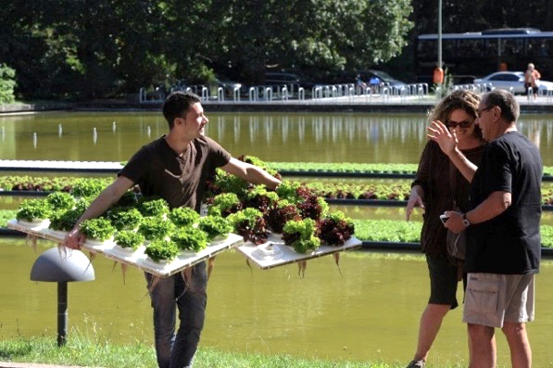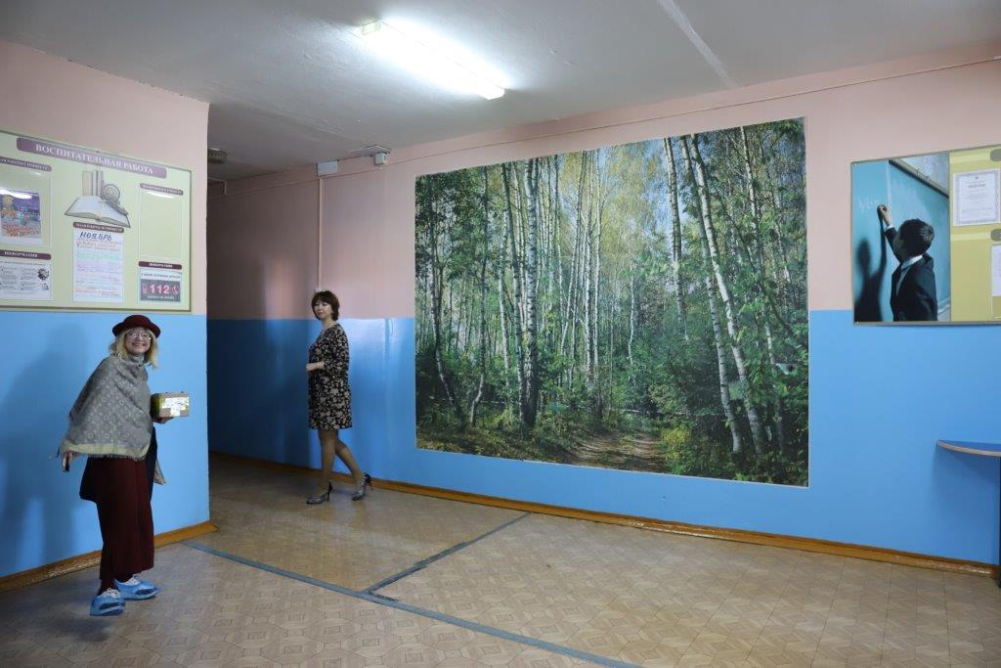

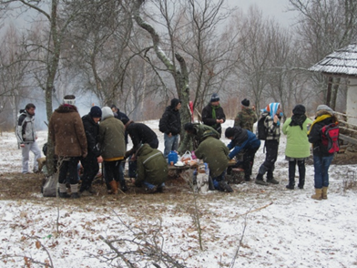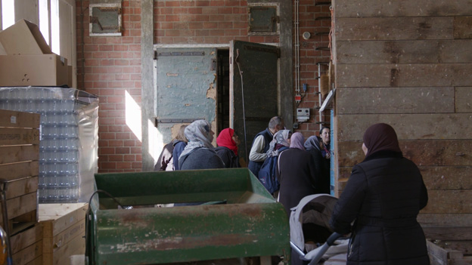
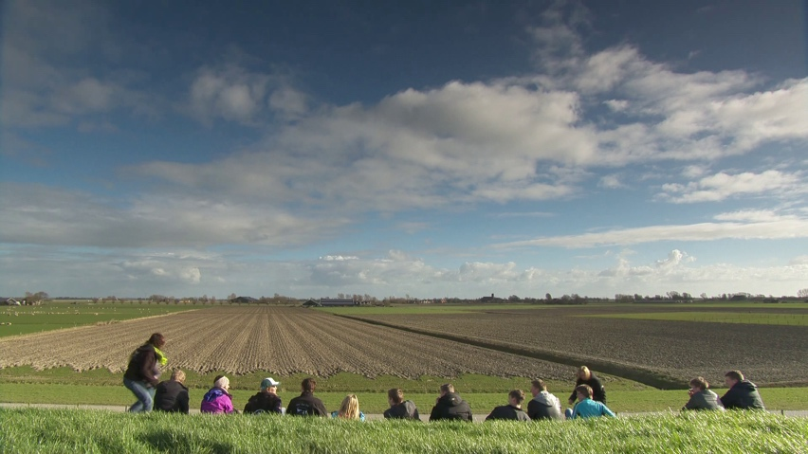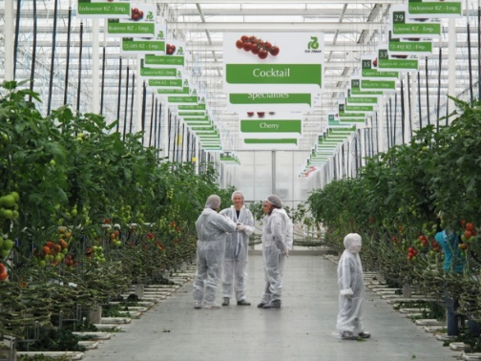

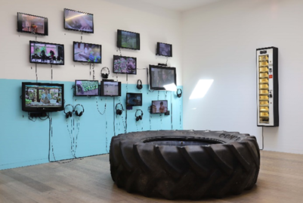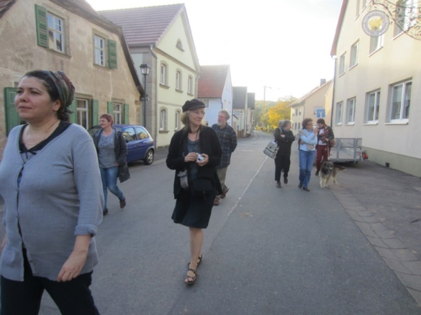

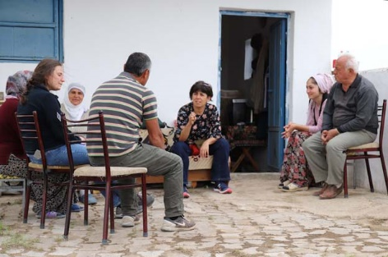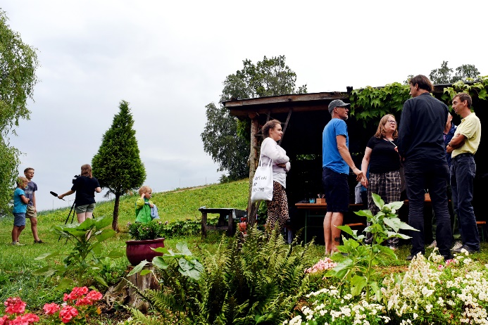

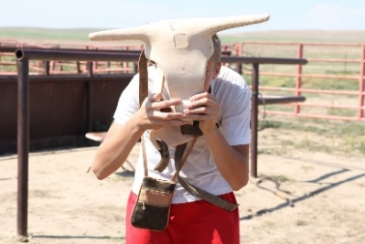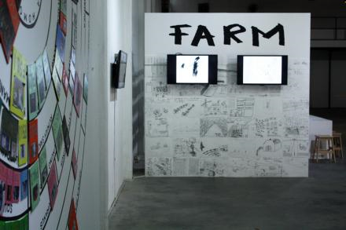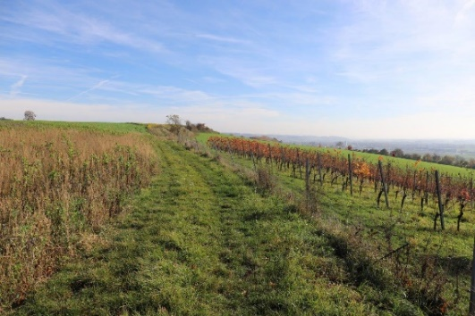

Images:
Pantry 2011, Harvest at Haus der Kulturen der Welt, Berlin / RSoE-Research 2019, Pushkino RU / Eco Nomadic School 2015, Brezoi RO / Boerenzij 2019, Farm-visit in Rhoon NL / Farmers & Ranchers 2014, Marrum NL / Eco Nomadic School 2016, Westland NL / The Rural 2019, Whitechapel Gallery, London / Eco Nomadic School 2012, Höfer Frauen Tour, Höfen DE / Potato Growers 2019, Derinkuyu TR / Farmtour in Festival der Regionen 2019, Rechberg AT / Jolly Ranch, Deer Trail USA / Farm Drawings 2017, Jakarta / FdR-research 2018, Wine Growing near Perg AT

The Rural School of Economics – from 2020

The Rural School of Economics is an extension of Myvillages’ ongoing work to acknowledge and share rural knowledge in collaboration, like e.g. the Eco Nomadic School and collaborative peer-to-peer learning with farmers. As contemporary rural culture has the knowledge of how to adapt to a place and the ability to connect with the non-human, it should be no news that we can learn from the countryside. We know that a 'learning by doing' attitude is often more developed in rural areas and that a practice-oriented attitude is relatively more common there. The RSoE reflects that by working in non-lingual and alternative learning sessions using pedagogics in transparent ways and test them by doing.

Our school constantly moves between rural places, and between everyday spaces and art spaces. The network of the RSoE includes village committees, farmers associations, regional scientists, international artists, museums etc. In order to stretch out a new cultural space we move and work across, and use the publicness of each situation to make space for thinking about, recognising and reconnecting with a rural (mind-set/particularity/possibility/memory….). The school is local and trans-local, and we want to bring those two aspects to Kassel: focusing on the city and focusing on what we together know across.

It’s is timely and urgent for rural culture to reclaim a role in the urban gaze that is dominant in art and culture and we want to contribute to the building of a collective future, with an interdependent rural and urban. The city of the future will benefit from other forms of knowledge, which will engender a revised set of values and alternative ways of seeing.

The focus of the Rural School of Economics is on:
- The rural as a place, a mind-set, a memory and a trans-local geography. Rural Mindsets are mobile and not just geographically defined. The school explores and recognise rural mindsets as a source of knowledge for a cultural and economic survival, that is rooted in intersectionality and interdependence.
- A School is any form of organised gathering where we learn and create mutually a place for recognising undervalued knowledge and sharing knowledge. Our “classrooms” can take many different forms, they can be informal and formal, on a field or around a table with food and drinks, they focus on localised knowledge and make trans-local connections.
- Economy is etymologically and fundamentally a social and cultural phenomenon that is part of our everyday. The School is an attempt to recognise and practice a different economic reality that could work for all of us, people and the planet.

The school is made by many. Our collaborators and their topics and reasons for connecting with the Rural School of Economics in 2021/22 include:

- Lumsden Village in Scotland and the Scottish Sculpture Workshop SSW; who want to set up a better system to connect local-everyday-knowledge and visiting-artist-knowledge in times of Brexit.
- Oost-Brabant, Het Groene Hart and Schiermonnikoog NL, all traditional agricultural regions that start a transition into circular agriculture. We focus on cows and landscape while working with the farmers-cooperation and researchers from WUR and UVA. Our partner is the Van Abbe Museum, located in Brabant but with little or no links to the rural.
- Pollinaria in the Italian Abruzzi area; a wine farm in the family for centuries, agricultural heritage, art production, rapid depopulation and a new influx of refugee communities.
- Brest and the surrounding area in Ukraine. We work with the village Zburazh, where older women hold textile design skills and subversive political communication skills. In an unsure political future, an off-grid residency is set up.
- Pushkino in Russia is marked by a large Lenin painting on the village hall. We invent new decorations and landmarks in co-design with youngsters by drawing the nature that surrounds this village.

Why would we like to set up and share classrooms in Kassel?
We want to be part of your collective school . 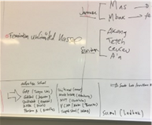

We know that Kassel has an important rural undercurrent that is largely paved over, and we would like to dig within the city to make it recognisable and shareable. The undercurrents lie within urban growing and local food initiatives, come from a not-distant agricultural Umland, live in the mind-set of residents whose families come from the countryside, and within many of the 39% of the population with migration background. We want to feature Kassel’s rural undercurrent during the show, focussing on the economic and trans-local rural dimensions of (wider) Kassel

We would like to open a class room in Kassel with others who want to articulate the economic knowledge of the rural, and we want to show Kassel’s rural undercurrent, focussing on the cultural dimension of rural migration and land-use in wider Kassel, and we want visitors of Documenta to become aware of the urban gaze. How not to perpetuate a cultural oppression based on a rural imagination that is directed from a urban perspective?
Having worked from within the rural and with urban art publics for 20 years, we are aware that this intertwined culture and recognition is going slow. It is never difficult to explain why the perspective onto the rural should be changed, it simply needs public attention, time and space to explain a model of urban-rural interdependence versus thematising the rural from an urban perspective. To change the fact that the rural is more commonly consumed than experienced; needs gatherings, commoning, Lumbung, meent, Allmende ..
Kassel’s Documenta will as always make a lot of space and time for art and will have a huge public.
We want to allow this public to become aware of their urban gaze, and to see and recognise the rural not as a remote or even exotic topic, but as a lived experience of many, that should remain accessible to many. The Rural School of Economics would like to open a classroom with others who want to articulate their knowledge of the rural. We see it as a place to experience an undercurrent that goes beyond the paradigm of urban growth, by making us aware of more general representations and the multiplicity of what the interdependent rural and urban economy is and can be. By situating the public within the trans-local and local rural mindsets, it can reveal rural culture and knowledge as a variety of strategies for the transition to a caring community. Making rural connections means not only questioning the global art world, more important it stops us being spectators and consumers of the objectivation of the rural and in that slipstream our planet. The transition from an agricultural and mining economy to a service, and above all a non-land-based, economy has frozen our gaze. Unearthing some of the undercurrent Kassel can make us aware that Kassel is not just a place that serves us, hosts us, but a city were rural mindsets are the lived experiences of many.

So the time-space of public platforms like Documenta are useful for our way of working, drawing attention, and diverting the urban gaze. We would like to make actual connections between those who live there and their rural mind-sets and practices. Between visitors with rural heritage and cultural expectations from elsewhere. Between the art production of Documenta and the rural cultural production of its home town.

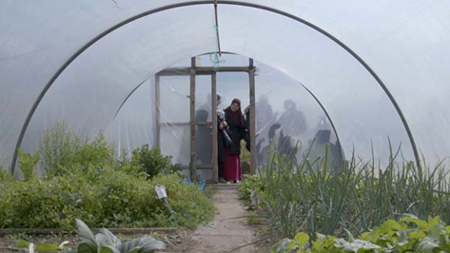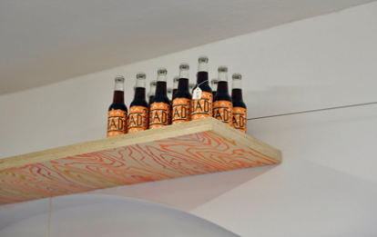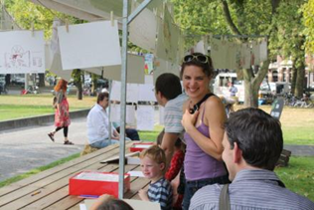

Our two-part suggestion for a trans-local and local contribution to the Collective School

- Localising by going
- Universalising by comparing

2021 Start research in Kassel: universal and local scale.
Connect with local and regional groups such as Essbare Stadt (Edible City) Zeicheninstitut, Migrant organisations , Kreisbauernverband Kassel (farmers association).
Start (online) trans-local classroom on Learning as Commoning & Learning about Commoning.

2022 Public and semi-public classrooms and field trips to the rural undercurrent in Kassel.
Permanent public display of the objects and ways-of-handling that embody this.
Publication of the study notes of everyone involved.

OUTCOMES and contributions for the Collective School
- Classrooms: public and semi-public activities: discursive seminars, collective drawing sessions, farm trips, soil drillings, shared lunches and dinners, making workshops etc
- Showing and sharing the Undercurrent: a making public of objects and goods that represent the local rural undercurrent, selected and arranged by residents and groups who want to share rural mindset
- Publishing notes from the learning (text, drawings, photos of handling, images, etc)
- Maybe: a Kassel Pantry (small) to feed events at ruru Haus/Documenta (could just be drinks or a biscuit, a bake)

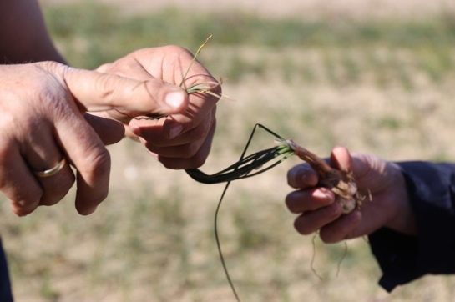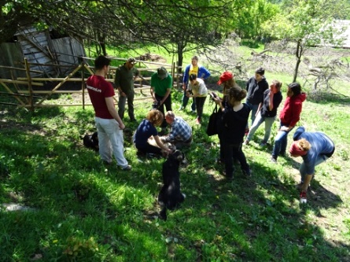

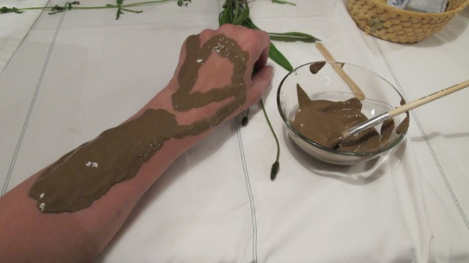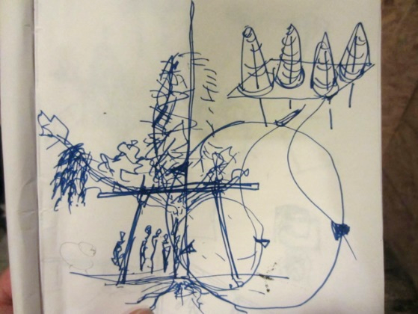

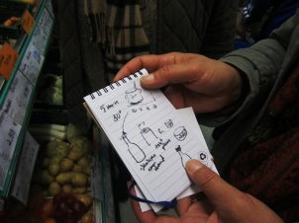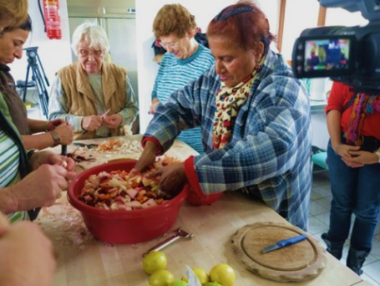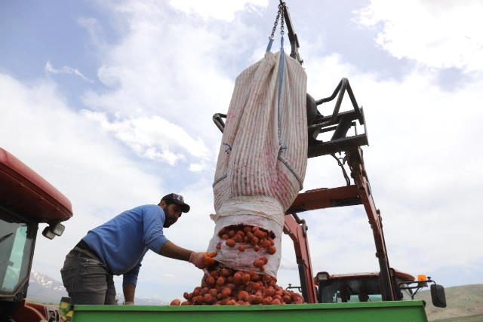

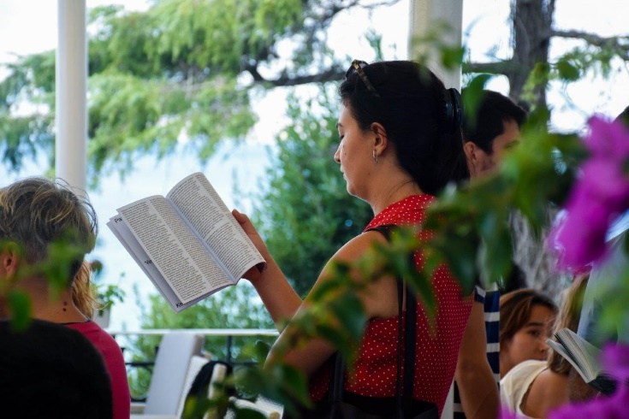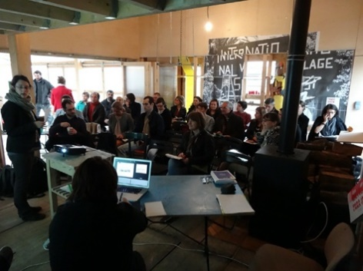

The local classroom: rural mindsets in Kassel – finding and showing the rural undercurrent

How to read the city from a different perspective?
Kassel the city becomes the place and key archive from which to read layered configurations of rurality. Migration into Kassel is closely connected to the post-war politic of culturalization and
industrialisation, including the millions of visitors who have come to Documenta over the years and the 39% of the population with a background in migration.

As former farmland and rural migration is just one of many consequences of land use and geopolitics, we are eager to add that layer to Kassel’s cultural humus as it is were industrialisation (and urbanisation) and the (ignored) rural mindsets meet. Having set up the Documenta – that now also can be seen as art-tourism was also a response to a cultural crisis in the mid of an after-war-europe. Art can make space for responds. To learn about the visible, invisible and underlaying rural culture that is the outcome of the political economy of urbanisation and segregation of class.

QUESTIONS to lead the research and visits and connection-building for the local classroom:

- How did rural migrants and mindsets arrive in Kassel, how were they rooted here and where do they remain recognisable? In objects, gardens, stories, dishes?
- How to land in Kassel, who owns land in Kassel?
- What are the short chain food tracks that can make us aware of the rural and urban connections (urban farming but even more; farm to table farmers)
- To learn about the visible, invisible and underlaying rural culture that is the outcome of the political economy of urbanisation and segregation of class in Kassel.
- To recognise the rural from elsehwere - the rural mindest that’s not geographically bound but still localises (what s visible/not visible) and allow those to make it visible, who carry and live it.
- Notes on the parallels between the right to self-subsistence and the right to self-representation (Kenneth Anders)

WITH local groups, residents and families, communities
- Essbare Stadt, Kassel Edible City and Communty Growing
- Communinty Supported Agriculture
- Bund der Antifaschisten, Anti Fascist Groups Kassel
- Zeicheninstitut
- Migrant organisations
- Community allotments
- FIND groups that are not art-related and have rural knowledge

The CLASSROOM:
- in motion, across Kassel and its Umland
- following lines of migration (into Germany, into the city, into the countryside)
“you show me”: touring and locating,
- host – visitor relationship - the German term for migrants “Gastarbeiter” (guestworker) versus we as visiting artists - problematics of hosting
- Farm visits, dinners, workshops
- Soil drilling and drawing
- Deep-listening and collecting knowledge in objects, photos and

A trans-local RSoE classroom in Kassel: comparing universal knowledge

We suggest to compare and collect the language and concepts to do with commoning, to decolonise and de-anglosise the terminology and to explain learning as commoning. The mode and mood of this classroom is peer-to-peer, horizontal and feeding into what is already there. Giving and receiving and roll on - more circular than relational.

- we see this is a more continuous discursive space in Kassel and within the Lumbung community
- Paying attention to linguistic tools – language, tone, translation – and make them accessible to those who face barriers to eg English, reading, listening
- Paying attention to the set-up of the physical social space – relating bodies and energies
- Learning about economic knowledge that is informed by practice
- Avoiding a monoculture in knowledge by including non-language based knowledge, and facing our blind spots in the divers positions such as e.g. cultural contexts and non-human knowledge
- Foregrounding knowledge that we still can reach but is marginalised by mainstream economics and politics
- Theorising whilst practicing, or: thinking things in the making (hands-on research)

Colleagues and friends we would like to invite from our side:
Rural Environmental Field School USA
Deepa Bhasti from the Foragers Collective, India
Van Abbe 4 Soils
Silke Helfrich, commons specialist
CERN connections Southern America and Asia
Fumihiko Sumitomo JP
Border School Texas USA
AMK and Archstoyania, Moscow RU
Wapke is an affiliated Researcher at www.ruralimaginations.com in Amsterdam
Kathrin an affiliated Researcher at R-Urban and the Community Economies Institute

OUTPUT: Notebooks, smells and drawings.
- learning notes, drawings and writing and illustrations,
- Ruth Cohn’s methodology on placing yourself with a diagram in the ‘I-We-Them-World'
  - Use Freire’s methodology of drawing and sketching what you’ve understood = the future learning material
- CERN methodology to Redraw the Economy
- En-plein-air deep connecting to the city
- Seeing and looking at the object – semiotic drawing lessons

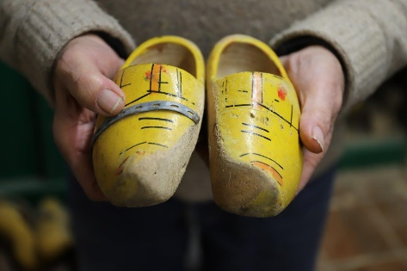

“The objects invite one to think about the non-linguistic knowledge a human being builds and shares through generations. In rural environments learning is acquired not only through linguistic or pedagogical means but also through living and dwelling practices within the community, the daily cycles of responsibilities and the division of labour. The objects, tools and goods accompany this learning process and, in and of themselves, possess forces of connections. These connections reach knowledge accumulated by practices across generations and exist not only between local and local, but also between global elements. They challenge the primacy of language and bring forth possibilities of non-linguistic ways of learning and knowing. Within today’s complexities of living together, reclaiming and appreciating this knowledge will be empowering for those who have not, for various reasons, mastered linguistic ways of being present in the cultures they live in.”

From: Kevser Güler on Boerenzij – a Rotterdam based exchange between local communities and their rural mindset and knowledge, connecting former farmers of the land in South Rotterdam with migrants to the city from rural backgrounds elsewhere.

