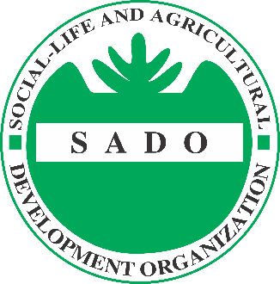

NATIONAL CALL TO TENDER FOR CONSTRUCTION OF WATER KIOSK AND PIPELINE EXTENSION IN IFTIN IDP CAMP BARDERA

SADO (Social-Life and Agricultural Development Organization), invites applications from registered eligible companies for the above-mentioned Service.

The tender will be conducted using SADO standard bidding documents, open to all qualified suppliers and service providers. The bidding documents (in English) can be downloaded from the website at https://somalijobs.net/ under the section “Construction of Water Kiosk and Pipeline extension in Bardera IDPs Camps” or from SADO website at https://www.sadosomalia.org/vacancies-postings/#tenders.

- Mogadishu Office Address: Bula Xubey, Wadajir District Behind Aden Abdulle Hospital Mogadishu, Somalia, Telephone +252614122223
- Bardera Office Address: Bula Kaskey, Opposite of Hormuud Telecom, Bardera District, Jubaland State Somalia, Telephone +252614122228

All bids must be submitted before 30 /05 / 2022 at 5:00 PM at the address mentioned above in a sealed envelope and by Email, at Procurement@sadosomalia.org copies to sado@sadosomalia.org. Late bids will be automatically rejected.

SADO will not be responsible for any costs or expenses incurred by the Bidders in connection with the preparation and submission of their bids to SADO.

Note: if you witness or suspect any unlawful, improper or unethical act or business practices (such as soliciting, accepting or attempting to provide or accept any kickback) during the tendering process, please contact the following phone number +252614122223 and/or send an e-mail to sado@sadosomalia.org

NOTE: Due to the large volume of expected respondents, those who will not have received feedback by end of 25th May 2022 should consider themselves not successful

