Communication Team Brief (Grade 9 -12)
By Katherine Xu and Perpetua Muthoni

Introduction
This document is organized by phase to reflect the progression of our thinking, from construct definition and research, to evidence-centered design, to training a Custom GPT to generate classroom-ready communication tasks.

The main pivots we made were narrowing our scope to Grade 9-12 instead of K-12, and focusing on “communicating to be understood.”

Phase 1: Construct definition and Research
Definition of the Construct
We started off by establishing a shared construct definition for communication that could work across subjects and modalities. We based our definition on the following descriptions by America Succeeds and a brainstorming session of the key competencies of communication:
- America Succeeds defines Communication as the ability to express ideas clearly and effectively across multiple formats and contexts, with sophisticated audience awareness and contextual appropriateness. This encompasses written, verbal, visual, and digital expression, requiring students to adapt their message based on who they’re communicating with and why.
- The ability to effectively exchange information, thoughts, and ideas with others in various environments (virtual and in-person) using various channels such as verbal, written, and non-verbal. (Pathsmith)
Our definition: Communication is the ability to make sense of information from diverse sources and to share that meaning clearly, respectfully, and purposefully with others across spoken, written, visual, nonverbal, and digital formats, adapting message, tone, and mode to audience, culture, context, and goal.
Synthesizing Existing Research and Frameworks
We researched communication rubrics that are used in K-12 and used that as the foundation for outlining key competencies and expected behaviours of good communicators within K-12.
- North Carolina Portrait of a Graduate: Durable Skills Rubric (Communication Rubrics)
- K-2 Complex Communication Rubric
- 3-5 Complex Communication Rubric
- 6-12 Complex Communication Rubric

We used Perplexity to find relevant research about communication frameworks and good examples of communication training across K-12 ( Link to Research).

Identifying the Core Competencies
Based on the research and our brainstorming, we settled on the following three core competencies buckets:
- Understanding & meaning-making
- Expressing ideas
- Adapting & exchanging in interaction.

Developing a Mind Map for Dimensions of Communication
After presenting the core competencies and our initial construct map to the class, we got some feedback about some additional dimensions of communication to incorporate into how we were thinking about the topic. We developed the mind map below and added some behaviours to expect (tied to the evidence-centered design process outlined in phase 2). The mind map layered in:
- Direction of communication (peer-to-peer, upward to adults, downward to less experienced peers)
- Conditions (modality, group structure, emotional charge, information balance)
- Observable behaviors aligned to each competency

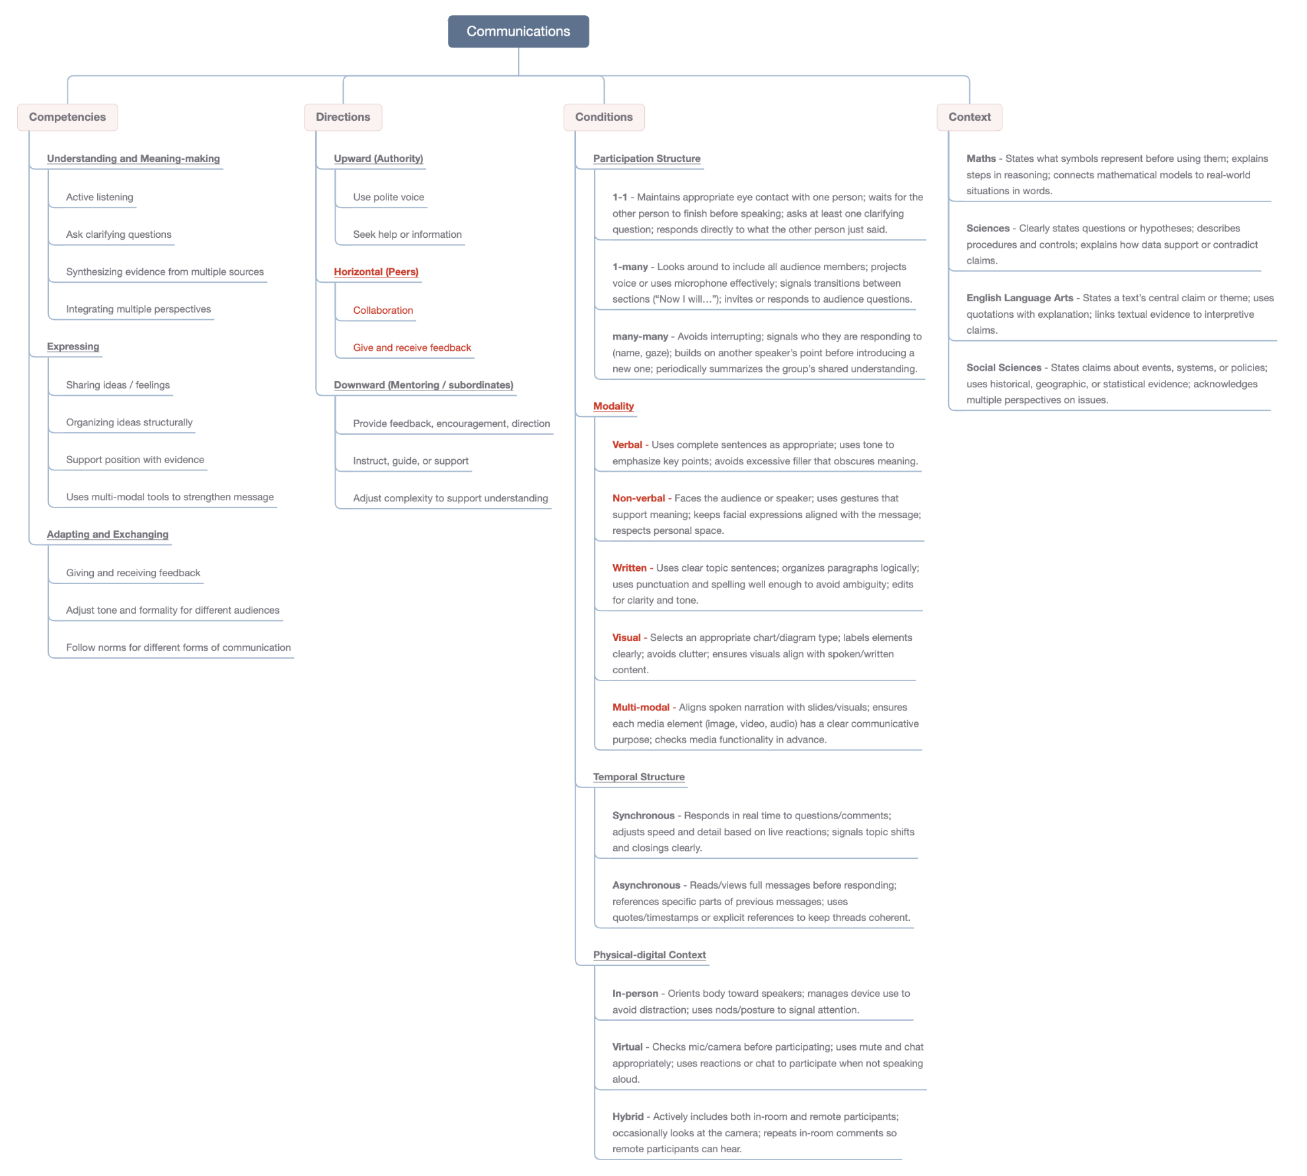

Phase 2: Evidence Centered Design
We moved into Evidence-Centered Design to ensure that communication could be assessed through observable student behavior rather than inferred traits. We had a broader set of models, but below are our final models after we narrowed our focus:
- Construct / Student Model - We articulated claims about what it means for a student to “communicate to be understood,” focusing on clarity, audience alignment, monitoring for understanding, and repair.
- Evidence Model - We identified what teachers and systems could see, hear, or capture when students are communicating effectively (e.g., paraphrasing, clarification, rephrasing, sequencing, confirming understanding).
- Task Model - We designed tasks that require communication for success by embedding:
  - Information gaps
  - Asymmetries in knowledge
  - Explicit interactional roles
  - Clear conditions where misunderstanding is likely and visible
A major insight in this phase was that communication cannot be meaningfully assessed without interactional dependency. Students must need to be understood for the task to succeed.

Phase 3: Training and Building the Model
We decided to use Customize GPT to build the model since it allows holding multiple files in its Knowledge for reference while generating outputs. Rather than fine-tuning model weights, this phase focused on instruction-level training, shaping the model’s behavior through carefully designed system instructions, task constraints, and exemplar structures.

We uploaded the Student, Evidence, and Task Model we developed earlier into the Knowledge for reference, alongside the standards, rubrics, and curriculum files. These resources functioned as the grounding context that the model must consult when generating tasks, ensuring alignment with curricular norms and assessment goals.
We then iteratively refined the model’s instructions to control: the reasoning sequence it follows (e.g., subject grounding → communication skill selection → task construction), the structure and formatting of outputs, and other performances through several fine-tuned rules.
Through repeated prompt testing and error analysis, we adjusted constraints to reduce hallucination, prevent undesired instructional commentary, and enforce consistent use of observable evidence. This iterative prompt engineering process effectively “trained” the model to behave as a task-generation assistant aligned with evidence-centered design principles.

What Worked Well
- The mind map helped us have a visual representation of the multiple dimensions of communication. We even got additional ones during the discussion like human-nonhuman interaction. It made a messy topic easier to deal with.
- Choosing a narrow subset of the dimensions to design around was helpful and made our initial examples more tangible (Active Listening in Peer-to-Peer, 1-1, In-Person, Synchronous Communication).
- Narrowing the construct further to “communicating to be understood” enabled us to develop simple, actionable tasks.

Key Learnings
- AI outputs require clear constraints to avoid drifting into generic pedagogy or getting stuck in a default. We put in so much information and did not really define how the GPT should make decisions, or what to prioritize. We ended up getting the same kind of tasks over and over.
- Early outputs of the Custom GPT were not comprehensive enough to serve as standalone lesson activities. We added some instructions to make sure the output was ready for classroom use without placing a burden on teachers to create materials. We did not fully get there, and some explicit, step-by-step instructions are needed to ensure the output matches exactly what we are looking for.
- Initial tasks sometimes let communication “spill outward”. We refined instructions to constrain interaction intentionally (within pairs or groups) so evidence stays attributable.

