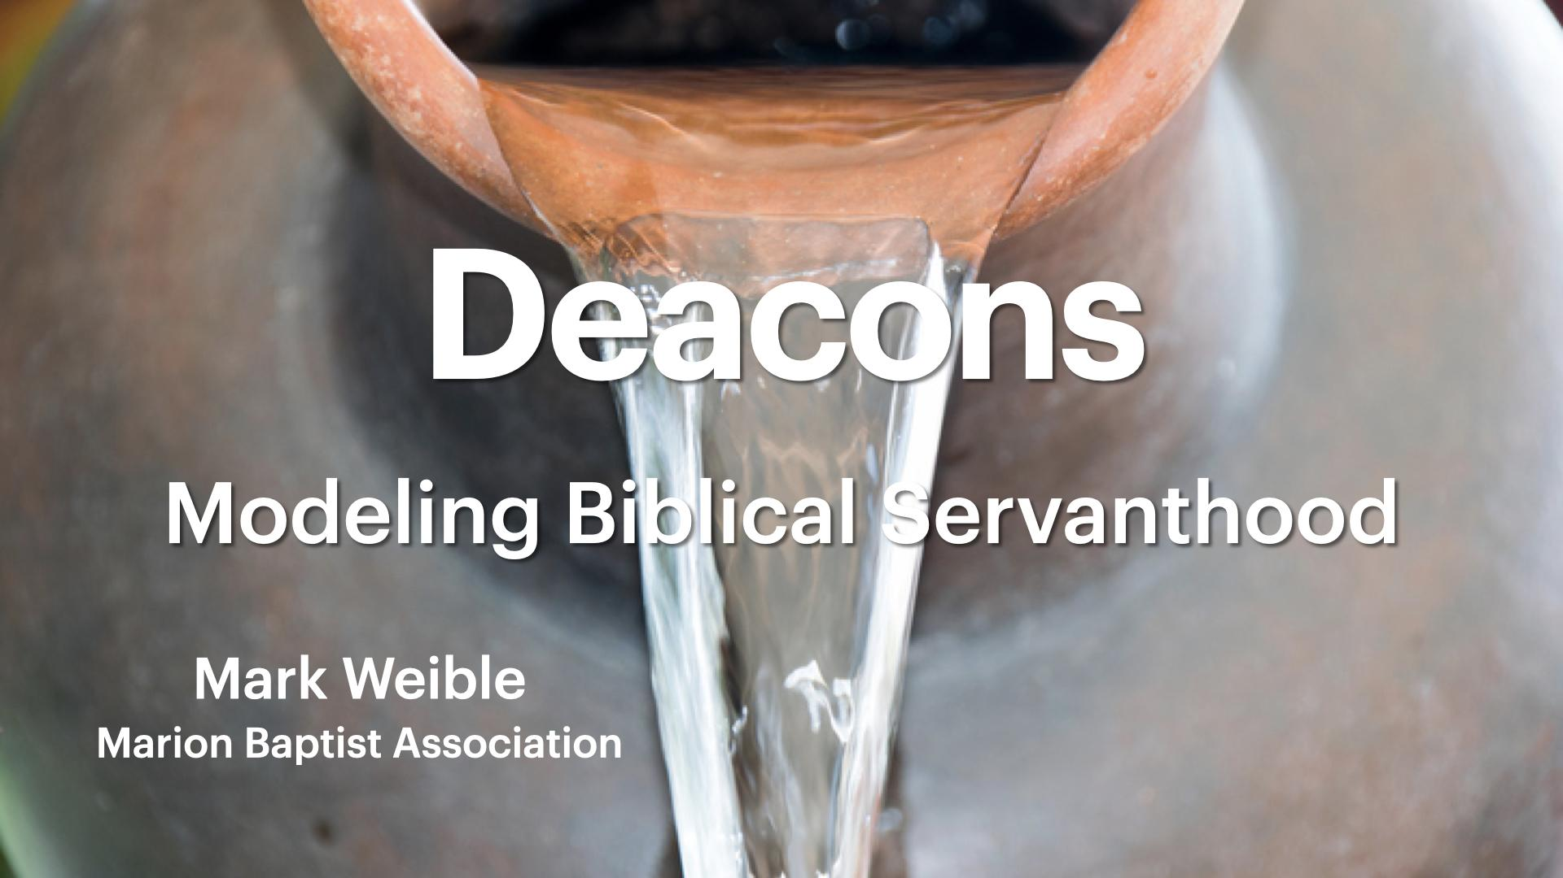

Deacons:
Modeling Biblical Servanthood

διάκονος (diakonos) in the New Testament:

Mt 20:26 | It shall not be so among you. But whoever would be great among you must be your servant,
Mt 23:11 | The greatest among you shall be your servant.
Mk 9:35 | And he sat down and called the twelve. And he said to them, “If anyone would be first, he must be last of all and servant of all.”
Mk 10:43 | But it shall not be so among you. But whoever would be great among you must be your servant,
Jn 2:5 | His mother said to the servants, “Do whatever he tells you.”
Jn 12:26 | If anyone serves me, he must follow me; and where I am, there will my servant be also. If anyone serves me, the Father will honor him.
Ro 15:8 | For I tell you that Christ became a servant to the circumcised to show God’s truthfulness, in order to confirm the promises given to the patriarchs,
Ro 16:1 | I commend to you our sister Phoebe, a servant of the church at Cenchreae,
1 Co 3:5 | What then is Apollos ? What is Paul? Servants through whom you believed , as the Lord assigned to each.
2 Co 6:4 | but as servants of God we commend ourselves in every way: by great endurance, in afflictions , hardships , calamities,
2 Co 11:23 | Are they servants of Christ? I am a better one— I am talking like a madman— with far greater labors, far more imprisonments, with countless beatings, and often near death.
Ga 2:17 | But if, in our endeavor to be justified in Christ, we too were found to be sinners, is Christ then a servant of sin? Certainly not!
1 Ti 4:6 | If you put these things before the brothers, you will be a good servant of Christ Jesus, being trained in the words of the faith and of the good doctrine that you have followed.

This is Why I Serve

Choose a Bible verse from the previous page that best describes your motivation for serving as a deacon and discuss your answers to the following questions with your team:

- What does it mean to be a servant in the Biblical sense?

- What must I give up in order to serve as a deacon?

- How did Jesus demonstrate servanthood?

- How have you been impacted by some else’s humble service? Share 1 example.

This is How I Serve

We exist to serve God, our church and others according to the purpose that God has established for our lives.



Insert your two-word purpose statement to complete the sentence below:

To the glory of God, I exist to serve by ________ing __________.

Rate your purpose statement for accuracy on a scale of 1-10:

Not me 2 3 4 5 6 7 8 9 Nailed it!
This is How I Serve

Read the following passage from I Corinthians 12 and discuss your answers to the questions that follow with your team.

12 For just as the body is one and has many members, and all the members of the body, though many, are one body, so it is with Christ. 13 For in one Spirit we were all baptized into one body—Jews or Greeks, slaves or free—and all were made to drink of one Spirit.
14 For the body does not consist of one member but of many. 15 If the foot should say, “Because I am not a hand, I do not belong to the body,” that would not make it any less a part of the body. 16 And if the ear should say, “Because I am not an eye, I do not belong to the body,” that would not make it any less a part of the body. 17 If the whole body were an eye, where would be the sense of hearing? If the whole body were an ear, where would be the sense of smell? 18 But as it is, God arranged the members in the body, each one of them, as he chose. 19 If all were a single member, where would the body be? 20 As it is, there are many parts, yet one body.
21 The eye cannot say to the hand, “I have no need of you,” nor again the head to the feet, “I have no need of you.” 22 On the contrary, the parts of the body that seem to be weaker are indispensable, 23 and on those parts of the body that we think less honorable we bestow the greater honor, and our unpresentable parts are treated with greater modesty, 24 which our more presentable parts do not require. But God has so composed the body, giving greater honor to the part that lacked it, 25 that there may be no division in the body, but that the members may have the same care for one another. 26 If one member suffers, all suffer together; if one member is honored, all rejoice together.
27 Now you are the body of Christ and individually members of it.
This is How I Serve

- I have certain skills, gifts, experience and a calling by God to serve the people of our church by…

- I am willing to give of my own time, talents and resources for the purpose of helping people who need…

- I can encourage the members of our church to care for the needs of others by…

- I can promote unity and healing within our church body by helping people to…

This is Whom I Serve

Read this passage from Matthew 25 and discuss your answers to the questions that follow with your team.

31 “When the Son of Man comes in his glory, and all the angels with him, then he will sit on his glorious throne. 32 Before him will be gathered all the nations, and he will separate people one from another as a shepherd separates the sheep from the goats. 33 And he will place the sheep on his right, but the goats on the left. 34 Then the King will say to those on his right, ‘Come, you who are blessed by my Father, inherit the kingdom prepared for you from the foundation of the world. 35 For I was hungry and you gave me food, I was thirsty and you gave me drink, I was a stranger and you welcomed me, 36 I was naked and you clothed me, I was sick and you visited me, I was in prison and you came to me.’ 37 Then the righteous will answer him, saying, ‘Lord, when did we see you hungry and feed you, or thirsty and give you drink? 38 And when did we see you a stranger and welcome you, or naked and clothe you? 39 And when did we see you sick or in prison and visit you?’ 40 And the King will answer them, ‘Truly, I say to you, as you did it to one of the least of these my brothers, you did it to me.’

- Who are the people in our church that need our help?

- Who are some people outside of our church family that we could help?

- What does the Bible say about “true religion” (James 1:27)
My Personal Action Plans:

Goal | With or For | Due Date | Compl Date

