

Heritage Network Conference 2026
Belfast and Armagh
Accessibility Information about our Venues and Tours
Document last updated: 28/08/2026

We want our Heritage Network Conference to be as inclusive as possible. With this in mind, we've put together this guide which outlines the accessibility of our key venues and optional tours.
The following pages set out some basic information about the accessibility of each venue and tour. If you have any more questions about the accessibility or how we can improve accessibility, please don’t hesitate to email us at admin@heritagenetwork.org.uk.

Useful links:
Changing Places Toilet – Locate the nearest toilet facilities.
AccessAble – Further accessibility information for our venues.

Health and Safety:
Defib Finder - Locate the nearest registered defibrillator.

What3Words
For each location, we have provided a unique What3Words (W3W) address. These three words identify a precise location and, in this case, will take you directly to the entrance of the venue or the meeting point for your tour.
To find your location, enter the three words into the What3Words website or use the What3Words app

Venues

Sunday 27th September (Arrival Day)
Venue | Timings | Accessibility information
2 Royal Avenue,  Belfast, BT1 1DA  W3W: polite.scales.newest  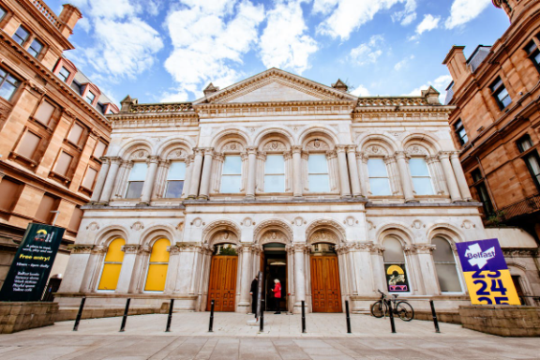 | Bag drop & Information point:  11:00 – 18:00  Welcome reception:  18:00-20:00 | Parking: The venue does not have its own car park the nearest car park is Castle Court Shopping Centre  Access: There is step-free level access at the most accessible entrance. There is seating available  Toilets: There are accessible toilets  Guide/assistance dogs: Guide and assistance dogs are welcome  Quiet spaces: There is a designated quiet sensory room  Water: Free water can be provided

Monday 28th September (Main Conference Day)
Venue | Timings | Accessibility information
Assembly Buildings Conference Centre,  2 – 10 Fisherwick Place,  Belfast, BT1 6DW  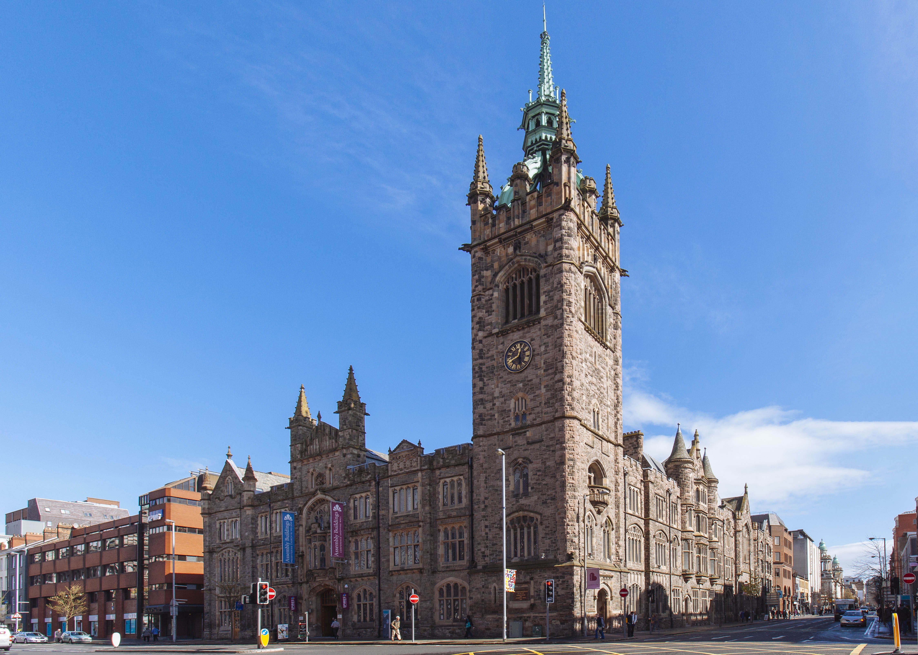 | Plenary & breakout sessions: 8.30 - 17:00  W3W: tennis.hedge.artist | Parking: The venue does not have its own car park. The nearest car park is Value Car Parks and on street parking  Access: There is step-free access via ramp at the most accessible entrance. There is seating available  Toilets: There are accessible toilets in the building  Guide/assistance dogs: Guide and assistant dogs are welcome  Quiet spaces: Meeting Room 1 is booked for this purpose  Water: Free water is available
Belfast City Hall,  Donegall Square, City Centre,  Belfast, BT1 5GS  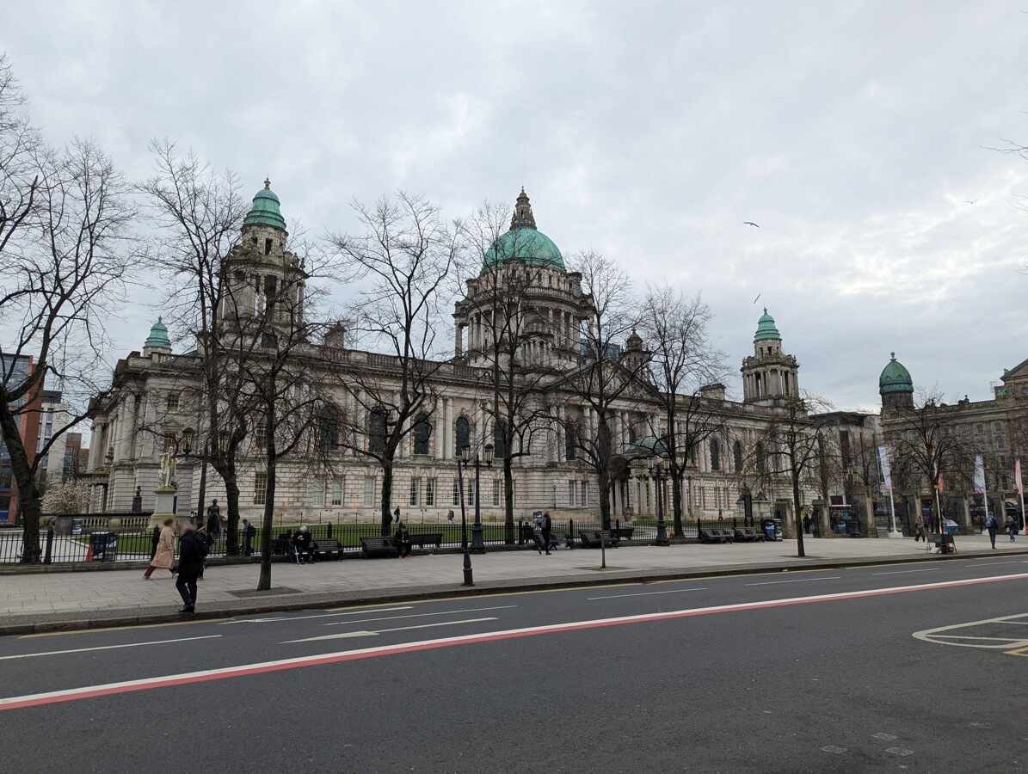 | Conference Dinner: 18:30 - 23:00  W3W: become.robots.worker | Access: There is step-free access, ramp or a lift (made of glass) at each entrance to the building. There is seating available  Toilets: Accessible bathrooms on the ground floor and throughout the building  Guide/assistance dogs: Guide and assistance dogs are allowed inside Belfast City Hall or the grounds  Quiet spaces: Quiet room available on request. Staff completed autism awareness training and are Autism Impact Champion-trained  Payment: Card only  Water: Free water refill station near the Donegall Square East entrance

Tuesday 29th September
Venue | Timings | Accessibility information
Armagh City Hotel,  The Fringe lounge,  2 Friary Rd, Armagh, BT60 4FR  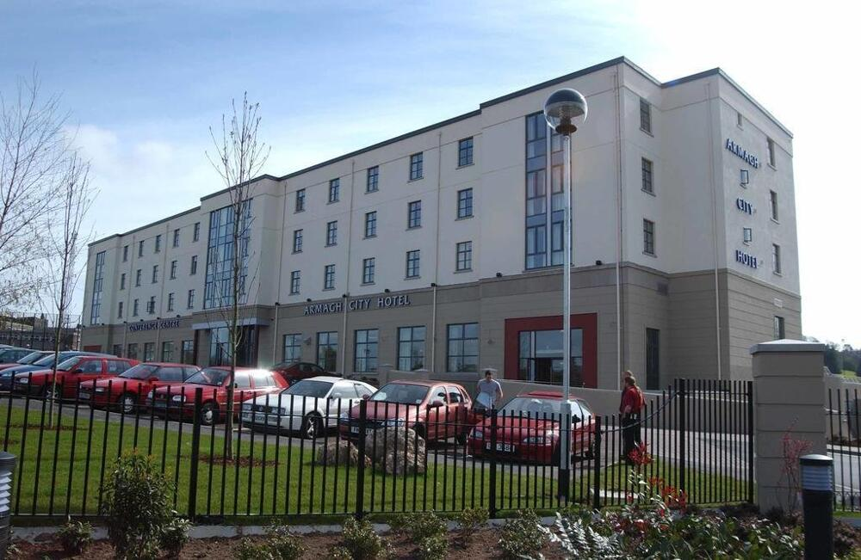 | Farewell lunch: 13:00 – 14:00  W3W: baroness.lamppost.debt | Parking: The venue has its own car park with disabled parking  Access: The main entrance is fully accessible and there are lifts (made of steel and mirrors) inside the building  Toilets: There are accessible toilets on the ground floor  Guide/assistance dogs: Guide and assistant dogs are welcome  Water: Free water can be provided

Tours and visits

Sunday 27th September, Belfast
Time | Venue | Meeting point | Accessibility information
13:00  And  15:30 | Assembly Rooms Belfast  A tour around Belfast’s historic Assembly Rooms, considering its architectural development, its changing relationship with the surrounding streets, and its importance as Belfast’s first civic building. The tour will also examine how the building reflects the city’s growth from a small settlement into a major commercial and industrial centre. | Assembly Rooms, Waring St, BT1 2DX (main entrance)  W3W: sleeps.gross.closet  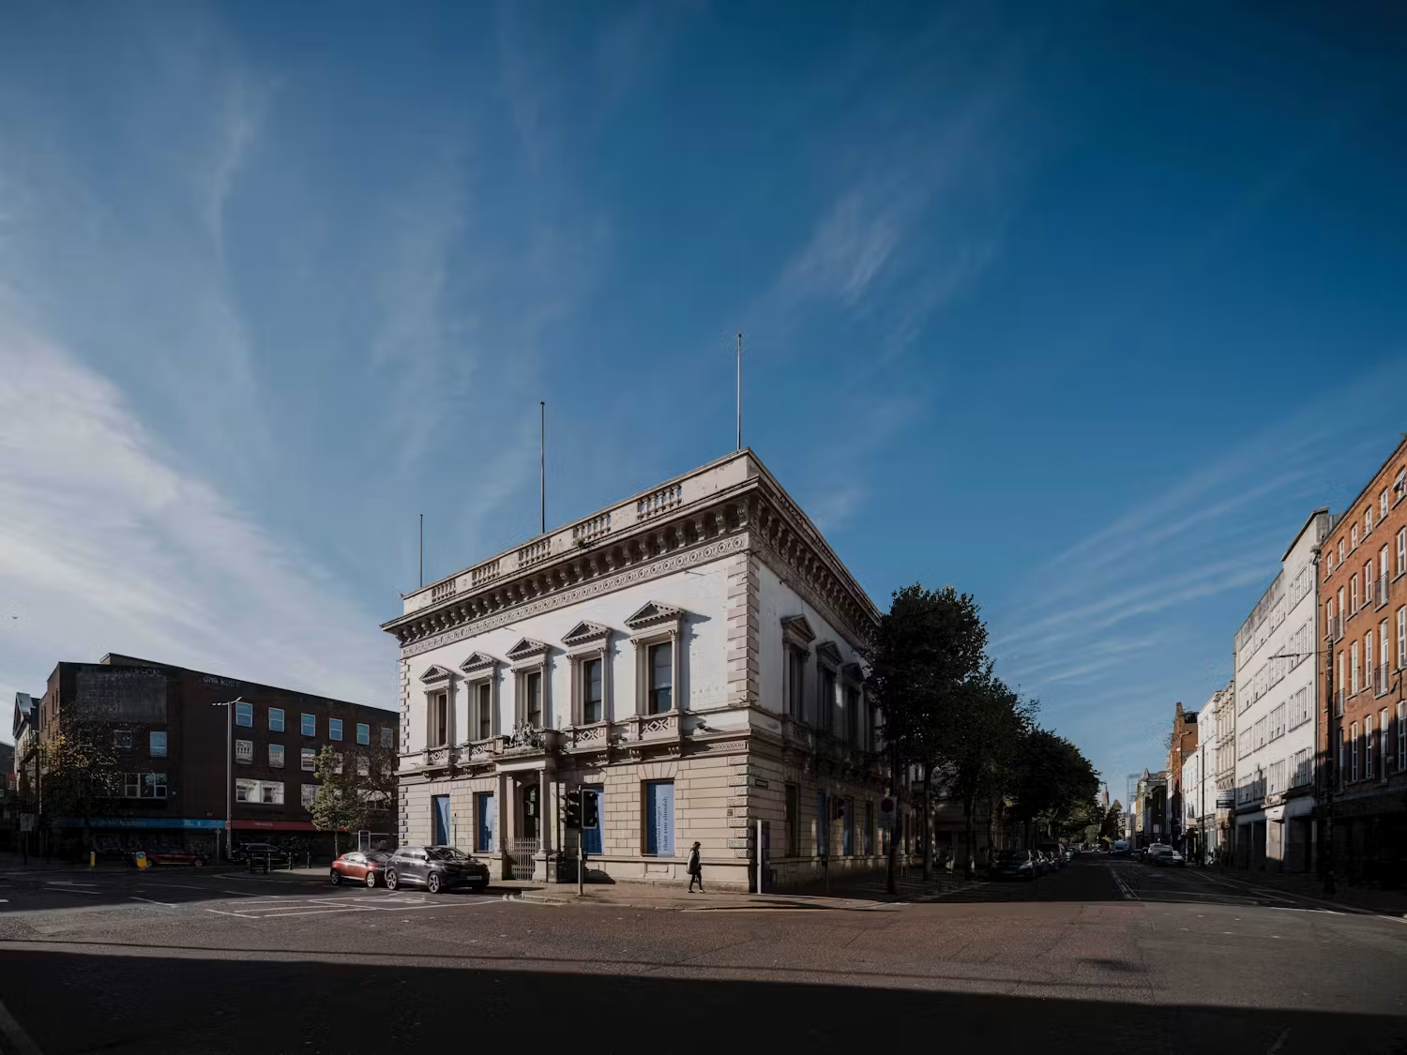 | This tour takes place in a vacant building, there is currently no disabled access  There are no functioning toilets in the building  The closest public toilets are located in Victoria Square Shopping centre - W3W: loans.cycles.bricks  Notes  The tour may involve uneven surfaces, steps and changes in ground level  Participants are advised to wear flat, closed-toe, non-slip footwear, as some areas may include uneven surfaces
13:00 | Belfast City Hall  The tour gives an extraordinary glimpse into areas not usually accessible to the public within the beautiful Baroque Revival building. Ascending the Grand Staircase, an experienced guide will lead you through rooms beginning in the Italian and Greek marble clad Rotunda. | City Hall, Donegal Square S, BT1 5GS (reception, via back gate)  W3W: become.robots.worker | There is a lift (made of glass) which will allow access to the first floor, and there are seating stops at most areas we will look at  Accessible bathrooms on the ground floor and along the tour route  Guide and assistance dogs are welcome  Quiet room available on request. Staff completed autism awareness training and are Autism Impact Champion-trained  Free water refill station near the Donegall Square East entrance  Anyone who cannot self-evacuate must have a Personal Emergency Evacuation plan (PEEP) and this is to be done by the tour organiser. Please email admin@heritagenetwork.org.uk if this applies.
13:00  And  15:30 | Crescent Arts Centre  A full tour of Crescent Arts Centre a grade B listed former school turned multipurpose arts and community hub over four floors. The Crescent has a strong focus on wellbeing, accessibility and sustainability in its activities. | Crescent Arts Centre, 2-4 University Rd, BT7 1NH (reception, ground floor)  W3W: scale.tamed.damage  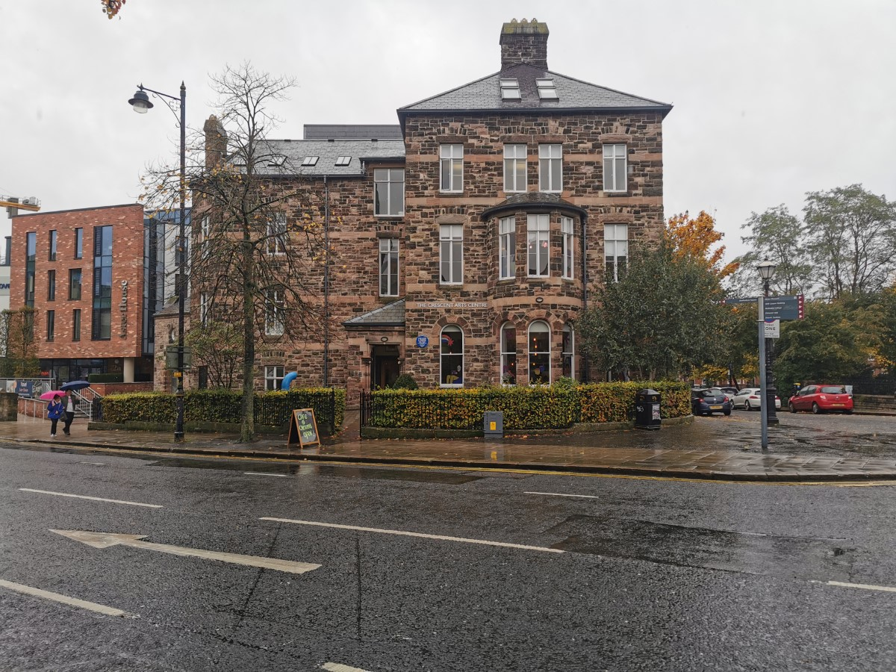 | Parking: Pay-and-display street parking is available nearby on Lower Crescent and Upper Crescent, with a 4-hour maximum stay during office hours. Long-stay car parks are within a 5-minute walk  Access: All areas are accessible by ramps and a lift (made of steel and mirrors). Doors are extra-wide, and most are automated  Toilets: Accessible toilets are available on every floor  Hearing/audio: induction loops are available at reception  Guide/assistance dogs: Assistance dogs are welcome  Quiet spaces can be provided on request
13:00 | Cultúrlann McAdam Ó Fiaich  This tour will bring visitors around the former Broadway Presbyterian Church which is now home to Cultúrlann McAdam Ó Fiaich - the largest Irish Language Centre on the island of Ireland, covering the history of the building and its current use as a community and cultural hub. | Cultúrlann McAdam Ó Fiaich, 216 Falls Rd, BT12 6AH (main entrance)  W3W: dwell.flock.flies  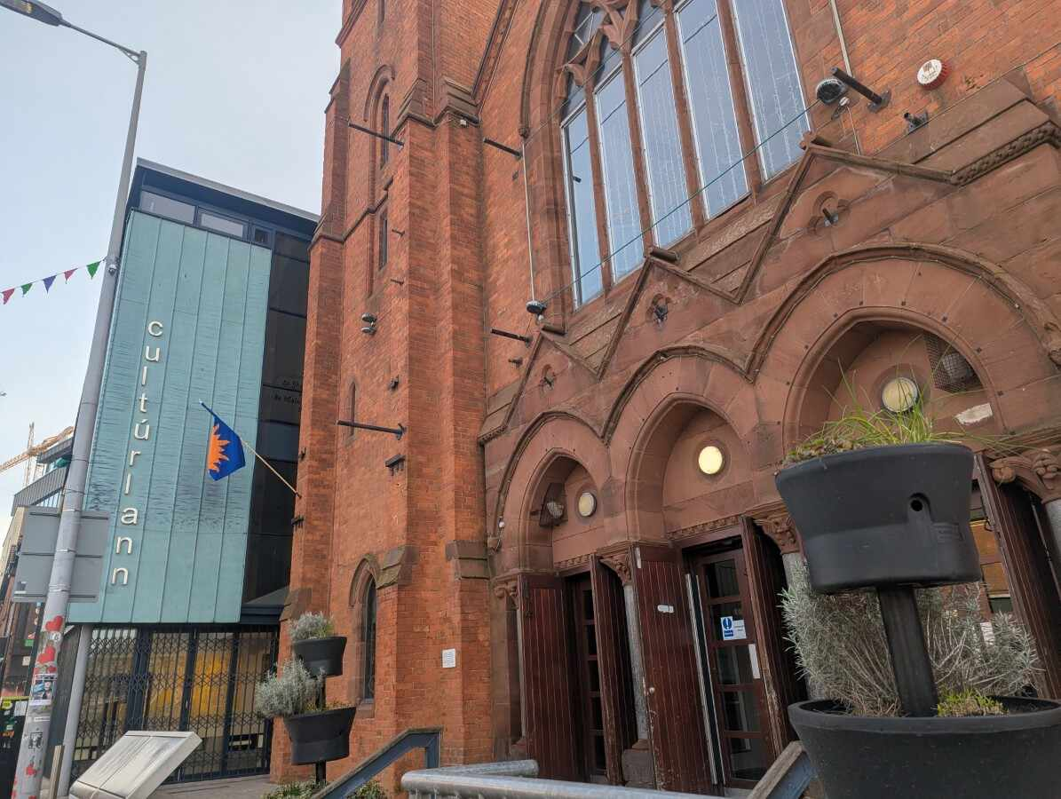 | Parking: No dedicated car park  Access: Ramped and stepped access at the main entrance. There is step-free access throughout most areas  Toilets: There are 2 accessible toilets, one on the ground floor and one on the first floor  Hearing/audio: No hearing assistance system is available  Guide/assistance dogs: Guide and assistance dogs are welcome  Water: There is a restaurant where water can be purchased
13:00 | Explore the North Belfast Heritage Cluster  The North Belfast Heritage Cluster is a partnership of 15 heritage organisations and assets within inner North Belfast focussing on placemaking, regeneration and collaboration. Join us on a tour of some of the area's most historic buildings and hear about their work as part of the heritage cluster. | Belfast cathedral, Donegall St, BT1 2HB (outside main entrance)  W3W: ticket.scare.level  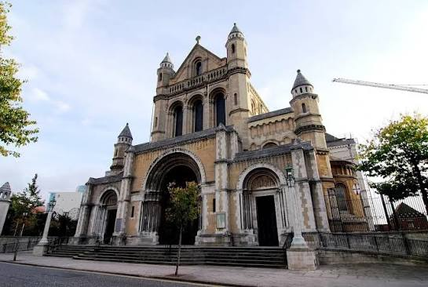 | Toilets: Access to the Cathedral on a Sunday is free and there are facilities inside  The full route is approx. 700 metres  Notes  The tour takes place outdoors and may involve uneven surfaces, steps and changes in ground level.  Participants are advised to wear flat, closed-toe, non-slip footwear, as some areas may include uneven surfaces.
13:00 | Tropical Ravine and Palm House  Join Belfast City Council for a one-hour walking tour of the Victorian glasshouses, the Palm House and the Tropical Ravine at the Belfast Botanic Gardens highlighting the connections between heritage, nature, and wellbeing. | Palm House, Belfast Botanic Gardens, College Park Ave, BT7 1LP  Accessed via the McClay Library entrance at Queen’s University, from College Park Avenue at the top of Botanic Avenue. The  W3W: ideas.cards.pops  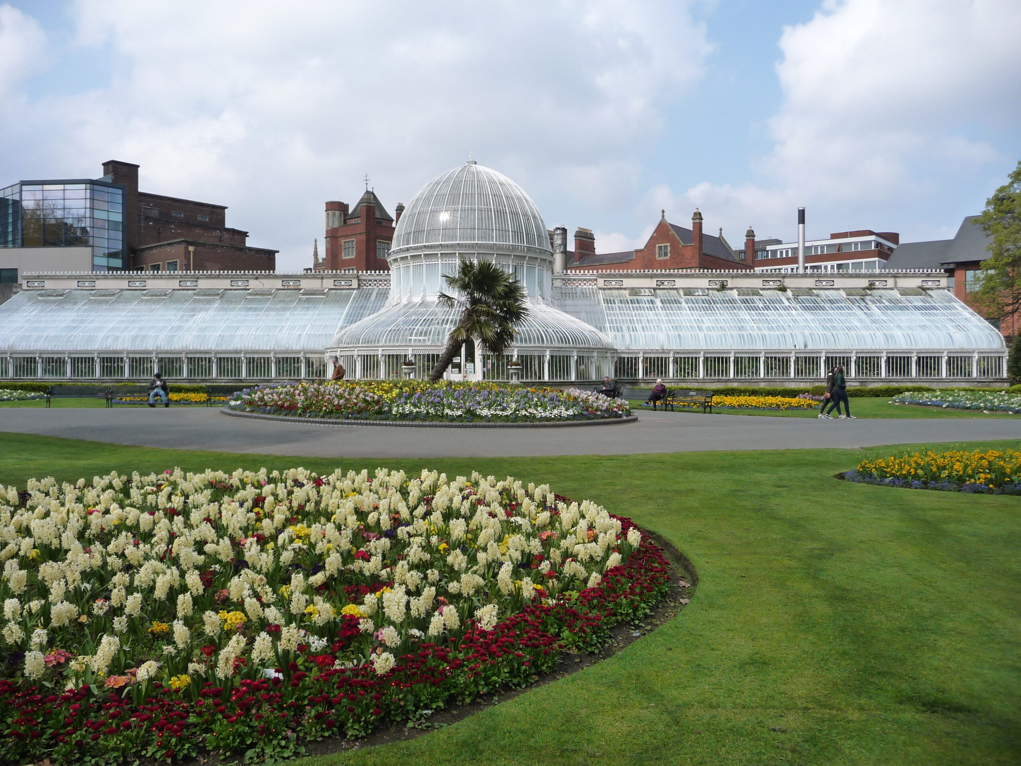 | No dedicated disabled parking spaces at the venue  The Palm House has a step leading into it and the walking tour will be across uneven ground, however there is one wheelchair which can be provided  The Tropical Ravine is wheelchair accessible, with a lift (made of steel and mirrors) providing access between the different levels  Chairs can be available for visitors  There is one accessible toilet within the Tropical Ravine  Guide and assistance dogs are welcome  There is no drinking water provision within the glasshouses. Visitors are advised to bring their own water, particularly because the glasshouses can be considerably hotter and more humid than outdoors.

15:30pm - 18:00 | Belfast Historic Waterfront (ending at 2 Royal Avenue)  Maritime Belfast Trust will lead a guided walking tour across the Belfast Historic Waterfront. Explore the city’s rich maritime past, the Dockside Stories project and the heritage that has shaped this unique destination bringing to life the people, places and industries that helped develop Belfast’s waterfront. | Thompson Dry Dock, Queens Rd, BT3 9AD  W3W: oils.grand.enter  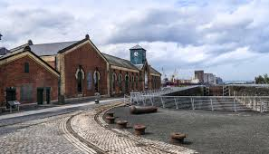 | This tour will be 2 miles long  There are a number of accessible car parking spaces in the surface car parks across Titanic Quarter  There are accessible toilets along the route. These are in visitor attractions and hotels - Titanic Hotel Belfast, Titanic Belfast and The O2 Belfast  There are a number of cafes and shops along the route where water can be purchased  Notes  The tour takes place outdoors and may involve uneven surfaces, steps and changes in ground level.  Participants are advised to wear flat, closed-toe, non-slip footwear, as some areas may include uneven surfaces.
15:30 | Hidden histories of North Belfast  Join us to uncover some hidden histories of North Belfast. On this journey, we will take in the beautiful buildings of St Malachy's College, Carnegie Oldpark Library and the North Belfast Working Men's Club. Expert guides will share stories from the area about a centurion, a ground-breaking physicist, and a robber baron who gave away his fortune. | Clifton House, 2 N Queen St, BT15 1ES (outside main entrance)  W3W; swift.fantastic.boot  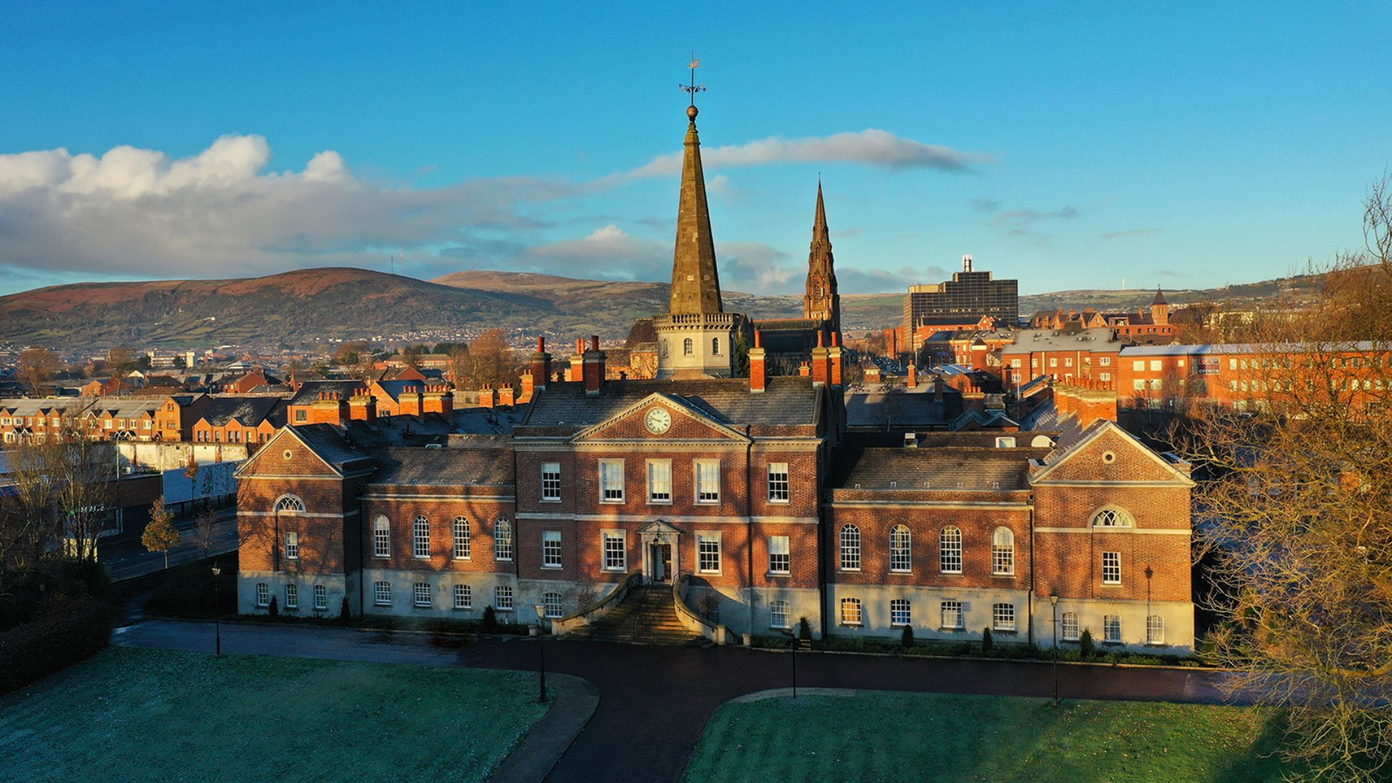 | The tour is approx. 3km in length  Toilets: There will be the opportunity to use Clifton House facilities, however there is no disabled access to the building  Notes  The tour takes place outdoors and may involve uneven surfaces, steps and changes in ground level.  Participants are advised to wear flat, closed-toe, non-slip footwear, as some areas may include uneven surfaces.
15:30 | Riddel's Warehouse  From its days as a bustling warehouse to its developing new role as a vibrant creative hub, this remarkable building has stood witness to the evolution of the city. Join Hearth Historic Buildings Trust for a guided tour and experience the rich history within its walls. | Riddel's Warehouse, 87 Ann St, Belfast BT1 3GH  W3W: begun.galaxy.casual  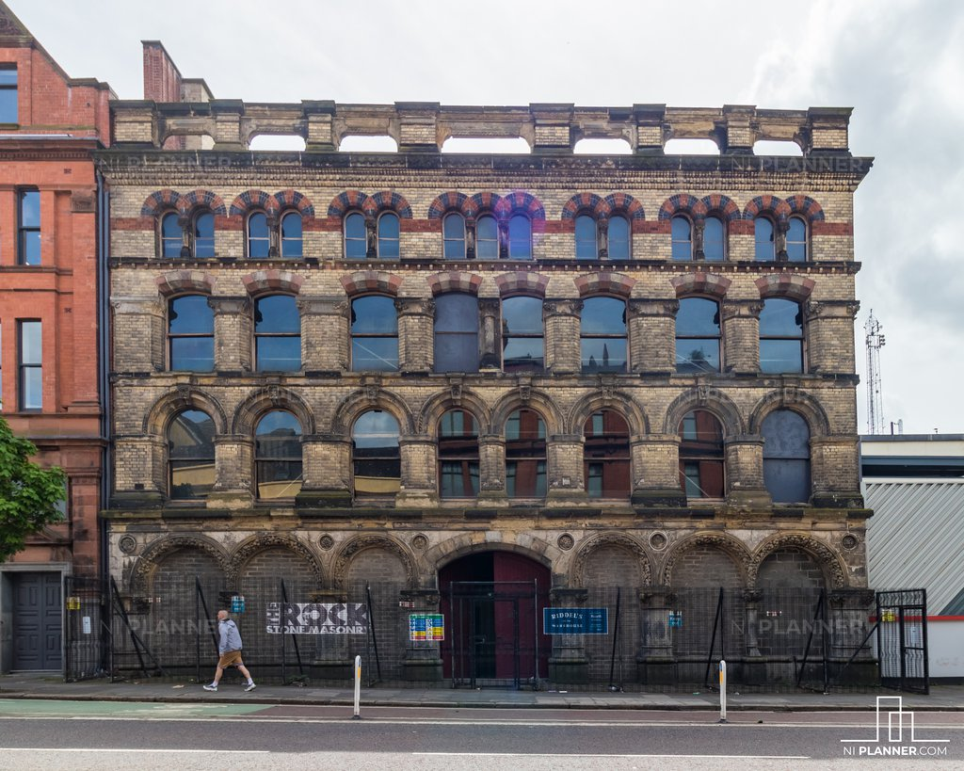 | Riddel's Warehouse is a dis-used Victorian warehouse and consequently there are uneven surfaces and steps to negotiate throughout  Zero step access to the building and ground floor where most of the tour takes place  20 steps to access first floor  5 steps to access second floor  No facilities on site. Attendees are advised to use facilities in the Laganside Bus Station across the street
15:30 | Templemore baths heritage  Learn the history behind the public bath houses of Belfast - from the washers to the swimmers, laundries to the linen, this tour will take visitors through time to learn about the beating heart of Victorian industry. | Templemore Baths, 96 Templemore Ave, Belfast BT5 4FW (Heritage entrance, left through main doors)  W3W: fuels.hears.ramp  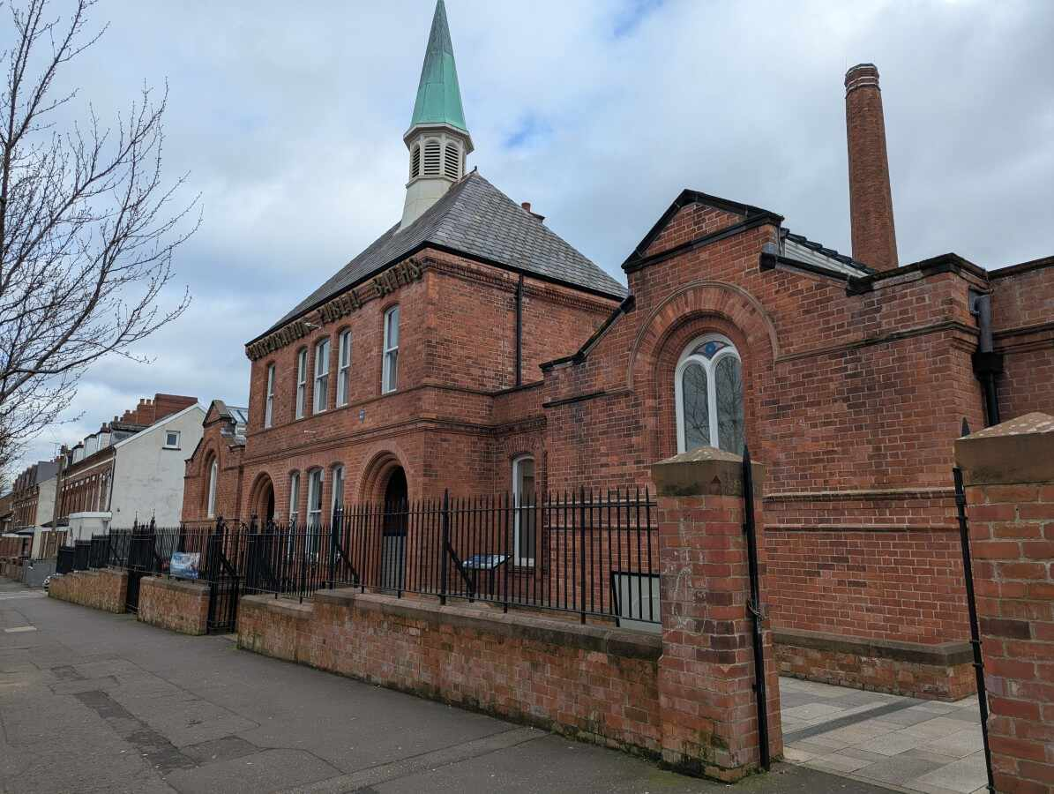 | Three disabled parking spaces  There is a small platform lift available, and the guides have sighted guide training  Three accessible toilets on property with changing facilities  Guide and assistance dogs are welcome  We have a room that can be used as a quiet area for guests  There is a water refill station located in the changing rooms of the gym

Tuesday morning 29th September, Armagh

Time | Venue | Meeting point | Accessibility information
09:00 – 13:00 | Armagh city's heritage  Discover the rich architectural story of Armagh on this guided walking tour through some of the city’s recently restored buildings. This tour highlights how a carefully planned cluster of conservation projects has revitalised and strengthened the character of this historic area through the Armagh Townscape Heritage Scheme. | Coach A  Pickup Donegal Square West  W3W: racing.tasty.yard | This tour involves walking approximately 2km  Including some inclines and downhill sections. A small number of sites include up to three or four flights of stairs (not consecutive)  Accessible public toilets are available at the pick-up point, on the ground floor of Belfast City Hall within the square  Notes  The tour takes place outdoors and may involve uneven surfaces, steps and changes in ground level.  Participants are advised to wear flat, closed-toe, non-slip footwear, as some areas may include uneven surfaces.
09:00 – 13:00 | Dan Winter’s cottage: Mud walls of memories  This tour will include a history of Dan Winter's cottage, its connections to the Battle of the Diamond, and to the weaving and linen industry. Delegates will see demonstrations of a 300-year-old weaving loom and spinning wheels. Tour guide Colin will have stories of his life growing up here as he was reared in the cottage, he will also be able to explain plans for a community hall on site. | Coach B  Pickup Donegal Square West  W3W: racing.tasty.yard  rebounder.thinking.inherits  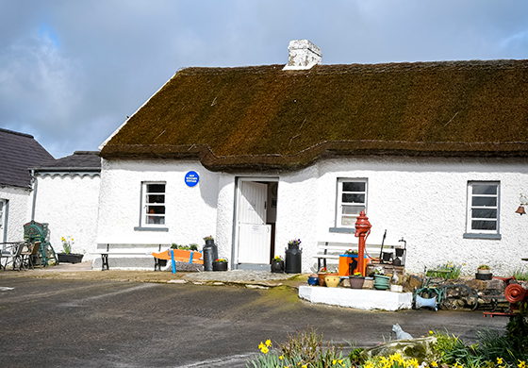 | There is a ramp for use if wheelchair access is required as there is a step to the entrance of the cottage  There are toilets on site, one with disabled access
09:00 – 13:00 | Loughgall: Reviving a plantation village  Join the Loughgall and District Improvement Association for a walking tour of Loughgall village showcasing the built, cultural and natural heritage of the area, and highlighting the association's plans and ambitions for the regeneration of the area. | Coach C  Pickup Donegal Square West  W3W: racing.tasty.yard  clocks.evolves.chuckling  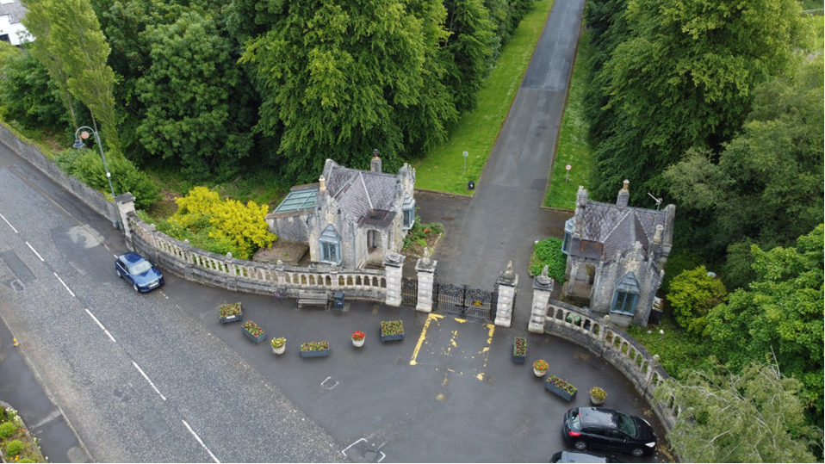 | The tour takes place outdoors and may involve uneven surfaces, steps and changes in ground level  Participants are advised to wear flat, closed-toe, non-slip footwear, as some areas may include uneven surfaces  Accessible public toilets are available on the ground floor of Belfast City Hall within the square  Public toilets including one accessible toilet will be available in Loughgall village for delegates to use
09:00– 13:00 | Lurgan’s restored townscape  Join the Lurgan Townscape Heritage team for a guided walk through the heart of Lurgan. This tour will showcase the stunning results of recent heritage restoration projects, which have transformed once derelict and underused buildings into vibrant, revitalised spaces. Discover the fascinating history of the town and see first-hand how valuing historic architecture can help create a better place to live, work, visit, and invest. | Coach D  Pickup Donegal Square West  W3W: racing.tasty.yard  blur.tinsel.topped  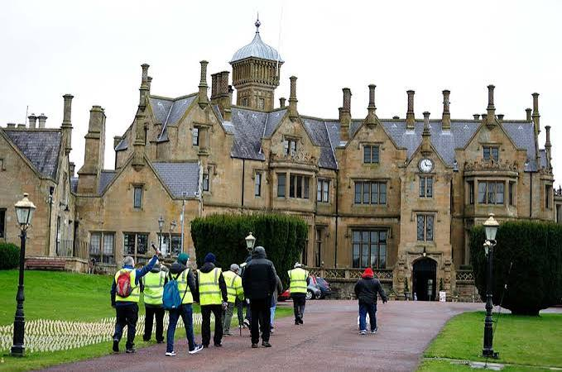 | The tour consists of approximately 1 ½ mile circuit around the town  The walking route primarily follows town centre pavements with gentle gradients and occasional sloping inclines  Notes  The tour takes place outdoors and may involve uneven surfaces, steps and changes in ground level.  Participants are advised to wear flat, closed-toe, non-slip footwear, as some areas may include uneven surfaces.
09:00 – 13:00 | Rural heritage development in Rathfriland  A guided tour of the rural village with Rathfriland Regeneration group, including their Chandler's House project which was selected as part of the Village Catalyst pilot program allowing development of the building into a multipurpose community space. | Coach E  Pickup Donegal Square West  W3W: racing.tasty.yard  senders.incur.manly  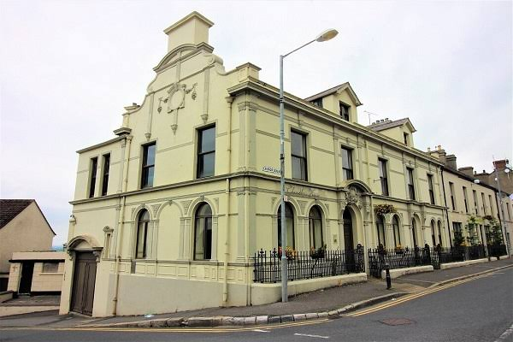 | This venue is fully accessible with flat level access  Disabled toilet available at the venue

Tuesday afternoon 29th September, Armagh

Time | Venue | Meeting point | Accessibility information
14:00 – 15:30 | Armagh city's heritage  Discover the rich architectural story of Armagh on this guided walking tour through some of the city’s recently restored buildings. As part of the Armagh Townscape Heritage Scheme, this tour highlights how a carefully planned cluster of conservation projects has revitalised and strengthened the character of this historic area. | Armagh City Hotel,  The Fringe lounge,  2 Friary Rd, Armagh, BT60 4FR  W3W: baroness.lamppost.debt | This tour involves walking approximately 2km  Including some inclines and downhill sections. A small number of sites include up to three or four flights of stairs (not consecutive)  Accessible public toilets are available at the pick up point, on the ground floor of Belfast City Hall within the square  Notes  The tour takes place outdoors and may involve uneven surfaces, steps and changes in ground level.  Participants are advised to wear flat, closed-toe, non-slip footwear, as some areas may include uneven surfaces.
14:00 – 15:30 | Armagh Observatory and Planetarium: Past, present & future  Join the staff of Armagh Observatory and Planetarium for a behind the scenes look in their historic Observatory. Learn about its unique history, and how a Georgian building handles modern crowds. Finally, discover its bold plans for the future and how this will impact not just Armagh and Northern Ireland, but the astronomy community on an international level. | Armagh City Hotel,  The Fringe lounge,  2 Friary Rd, Armagh, BT60 4FR  W3W: baroness.lamppost.debt  seating.captions.hacking  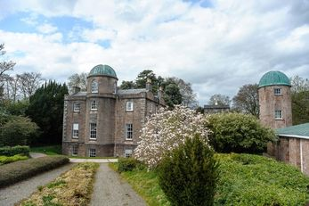 | There is a toilet in the Planetarium facility  Water can be bought at the Planetarium Café  Planetarium facility equipped with a lift  Observatory facility does not have a lift  Both the Planetarium and the Observatory will have spaces available for quiet areas
14:00 – 15:30 | Shaping Heritage Together: Communities at the heart of place [Workshop] Sarah Cargill, Regeneration Officer  A workshop looking at the place-based approach that places communities at the heart of heritage decision-making, co-designing a Borough-wide Heritage Strategy, reflecting local aspirations and identity, and fostering long-term stewardship of built, natural, and cultural heritage assets for future generations. | Armagh City Hotel,  The Fringe lounge,  2 Friary Rd, Armagh, BT60 4FR  W3W: baroness.lamppost.debt | The main entrance is fully accessible and there are lifts (made of steel and mirrors) inside the building  There are accessible toilets on the ground floor  Guide and assistant dogs are welcome  Free water can be provided  There is a portable induction loop at this venue
14:00 – 15:30 | St Patrick's cathedrals  As you approach Armagh, you will notice its most distinctive landmarks right away. From opposite hills, two striking cathedrals face each other across a valley, both honouring St Patrick (St Patrick's Roman Catholic cathedral and St Patrick's Church of Ireland cathedral). This tour will include a short, guided visit to each of these cathedrals, setting off from Armagh City Hotel to St Patrick's Church of Ireland cathedral before heading to St Patrick's Roman Catholic cathedral. | Armagh City Hotel,  The Fringe lounge,  2 Friary Rd, Armagh, BT60 4FR  W3W: baroness.lamppost.debt  aura.violinist.building  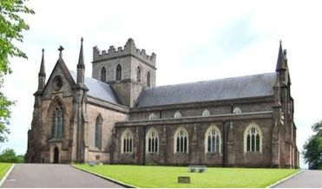 | St Patrick's Roman Catholic cathedral:  Access: The main entrance is fully accessible. Most of the Cathedral is accessible, with ramps available for wheelchair users  Toilets: Toilets are available at Music Hall, 9 Vicars’ Hill, a short distance from the Cathedral's main entrance  Hearing/audio: A hearing loop system is available  St Patrick's Church of Ireland cathedral:  Access: Disabled access is provided  Toilets: Disabled toilet facilities are available at St Malachy’s Church, near the front porch
14:00 – 15:30 | Whaley's Buildings  A tour around and discussion of Whaley's Buildings, 11 houses restored by the Hearth Historic Buildings Trust in the 1990s following dereliction and bomb damage. The rescue of these buildings was a catalyst for further heritage regeneration in Armagh. | Armagh City Hotel,  The Fringe lounge,  2 Friary Rd, Armagh, BT60 4FR  W3W: baroness.lamppost.debt  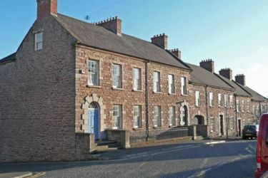 | This tour may encounter some steps, but alternate routes can be found is required  Notes  The tour takes place outdoors and may involve uneven surfaces, steps and changes in ground level.  Participants are advised to wear flat, closed-toe, non-slip footwear, as some areas may include uneven surfaces.

