

Dementia Friendly Activity Guide

In this Guide
Contents
Dementia Friendly Activity Guide 1
In this Guide 1
Introduction 3
Tips for Running a Dementia-Friendly Activity 3
Activity 1: Tile prints 4
Summary 4
Materials and Preparation 4
Archaeological Background 4
Conversation Prompts 4
Activity Resources 5
Make Your Own Tile Prints 8
Activity 2: Stained-Glass 9
Summary 9
Materials and Preparation 9
Archaeological Background 9
Conversation Prompts 9
Activity Resources 10
Make Your Own Stained-Glass 15
Activity 3: Iron Age Pottery Making 16
Summary 16
Material and Preparation 16
Archaeological Background 16
Conversation Prompts 17
Activity Resources 18
Make Your Own Iron Age Pot 22
Activity 4: Weaving 23
Summary 23
Materials and Preparation 23
Archaeological Background 23
Conversation Prompts 23
Activity Resources 24
Weaving Your Own Baskets 26
Activity 5: Roman Mosaic Making 27
Summary 27
Materials and Preparation 27
Archaeological Background 27
Conversation Prompts 28
Activity Resources 28
Make Your Own Roman Mosaic 30

Introduction
Welcome to Canterbury Archaeological Trust’s Dementia-Friendly Activity Guide.
This guide is designed to help people living with dementia explore and enjoy archaeology, heritage, and history in fun and creative ways. But these activities aren’t just for those with dementia — anyone can take part and enjoy them.
You can do all the activities at home or in a group setting. Some may need a few materials, but many use everyday items you might already have around the house. Feel free to use these ideas as a starting point — we encourage you to get creative and come up with your own versions too.

Tips for Running a Dementia-Friendly Activity
When you're leading an activity, it's important to make sure everyone feels comfortable and relaxed. Try to create a calm and welcoming space and give yourself plenty of time to enjoy the experience together — there's no need to rush or set a strict deadline.
Start by looking at the pictures and using the prompts to spark a conversation about life in the past. It can help if you begin talking first. Sometimes, the person you're with might start chatting about things that seem unrelated — and that's okay! These personal stories are valuable and may connect in unexpected ways. Let them share freely and enjoy the moment by listening actively.
Try to avoid saying things like “Do you remember when…” or correcting them, as this can be upsetting. Instead, you can share your own memories by saying “I remember when…” — this can be a gentle and helpful way to connect. Take a look at our downloadable conversation prompts for more ideas.
When you're ready to begin the activity, take it step by step. Don’t give all the instructions at once. It can be helpful to do the task alongside them, showing each stage as you go. Speak clearly and demonstrate what to do. If they ask for instructions to be repeated, that’s perfectly fine — just keep showing and explaining patiently. Your calm and supportive approach will make the experience more enjoyable for everyone.

Activity 1: Tile prints

Summary
This activity involves making impressions in clay, plasticene or other mouldable material. You can use anything you like to impress a shape or pattern into your tile. This session can be adapted depending on the size of the group you are working with and what they enjoy doing.

Materials and Preparation
We recommend using air drying clay for this activity. The link below provides information for a possible supplier. You can also use plasticene or other mouldable materials.
https://www.cowlingandwilcox.com/modelling-clay/32401-scola-air-drying-clay-45kg?gad_source=1&gad_campaignid=16440658483&gbraid=0AAAAAD-2ndl9IFxK4B_7s7xGOxWEDYxR0&gclid=CjwKCAjw6P3GBhBVEiwAJPjmLiwRbZkdDZXTR_ouNdfCohH6SihTt6d9W5C0JVLD1YWCyX7gUR-KxBoCksIQAvD_BwE
It is best to shape your tiles before you start the activity. You can do this using a rolling pin or a glass bottle. Use a cookie cutter or blunt knife to cut a shape out of the rolled and flattened clay. A square of approximately 15x15cm is a good size.
To make impressions in the clay, you can use any textured object, such as leaves or string. You may want to also provide cling film to add a layer between the object and the clay.

Archaeological Background
Ceramic tiles were very important objects in the past and were used from the Roman period onwards. They were used for floors and for roofs and were often made in bulk for building work. You can see from this recreated image of Folkestone Roman Villa that there were a lot of tiles used in the construction of the building. (figure 1). When tiles were made, they were often left out in the open to dry after being formed into the right shape (figure 2). When left out to dry, people or animals might walk over them and leave imprints in the wet clay (figure 3).
People making tiles would also sometimes make marks in the tiles using their hands or a stamp, and these marks would correspond to a particular person or workshop, like a maker’s mark (figure 4).
Archaeologists often find these tiles, and the footprints and other marks can tell us a bit about how people were living in the past. For example, we can identify the animals that were living nearby and the number of different workshops that were making tiles in a particular area.
Decorated tiles were also sometimes made by pressing objects into the tile when it was wet (figure 5). The objects that people used to do this were usually textured, such as string, and would leave lovely patterns on the surface of the tile.

Conversation Prompts
What do you think these tiles were used for?
What can you see in the tile?
Can you identify who or what made the mark?
If you were to recreate the mark on the tile, how would you do it?

Activity Resources
Figure 1: Folkestone Roman Villa showing the large number of roof tiles that would have been used to build it.
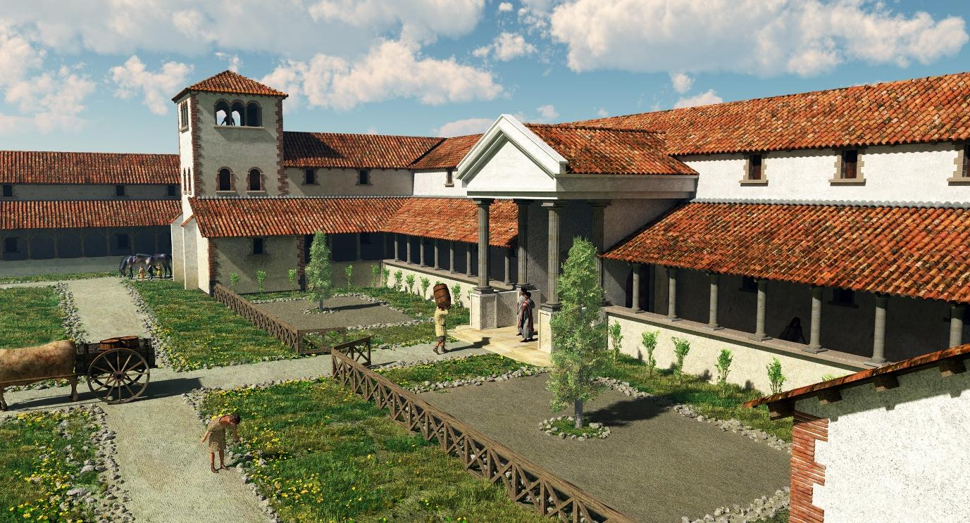

Figure 2: Tiles that have been left out to dry in the open, where sometimes animals or people walk over them.
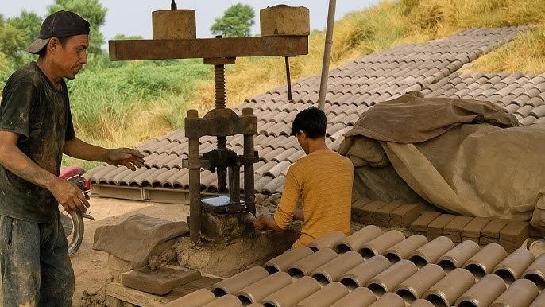
Figure 3: Imprints on Roman tiles, like some of those found at East Wear Bay in Folkestone. The top image shows a human footprint, the second shows a cat pawprint, the third shows a dog pawprint.
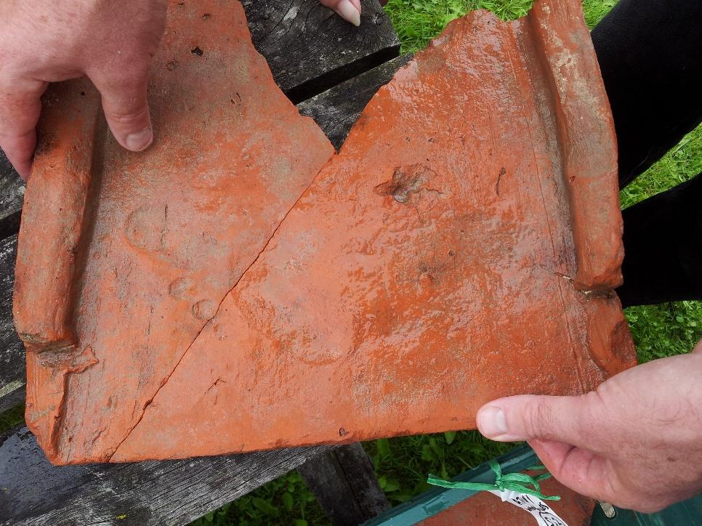
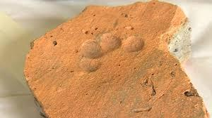

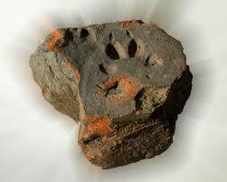

Figure 4: Roman tile stamped with the symbol for the Classis Britannica found at Folkestone. This is the official stamp for the Roman navy.
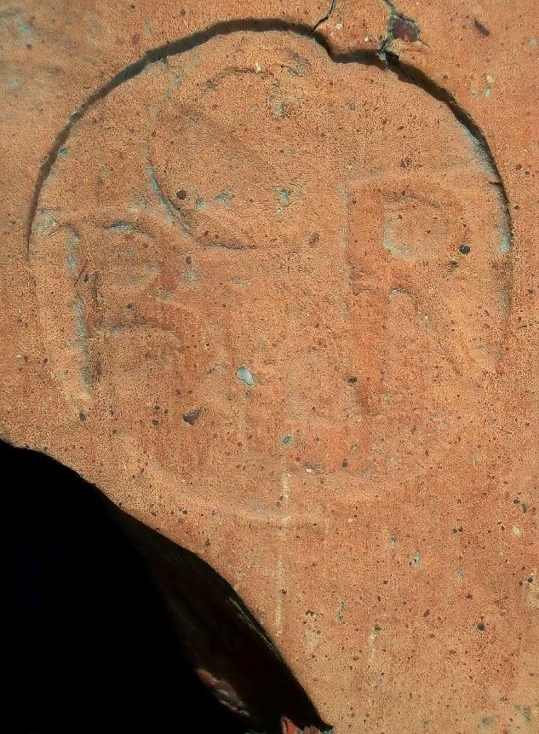

Figure 5: Medieval tiles decorated using an impressed or stamped design.
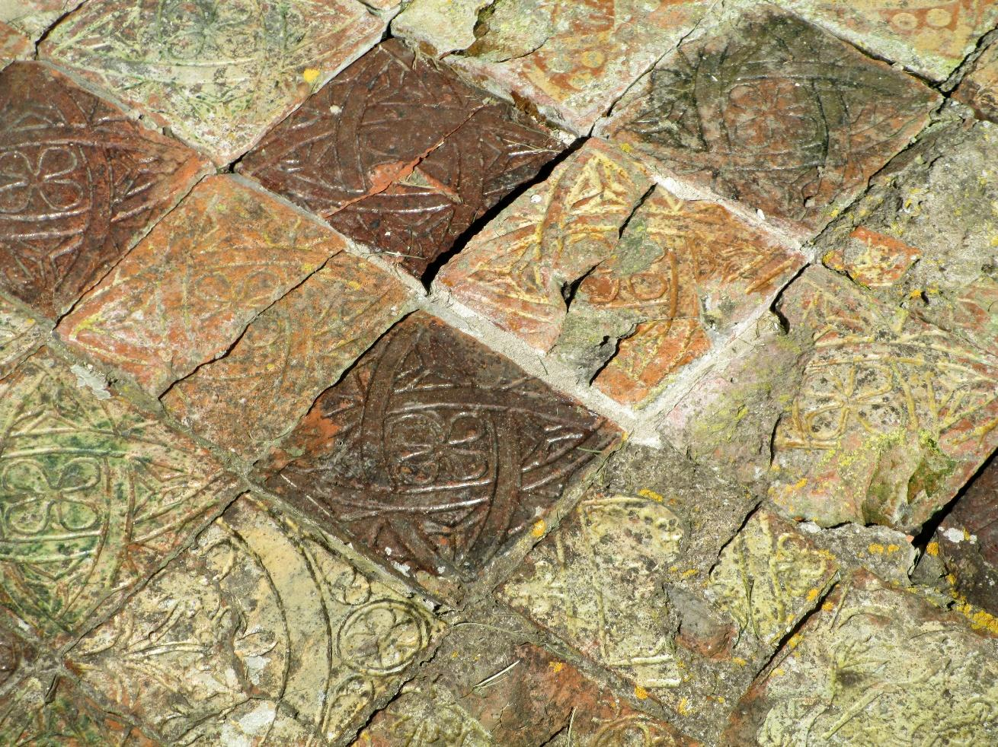

Make Your Own Tile Prints
Using the pre-cut tiles you prepared, hand out a tile to each participant. Leave different items on the table that can be used to make an impression in the clay and encourage the participants to experiment with them. They can also use their fingers or the edges of different objects to make marks in the clay.
You may wish to add a layer of cling film over the top of the clay tile so that objects do not get covered in clay. This should be removed at the end of the activity and can be done as a final ‘reveal’.
Encourage participants to make patterns or create an image. Do they want to sign their name or create their own makers mark?
What objects have they used to make their impressions and why have they chosen them?
What else could you use to make a design or interesting impression?
Do any of the designs relate to the participants in a personal way?
Once you have completed your tiles, they will need to be left to dry overnight. It is possible to then paint your tiles and/or to glaze them as part of a follow-up session. If you can, find a way to display them and to talk about what everyone has created with pride.

Activity 2: Stained-Glass

Summary
This activity involves making your own stained-glass window decorations using a craft kit. You can create your own kit using low-cost craft materials. This session can be adapted depending on the size of the group you are working with and what they enjoy doing.

Materials and Preparation
We recommend using pre-prepared craft kits for this activity like these supplied by Baker Ross:
https://www.bakerross.co.uk/leaf-stained-glass-decoration-kits
There are a wide range of differently themed kits available, and you can choose one to suit the season or time of year.
If you prefer, you can make your own kits using card, a craft knife, glue and brightly coloured tissue paper. We recommend that you prepare the card designs in advance and use non-toxic glue, such as PVA.

Archaeological Background
Stained-glass windows were a dazzling highlight of European architecture between 1150 and 1550, especially in cathedrals, churches, and grand homes (figure 1). These colourful creations, made from painted glass pieces joined by lead strips, weren’t just beautiful—they transformed spaces with shimmering light that changed throughout the day and seasons, adding a magical touch to religious settings (figure 2).
Our understanding of how these windows were made comes largely from a 12th-century guide called On the Various Arts, written by a German monk known as Theophilus. Surprisingly, the basic techniques he described are still used today.
To make glass, artisans combined sand and ash, heating them until they melted into a gooey substance that hardened into glass when cooled. From around the year 1000, they used ash from woodlands, which made strong but sometimes weather-sensitive glass. Because of this, stained-glass windows often needed repairs and rarely survive in perfect condition (figure 3).
Creating a window started with a detailed design called a vidimus—Latin for “we have seen.” Before paper was common, artists sketched their plans on chalk-covered tables, marking colours and outlines to guide the cutting and painting process (figure 4).
Glass cutting was a skilled art. In medieval times, heated irons and ‘grozing’ tools helped shape the pieces. By the 16th century, diamond cutters made the job easier and more precise (figure 5).

Conversation Prompts
What colours can you see in these images of stained-glass window?
What images are being depicted?
Why do you think medieval people chose these designs?
What is your favourite of these designs?
Why is it your favourite?
Have you seen stained-glass in person before?
Where did you go to see it?
How did it make you feel?

Activity Resources
Figure 1: Stained-glass window at Canterbury Cathedral (top left), at Elizabeth House Museum in Great Yarmouth (bottom), and at Hever castle in Kent (top right).
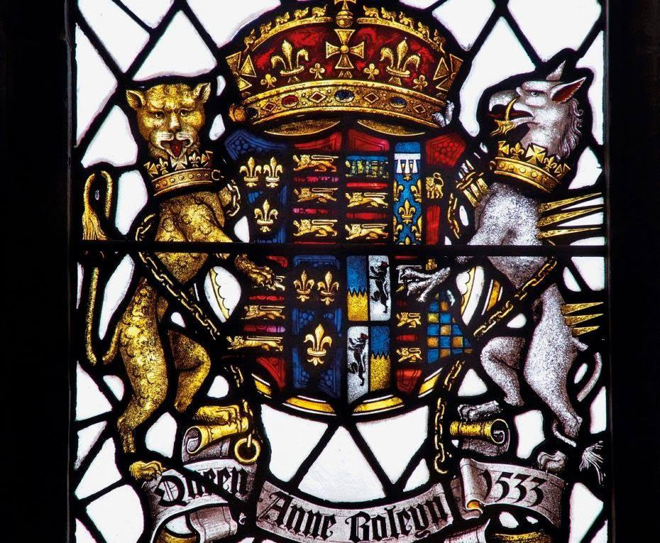
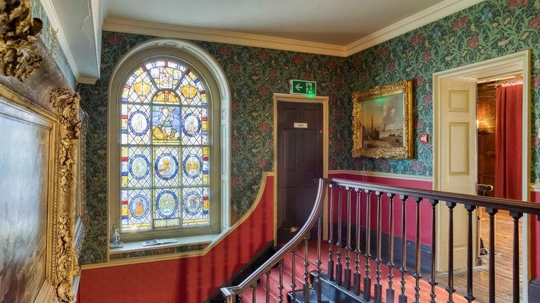
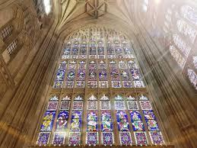

Figure 2: Stained-glass window from Church of St Peter and St Paul, Tonbridge, Kent

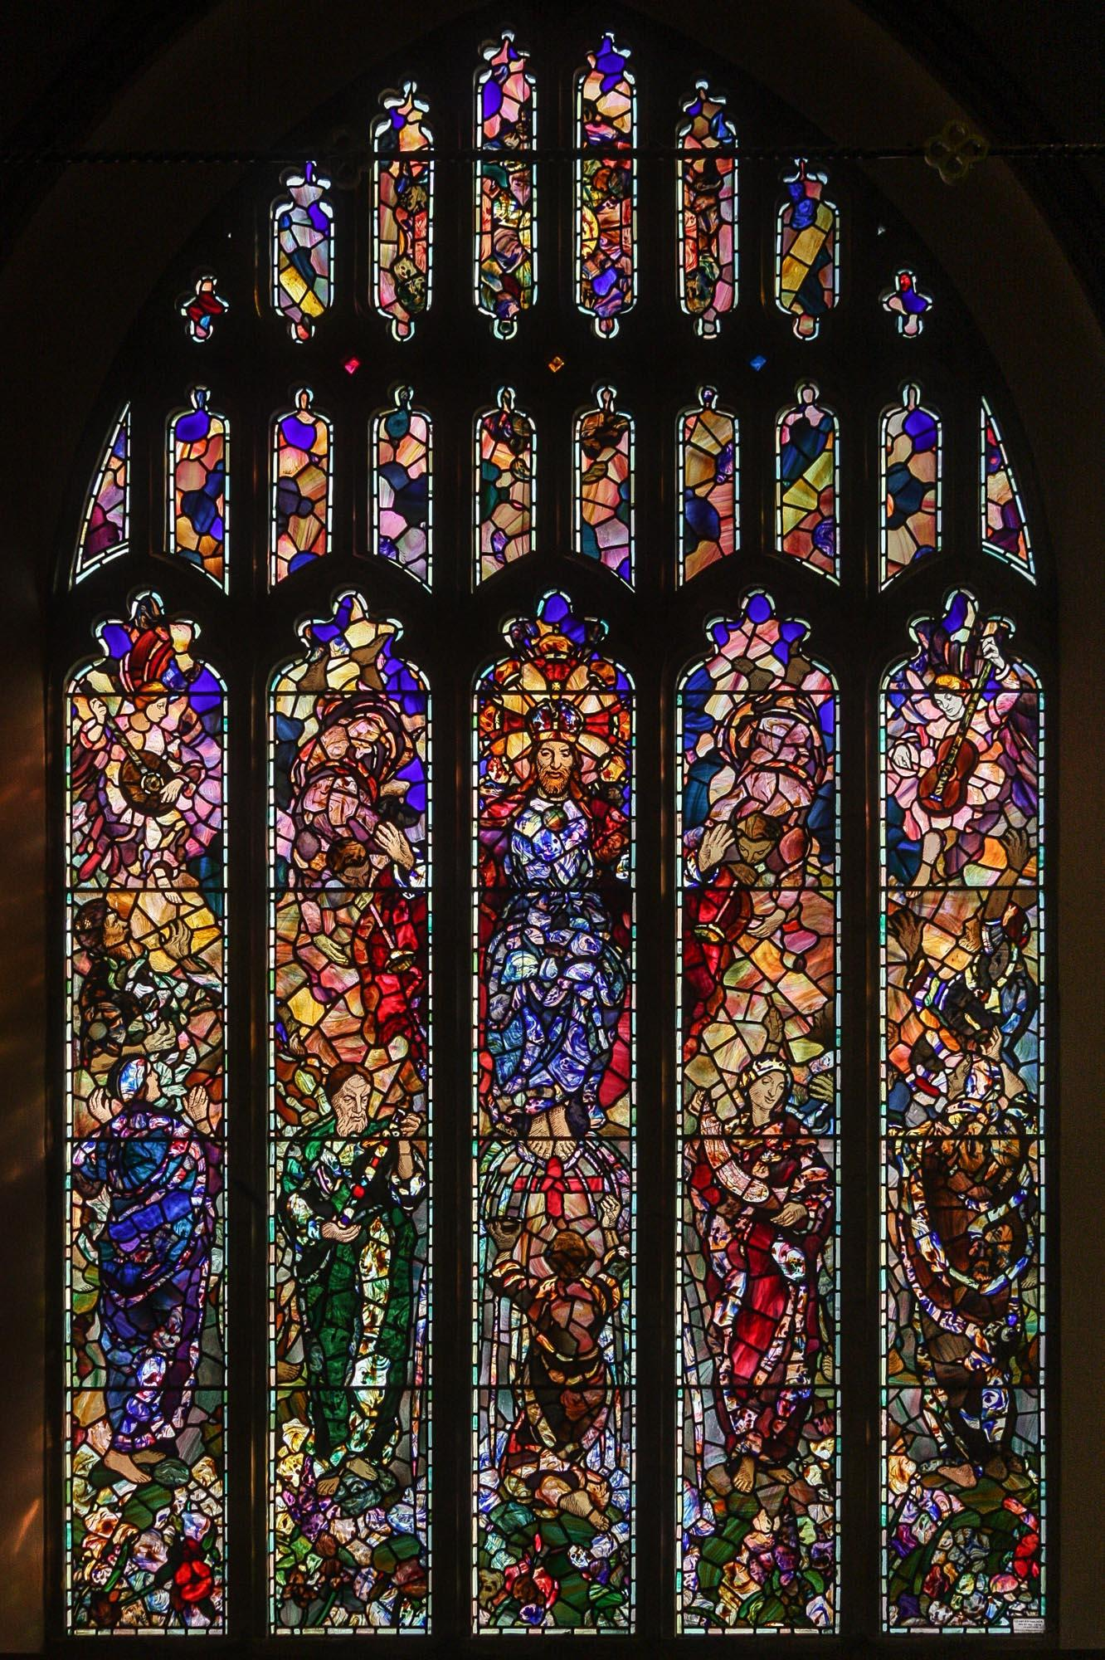

Figure 3: Fragment of stained-glass depicting the Virgin Mary that was found as part of the Canterbury Whitefriars excavation.
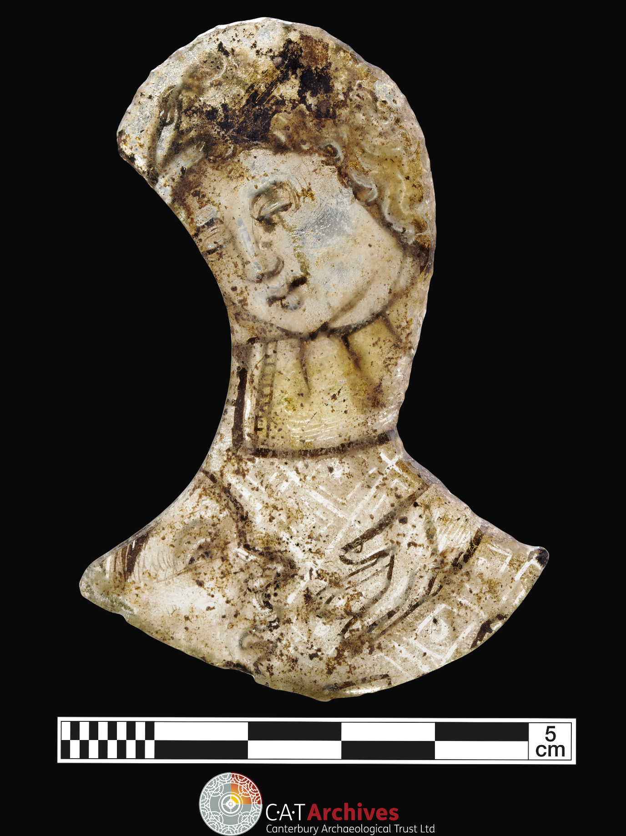

Figure 4: Design for a stained-glass window for the Convent of Hohenberg (Odilienberg), by Hans Baldung Grien, about 1508, Germany. Museum no D.199-1888. © Victoria and Albert Museum, London
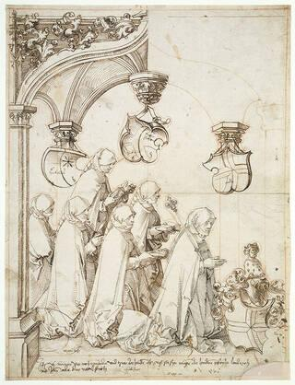

Figure 5: Images showing how stained-glass is made.
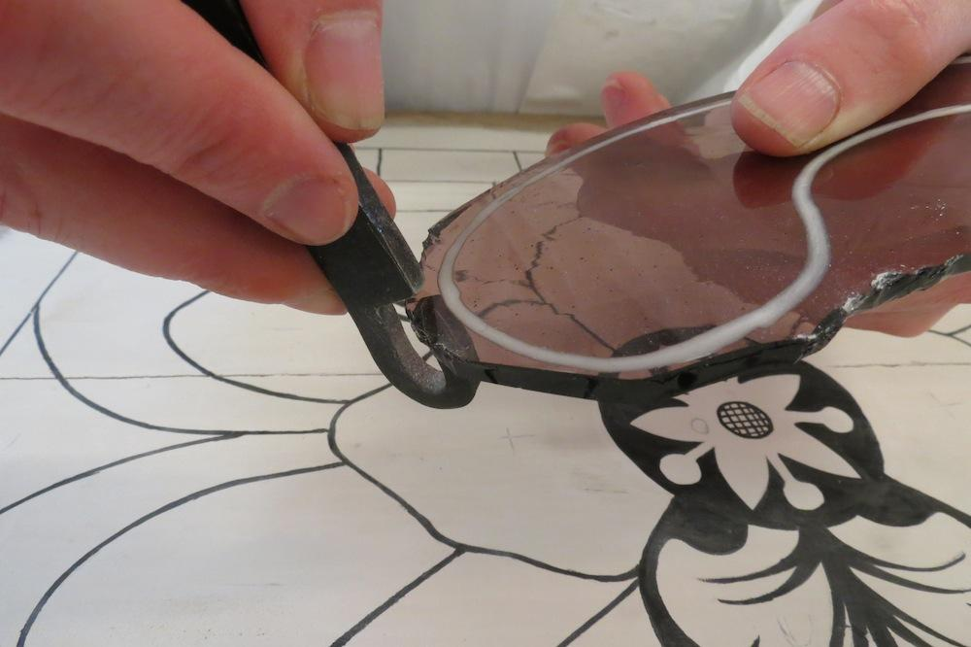
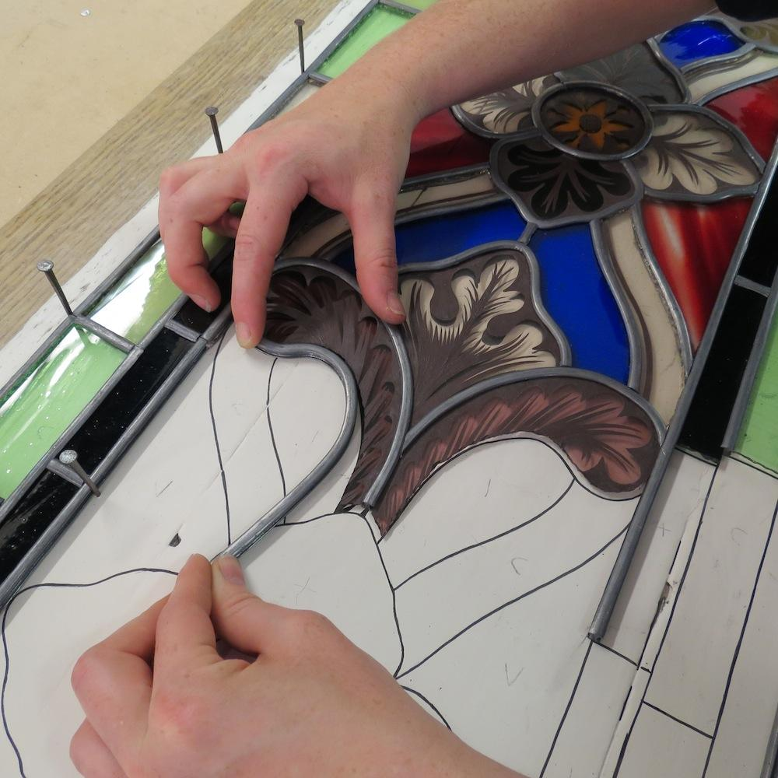

Make Your Own Stained-Glass
- Take two matching copies of the stained-glass design you want to work with that are made from card. Add glue to one side of one of the designs.
- Using the film or tissue paper, cut out the shapes you want to use fill in the gaps of the design.
- Stick the film or tissue paper down in the area you want and repeat until all the gaps have been filled.
- Using the second copy of the stained-glass design, add glue and stick it over the top of the film or tissue paper so that both sides show the design outline and filled panels.
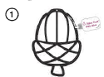
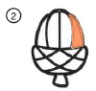
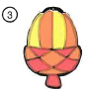
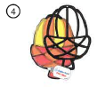
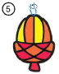
- Use string or ribbon to suspend your design so it can be hung in a window.

What colours have they have chosen to use in their design and why?
What design have they chosen to work with?
Is this design relevant to them at all?
Are they making their stained-glass for a gift?
Who are they making it for?

Activity 3: Iron Age Pottery Making

Summary
This activity involves making and decorating pottery using the same methods that people in the Iron Age were using in Britain. It can take a while to undertake this session, so leave plenty of time to do each of the stages involved and for clearing up afterwards. As there are multiple stages involved, you may wish to go through each stage one at a time so that everyone is following along at the same time. This session can be adapted to suit the size of your group and what they would like to do.

Material and Preparation
We recommend that you use air drying clay like that used in the tile making activity. Baker Ross also supplies this in smaller volumes for smaller groups:
https://www.bakerross.co.uk/white-air-drying-clay-1
It is a good idea to pre-portion your clay before the start of the session and to distribute a ball of clay to each participant once you get started. It is worth noting that some people might prefer to wear gloves and supplying these to your participants might make them more likely to want to get involved.
You should also provide some clay decorating tools like these from baker Ross:
https://www.bakerross.co.uk/plastic-modelling-tools
However, you can make use of everyday household objects for this, such as a blunt knife, string for making imprints in the clay, or teaspoons.
You may want to set out plastic tablecloths on the work surfaces you will use, though the clay will clean off fairly easily so long as the surface is smooth.

Archaeological Background
The Iron Age is a period of time that started around 800BC and ended in AD43, which is when the Romas arrived. So, it began around 2800 years ago and ended around 2000 years ago (figure 1).
People lived at East Wear Bay in the Iron Age, and we know that they did because we have uncovered archaeological evidence (figure 2). A lot of what we have found is the pottery that they used.
What we find on the site at East Wear Bay is generally pottery that has been thrown away because it was broken (figure 3). Sometimes we can put pots back together if we have most of the pieces, and sometimes we have to imagine what we think the complete pot looked like (figure 4).
There are many different ways to make a pot, and in the Iron Age, they did not use pottery wheels, they used their hands. You take your clay, and you roll it into a long sausage shape. Then you take you sausage and you coil it around itself to form the shape of the pot. Then you smooth it out using your fingers to make the shape. Then finally you decorate your pot using tools to create a design. We have some examples of Iron Age designs that you can use to inspire you (figure 5).

Conversation Prompts
Do you have any pottery at home?
What types do you have?
What do you use it for?
Do you have any special pottery that you only use for special occasions?
Any pottery that you think is special or your favourite?
Have you ever broken any pottery, or has anyone in your family ever broken any?
What did you do with it when it broke?
Which of the Iron Age pots is your favourite?
Why is it your favourite?
How do you think they put the decorations onto the pots?
What do you think they used these pots for?

Activity Resources
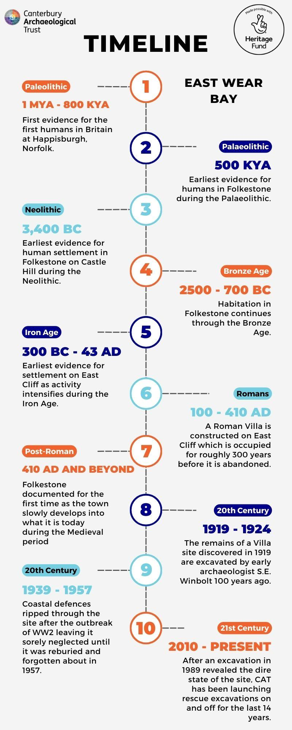
Figure 1: Timeline showing the different phases of activity at East Wear Bay and where the Iron Age sits within this timeline.

Figure 2: Recreation image of what East Wear Bay looked like during the Iron Age.
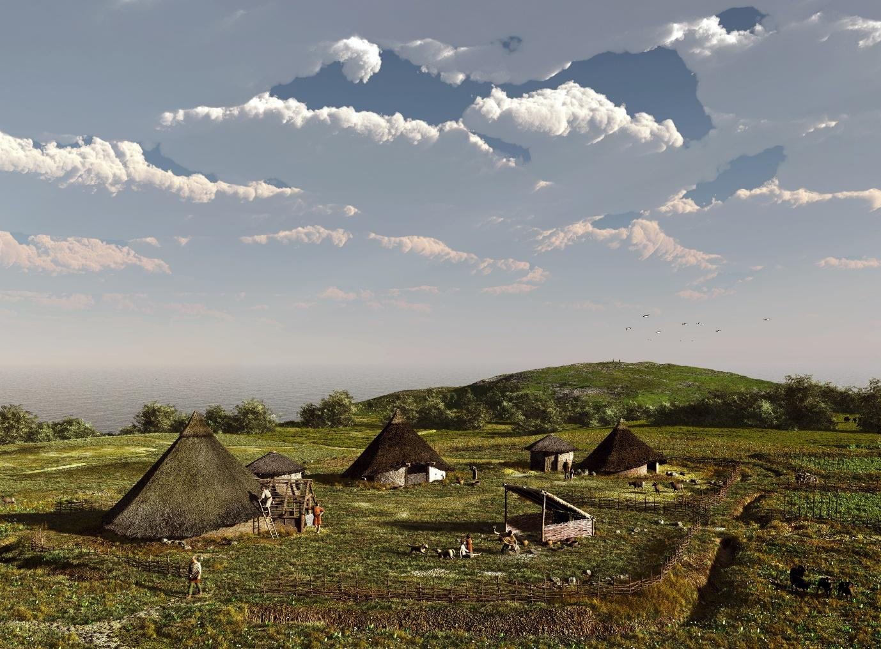
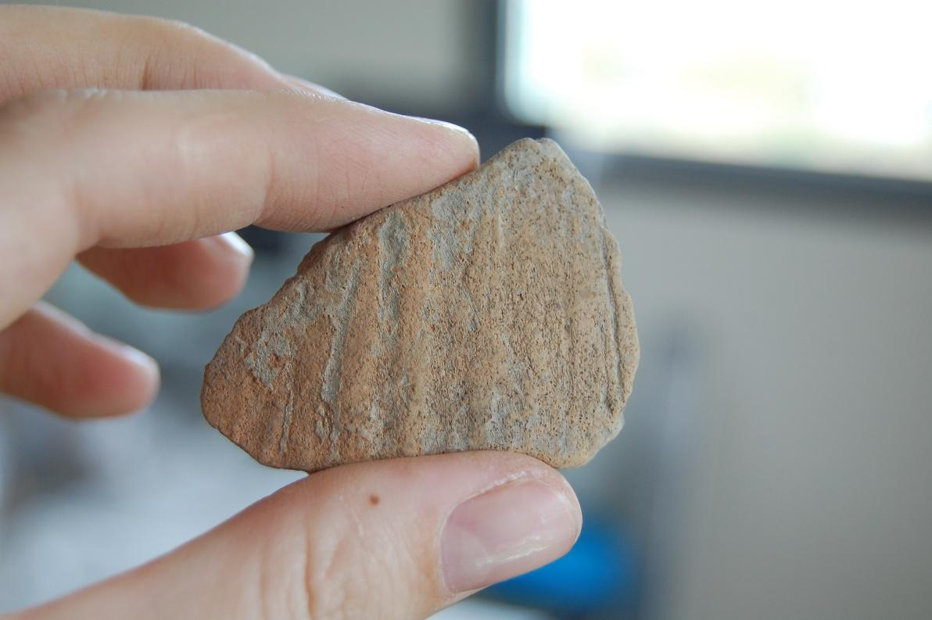
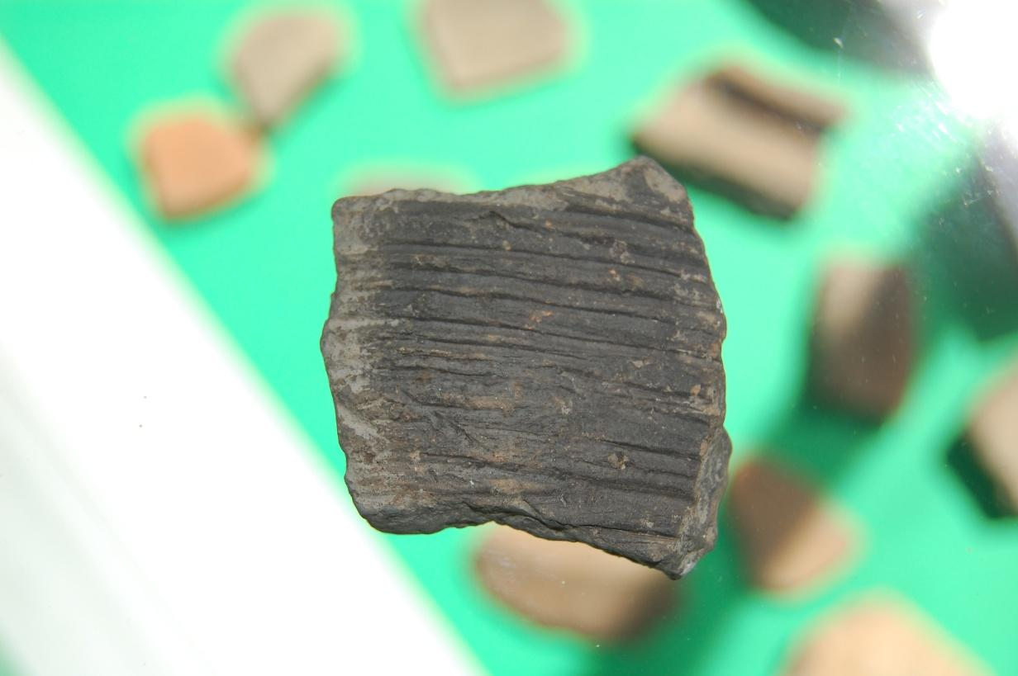
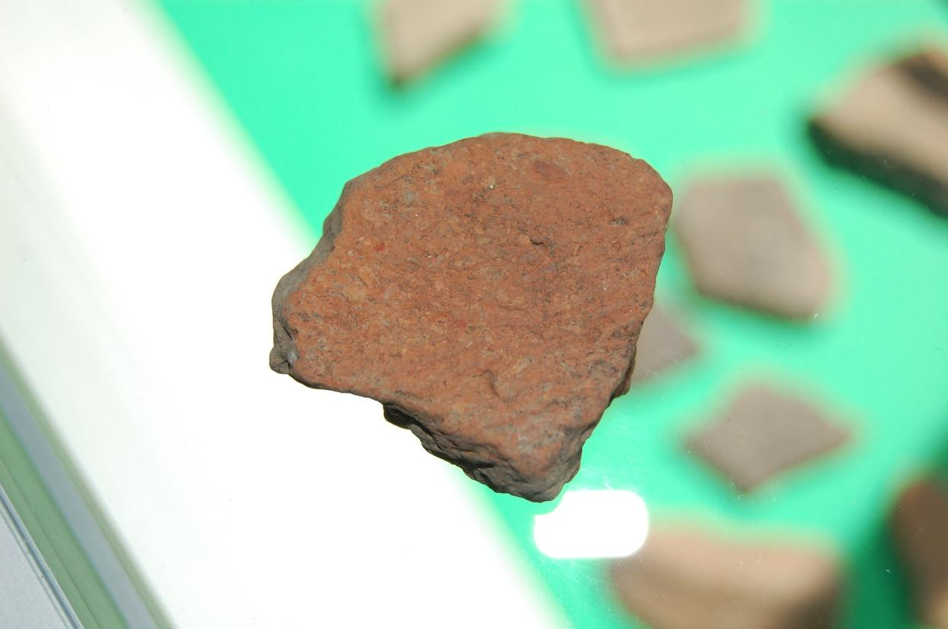
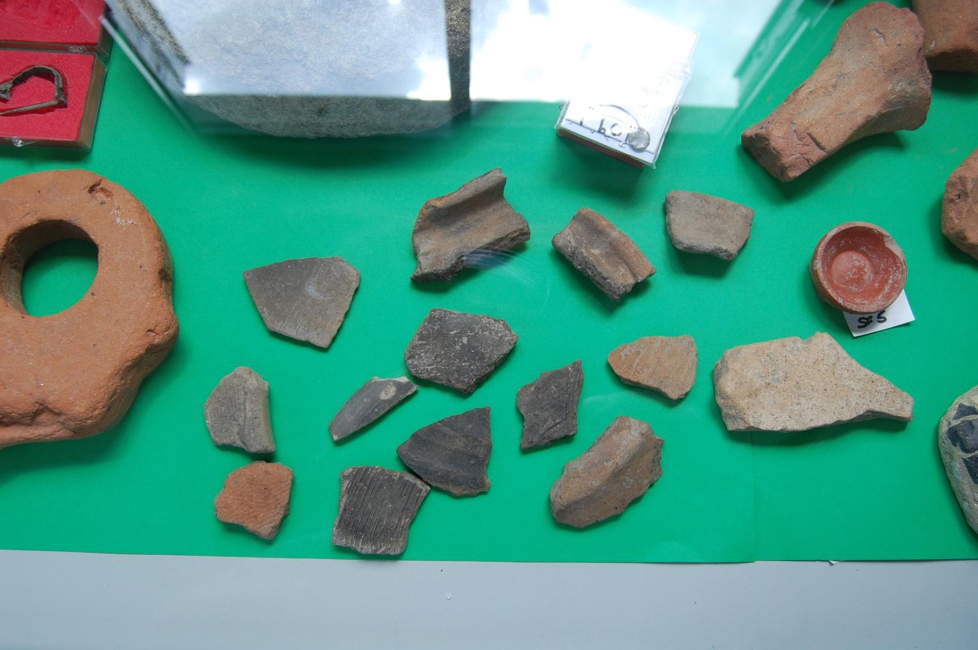
Figure 3: Fragments of Iron Age pottery found at East Wear Bay

Figure 4: Iron Age pots that have been reconstructed.
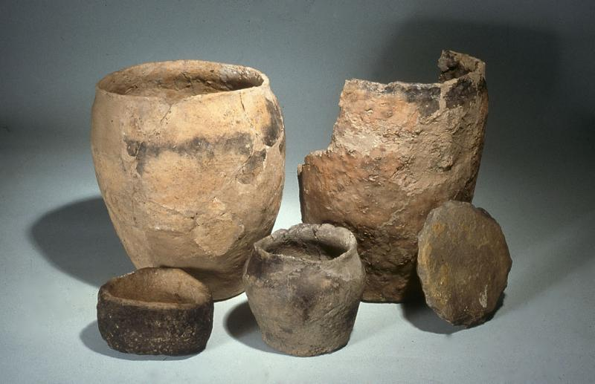

Figure 5: Different designs of Iron Age pottery for inspiration.
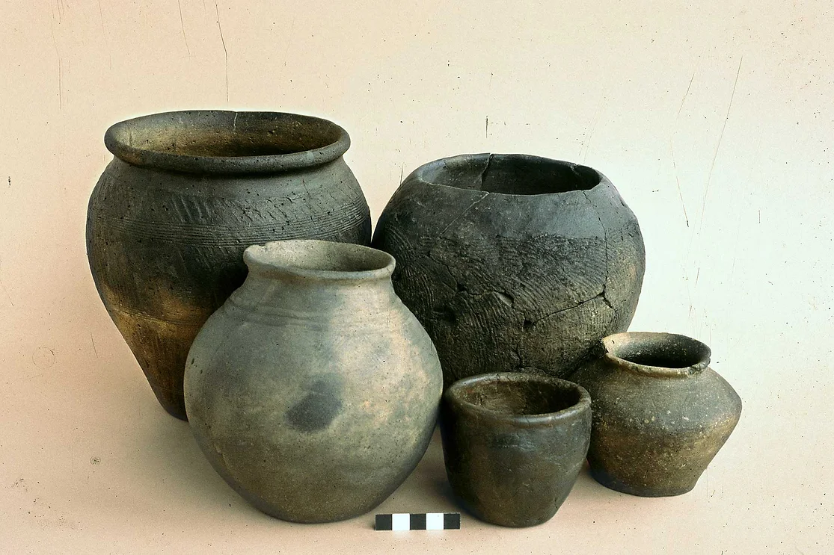
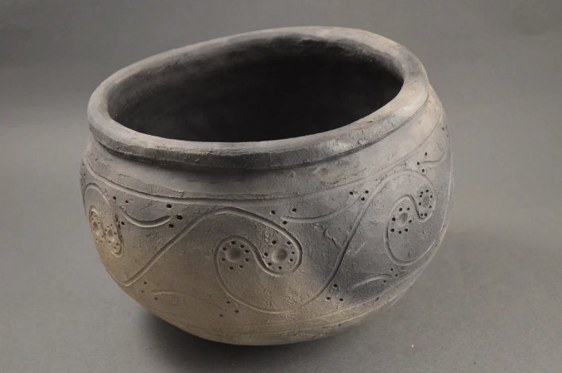
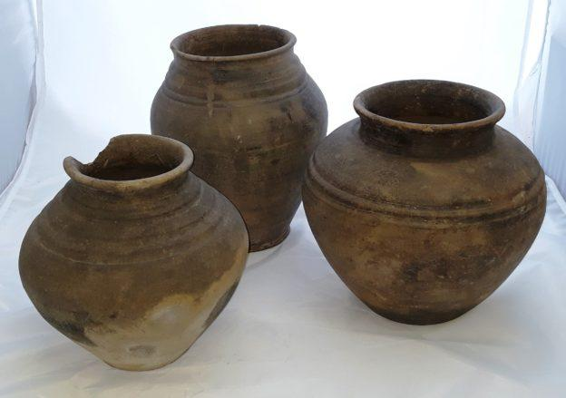
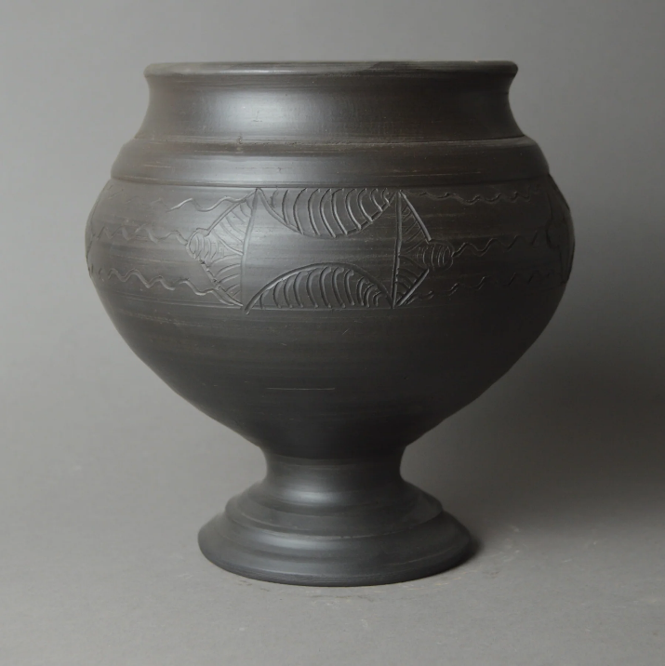

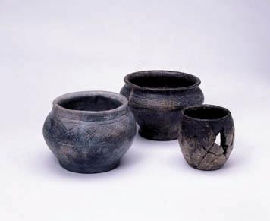

Make Your Own Iron Age Pot
- Start out with a ball of clay
- Divide into two balls, one larger than the other
- Flatten the smaller ball out
- Shape the clay into a shallow bowl
- Roll the larger ball into a long thin sausage
- Wrap the sausage around the shallow bowl and build the sides up
- Smooth out the sides and blend the clay together
- Decorate your pot with the tools provided.


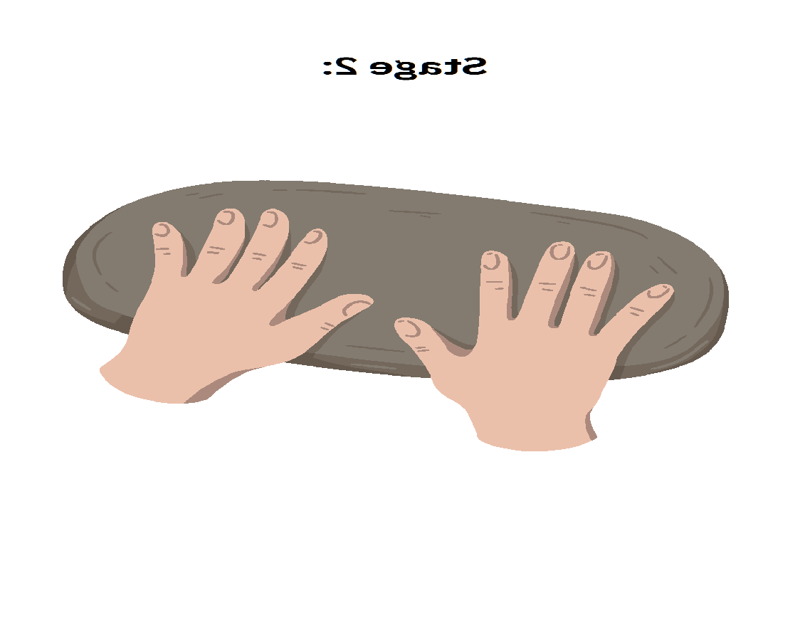
1 2 3


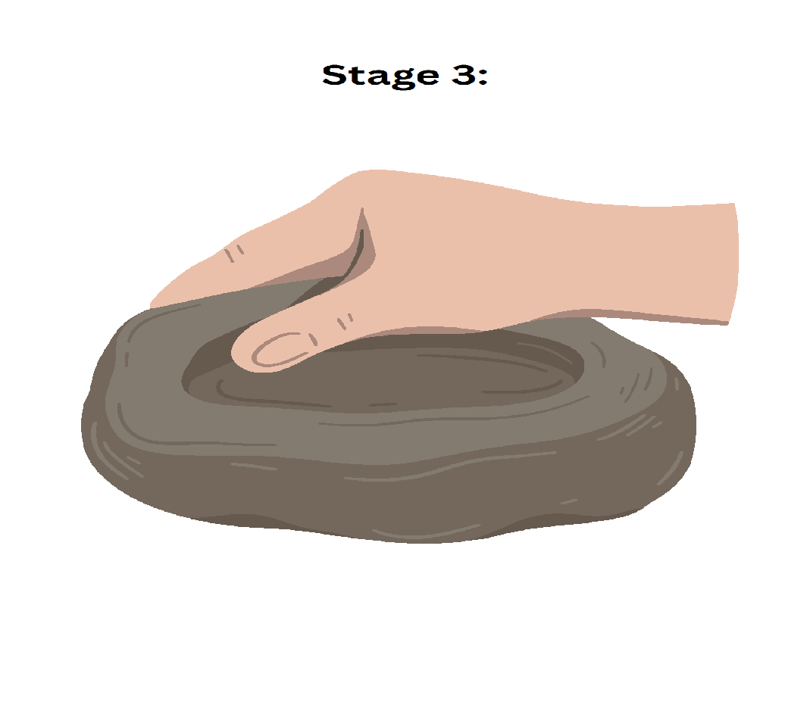
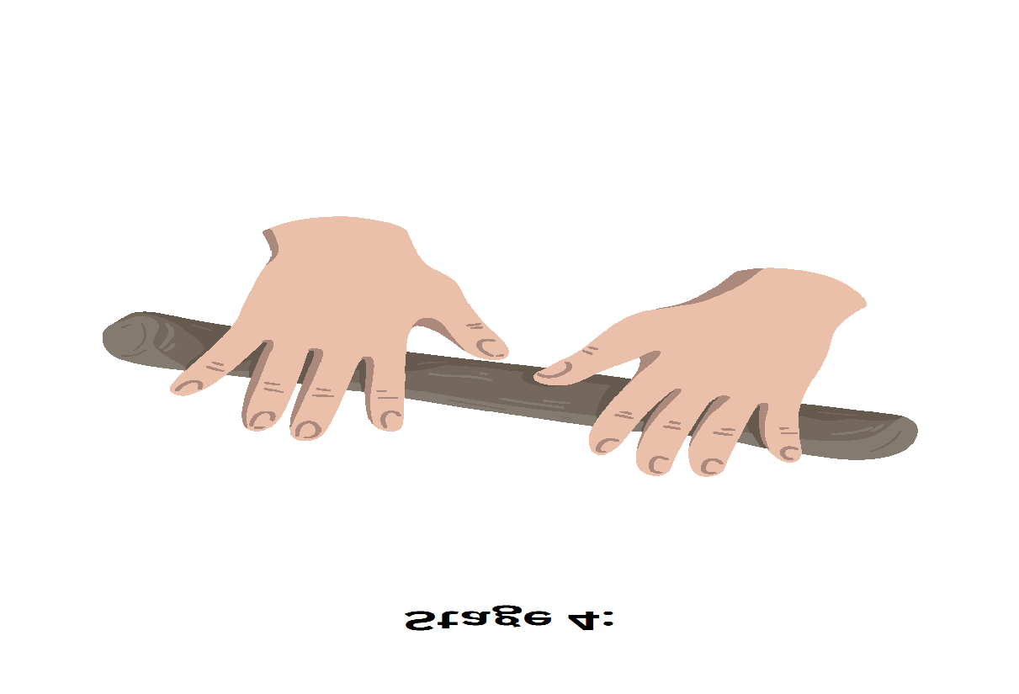
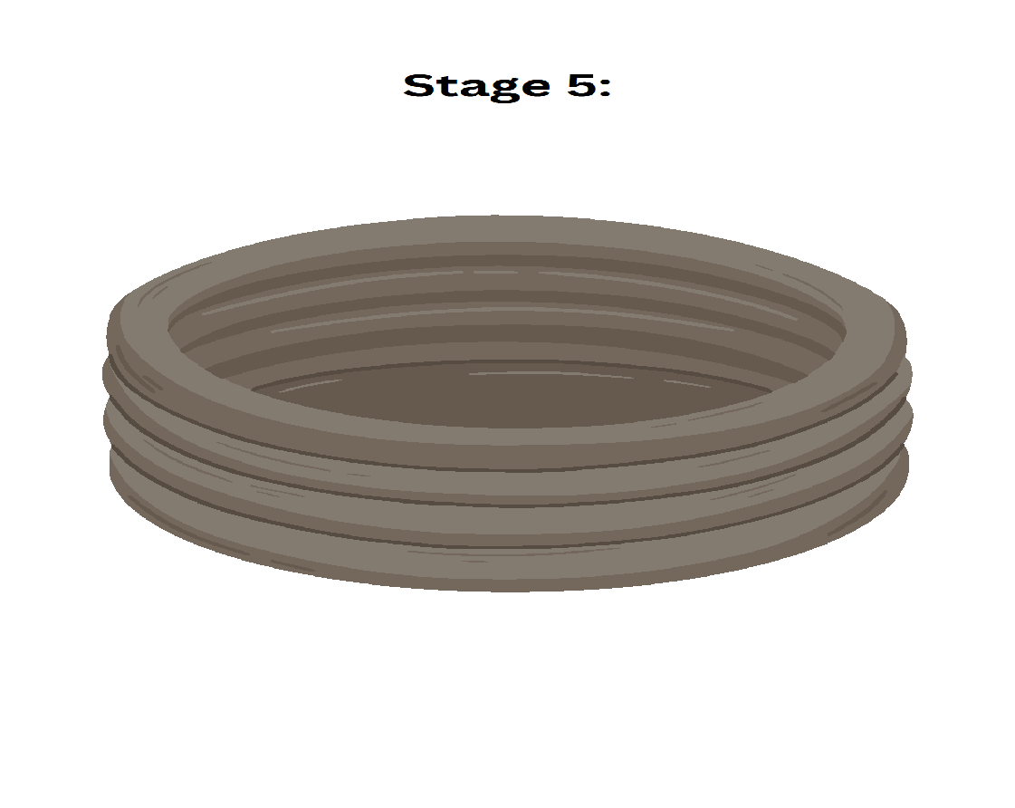
4 5 6

7 8
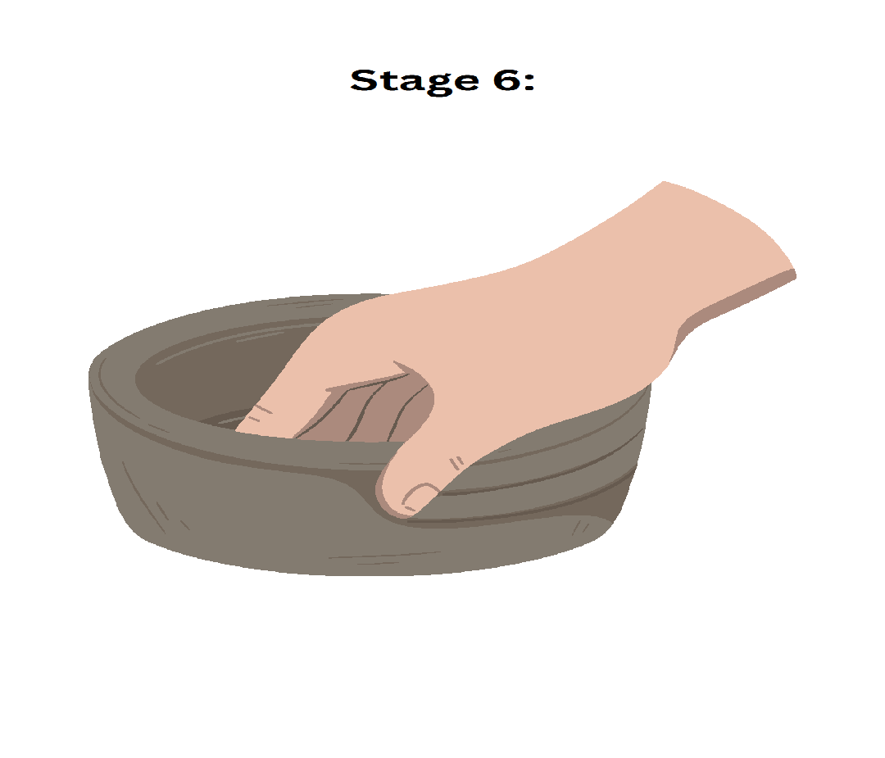
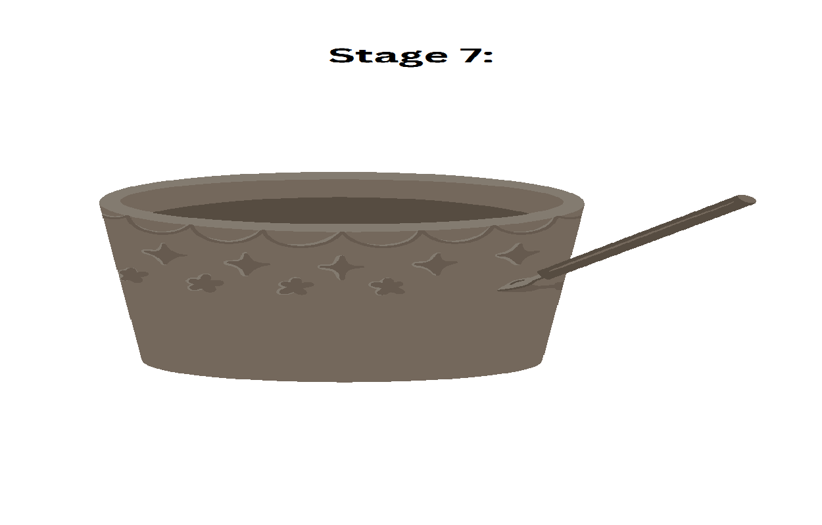

What design have they chosen to undertake?
Are they making their pot for someone as a gift?
Who are they going to gift it to?
Is this process of making the pot difficult or easy?
Which is the most difficult stage?

Activity 4: Weaving

Summary
This activity involves thinking about how people worked fabrics in the past and the tools they used. There is an opportunity to do some weaving as part of the practical activity. This session can be adapted to accommodate individuals or groups and can be completed using household items, or a specially made craft pack.

Materials and Preparation
We recommend making use of a weaving craft pack from baker Ross, or other similar supplier: https://www.bakerross.co.uk/autumn-weaving-basket-kits
However, you can create similar materials using card and brightly coloured wool or yarn.

Archaeological Background
At East Wear Bay, we don’t find any of the organic materials, like fabric or thread, that would tell us directly about textile work. These materials naturally decay over time, so what remains are the tools people once used (figure 1).
Among the most common finds are bone needles, spindle whorls, and loom weights. These give us valuable clues about the kinds of activities that took place.
Bone needles may have been used for weaving, mending, or sewing loosely woven fabrics. There's also a technique called Nalbinding, a kind of early needlework that might have been practiced here from the Roman period onward (figure 2).
Spindle whorls acted as weights on spindles, helping to spin fibres into yarn. Their shape is usually rounded, and their weight can tell us what kind of material they were used for. Heavier whorls were likely used for spinning thicker fibres like wool. While some were made of stone, many were crafted from ceramic, often repurposed from broken pottery (figure 3).
Loom weights helped keep the vertical threads (the warp) taut while weaving. At East Wear Bay, many loom weights were made from chalk, a soft, local stone that’s easy to shape and not too heavy, perfect for the job. However, these were also made from clay (figure 4).

Conversation Prompts
Have you ever tried sewing, weaving or knitting?
What did you make?
Is there anyone in your family who used to make clothes or fix them?
What kind of fabrics did you wear when you were younger?
Did anyone teach you how to sew or mend clothes?
Have you ever worn something that was handmade?
Have you ever seen someone spin wool into yarn?
Do you have any woven fabrics or rugs in your home?
What patterns or textures do they have?

Activity Resources
Figure 1: Delicate and rare Iron Age fabric from Scotland that has been preserved. It is incredibly rare to find any surviving fabrics in archaeology.
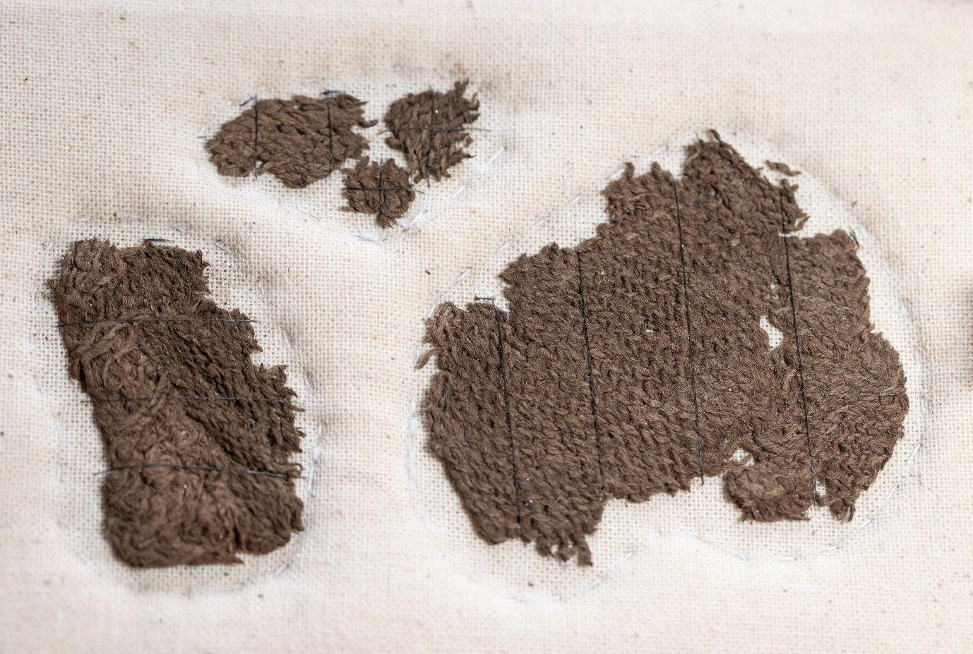

Figure 2: Bone needle found at East Wear Bay.
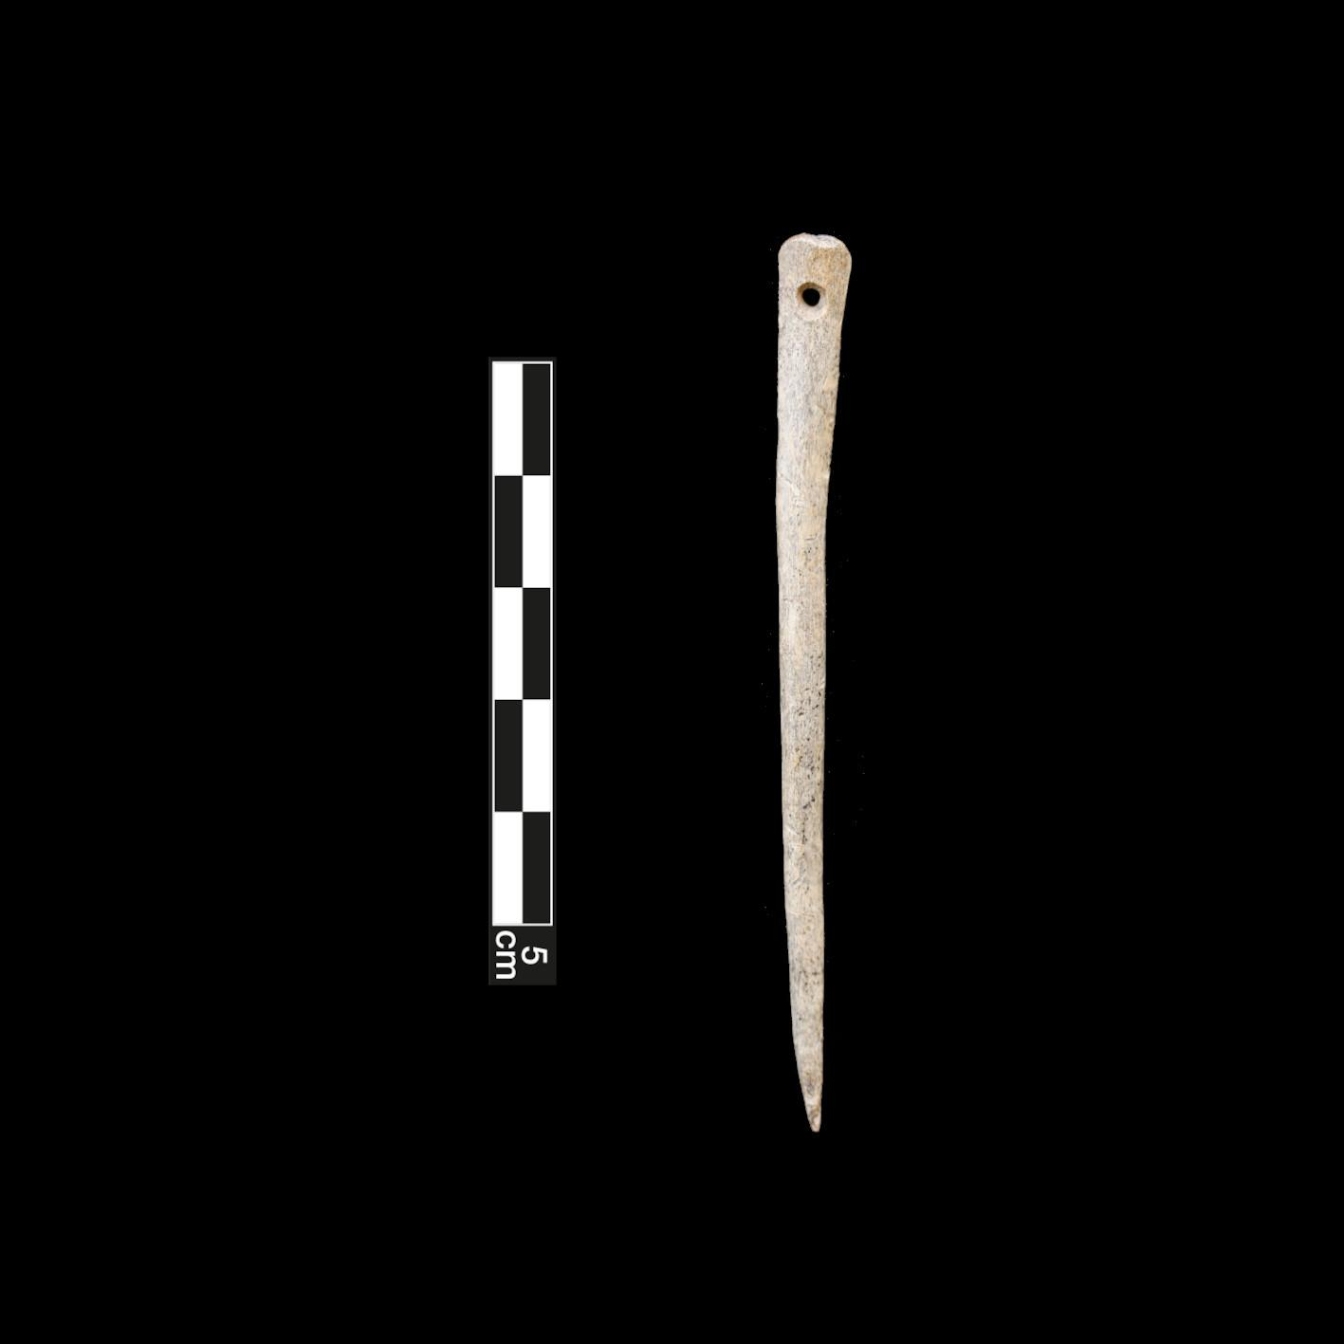

Figure 3: Ceramic spindle whorl found at East Wear Bay.
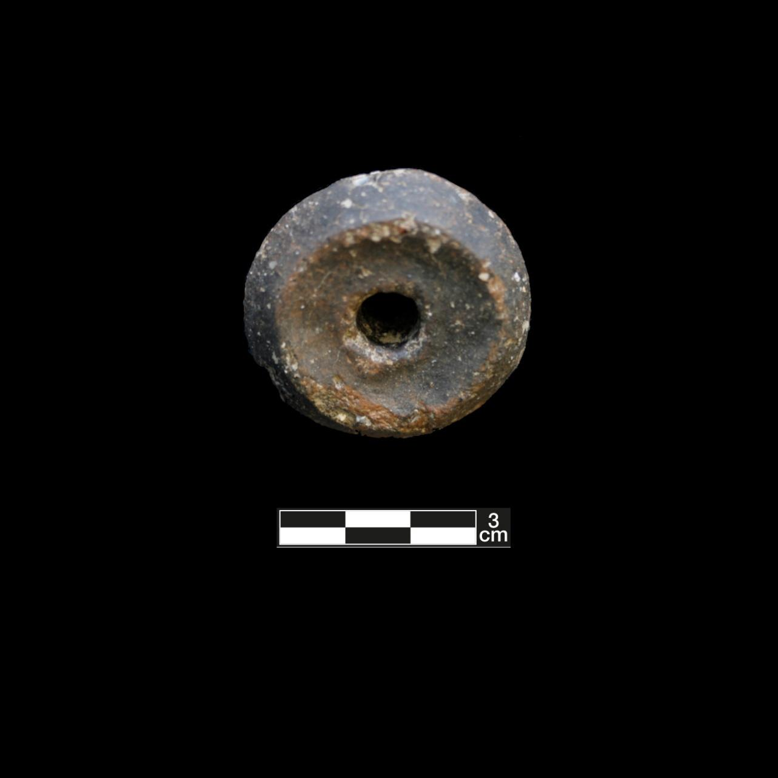

Figure 4: Loom weight made from clay.
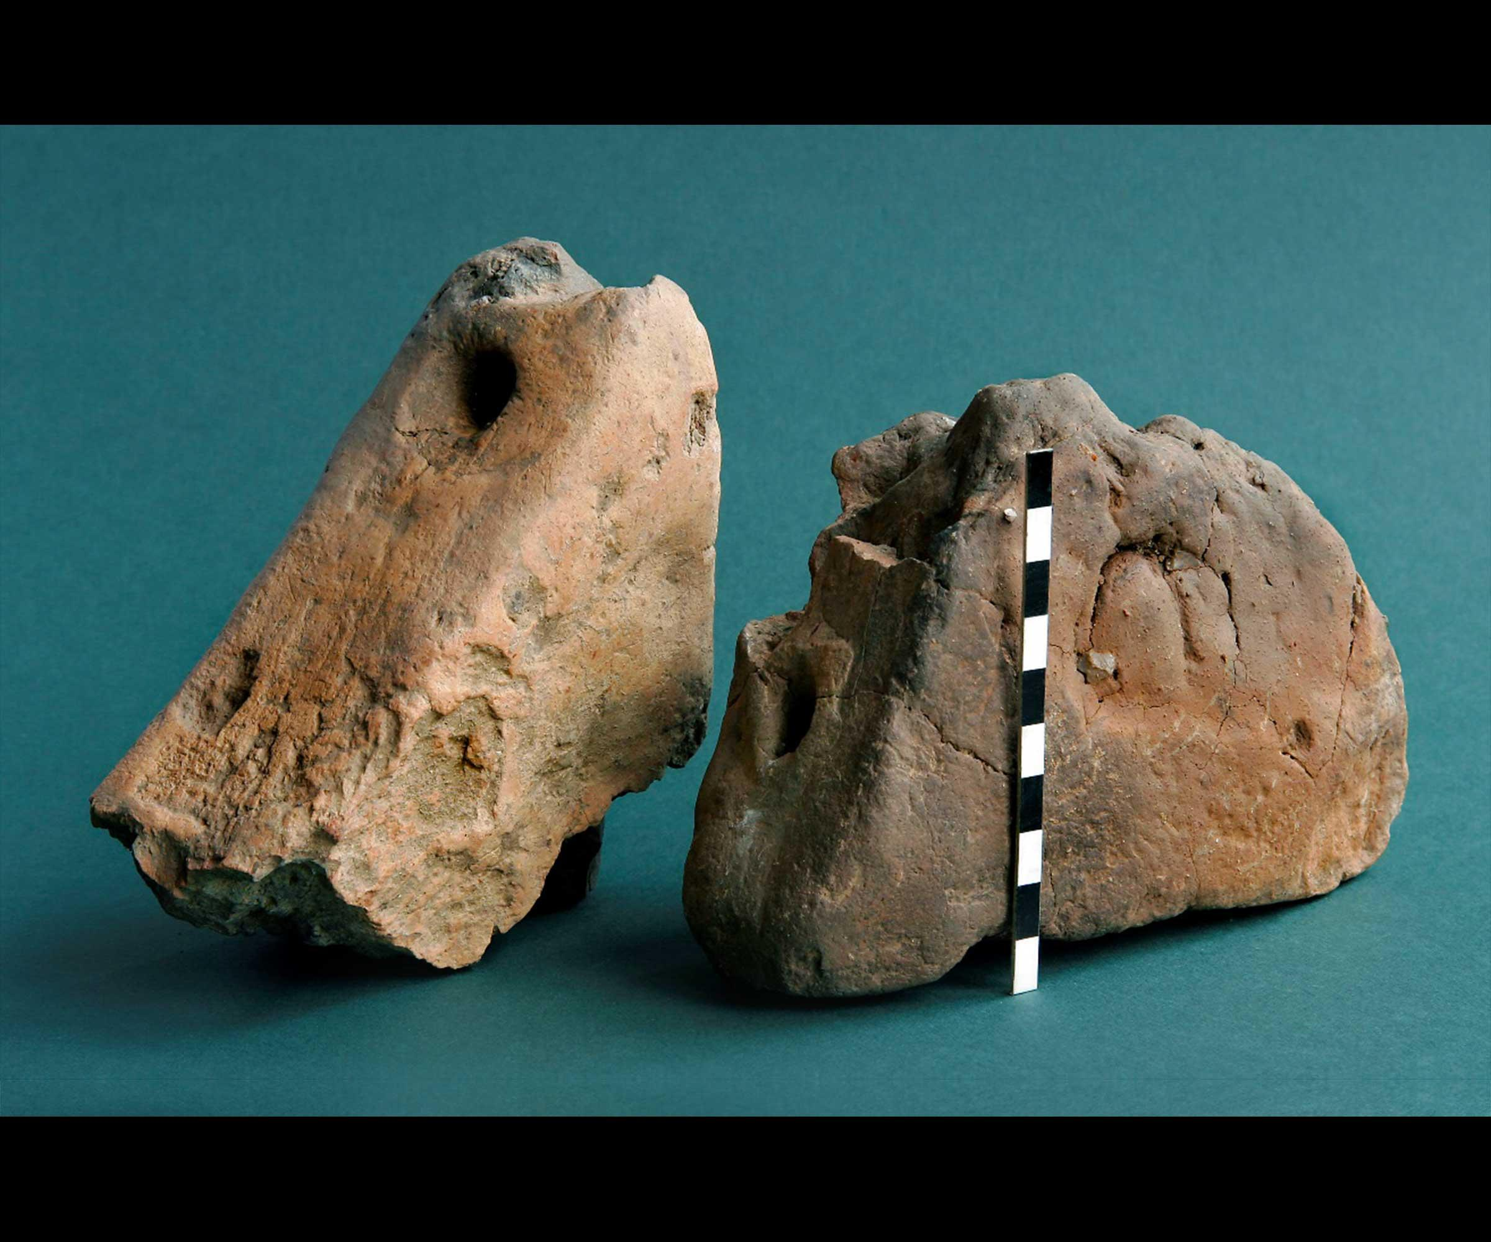

Weaving Your Own Baskets
Using the craft kit supplied, follow the instructions provided.
If you are making your own using materials at home, ensure that the card you have made to create a frame for the weaving is robust and that an ‘over and under’ approach is used. You can cut strands of coloured wool to the correct size in advance or cut these as you go.
What colours have they chosen to work with?
Have they done anything like this before?
Are they going to give their basket as a gift?
Who will receive it?
Is weaving easy or hard to do?
What makes it difficult?

Activity 5: Roman Mosaic Making

Summary
This activity involves using sea glass and other rounded fragments of stone or glass to create a colourful mosaic design. If you want to do this activity using household items, you can switch the wooden coaster that is used as a base for a cardboard option and replace the glass tiles with scrunched up balls of coloured paper. There is also the option of using sticky foam squares for mosaic tiles, which means that glue is not required. This activity can be modified to accommodate any number of participants and for any level of ability.

Materials and Preparation
If you choose to create mosaic coasters using durable materials, we recommend the following materials:
Wooden coasters: https://www.amazon.co.uk/Unfinished-Painting-Pyrography-Christmas-Decoration/dp/B0BVQ3YB67/ref=asc_df_B0BVQ3YB67/?tag=googshopuk-21&linkCode=df0&hvadid=697260420145&hvpos=&hvnetw=g&hvrand=1836072973730895132&hvpone=&hvptwo=&hvqmt=&hvdev=c&hvdvcmdl=&hvlocint=&hvlocphy=9045109&hvtargid=pla-2194499123176&mcid=f6989e70347136628fe8084257690c74&gad_source=1&th=1
PVA glue: https://www.bakerross.co.uk/mini-washable-pva-glue
Glass tiles: https://www.bakerross.co.uk/glass-mosaic-tiles-1
You can also go and find sea glass or make use of other suppliers that provide rounded glass for crafts.
Sticky foam squares also make a good replacement for the glass tiles and these work well with a cardboard base: https://www.bakerross.co.uk/self-adhesive-foam-mosaic-squares
If using the foam squares, it is good to have scissors handy to be able to cut the squares into shape if needed.

Archaeological Background
Roman mosaics are decorative surfaces made from tesserae, which are small, colourful cubes of stone, tile, or glass arranged in intricate patterns and scenes, primarily for floors but also for walls and vaults. Adopted from the Greeks, the Romans elevated mosaic art, using it to display wealth in public and private buildings and depicting everything from mythological stories and emperors to scenes of daily life (figure 1).
Mosaics were built on a concrete base and were an invaluable record of Roman life, culture, and art, with many examples surviving today. Really beautiful examples exist in Pompei, which was a Roman town in Italy that was destroyed by the eruption of Mount Vesuvius in the first century AD (figure 2).
Some of the most famous mosaics in Britain can be found at Fishbourne Roman Palace in West Sussex, and these depict things that we think were relevant to those living in Britain at the time (figure 3).
There is a mosaic also at Folkestone Roman Villa, which was found at East Wear Bay (figure 4).
Modern mosaics are still created today, and it is possible to find a range of different examples if you look around when out and about (figure 5).

Conversation Prompts
What design do you think you will do?
Is your design inspired by anything or by anyone?
What colours will you choose to use?
Will you make your mosaic into a gift?
Who will you give it to?
What is difficult about doing this activity?
How long do you think it took the Romans to make their mosaics?

Activity Resources
Figure 1: Greek mosaic that was used to show the wealth of the person who had it in their home.

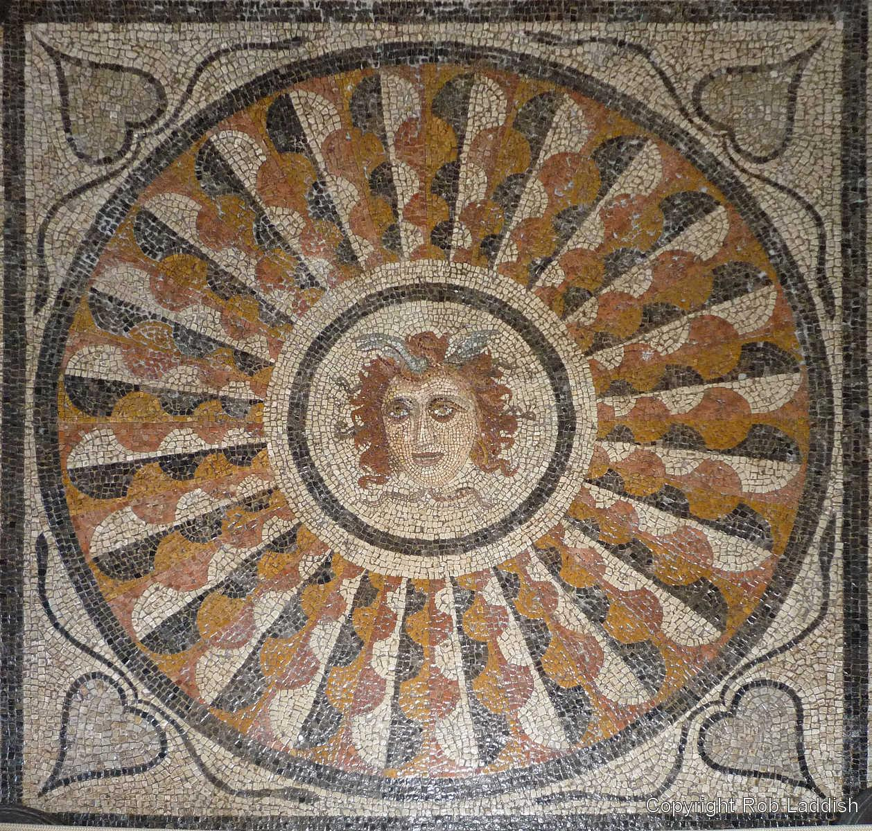

Figure 2: Roman period mosaics from Pompeii in Italy.
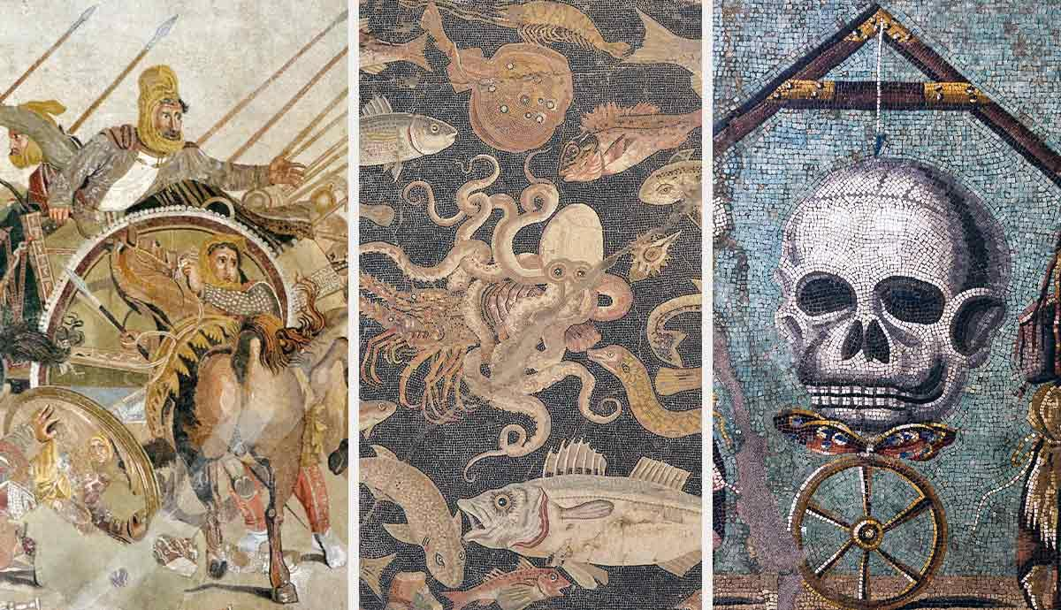
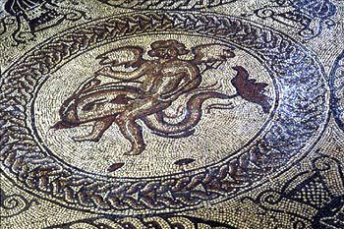
Figure 3: Roman period mosaics from Fishbourne Palace in Sussex.

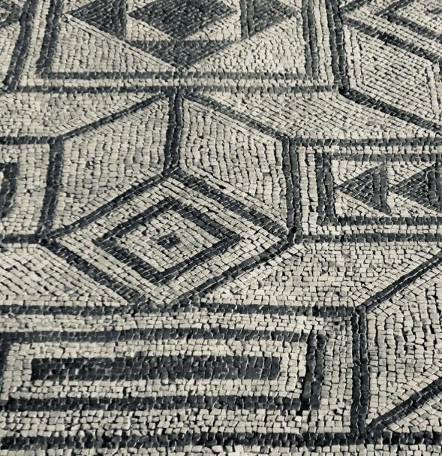

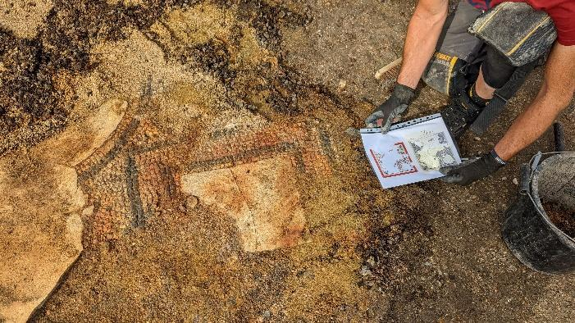
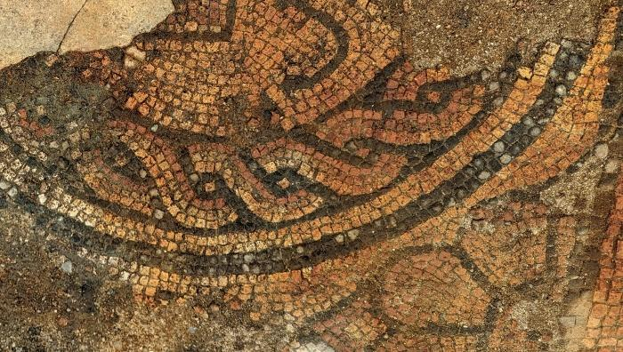
Figure 4: Roman period mosaic from East War Bay in Folkestone.
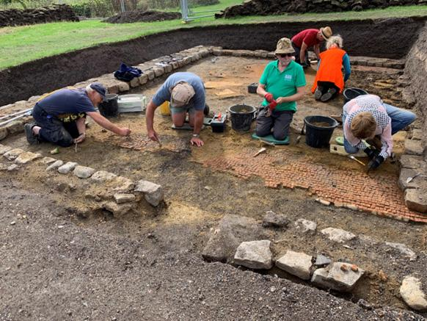

Make Your Own Roman Mosaic
Collect all the material needed for the activity and make sure everyone can reach what they may need to use.
Hand out one card or wooden base, depending on what you have decided to use. Encourage participants to draw their design onto the tile first, as this will help when deciding where to place the coloured tiles.
If using glass tiles, paint the tile in PVA glue and then start to place the coloured tiles within the design area. If using sticky foam tiles, these can be peeled and arranged gradually.
If using glass tiles, it is recommended that you paint the whole surface of the tile with PVA glue once the design is complete as this will help to cement them pieces in place.
What colours have you chosen to use?
Why these colours?
What design have you decided to use?
Are any of these designs inspired by the Roman and Greek examples shown in the resources?
Is this task easy or difficult to do?
Would you want to have been a mosaic maker in the Roman era?
If you were to do this task again, what would you do differently?

