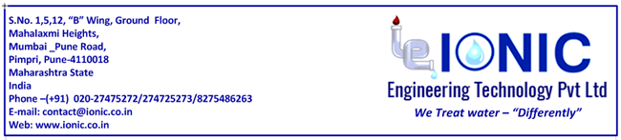
Job Position: Technical support engineer
Min. Qualification - Required B.E./B. Tech - Chemical Engineer with aptitude for working in water and waste water industry.
Roles and responsibilities:
1.Minimum 1 year experience in Water and Wastewater treatment or any process industry.
2. Candidate should have Knowledge about Water and Wastewater treatment plants.
3. Candidate from Pune will be preferred.
4. Job profile
- Preparing proposals
- Preparing technical documentation like operation and maintenance manuals, SOPs.
- Preparing BOM, BOQ, QAP, Data sheets, technical specification
- Process Engineering calculations
- Basic Engineering
- Detailed engineering and design validation
- Technical trouble shooting
- Project Management
- Equipment Testing and validation of process.
- Improving the designs, performance and efficiency of the existing products
- New R&D, Process development and conducting experiments.
- Feasibility, Treatability and Pilot studies
- Installation & commissioning
- Site Support at Project Execution
- Quality Assurance
- ISO Documentation

Specific requirement: Candidates with strong academic background in basic chemistry, chemical engineering, process engineering, process calculations with aptitude for water and waste water treatment and looking for a long term career in this field is preferred. Candidate should be a self-learner and must have focus, discipline, dedication and determination to complete the given task successfully in the allocated time.

