**Subject:** Welcome to OLS!

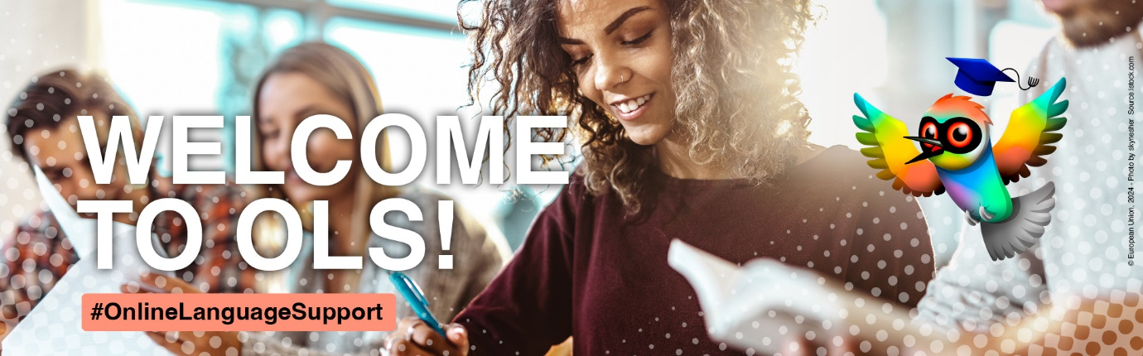

Dear …

Online Language Support (OLS) is waiting for you!

The current version of OLS was launched on 1 July 2022 with a wide range of interactive and engaging learning activities in 29 languages. It is hosted on the [EU Academy](https://academy.europa.eu/), the corporate learning management platform of the European Commission, and offers **an “open” and a “core” area**.

The **core area**, with its community of almost 350 000 mobility participants, is available exclusively for Erasmus+ and European Solidarity Corps participants and has functionalities and content varying from placement tests with downloadable certificates and courses at different levels to learning games and personalised learning experiences. Whether it’s learning the basics of Bulgarian or mastering native-level German, [click here](https://academy.europa.eu/courses/learn-a-new-language) to check the available content for yourself.

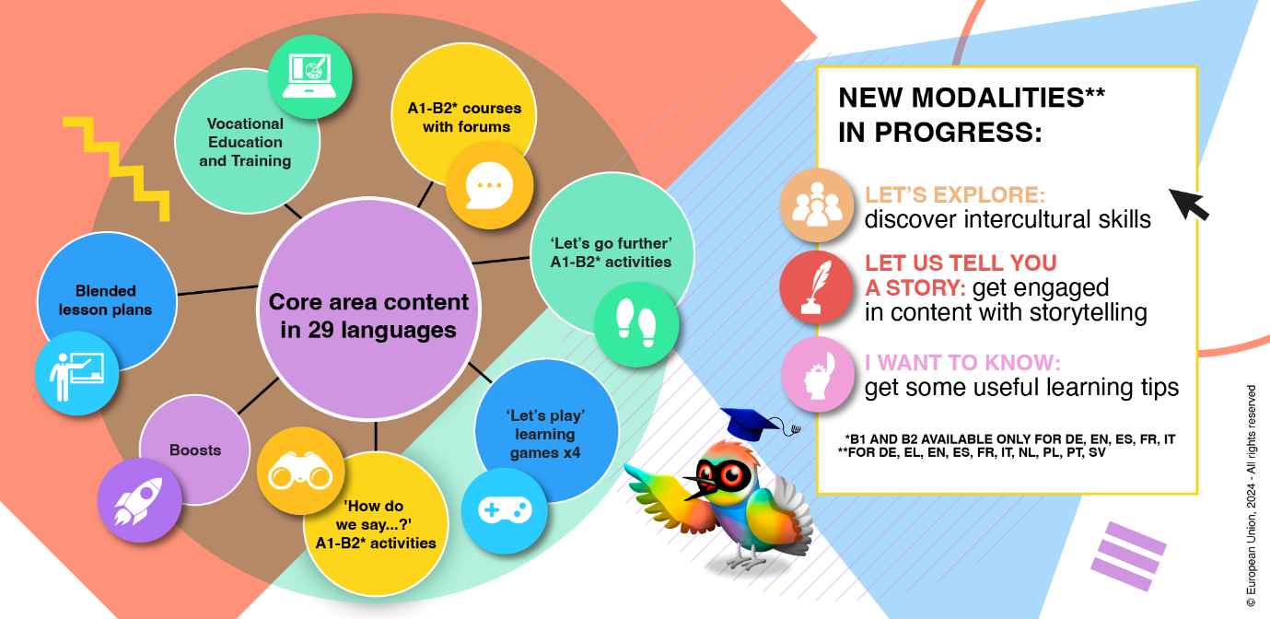The core area also allows participants access to the **forums**, where they can practice their language with others, ask questions about all aspects of their mobility experience and participate in discussions, speaking sessions and mini contests moderated by the community managers. The community managers are native speakers who are there to stimulate discussions with posts, quizzes and fun facts about their country. If you want to learn more about the forums, [click here](https://academy.europa.eu/mod/forum/view.php?id=47202).

The **open area** is for the general public and currently has more than 120 000 members. It provides discovery videos for all 29 languages and basic learning videos and quizzes covering five different topics to encourage language learning in a fun way. If you want to learn some curious facts yourself, [click here](https://academy.europa.eu/courses/learn-language-basics-with-online-language-support/view/).

It only takes a few seconds to set up your profile and begin testing OLS! Our [intro module](https://academy.europa.eu/courses/welcome-to-the-eu-academy) will walk you through the process of creating an account, which you can use to access OLS but also other courses on the EU Academy. We are also sharing below some ‘how-to’ tips that will guide you on your OLS journey.

Do you still have some questions? You might wish to consult [OLS FAQs](https://academy.europa.eu/local/euacademy/pages/faq/category.php?id=8) for further information or reach out to us via the [Helpdesk](https://academy.europa.eu/mod/forum/discuss.php?d=26455), where one of our community managers will assist you.

See you on OLS!

**How to take a placement test**

1. Visit OLS on EU Academy by clicking on the link [**here to get started**](https://academy.europa.eu/courses/learn-a-new-language)
2. Choose the language community of the language you wish to learn with OLS. Community managers are there to assist you with specific questions you might have.
3. Click on the placement test to start your test.
4. Complete your placement test.
5. Following your assessment, you will find a range of learning materials appropriate to your level on your EU Academy dashboard here: [**https://academy.europa.eu/my**](https://academy.europa.eu/my)

**How to complete language courses**

After you have taken the language assessment to ascertain your level, a range of learning materials appropriate to your level will appear on your dashboard.

1. Access your dashboard here: [**https://academy.europa.eu/my**](https://academy.europa.eu/my)
2. Consult the content which has been made available to you and click on any piece of content to start learning.
3. Good luck! Your progress will be automatically recorded.
4. At any time, you can retake the placement test to monitor your progress. Following the result of this assessment, new language resources will be made available to you on your dashboard.

**To access a community with forums, speaking sessions and contests**

1. Visit OLS on EU Academy by clicking on the link [**here to get started**](https://academy.europa.eu/mod/forum/discuss.php?d=26458).
2. Choose the language community of the language you wish to learn.
3. Community managers can then be contacted to assist with any specific questions.