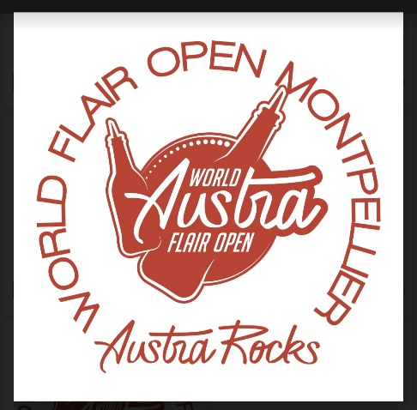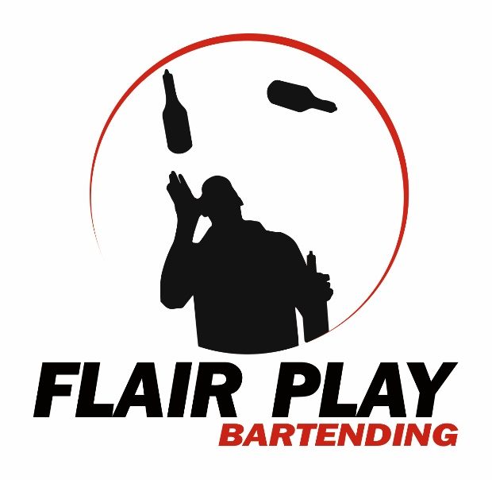

RULES /// « AUSTRA ROCKS WORLD FLAIR OPEN » 2026
PARTICIPANT/
Be at least 18 years old and have been practicing Flair for at least 5 months.
Registration of 30€! ( Be careful! If you do not come without warning, you will be removed from the list in future editions).
A wristband will be given to you to have free sodas at the bar.
A competition T-shirt will be given to you as a gift.
A maximum of 20 participants per competition aged 18 years old minimum.
Everyone will be required to bring their own music on a USB medium or a link sent by email to the DJ.

Each participant will be scored on: 200pts
The dress, the style, the cleanliness of the service and the show, the smile, the interaction with the audience, the creativity and the technique.
NOTATION/
Participants will be scored out of a total of 200 points. WFA Scoring system.
50pts – Difficulty
50pts – Originality
50pts – Choreography
50pts – Execution
10pts – Finest call Stall
DEDUCTION/
Spill / -1 pts
Drop / -2 pts
Brake / -10 pts
Miscellaneous / -5 pts
Missing Drink-Not Sponsor Flair / -15 pts
QUALIFICATION/
- A 5-minute passage per candidate with 2 Cocktails to be made
-During the 5-minute routine, you will have to sniff at least 30 seconds with the BACARDI bottle.
- Permission to tape metal or plastic spouts.
-"Austra Rocks" or "WFA" stickers will be given for the bottles.
Cocktail n°1 / STRAWBERRY BACARDI MOJITO - Réalisation en Working flair
-50ml Bacardi Gold Decoration: Mint or Lime Head & 2 straws.
-10ml Finest Call Glass Cane Syrup: Collins 12oz & Crushed Ice
-30ml Finest Call Strawberry Puree
-2bar spoon sugar
-6/8 Fresh Mint Leaf
-4 tsp lime
-2dash Angostura Bitter
-Top Soda.
Cocktail n°2 / MAI TAI – Realization in Exhibition flair
-30ml Dark rum Decoration: Lime or Pineapple & 2 straws.
-30ml White Rum Glass: Collins 12oz & Ice Cubes
-15ml Triple sec
-10ml Orgeat
-40ml Sweet’n Sour mix Finest Call
-40ml Finest Call Pineapple Juice
*All products and ingredients will be provided as well as glasses.

Specification:
1 bottle in working flair = 20cl minimum
1 bottle exhibition = 2cl minimum
PROHIBITION/
When the candidate passed, there were no burning bottles.
You will be able to "Flair" with bottles other than the "sponsor" brands but without labels and with sponsor stickers.
It will be forbidden to "flair" with empty bottles.
BONUSES
-A 40ml "Pour Test" to pour during the 5min routine that can give +5pts.
10pts – Finest call Stall

FINAL
For the Final, the first 8 will be qualified for a second round, 6-minutes stage appearance with the same Cocktails to make.

THE JURY/
In order to score the participants as well as possible, 3 judges will be present: 3 professionals from Flair Bartending and Cocktail procedure.

PRIZES and PRIZES BEST Female PRICE
1st Price: 1400€ 1st Price : 200€
2nd Price: 850€
3rd price: 550€
4th prize: 400€
5th prize: 300€

