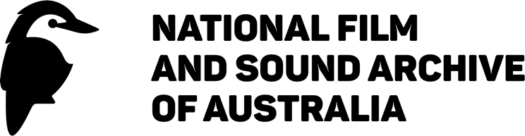
2024–2027
Disability Inclusion Action Plan
This plan is available in alternative formats which are available on our website. Hard copy formats are also available on request.
This plan is registered with the Australian Human Rights Commission (AHRC).
We value community feedback and encourage you to share your thoughts and experiences with us to ensure our continued improvement and progress in meeting the goals in our DIAP.
For general enquiries, feedback and services,
please contact:
enquiries@nfsa.gov.au
Tel: +61 2 6248 2000
Toll free (within Australia): 1800 067 274
Produced by
The National Film and Sound Archive of Australia and Accessible Arts
Design and editing by
The National Film and Sound Archive of Australia
Additional design, typesetting and print management by
Giraffe Visual Communication Management
Images
The images included in this document has been selected from the NFSA’s audiovisual collection. They are a celebration of people often underrepresented in Australian screen culture. We are proud to collect, preserve and share of people with disability as part of our ongoing commitment to diversity and inclusion.
Page 4: Geoffrey Gurrumul Yunupingu in Gurrumul (2016). Directed by Paul Williams. Image by Dan Maxwell. Courtesy of Resolution Media. NFSA title 1514333.
Page 8: Lee and Nasir in The Streets Barber Stories – Episode 11 Lee (2019). Directed by Vidad Narayan & Bryce McCoy. Courtesy of Round 3.
Page 14: The Deaf Butterflies perform ‘Singin’ in the Rain’ at I Dance II, presented at the NFSA for the ACT’s inaugural Uncharted Territory festival (2023). Image by Grace Costa.
Page 30: Rock band Rudely Interrupted in Rudely Interrupted (2009). Directed by Benjamin Jones. Courtesy of Perpetual Entertainment. NFSA title 796531.

ACKNOWLEDGEMENT OF COUNTRY
We acknowledge the traditional owners of this land: the Aboriginal and Torres Strait Islander peoples who have practised, nurtured and developed the world’s oldest continuous human culture over tens of thousands of years.
We feel privileged to live and work on this land, and to collaborate with its extraordinary people.
We at the National Film and Sound Archive of Australia pay our respects to Aboriginal and Torres Strait Islander Elders past and present; and acknowledge and thank the Indigenous partners, creators and staff whose insights, talents, productions and generosity of spirit are essential to our work.
As a national cultural organisation, it is an honour and a joy to assist in preserving, promoting and making accessible Australian First Nations stories.

Contents
Language and definitions 5
Access 5
Disability 5
Inclusion 5
Intersectionality 5
About us 7
From the CEO 8
Disability in Australia 9
Our Disability Inclusion Action Plan 11
Alignment with our Strategy 11
Our DIAP Goals 12
Contributors 13
Our achievements to date 14
Case Study: Dementia friendly screening pilot 14
Case Study: Accessibility in Arc cinema 15
Disability Inclusion Action Plan goals and actions 17
Attitudes and behaviours 17
Accessible and liveable communities 20
Meaningful employment 23
Systems And Processes 26
Governance and policy context 29
Legislation and policy 29
International 29
National 30
Endnotes 31

Language and definitions
We recognise that there are varying views on language and terminology around disability in Australia and internationally. Language can be both a personal and political choice.
We have chosen to write this plan using the person-first language of ‘person with disability’ to recognise that disability is just one aspect of a person’s life and does not determine who they are. This is currently the preferred language used by governments across Australia. However, we respect that different people have different preferences about language.
Access
Access is about recognising and removing barriers to full and equitable participation in society for everyone. Access to services, facilities, programs, events and employment opportunities ensure that all Australians can be equal participants in our community. Recognising the unique value that every individual brings is central to the concept of access. Barriers to access can be categorised as physical or social, or relating to attitudes, communication or policy.
Disability
The United Nations Convention on the Rights of Persons with Disabilities (2008) defines disability as including “a long-term physical, psychiatric, intellectual or sensory impairment that, in interaction with various barriers, may hinder the person’s full and effective participation in the community on an equal basis with others.”
Inclusion
Inclusion is about understanding and embracing differences of age, disability, gender, religion, sexual preference or ethnicity. Inclusion creates a space in which all people can access and have meaningful participation in programs and services. The opportunity to be valued, connect with others, be represented and feel a strong sense of belonging, with choice and control, is fundamental to creating an inclusive community. We recognise that inclusion is about making change happen so that the world becomes accessible to all people. By evolving with our community, we reflect a society that embraces everyone.
Intersectionality
Intersectionality acknowledges the ways in which aspects of a person’s identity can overlap and expose them to varying forms of marginalisation. Being part of more than one underrepresented group may compound the barriers experienced by an individual.
The National Film and Sound Archive of Australia is committed to telling the national story in all its diversity. We value the unique experiences of everyone and acknowledge the multidimensionality of the disability community. We approach accessibility through an intersectional lens to address the needs of individuals who are most disadvantaged and to remove barriers to equitable participation.
We embrace and support equality for people with disability from all backgrounds and lived experience including First Nations people, Culturally and Linguistically Diverse people, women and non-binary people, members of the LGBTQIA+ community, people from regional and remote areas, older people, children and young people, and people from low socio-economic backgrounds.
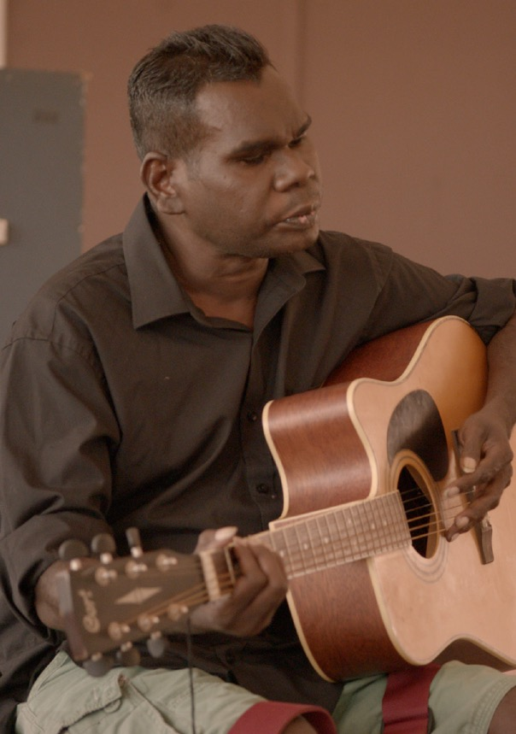
Groundbreaking Yolngu artist Gurrumul Yunupingu in the documentary Gurrumul.

About us
The National Film and Sound Archive of Australia (NFSA) is the national audiovisual cultural institution. Australians were early adopters of film and sound technologies, and the appetite to make, enjoy and discuss audiovisual culture remains strong. From our earliest recordings in the 1890s to the latest games and immersive digital productions, the collection captures not only our technical and artistic achievements, but also our stories, obsessions and myths; our triumphs and sorrows; who we were, are, and want to be. Our memories preserved with the uncanny immediacy of recorded sound and motion pictures.
The collection dates back to 1935, making it one of the first audiovisual archives in the world. Originally known as the National Historical Film and Speaking Record Library and operating under the auspices of the Commonwealth National Library, the NFSA became an independent cultural organisation in 1984.
Today, our collection includes not only film, video and audio recordings, but also contextual materials such as costumes, scripts, props, photographs and promotional materials. It is a diverse, dynamic and often surprising repository, ranging from items inducted into the UNESCO Memory of the World register to sporting matches, game shows and advertising jingles. As well as preserving these items for future generations, our curators continue to grow the collection ensuring it provides an unbroken record of life in Australia, and of Australian creativity.
The way that Australian and international audiences engage with screen and audio content has changed dramatically during the life of the organisation. Audiences want to engage in ways that are immersive, interactive and experiential; to enter into a dialogue with our cultural heritage in a way that illuminates contemporary issues. Our national audiovisual collection is rich. We want audiences to use it for learning, for inspiration and for entertainment.
Public programs and services – including Sounds of Australia, NFSA Restores, screenings and events, and educational programs delivered online and at our headquarters in Acton, Canberra – ensure that the collection is available for enjoyment, learning, research and re-use by creators.
From the CEO
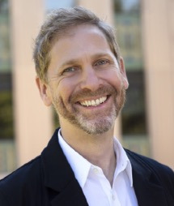

As a national cultural institution, we exist to serve all Australians.
Some 20% of Australians identify as living with disability, and so they key to our success is understanding how we can remove barriers so everyone in the community can engage with our work.
At the same time, as an inclusive employer that thrives on multiple cultural perspectives, we must ensure that we reduce barriers to participation in our workplace itself.
So this Disability and Inclusion Action Plan, replacing our previous Access Action Plan, is a timely and important piece of work, informed by consultation with a range of stakeholders and supported by the team at Accessible Arts.
We have taken the opportunity to interrogate what services we provide, as well as how we provide them. Services such as ramps and audio describing are critical, but so are our collecting and programming policies that define what we collect, and what we select for screening, streaming and display. Ensuring that Australians living with disability see themselves in our collection is as important as offering the collection to others to help them see the world from different vantage points.
Any strategy whose goal is inclusivity must articulate not just things to do, but a way of doing things. We intend that this Disability and Inclusion Action Plan will make accessibility and inclusion an inherent part of all our decision making, as well as representing our specific commitments and goals in the important areas of representation and accessibility.

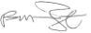
Patrick McIntyre
Chief Executive Officer
Disability in Australia
- 1 in 5 Australians (17.7% or 4.4 million people) identify as people with disability1
- 19.4% of people in the ACT identify as people with disability2
- More than 1 million people with disability are from non-English speaking backgrounds3
- 45.1% of Aboriginal and Torres Strait Islander people aged 15 and over experience disability4
- 20% of people with disability in Australia are twice as likely to be in the bottom 20% of gross household incomes5
- 45% of people with disability in Australia are living either near or below the poverty line, more than double the OECD average of 22%6
- 45% of the Australian population will experience a mental health condition at some point in their lives7
- 4.4% of people with disability in Australia use a wheelchair8
- 384,000 Australians are estimated to be blind or have low vision; approximately 10% are blind and 90% live with low vision9
- 1 in 6 Australians are impacted by hearing loss. There are approximately 30,000 Deaf Auslan users with total hearing loss10
The NFSA embraces the social model of disability. We recognise that the barriers people with disability experience are from the environment and the society they live in and are not inherent to their condition. By shifting the focus from a person’s medical diagnosis to barriers that may cause marginalisation through limiting participation, representation, autonomy and self-expression, we are empowered to make change by addressing these barriers.
Disability can be both permanent or temporary and hidden or visible. Within the definition of disability, we include people who are neurodivergent, people with mental health conditions, members of the d/Deaf community as well as people with chronic illness and disease. We also acknowledge the extensive support network provided by family members, friends and support workers for people with disability.
The NFSA recognises that not everyone who experiences barriers chooses to identify as disabled or as being a part of the disabled community. We also follow the principles of universal design, acknowledging that a one-size-fits-all approach is insufficient and recognising the intricacies of intersectionality within the realm of disability and that the act of identifying is a process that may take time for some.
- Recent Australian-wide surveys¹¹ have found that people with disability were more likely than people without disability to:
- Recognise the positive impacts of arts and creativity across all areas
- Agree that the arts allow them to connect with others
- Believe that the arts should receive public funding
- Affirm that creatives make an important contribution to society
- Give time or money to the arts
- Attend arts events
- Express themselves to improve their wellbeing and creatively participate in the arts
- Engage with the arts online.
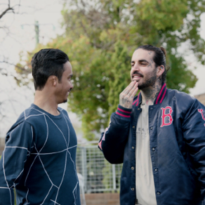
Lee and Nasir in the web series. The Streets Barber Stories.

Our Disability Inclusion Action Plan
The NFSA’s purpose is to tell the national story by collecting, preserving and sharing audiovisual media, the cultural experience platforms of our time. We acknowledge the disabled community as an integral part of our diverse national story and our inherent responsibility to make the national collection accessible and inclusive.
We aim to foster a culture of inclusivity, to make our physical and digital environments accessible, to continue to attract and support a diverse workforce, and to make our processes accessible for the benefit of everyone. Our Disability Inclusion Action Plan (DIAP) is an essential tool and resource to guide us in improving the inclusivity of our work. We work with and for people with disability to ensure that everyone can participate and be seen and heard as part of Australian society in the work we do.
Our previous Access Action Plan (2013–2023) outlined our commitment to providing accessible buildings, programs and activities and reaching the broadest possible community. Our staff are highly committed to access and inclusion and in this new plan, we will direct this energy to building on our existing achievements. As proud custodians of a unique and valuable public cultural asset, we will continue to foster a strong culture around diversity and inclusion.
This plan will identify our strengths and opportunities with regard to our strategic priorities within the framework of access. It will provide a strategy for accountability for our aims of inclusivity for Australians with disability.
Alignment with our Strategy
Our DIAP will allow us to deliver on our commitment to being Australia’s most dynamic and valued cultural organisation.
We are moving towards being a digital-first organisation and are already moving away from privileging those who can attend our premises in person to making the online experience the most important and valuable, which reduces some access barriers. The NFSA is committed to better and new uses of digital tools to increase discoverability and usage by all audience segments nationally.
This DIAP aligns with other key strategies and documents within the organisation, including the NFSA Strategic Direction 2022–25, Corporate Plan 2023–24 to 2026–27, Reconciliation Action Plan and Sustainability Strategy.

Our DIAP Goals
We have set ourselves the following goals to achieve over the course of this DIAP. In each of these four areas, we have developed a range of objectives and actions to deliver over the next four years.
Priority levels ranging from 1 to 4 have been designated to emphasise the significance of initiating an action point, rather than focusing on the timeframe for its completion. For example, actions required to attain a Priority 1 outcome will promptly commence, while those associated with Priority 4 will be addressed with relatively lower urgency.
These goals aim to remove or reduce barriers to full participation in experiences, programs and events, access to the collection, employment and all other activities:
- We reflect inclusive attitudes in all aspects of our work and through our connections and collaborations. Positive attitudes enable, engage and empower inclusive behaviours, reflect the society we live in and tell the Australian story.
- We are committed to providing access across our physical and digital spaces and to celebrating stories that represent the disabled community.
- We are dedicated to supporting the diversity, inclusivity and accessibility of our workplace. We will ensure people with disability have equal opportunity to gain and retain employment within an inclusive workplace culture. We maintain an ongoing commitment to learning and development around inclusivity and social awareness of disability.
- We embed access and inclusion into our systems, processes and technology, through a framework of regular feedback, review and reflection.
In lieu of formal guidelines for Commonwealth entities, we have chosen to follow the NSW Disability Inclusion Action Planning framework, which uses these four outcome areas, and to which our goals are aligned:
- Attitudes and behaviours
- Accessible and liveable communities
- Meaningful employment
- Systems and processes

Contributors
In formulating this DIAP, we collaborated with Accessible Arts, the peak arts and disability organisation in NSW. We also engaged with a diversity of stakeholders including partner organisations, community members and staff, who provided their insights and feedback on access and inclusion at the NFSA.
The consultation process included:
- Presentations and discussions with the NFSA Management Team
- A series of interviews with key staff from across the organisation and Executive
- An internal survey to all staff
- An external survey, sent to nearly 6,000 subscribers and available for visitors in Acton via QR code
- A series of focus groups with community, community partners and internal stakeholders
- A ‘walk and talk’ session with people with disability, to assess the physical spaces at Acton
- An audit of samples of NFSA documents and website pages to assess their accessibility
- A workshop to review the draft DIAP
- Interpretation workshops with individual teams
The NFSA thanks everyone who contributed their time, expertise and feedback to develop this plan. Building consultation processes with the disability community and associated key stakeholders is a key feature of the DIAP. This will ensure that designs for all new programs, and updates to the built and digital environments, are informed by – and provide agency to – audiences with disability.

Our achievements to date
Case Study: Dementia friendly screening pilot
The NFSA is proud to have been part of this pilot project, creating a model for running dementia friendly screenings; sensory-rich social activities that promote community connection, companionship and a connection to a sense of self and past for people with dementia.
The pilot was developed and delivered by the Dementia Friendly Screening team, with consultation and input from people with dementia and their caregivers. The team included Dr Jodi Brooks, Senior Lecturer at the School of the Arts and Media at the University of New South Wales; Dr Fincina Hopgood, Senior Lecturer in the School of Humanities, Arts and Social Sciences at the University of New England; and Karina Libbey, former Public Engagement Manager at the NFSA.
The pilot event took place in October 2022 at the NFSA Acton and involved:
- Holding a workshop and site visit in design stages, with representatives from Carers ACT, the Ministerial Advisory Council on Ageing, and Dementia Australia ACT’s network
- Screening The Sapphires (Wayne Blair, 2012), which aligned with dementia friendly guidelines and community input and was ideal for stimulating memory and enjoyment through music
- Displaying the blue sequinned dress from The Sapphires, connecting attendees to the content of the film
- Enhancing wayfinding signage and employing soft lighting to facilitate movement within the cinema
- Including an intermission, clearly communicated in the program and pre-screening welcome
- Offering an additional relaxed cinema space, with higher lighting and lower volume
- Catering a morning tea which encouraged interaction among attendees
- Providing a souvenir program with specific event details and feedback options
- Publishing a detailed schedule on the NFSA website which allowed guests to plan their day
- Having a photographer arranged by Carers ACT as well as a Polaroid camera on hand for capturing memories that participants could keep
- Upskilling and training staff, aided by Dementia Australia’s programs.
The pilot achieved its goals, providing inclusive social engagement for people with dementia and their families and working towards the broader de-stigmatisation of dementia through awareness-building and community connections. Attendees expressed gratitude for the experience which allowed them to share a meaningful activity with their loved one. Further screenings are planned for 2024 and onward, with the continuing support of the NFSA.
The Dementia Friendly Screening pilot exemplifies the power of collaboration, consultation and careful planning in creating an environment that promotes inclusivity, enjoyment and social connection for people living with dementia and their families.

Case Study: Accessibility in Arc cinema
In 2023, the NFSA Acton's Arc Cinema underwent a major upgrade in accessible technology with the implementation of the Dolby Accessibility Solution (DAS). This comprehensive system has transformed the cinema experience, by seamlessly integrating accessibility features and enabling a wide range of access options for diverse audiences.
Through the DAS, individual cinema audience members are equipped with receiver units, resembling mobile phones, which grant them the ability to personalise their viewing experience by selecting from a variety of accessibility options. These options include closed captions, audio descriptions, boosted audio, assisted listening and even sign language, with the expectation that more will be added in the future. The DAS system empowers viewers to choose and combine accessibility features to suit their unique requirements. This user-friendly and discrete approach allows us to meet each patron’s unique requirements.
The investment in DAS technology embodies our commitment to fostering a more inclusive cinematic environment and enhances the experience of people with accessibility needs, but also signifies a transformative step towards a more inclusive and welcoming entertainment precinct.

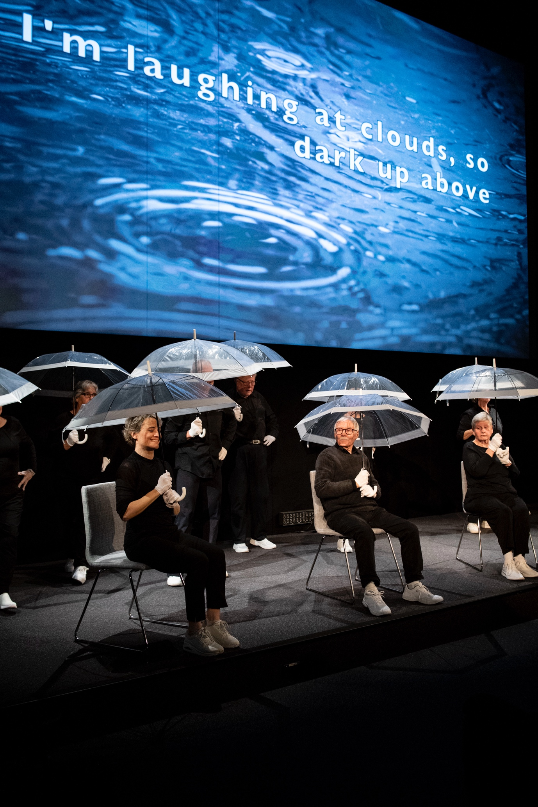
The Deaf Butterflies performing ‘Singin’ in the Rain’.

Disability Inclusion Action Plan goals and actions
Attitudes and behaviours
The attitudes and behaviours of the general community towards people with disability have been described as the single greatest barrier to full access and inclusion. Attitudes and behaviours permeate all aspects of life. Low expectations and negative attitudes about people with disability as artists serve as barriers to professional practice. Developing positive attitudes involves increasing awareness and changing negative perceptions over time.
Goal 1: We reflect inclusive attitudes in all aspects of our work and through our connections and collaborations. Positive attitudes enable, engage and empower inclusive behaviours, reflect the society we live in and tell the Australian story.
OBJECTIVE | ACTION | OWNER | PRIORITY LEVEL
1.1 DIAP  Successfully launch, implement, promote and report on the DIAP | DIAP launched, published on the NFSA website and shared with stakeholders | Executive, Communications, Editorial, Executive, Marketing | 1
1.1 DIAP  Successfully launch, implement, promote and report on the DIAP | Establish a committee to monitor the DIAP and oversee implementation and reporting | Executive, Governance | 1
1.1 DIAP  Successfully launch, implement, promote and report on the DIAP | Encourage the NFSA Diversity and Inclusion Network to advocate for access and inclusion issues | People and Culture | 1
1.2 Staff confidence and competence  Ensure all staff are appropriately skilled in accessibility and inclusion | Develop an education and training plan, with ongoing access to relevant resources, to ensure access and inclusion competence across the organisation | People and Culture | 1
1.3 Awareness of NFSA accessible services and programs  Increase visibility of the NFSA’s accessibility commitment and initiatives internally and externally | Include access information in marketing material for events | Marketing | 1
1.3 Awareness of NFSA accessible services and programs  Increase visibility of the NFSA’s accessibility commitment and initiatives internally and externally | Promote existing awareness schemes to support people with invisible disability, for example ‘The Sunflower’ | Programs | 1
1.3 Awareness of NFSA accessible services and programs  Increase visibility of the NFSA’s accessibility commitment and initiatives internally and externally | Ensure the website provides clear and useful information on accessible programs and services | Editorial, Marketing | 2
1.3 Awareness of NFSA accessible services and programs  Increase visibility of the NFSA’s accessibility commitment and initiatives internally and externally | Provide regular updates on accessible programs and services to staff | Communications | 2
1.3 Awareness of NFSA accessible services and programs  Increase visibility of the NFSA’s accessibility commitment and initiatives internally and externally | Communicate with audiences to ensure they are aware of current offerings and feel welcome in NFSA premises | Marketing | 2
1.3 Awareness of NFSA accessible services and programs  Increase visibility of the NFSA’s accessibility commitment and initiatives internally and externally | Where appropriate, work with disability service providers to increase external awareness of NSFA programs and accessibility options | Programs | 2
1.4 Representation and visibility  Allow the disabled community to see and hear themselves at NFSA events and online | Surface and highlight relevant collection material made by and including people with disability on the NFSA website and social media | Editorial, Marketing | 1
1.4 Representation and visibility  Allow the disabled community to see and hear themselves at NFSA events and online | Increase representation of people with disability across marketing and communications platforms and collateral | Communications, Editorial, Marketing | 2
1.5 The collection  Ensure the collection is representative of all Australians | Ensure collection policies, frameworks and procedures include a focus on representing stories made by and including people with disability | Collection Research and Development | 1
1.5 The collection  Ensure the collection is representative of all Australians | Conduct an audit to gauge the current collection profile of disability related representation | Collection Research and Development | 2
1.5 The collection  Ensure the collection is representative of all Australians | Review collection search filters and consider including disability related search options where appropriate | Digital Platforms | 3
1.6 Utilising expertise  Improve the NFSA’s understanding of access needs and utilise lived experience of people with disability to inform organisational decision-making | Establish and maintain strong, ongoing relationships with communities and networks relating to disability | Executive, Programs | 1
1.6 Utilising expertise  Improve the NFSA’s understanding of access needs and utilise lived experience of people with disability to inform organisational decision-making | Maintain ongoing consultation or research when planning accessible programs, events and updates to facilities | Capital Works, Programs | 1
1.6 Utilising expertise  Improve the NFSA’s understanding of access needs and utilise lived experience of people with disability to inform organisational decision-making | Utilise expertise from arts and disability related organisations and consultants, and organise user testing for evaluation and feedback where required | Project leaders | 1
1.6 Utilising expertise  Improve the NFSA’s understanding of access needs and utilise lived experience of people with disability to inform organisational decision-making | Scope the establishment of an external access and inclusion advisory group, which could be utilised across NFSA work areas and projects | DIAP Committee | 2

Accessible and liveable communities
Creating liveable communities for people with disability is more than modifying the physical environment. It covers areas such as access to transport, community recreation and culture, social engagement and universal design.
Goal 2: We are committed to providing access across our physical and digital spaces and to celebrating stories that represent the disabled community.
OBJECTIVE | ACTION | OWNER | PRIORITY LEVEL
2.1 Building accessibility  Improve the current level of accessibility of NFSA buildings | Consider access, inclusion and user experience for people with disability in all capital works projects | Capital Works | 1
2.1 Building accessibility  Improve the current level of accessibility of NFSA buildings | Scope the implementation of recommendations from disability related organisations and consultants, including the Accessible Arts Walk and Talk report | Capital Works, Property and Security | 1
2.1 Building accessibility  Improve the current level of accessibility of NFSA buildings | Scope access improvements to the McCoy Circuit entrance of the NFSA Acton building, navigating heritage constraints | Capital Works | 2
2.2 Bathroom facilities  Provide equitable and accessible bathroom facilities for people with disability | Consider updates to accessible bathrooms to ensure they align with current standards. This could include the addition of an adult changing facility | Capital Works | 3
2.3 Getting to the NFSA  Provide accessible transport and parking options | Ensure the website provides clear information on visiting NFSA Acton, including parking and entry options | Communications, Editorial | 1
2.3 Getting to the NFSA  Provide accessible transport and parking options | Review parking and transport to improve ease of access to accessible entry and exit points and improve associated signage | Property and Security | 4
2.4 Visual communication  Provide information in visual formats about getting to and experiencing physical spaces | Provide videos and additional information that supports people with disability to visit NFSA Acton | Editorial | 3
2.5 Wayfinding and signage  Provide information to assist people in navigating buildings and experiences | Improve signage, maps and wayfinding, and opportunities for independent navigation as part of a broader signage strategy | Capital Works, Marketing | 2
2.5 Wayfinding and signage  Provide information to assist people in navigating buildings and experiences | Provide information about accessible services and how to use them, such as hearing loops | Marketing, Programs | 2
2.5 Wayfinding and signage  Provide information to assist people in navigating buildings and experiences | Provide sensory guides/information for NFSA exhibitions and experiences | Exhibitions and Experiences | 2
2.6 Accessible experiences and events  Ensure exhibitions, experiences and events are designed and delivered with access and inclusion in mind | Continue to partner with relevant disability organisations on accessible programs, such as dementia friendly screenings | Programs | 2
2.6 Accessible experiences and events  Ensure exhibitions, experiences and events are designed and delivered with access and inclusion in mind | Deliver more public programs that celebrate the work of disabled creatives including filmmakers, composers and actors | Programs | 2
2.6 Accessible experiences and events  Ensure exhibitions, experiences and events are designed and delivered with access and inclusion in mind | Increase programs and sessions tailored for different communities such as neurodiverse groups or others with specific access needs, for example Blind/low vision community or d/Deaf community members | Programs | 3
2.6 Accessible experiences and events  Ensure exhibitions, experiences and events are designed and delivered with access and inclusion in mind | Develop accessible experiences and events guidelines for the NFSA. These could include which types of events should have Auslan, audio description, live captioning or other types of access services; and colours, labelling, contrast, height of displays and designated places to rest in exhibitions | Exhibitions and Experiences, Programs | 3
2.6 Accessible experiences and events  Ensure exhibitions, experiences and events are designed and delivered with access and inclusion in mind | Scope opportunities to work with innovators and key stakeholders to introduce more interactive accessible events and experiences | Exhibitions and Experiences, Programs | 4
2.7 Seating  Provide inclusive seating options for everyone | Provide a range of seating options for patrons, ensure space is provided to make available seating more accessible | Capital Works, Exhibitions and Experiences | 1
2.8 Quiet visitation  Provide quiet and/or low sensory options for people with sensory sensitivities | Establish a quiet space and/or quiet or low sensory visiting times for those with sensory sensitivities | Capital Works, Programs | 3
2.9 Ticketing  Ensure ticketing processes are suitable for those with access requirements | Scope the implementation of a booking system that is accessible through screen readers | Programs | 2
2.9 Ticketing  Ensure ticketing processes are suitable for those with access requirements | Provide direct contact information in relation to ticketing and visitor experience around accessibility | Programs | 2
2.10 Online and digital offerings  Ensure online and digital experiences provide access for people with disability | Improve the accessibility of online content through updates to the website and other online viewing tools | Digital Audience, Digital Platforms, Editorial | 2
2.11 Accessibility of the collection  Increase and enhance use and experience of the collection for people with disability | Consider which content should be prioritised for various access services, including captioning and audio description | Digital Platforms, Editorial, Marketing | 4

Meaningful employment
Employment rates for people with disability are significantly lower than for people without disability. People with disability experience multiple barriers at all stages of the employment process, ranging from inaccessible interview venues, lack of reasonable adjustments to the work environment, rigid role descriptions and online testing that may place applicants at a disadvantage. These factors reduce their opportunities to gain and retain employment. Research indicates that organisational commitment to workforce equality and inclusion is closely linked to strong business performance.
Goal 3: We are dedicated to supporting the diversity, inclusivity and accessibility of our workplace. We will ensure people with disability have equal opportunity to gain and retain employment within an inclusive workplace culture. We maintain an ongoing commitment to learning and development around inclusivity and social awareness of disability.
OBJECTIVE | ACTION | OWNER | PRIORITY LEVEL
3.1 Workforce planning  Ensure workforce planning appropriately considers disability and access | Ensure the NFSA’s workforce plan includes a commitment to disability recruitment and retention | People and Culture | 1
3.2 Inclusive recruitment and retention  Ensure recruitment processes and retention strategies utilised by the NFSA are inclusive | Engage specialists to review current recruitment practices | People and Culture | 1
3.2 Inclusive recruitment and retention  Ensure recruitment processes and retention strategies utilised by the NFSA are inclusive | Continue to promote internal systems for all staff to help support health and wellbeing in the workplace | People and Culture | 1
3.2 Inclusive recruitment and retention  Ensure recruitment processes and retention strategies utilised by the NFSA are inclusive | Provide hiring managers with training around inclusive recruitment in areas which could include supporting recruitment, interview and onboarding processes, and providing reasonable adjustments | People and Culture | 2
3.3 Increase employment of staff with disability  Increase representation of people with disability across the NFSA workforce | Ensure relevant staff surveys capture data on the number of staff identifying with disability and track this over time | People and Culture | 2
3.3 Increase employment of staff with disability  Increase representation of people with disability across the NFSA workforce | Establish strategies for tracking recruitment of staff with disability to meet Australian Public Service targets | People and Culture | 2
3.3 Increase employment of staff with disability  Increase representation of people with disability across the NFSA workforce | Scope the introduction of an identified role for a person with disability to work on access and inclusion at the NFSA | People and Culture, Executive | 2
3.3 Increase employment of staff with disability  Increase representation of people with disability across the NFSA workforce | Scope having paid internships and traineeships at the NFSA for people with disability | People and Culture | 2
3.4 Onboarding processes  Ensure onboarding processes are inclusive for all staff | Provide information, support materials and training as part of the onboarding process for new staff | People and Culture | 1
3.4 Onboarding processes  Ensure onboarding processes are inclusive for all staff | Review accessibility and support for new staff with access requirements | People and Culture | 1
3.5 Staff access requirements  Support the needs of staff with access requirements | Scope partnerships with disability network organisations to support staff with disability in the workplace | People and Culture | 1
3.5 Staff access requirements  Support the needs of staff with access requirements | Ensure evacuation processes and training consider staff with disability and their specific needs | Property and Security | 1
3.5 Staff access requirements  Support the needs of staff with access requirements | Promote the Diversity and Inclusion Network so staff with disability can come together where desired | People and Culture | 1
3.5 Staff access requirements  Support the needs of staff with access requirements | Consider an annual process for staff to update their access requirements once already working at the NFSA and encourage regular discussions surrounding access | People and Culture | 3
3.6 Accessible work environment  Improve the current level of accessibility of NFSA buildings | Seek input and feedback from staff on an annual basis relating to workplace barriers and solutions | People and Culture | 3
3.7 Procurement, contractors and third parties  Ensure accessibility standards are adhered to by third parties working with the organisation | Include accessibility considerations and requirements in procurement policies and contract agreements | Procurement | 3
3.7 Procurement, contractors and third parties  Ensure accessibility standards are adhered to by third parties working with the organisation | Scope the delivery of disability awareness education and training to third parties and contractors onsite at the NFSA Acton such as the cafe and security staff | People and Culture, Property and Security | 4
3.8 Creating a safe workplace  Provide a physically and psychologically safe workplace for staff | Implement safety mechanisms such as psychosocial risk assessments | People and Culture | 1
3.8 Creating a safe workplace  Provide a physically and psychologically safe workplace for staff | Ensure any changes to workspaces effectively meet the access needs of all staff | Capital Works, Property and Security | 1

Systems And Processes
A common barrier for people with disability is the difficulty navigating systems and processes to access the services, venues and support they need in the community. This could include accessing information, barriers to communication, or a lack of options to access services.
Goal 4: We embed access and inclusion into our systems, processes and technology, through a framework of regular feedback, review and reflection.
OBJECTIVE | ACTION | OWNER | PRIORITY LEVEL
4.1 Embedding access  Ensure access and inclusion principles and values are embedded across the organisation | Update venue hire information to ensure clients know what the NFSA offers in relation to accessibility | Programs | 1
4.1 Embedding access  Ensure access and inclusion principles and values are embedded across the organisation | Update organisational style guides to reference accessibility | Editorial, Marketing | 1
4.1 Embedding access  Ensure access and inclusion principles and values are embedded across the organisation | Regularly revisit and review DIAP progress within teams and implement improvement strategies as required | DIAP Committee | 2
4.2 Accessible technology  Utilise technology to increase accessibility across the NFSA | Continue to explore technical solutions and AI systems and tools for generating transcripts, entity analysis and voice activation | Digital Platforms | 3
4.3 Website accessibility (technical)  Increase and enhance user experience of the website for people with disability | Improve search function of the website and its discoverability, improve website navigation, enhance metadata | Digital Platforms | 1
4.3 Website accessibility (technical)  Increase and enhance user experience of the website for people with disability | Conduct accessibly and usability testing, including by people with disability, on new website and web updates and implement findings | Digital Platforms | 2
4.4 Access information  Provide comprehensive accessibility information online to help visitors navigate the NFSA and its collection | Update access request forms to include a field that captures client accessibility needs pertaining to exploration and use of the collection | Access | 2
4.4 Access information  Provide comprehensive accessibility information online to help visitors navigate the NFSA and its collection | Redesign the NFSA website’s accessibility pages and ensure they are easily found | Digital Audience, Digital Platforms, Editorial | 4
4.5 Social media  Increase the accessibility of NFSA social media posts | Include accessible elements such as image description, alt text and captioning on social media posts where possible | Communications, Marketing | 1
4.6 Marketing and communications  Ensure all marketing and communications are accessible to people with a range of access needs | Provide tailored training for the Marketing and Communications team on producing accessible content | People and Culture | 1
4.6 Marketing and communications  Ensure all marketing and communications are accessible to people with a range of access needs | Continue to use universal access symbols on marketing and communication material, ticketing and the NFSA website | Editorial, Marketing, Programs | 1
4.6 Marketing and communications  Ensure all marketing and communications are accessible to people with a range of access needs | Conduct outreach and work with communities and networks representing people with disability to increase awareness of NFSA activities | Communications, Marketing | 3
4.7 Document accessibility  Ensure all documents are available in accessible formats | Review and action items from the Accessible Arts Document Review report | Digital Audience, Marketing | 1
4.7 Document accessibility  Ensure all documents are available in accessible formats | Develop and communicate accessible document guidelines, for both internal and external documents | Marketing | 3
4.7 Document accessibility  Ensure all documents are available in accessible formats | Scope the provision of more content and materials in Easy Read format | Marketing | 3
4.8 Continuous improvement  Build methods of ongoing improvement around access and inclusion at the NFSA | Ensure feedback mechanisms across the organisation are accessible and available in a variety of formats | Project leaders | 4
4.8 Continuous improvement  Build methods of ongoing improvement around access and inclusion at the NFSA | Provide audiences with opportunities for ongoing feedback and consultation about access improvements across the NFSA | Marketing | 4

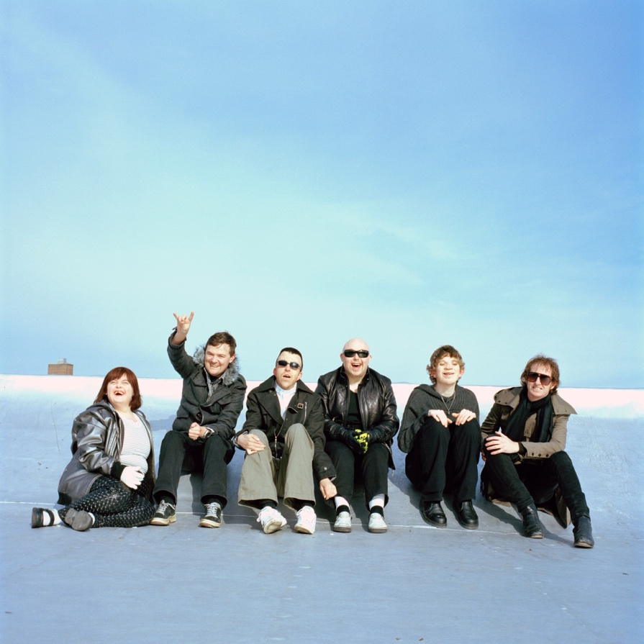
Members of the band Rudely Interrupted in the rock documentary. Rudely Interrupted.

Governance and policy context
The internal DIAP Committee will have oversight of the implementation of the plan. The committee will be made up of identified personnel from across the NFSA and will be led by a Coordinator.
The committee will meet at least twice per year to review key milestones and evaluate the continued effective application of the plan. They will report annually to the board on progress. The committee will engage community and external stakeholders for advice as required.
Legislation and policy
We have drawn from Australian legislative requirements and strategies to develop this plan. To ensure the rights of people with disability are upheld and protected, there have been significant changes to law and policy in Australia recently. We provide a summary of some of the key documents as follows.
International
Internationally, Australia is a signatory to the UN Convention on the Rights of Persons with Disabilities (2008). This Convention recognises that disability is “an evolving concept and that disability results from the interaction between persons with impairments and attitudinal and environmental barriers that hinders their full effective participation in society on an equal basis with others”.¹²

National
At a federal level, Australia has had the Disability Discrimination Act for over 30 years (since 1992). Various Australian standards and frameworks support this Act, including the Disability (Access to Premises – Buildings) Standards (2010), Building Code of Australia (BCA), Disability Standards for Accessible Public Transport (2002), World Wide Web Access: Disability Discrimination Act Advisory Notes (2014) and Disability Standards for Education (2005).
The National Disability Insurance Scheme (NDIS) was implemented in 2014 to provide Australians with permanent and significant disability with the reasonable and necessary supports they need to live an ordinary life.
A three-year Royal Commission into Violence, Abuse, Neglect and Exploitation of People with Disability commenced in Australia in 2019 and delivered its final report in 2023. It is a broad enquiry into the challenges that people with disability face in Australia, with the aim of uncovering the truth about our past and current treatment of people with disability. The inquiry has provided recommendations to government on how to better protect people with disability from all forms of violence, abuse, neglect and exploitation, and how to achieve best-practice reporting and investigation processes. The royal commission aims to promote a more inclusive society that supports the independence of people with disability and their inherent rights.
The Australian Disability Strategy (ADS) 2021-2031 was recently released to provide a unified national approach to building inclusion for people with disability in Australia. The strategy guides activity across all areas of public policy to achieve the vision of an inclusive Australian society that ensures people with disability can fulfil their potential, as equal members of the community. The rights of people with disability are central to the strategy, which aims to drive mainstream services and systems to improve outcomes for people with disability. It engages the whole community in achieving a more inclusive society.
Our DIAP aligns with other international, national and Australian Capital Territory social policy and frameworks including:
- United Nations Sustainable Development
- Goals (2017)
- Disability Discrimination Act 1992 (Commonwealth)
- Disability Services Act 1986 (Commonwealth)
- Australian Public Service Disability Employment Strategy 2020-2025 (Commonwealth)
- National Arts and Disability Strategy 2009 (Commonwealth)
- Disability Services Act 1991 (Australian Capital Territory)
- Disability Justice Strategy 2019-2029 (Australian Capital Territory)
- World Wide Web Consortium (W3C) Web Content Accessibility Guidelines (WCAG).

Endnotes
- Australian Bureau of Statistics 2019, Disability, ageing and carers, Australia: Summary of findings, retrieved 30 January 2024 www.abs.gov.au
- Australian Bureau of Statistics 2019, Disability, ageing and carers, Australia: Summary of findings, retrieved 30 January 2024, www.abs.gov.au
- National Ethnic Disability Alliance 2010, What does the data say? People from NESB with disability in Australia, retrieved 30 January 2024, library.bsl.org.au/what-does-the-data-say.pdf
- Australian Bureau of Statistics 2016, 4714.0 - National Aboriginal and Torres Strait Islander social survey, 2014-15, retrieved 30 January 2024, www.abs.gov.au
- Australian Bureau of Statistics 2016, 4430.0 - Disability, ageing and carers, Australia: Summary of findings, 2015, retrieved 30 January 2024, www.abs.gov.au
- PricewaterhouseCoopers 2011, Disability expectations: Investing in a better life, a stronger Australia, Price Waterhouse Coopers, retrieved 30 January 2024, www.pwc.com.au/disability-in-australia.pdf
- Australian Bureau of Statistics 2008, National survey of mental health and wellbeing: Summary of results, retrieved 30 January 2024, www.abs.gov.au
- Australian Bureau of Statistics 2019, Disability, ageing and carers, Australia: Summary of findings, retrieved 30 January 2024, www.abs.gov.au
- Vision Australia 2018, Our mission, Our story, retrieved 30 January 2024, www.visionaustralia.org/Our-Mission-Our-Story.pdf.
- Access Economics Pty Ltd 2006, Listen hear! The economic impact and cost of hearing loss in Australia, retrieved 30 January 2024, hearnet.org.au/Listen-Hear.pdf
- Australian Network on Disability 2017, 2017 Disability confidence survey report, retrieved 30 January 2024, and.org.au/Disability_Confidence_Survey_Report.pdf
- United Nations 2008, Convention on the Rights of Persons with Disabilities, retrieved 30 January 2024, www.un.org/convention.pdf

McCoy Circuit, Acton ACT 2601
+61 2 6248 2000
Freecall: 1800 067 274
The NFSA also has offices in Sydney and Melbourne and Access Centres in state libraries in Hobart, Brisbane, Adelaide, Darwin and Perth.
NFSA.GOV.AU

