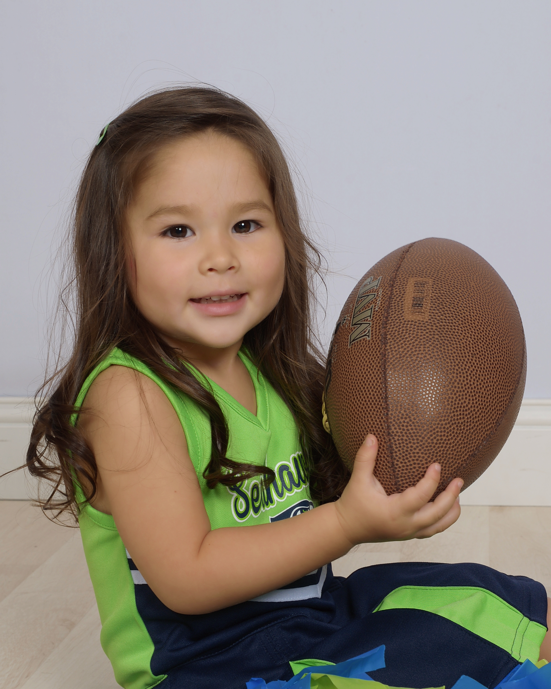

Giselle Pier

Agency Contact: damon@actorsinaction.com
(503) 780-7555 www.actorsinaction.com
Birthday 05/05/2016
Height: 3’ 16”
Weight: 20 lbs
Pant: 3T
Shoe: 7 (toddler)
Neck: 10 1/2”
Chest: 21”
Waist: 21 1/2”
Hip: 22”
Eye color: brown
Hair Color: brown

Special Skills/ Hobbies

Enjoys playing with friends outdoor, sing, dance, and act pretending to be Elsa from Frozen , Spanish-English

