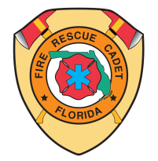

2026 SJCFR FIREMATICS
PERSONAL HEALTH RECORD/CONSENT

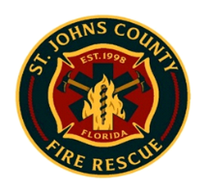

To be filled out by parent, guardian, or adult participant. Please print in ink.
Identification :

Name ______________________________________________________ Date of birth _____________ Age _______ Sex ________

Name of parent or guardian ______________________________________________Telephone ______________________________

Home address ____________________________________________ City____________________ State______ Zip _____________

Cadet/Explorer Post Name and Number: ___________________________________ Advisor: ______________________________

If person named above is not available in the event of an emergency, notify:

Name ___________________________________________ Relationship__________________ Telephone _____________________

Name of personal physician ______________________________________________________ Telephone _____________________

Personal health/accident insurance carrier ___________________________________________ Policy no. _____________________

Check all items that apply, past or present, to your health history. Explain any “Yes” answers.

ALLERGIES: Food, medicines, insects, plants: Yes  No  Explain: ______________________________________________

GENERAL MEDICAL INFORMATION:

ADHD (Attention-Deficit)? Yes No History of heat stress? Yes No Hemophilia? Yes No   
Convulsions/Seizures? Yes No High blood pressure? Yes No Asthma? Yes No  
 
Diabetes? Yes No Kidney disease? Yes No Heart trouble? Yes No   
Explain: ____________________________________________________________________________________________________

Please list ALL medications taken in the 30 days prior to arrival at the Fire Cadet activity where this from is to be used: ___________________________________________________________________________________________________________

List any medications to be taken during fire cadet event, including drug, dosage, route (oral, injection, etc.), and frequency:
____________________________________________________________________________________________________________

List any physical or behavioral conditions that may affect or limit full participation in fire ground type activities:
___________________________________________________________________________________________________________

I give permission for full participation in the Fire Cadet activity held at the 2024 Pasco Firematics Competition, subject to limitations noted herein. In case of emergency, I understand every effort will be made to contact me (if participant is an adult, my spouse or next of kin). In the event I cannot be reached, I hereby give my permission to the licensed health-care practitioner selected by the adult leader in charge to secure proper treatment, including hospitalization, anesthesia, surgery, or injections of medication for my child (or for me, if participant is an adult).

Signature of Parent/Guardian or adult _________________________________________________________ Date _______________

Printed Name of Parent/Guardian or adult: _________________________________________________________________________

Signature of Witness: ______________________________________________________________________Date: _______________

Printed Name of Witness: ______________________________________________________________________________________

