
📈 Awareness

Awareness:

✍️ What has brought you joy over the last quarter?

✍️What has weighed you down? If you named a situation (eg. work presentation) what is the emotion that comes up for you?

📈 Recognising

✍️What are the top 3 emotions you’ve felt over the last few weeks?

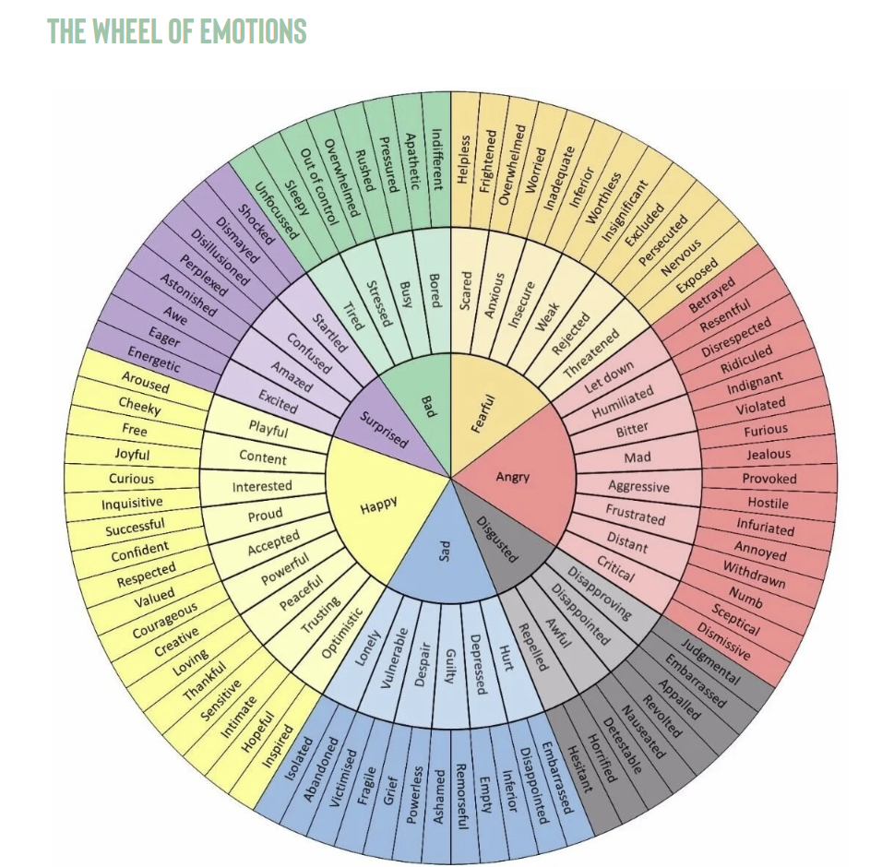

✍️What are the early signs - where in your body can you feel it?

eg. I feel tightness in my chest
I feel tension in my neck/shoulders
I clench my jaw and breathe shallow

✍️What patterns do you notice that emotionally disregulate you, what do you currently do to help this?

eg. Poor sleep hygiene, or hormones up/down = feeling more intolerant and reactive; and I’m less productive in my work.

What I currently do is have 3 coffees a day to get through and just take some deep breaths outside.

✍️What triggers in your environment cause you to feel emotionally disregulated?

eg. constant notifications from devices,demanding boss or clients, young kids, challenging relationships with partner/family/friends/colleagues, loud people, erratic noises, working around construction, or meeting in concrete floor cafes with blenders and coffee grinders going, bad sleep; cycle timing and hormones, phone/laptop notifications.

📈 Permission & Softening

✍️What tools, techniques, methods have you tried to help you regulate?

eg. box breathing, meditation, walking in nature, journaling and venting, brain dumping

✍️What strategies could you add to your emotional regulation toolkit?
eg. tapping, 10second mindfulness, music to change state, gratitude rant to uplift your state.

📈Accountability / Health Habits [10 mins]

✍️ Recall your goals / intentions from the start of the year.
What tools or strategies will help you stay focused if roadblocks arise?

