ESF Lord’s Day Sermon
8/2/2026
Dr. Jin M Cho
Called to Shine
I Peter 2:9–12
Intro.
Good morning.
I’d like to begin with a simple confession. I am standing here today because of one man. The remarkable thing is that he never knew my name. He never met me, and he passed away long before I was born. Yet I am standing here today because of him.
Have you ever had someone like that in your life? Someone who changed the direction of your life without ever knowing you? Today, I want to tell you about that man.
About 140 years ago, the first Protestant missionary arrived in Korea. His name was Horace Underwood.
(Picture – Horace Underwood) 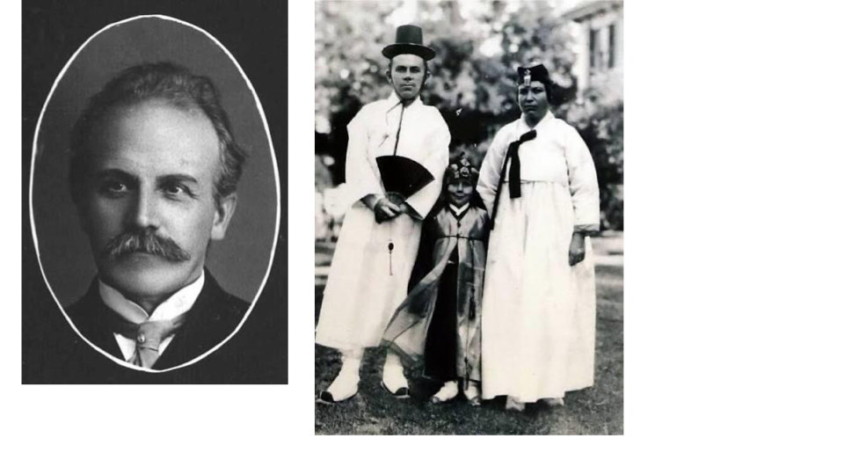
Today, Korea is well known around the world. People know Samsung, Hyundai, Kia, K-pop, and Korean culture. But when the missionary arrived, Korea was almost unknown to the world. Most people could not even find Korea on a map.
Yet this 26-year-old missionary believed that every Korean deserved the opportunity to hear the gospel. He did not know that thousands of churches would one day be established. He did not know that millions of Koreans would one day confess Jesus Christ. He certainly did not know that one day I would stand in a church in American telling his story.
He came for one reason: he believed that God had called him.
Whenever I think about his life, I find myself asking one question: Why does God ask us to be faithful when we may never see the results? I believe today's passage answers that question.

Called Before We Are Sent
Please turn with me to 1 Peter 2:9. Peter writes, " But you are a chosen people, a royal priesthood, a holy nation, God’s special possession,..." (I Peter 2:9a)
When we read those words, it is easy to imagine Peter speaking to great Christian leaders. But he wasn't. Peter was writing to believers scattered throughout the Roman Empire.
I know many of you are already familiar with the background of this letter, so I won't spend much time on it. They were facing rejection, suffering, and pressure because they followed Christ. The world looked at them and saw insignificant people. God looked at them and called them His chosen people. What an incredible difference!
Before Peter tells them what to do, he reminds them who they are. The world asks, "What have you accomplished? What are you capable of doing?" But God asks a very different question: "Who are you?" The Christian life always begins there. It does not begin with our performance, our accomplishments, or our abilities. It begins with our identity. Before God calls us to do anything, He tells us who we are. We are His chosen people, His royal priesthood, His holy nation, and His own possession. In other words, God is saying, "You are Mine."
Then Peter tells us why. He begins with two simple words: "that you may..." Those words connect our identity with our mission. God's calling always begins with identity and leads to purpose.

Called to Shine
Peter continues, "... that you may declare the praises of him who called you out of darkness into his wonderful light. " (v. 9b)
Those words, "that you may," reveal God's purpose for His people. Why does God say, “You are Mine”? Peter gives us one simple answer: so that we may declare His praises.
Many people think salvation is the finish line. Peter says it is the starting line. God did not simply save us from something; He also saved us for something. He called us out of darkness so that we might shine in the darkness.
When we hear the word declare, we usually think about speaking. And that is certainly part of it. The gospel must be proclaimed. But Peter has something much bigger in mind. Just a few verses later he says, " Live such good lives among the pagans that, though they accuse you of doing wrong, they may see your good deeds and glorify God on the day he visits us." (v. 12) Peter understood that declaring God's greatness is not only something we say. It is something we live. That is why God does not keep His people inside the church. He sends us into our homes, our neighborhoods, our schools, our workplaces, and every corner of society. Light was never meant to remain inside the church. Light shines where there is darkness.
The believers Peter wrote to never imagined what lay ahead. They had no idea they would become part of God's great story. But they did.
The same was true of Horace Underwood. He simply lived the calling Peter describes. God said, "You are Mine." Then God said, "Go and let My light shine through your life." Underwood never saw the full harvest, but his faithful obedience became part of God's great story.
He established schools, helped begin hospitals, preached the gospel, taught the Scriptures, and planted churches. But behind everything he did was one purpose. He never tried to make his own name great. He wanted people to know the greatness of God. In Peter's words, Underwood declared “the praises of him who called you out of darkness into his wonderful light. " (v. 9b). He shared the gospel not only by what he said, but by the way he lived.

God never asked Underwood to produce the harvest. He simply asked him to be faithful. The harvest belonged to God then, and it still belongs to God today. Our responsibility is faithfulness. The results belong to God.

The Story Continues
The seeds Underwood planted reached places he could never have imagined. One of those places was my family. My grandfather studied at Pyongyang Theological Seminary, Korea's first theological seminary. He devoted his life to preaching the gospel and planting churches.
Eventually, he was martyred for his faith. But the story did not end there. The faith reached my father and his three brothers. All four devoted their lives to serving Christ as pastors. Eventually, that same faith reached me.
Sometimes I stop and think about that. Underwood never knew my family. But God did. God took the faithfulness of one servant and used it to bless one generation after another. That is how God writes His story.
More than forty years ago, God brought me from Korea to Chicago. The first church I attended was the Korean church where my father was serving as the senior pastor. One of the associate pastors on the staff faithfully led the young adult ministry. Every week he guided us through a Bible study workbook called Search the Scriptures. Week after week, he taught us how to read the Bible carefully, how to understand God's Word faithfully, and how to apply it to everyday life. Those Bible studies shaped me deeply.
You may be wondering who that young associate pastor was. It was your senior pastor, Rev. Timothy Hong.
At that time, neither of us could have imagined that one day I would stand here in this church, sharing God's Word with him.
Again, that is how God writes His story! He connects one life to another, one generation to the next, accomplishing far more than any of us can see.

Now It Is Our Turn
Before coming here today, I found myself reading about Horace Underwood once again. Not simply as one of the first missionaries to Korea, but as a man who quietly trusted God. Among the many things he wrote, one sentence especially stayed with me. He wrote it after seeing one of his first Korean converts come to faith in Christ. Looking at that one new believer, Underwood wrote:
"We knew that day had begun to dawn in dark Korea and felt sure that one believer was a pledge... of a people whom He would make His own." (Horace Underwood)
What an extraordinary statement. Underwood saw one believer. God saw a nation. Underwood could only see one person standing before him, but by faith he believed that God was already doing something far greater than anyone could imagine.
When Underwood looked at that first believer, he had no idea that one day there would be a family like mine. But God did. I stand before you today because one missionary believed that God was already at work in Korea. I am the fruit of a missionary.
Then another thought came to me. I am not the only one who can say that. Every one of us is the fruit of someone else's faithfulness. Perhaps it was your parents who first taught you about Jesus. Perhaps it was a pastor, a Sunday school teacher, a campus minister, a missionary, or simply a faithful friend. Someone reflected the light of Christ into your life, and because they were faithful, you are here today.
That is exactly what Peter reminds us in this passage. We are “a chosen people, a royal priesthood, a holy nation, God’s special possession,..." (I Peter 2:9a), and we have been called for a purpose: "... that you may declare the praises of him who called you out of darkness into his wonderful light. " (v. 9b)
That calling was for neither Peter's readers nor Horace Underwood alone. It is God's calling for every one of us. We may never know the full harvest of our faithfulness. Underwood never did. The harvest belongs to God. Our calling is simply to be faithful and to let our light shine where God has placed us.
So let me leave you with one question.
Who will become the fruit of your faithfulness?
Peter understood that declaring God's greatness is not only something we say. It is something we live. Perhaps, years from now, perhaps even generations from now, someone will thank God for your life, just as I thank God today for the missionary who faithfully followed God's call.
You may never know that person's name. You may never see the harvest. But God will.
Now hear the voice of God.
"You are Mine."
"Now go and let your light shine."

Hello! Thank you for your help.
There are subtitles, but they don't need to be included in the PowerPoint.

