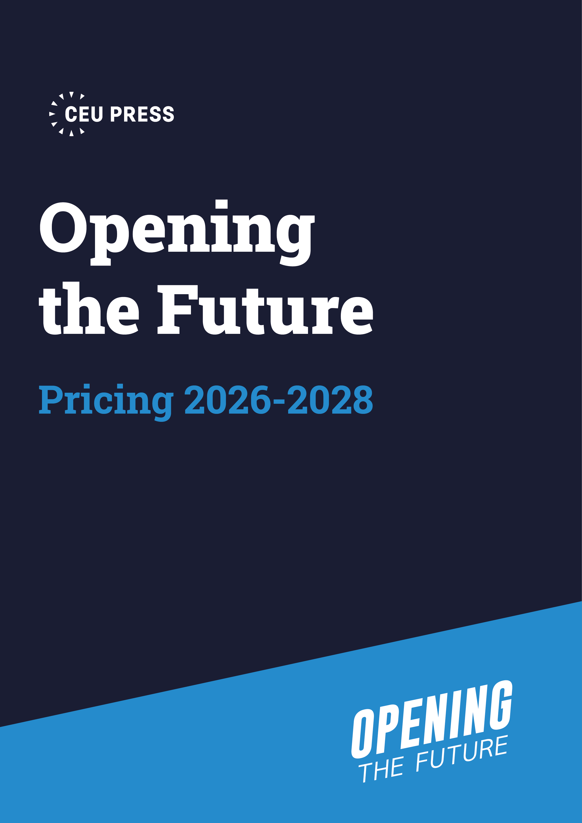
CEU Press Opening the Future
Pricing 2026-2028
Prices valid at time of writing (January 2026), valid for libraries who join to support the model in 2026 and 2027. Future prices subject to change. Updated pricing will be released later in 2026 for those libraries whose membership will begin in 2027 or subsequent years.

This pricing document covers the subscription periods 2026-2028.

Contents
About the model 3
United Kingdom 4
Europe and Rest of World 6
United States and Canada 8
Library consortia offers 10
Contacts and how to stay in touch 10

About the model
Opening the Future (OtF) funds BPC-free open access book publishing while also broadening your own collection through an affordable subscription to closed content.

We're reshaping how knowledge dissemination is funded and accessed, by leveraging the collective contributions of academic libraries worldwide. Your Opening the Future membership funds a press to publish new OA monographs, while your library benefits from access to closed content, and no single institution bears a disproportionate burden. For a modest annual fee your library gets DRM-free, unlimited access to a closed-access selection of a publisher's backlist, with perpetual access after three years. The membership revenue is used by the publisher solely to produce new OA monographs, moving towards an affordable, sustainable model for academic publishing and creating a collection of OA books that are open for the world.

Through OtF, collections can grow at vastly reduced fees while simultaneously funding future OA books. Be part of something special. Join over 100 Universities around the world already committed to Opening the Future.

The model was developed and implemented at CEU Press in partnership with Copim.

United Kingdom
For UK institutions, we base our tiers on the Jisc banding system. You can find your Jisc band at subscriptionsmanager.jisc.ac.uk/about/jisc-banding.
Backlist packages: History, Politics, Librarian’s Choice, Editors’ Choice, East Meets West, and OA Supporter Membership (no content)
Tier | 2026 | 2027 | 2028
Jisc Band 1-3 | £ 1158 | £ 1216 | £ 1277
Jisc Band 4-5B | £ 811 | £ 852 | £ 894
Jisc Band 6-10 | £ 348 | £ 365 | £ 383
Midlist package: Past Meets Present
Tier | 2026 | 2027 | 2028
Jisc Band 1-3 | £ 1745 | £ 1832 | £ 1924
Jisc Band 4-5B | £ 1050 | £ 1103 | £ 1158
Jisc Band 6-10 | £ 630 | £ 662 | £ 695
Shown in the tables are the annual fees in GBP (Pound Sterling, £) per package per year, excluding VAT. Membership term is for a minimum of 3 years and Libraries can sign up for more than one package. Due to rising publication costs, a 5% annual increase has been applied for annual payments.
If you would like to prepay your entire 3-year subscription in one go, please refer to the tables below. The one-off payment option benefits from a fixed annual price with no price increase during the 3-year term. Price is per package, excluding VAT.
Backlist packages: History, Politics, Librarian’s Choice, Editors’ Choice, East Meets West, and OA Supporter Membership (no content)
Tier | 3-year prepayment in one payment - 2026 | 3-year prepayment in one payment - 2027 | 3-year prepayment in one payment - 2028
Jisc Band 1-3 | £ 3474 | £ 3648 | £ 3831
Jisc Band 4-5B | £ 2433 | £ 2556 | £ 2682
Jisc Band 6-10 | £ 1044 | £ 1095 | £ 1149

Midlist package: Past Meets Present
Tier | 3-year prepayment in one payment - 2026 | 3-year prepayment in one payment - 2027 | 3-year prepayment in one payment - 2028
Jisc Band 1-3 | £ 5235 | £ 5496 | £ 5772
Jisc Band 4-5B | £ 3150 | £ 3309 | £ 3474
Jisc Band 6-10 | £ 1890 | £ 1986 | £ 2085

To sign up as a member
subscriptionsmanager.jisc.ac.uk - invoicing is handled by Jisc.

For more information
https://www.aup.nl/en/open-access/opening-the-future
Invoicing queries: help.digitalresources@jisc.ac.uk
General queries:
Kat Baier (UK, Europe and ROW), k.baier@aup.nl
Yulia Laktinova (Eastern Europe), y.laktionova@aup.nl
Linda McGrath (DACH, US and Americas), l.mcgrath@aup-germany.de

Europe and Rest of World
European/ROW institution tiers are based on FTE.
If your institution is based in a country covered by the Research4Life programme, please use the smallest tier pricing.
Backlist packages: History, Politics, Librarian’s Choice, Editors’ Choice, East Meets West, and OA Supporter Membership (no content)
Tier | 2026 | 2027 | 2028
European/ROW small institutions 1-5000 | € 405 | € 425 | € 446
European/ROW medium sized institutions 5001-10000 | € 926 | € 972 | € 1021
European/ROW large institutions 10001+ | € 1389 | € 1458 | € 1531
Midlist package: Past Meets Present
Tier | 2026 | 2027 | 2028
European/ROW small institutions 1-5000 | € 725 | € 761 | € 799
European/ROW medium sized institutions 5001-10000 | € 1205 | € 1265 | € 1329
European/ROW large institutions 10001+ | € 2010 | € 2111 | € 2217
Shown in the tables are the annual fees in EUR (Euro, €) per package per year, excluding VAT. Membership term is for a minimum of 3 years and Libraries can sign up for more than one package. Due to rising publication costs, a 5% annual increase has been applied for annual payments.
If you would like to prepay your entire 3-year subscription in one go, please refer to the tables below. The one-off payment option benefits from a fixed annual price with no price increase during the 3-year term. Price is per package, excluding VAT.
Backlist packages: History, Politics, Librarian’s Choice, Editors’ Choice, East Meets West, and OA Supporter Membership (no content)
Tier | 3-year prepayment in one payment
European/ROW small | € 1215 | € 1275 | € 1338
European/ROW medium | € 2778 | € 2916 | € 3063
European/ROW large | € 4167 | € 4374 | € 4593
Midlist package: Past Meets Present
Tier | 3-year prepayment in one payment
European/ROW small | € 2175 | € 2283 | € 2397
European/ROW medium | € 3615 | € 3795 | € 3987
European/ROW large | € 6030 | € 6333 | € 6651

As of August 2024, CEU Press are working in partnership with Amsterdam University Press (AUP). As a result, the invoicing is now handled by AUP for European customers.

To sign up as a member
https://www.aup.nl/en/open-access/opening-the-future
Email us to sign up:
Kat Baier (UK, Europe and ROW), k.baier@aup.nl
Yulia Laktinova (Eastern Europe), y.laktionova@aup.nl
Linda McGrath (DACH, US and Americas), l.mcgrath@aup-germany.de

For more information
https://www.aup.nl/en/open-access/opening-the-future
General and invoicing queries: Kat Baier (UK, Europe and ROW), k.baier@aup.nl
Yulia Laktinova (Eastern Europe), y.laktionova@aup.nl
Linda McGrath (DACH, US and Americas), l.mcgrath@aup-germany.de

United States and Canada
Banding for US institutions is tiered, based on the Basic Carnegie Classification. For Canadian institutions the tiers are based on CRKN banding.
Backlist packages: History, Politics, Librarian’s Choice, Editors’ Choice, East Meets West, and OA Supporter Membership (no content)
Tier | 2026 | 2027 | 2028
Associate’s Colleges | CRKN Bands 1–5 | $ 491 | $ 516 | $ 541
Baccalaureate/Master’s Colleges & Universities | CRKN Bands 6–9 | $ 1100 | $ 1155 | $ 1213
Doctoral Universities | CRKN Bands 10–13 | $ 1650 | $ 1733 | $ 1820
Midlist package: Past Meets Present
Tier | 2026 | 2027 | 2028
Associate’s Colleges | CRKN Bands 1–5 | $ 850 | $ 893 | $ 938
Baccalaureate/Master’s Colleges & Universities | CRKN Bands 6–9 | $ 1417 | $ 1488 | $ 1562
Doctoral Universities | CRKN Bands 10–13 | $ 2363 | $ 2481 | $ 2605
Shown in the tables are the annual fees in USD (US Dollars, $) per package per year, excluding VAT. Membership term is for a minimum of 3 years and Libraries can sign up for more than one package. Due to rising publication costs, a 5% annual increase has been applied for annual payments.
If you would like to prepay your entire 3-year subscription in one go, please see the tables below. The one-off payment option benefits from a fixed annual price with no price increase during the 3-year term. Price is per package, excluding VAT.
Backlist packages: History, Politics, Librarian’s Choice, Editors’ Choice, East Meets West, and OA Supporter Membership (no content)
Tier | 3-year prepayment in one payment 2026 | 3-year prepayment in one payment 2027 | 3-year prepayment in one payment 2028
Associate’s Colleges | CRKN Bands 1–5 | $ 1473 | $ 1548 | $ 1623
Baccalaureate/Master’s Colleges & Universities | CRKN Bands 6–9 | $ 3300 | $ 3465 | $ 3639
Doctoral Universities | CRKN Bands 10–13 | $ 4950 | $ 5199 | $ 5460

Midlist package: Past Meets Present
Tier | 3-year prepayment in one payment | 3-year prepayment in one payment 2027 | 3-year prepayment in one payment 2028
Associate’s Colleges | CRKN Bands 1–5 | $ 2550 | $ 2679 | $ 2814
Baccalaureate/Master’s Colleges & Universities | CRKN Bands 6–9 | $ 4251 | $ 4464 | $ 4686
Doctoral Universities | CRKN Bands 10–13 | $ 7089 | $ 7443 | $ 7815

Invoicing is handled by Lyrasis, a respected non-profit library partner based in the USA. Lyrasis will process the invoices in USD, using the exchange rate valid on the day of order.

To sign up as a member
lyrasis.org/content/CEUPress

For more information
https://www.aup.nl/en/open-access/opening-the-future

Invoicing queries: max.stecker@lyrasis.org and membersupport@lyrasis.org

General Queries:
Kat Baier (UK, Europe and ROW), k.baier@aup.nl
Yulia Laktinova (Eastern Europe), y.laktionova@aup.nl
Linda McGrath (DACH, US and Americas), l.mcgrath@aup-germany.de

Library consortia offers
If your institution is a member of a library consortium, and would like to propose Opening the Future for consortium participation, please contact Kat Baier, Head of Sales (k.baier@aup.nl) at CEU Press for a consortium proposal and customised price offer.

Contacts and how to stay in touch
- Contact Kat Baier (CEU Press Head of Sales) with any questions at k.baier@aup.nl

- Subscribe to CEU Press’ newsletter to receive updates about CEU Press and Opening the Future.

- Follow us on LinkedIn

