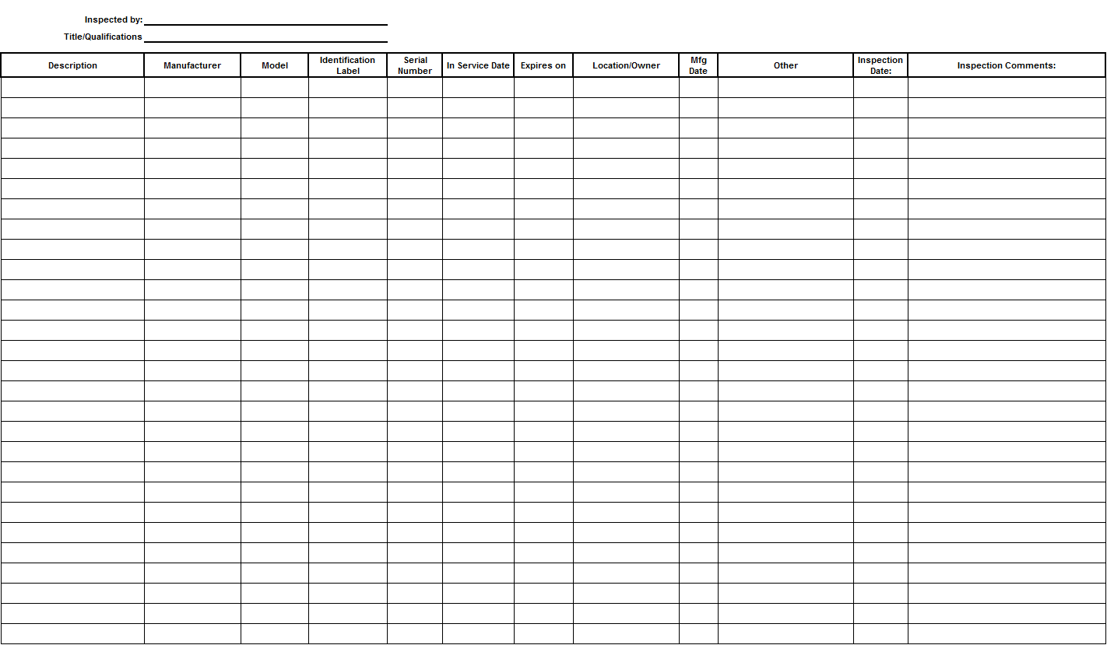**Fall Protection Equipment Inspection Form**

**Note:** Inspection Criteria located on Page 2 and 3.

|  |  |  |  |  |
| --- | --- | --- | --- | --- |
| **Item** | **Inspection Criteria** | | | |
| **Full Body Harness** | General   * Inspect according to the manufacturer’s instructions. * Verify manufacturer’s label is intact and legible. * Determine if the harness is beyond the manufacturer’s recommended life span. (As specified by the manufacturer. If not specified, 5 years from the date put in service unless it fails inspection first). | | | |
| D-rings, Connecting/Adjustment Buckles   * Deformity (bent grommets or tongues, bowed buckles) * Cracks * Burrs * Corrosion * Chemical/Paint damage * Other * Spring and function (adjustment buckles specific) | | Webbing   * Burns, holes or melted areas * Welding slag * Chemical/Paint damage * Cuts/Tears * Abrasion damage * UV damage * Impact indicators (grommets, D-ring pad, designed indicators, heat signatures) * Stitching for pulls or frays * Webbing end for triple termination * Webbing loops for excessive wear due to metal components | |
| **Lanyards** | General   * Inspect according to the manufacturer’s instructions. * Verify manufacturer’s label is intact and legible. * Determine if the harness is beyond the manufacturer’s recommended life span. (As specified by the manufacturer. If not specified, 5 years from the date put in service unless it fails inspection first). | | | |
| Snaphooks, Hardware, & Carabiners   * Deformity * Cracks * Burrs * Corrosion * Chemical/Paint Damage * Gate function * Other | Webbing   * Burns, holes or melted areas * Welding Slag * Chemical/Paint Damage * Cuts/Tears * Abrasion damage * UV damage * Impact indicators (grommets, D-ring pad, designed indicators, heat signatures) * Stitching for pulls or frays * Webbing end for triple termination * Webbing loops for excessive wear due to metal components | | Energy Absorber   * Signs of deployment * Pouch   + Holes   + Burns   + Chemical/Paint damage   + Broken or frayed stitching |
| **Self-Retracting Lifelines** | Inspect according to the manufacturer’s instructions.  Verify:   * Manufacturer’s label is intact and legible * No visible damage to the housing * Connectors are in good condition * Impact indicator is “ok” * Cable or web lanyard is in good condition * Locking device activates when pulled quickly | | | |

|  |  |
| --- | --- |
| **Item** | **Inspection Criteria** |
| **Vertical Rope Lifeline** | General   * Inspect according to the manufacturer’s instructions. * Verify manufacturer’s label is intact and legible. * Determine if the harness is beyond the manufacturer’s recommended life span. (As specified by the manufacture. If not specified, 5 years from the date put in service unless it fails inspection first).   Snaphooks & Carabiners   * Deformity * Cracks * Burrs * Corrosion * Chemical/Paint Damage * Gate Function * Other |
| **Horizontal Lifeline (manufactured kit)** | * Verify manufacturer’s label is intact and legible. * Inspect according to the manufacturer’s instructions.   **Note:** Pre-designed horizontal life lines are installed in accordance with manufacturer's instructions and used under the supervision of a Fall Protection Competent Person. Horizontal life lines which have not been pre-designed for a specific purpose are designed and installed under the supervision of a Fall Protection Qualified Person - Work at Heights. |