

Press Release

L-Acoustics Brings Whole-Home Audio Solution
to Luxury London Home

Extensive audio ecosystem ensures consistent high-quality audio throughout

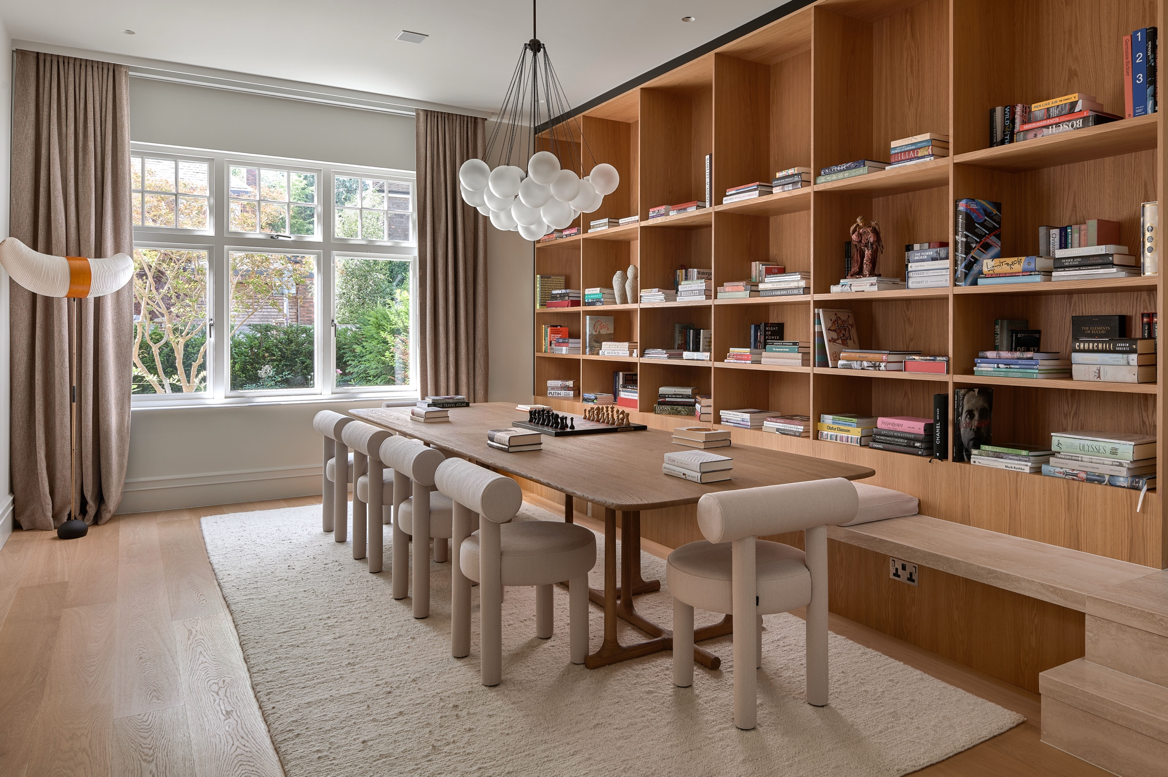

London, UK – September 2026 – In the heart of Putney in South-West London, a masterful fusion of architectural elegance and acoustic excellence has transformed a distinguished 7,000 square-metre residence. What began as a vision for a single 5.1 media room, evolved into an ambitious whole-home audio solution, expertly crafted by premier home integration specialist Cinergy, and built exclusively on professional sound systems from L-Acoustics.

The journey began when Cinergy introduced their audiophile client to the world of L-Acoustics at the brand's prestigious Highgate showroom. The demonstration proved transformative – what started as a focused brief expanded into an inspiring vision to create an unparalleled sonic environment throughout the property.

The result is a harmonious blend of technology and luxury that spans 80% of the residence. From a sophisticated media room with an integrated recording studio on the top floor to the reimagined living spaces below, each area has been thoughtfully designed to deliver an exceptional audio experience. This comprehensive solution gives the family the flexibility to pursue individual musical interests, gather for shared listening experiences, or host elegant soirées.

“From day one, it was very apparent that the owner had a huge appreciation for music,” says Tom Jarvis, founder of Cinergy. “His main media room is an audio only space, without even a TV. What also became clear to us was that he cared about creating a consistent sound, so having one brand throughout the home really appealed – across private living spaces, areas for parties and socialising and through into the garden. He was inspired by the authentic richness and detail of the L-Acoustics sound and wanted that everywhere.”

To ensure flawless execution, Cinergy employed L-Acoustics Soundvision 3D sound design and mapping tools to optimise speaker selection, placement and performance. “Designing the right system can be carried out by L-Acoustics with the Soundvision software. It’s able to tell you precisely what you need, eliminating all the guesswork from our job,” Jarvis explains. “It gives me a predictable system that delivers the exact same sound performance that the client experienced in the showroom.”

The installation showcases the finest in L-Acoustics technology. In the main living room, 1.5m tall Syva colinear loudspeakers with Syva subwoofers create a striking visual and acoustic centrepiece. These medium throw colinear source systems, which are capable of delivering levels up to 137dB, are complemented by an artfully integrated network of five X4i in-ceiling speakers, two surface mount X4r speakers and two SB10r subwoofers, one in the ceiling and one in the wall.

“It's set up as a two-channel zone with the main Syva speakers and then all of the others can be paired in or out to fill the rest of the space with music, according to taste and the function of the room” adds Jarvis.

The sophisticated audio experience on the ground floor continues in the library with a refined 2.1 set up using Syva and including an ultra-compact SB10i discretely housed within the joinery. Adjacent spaces include a 5.1 system in the TV room with X4i in-ceiling rear surrounds as well as an SB10 also installed in the joinery while the kitchen diner benefits from four X4r in-ceiling speakers along with one SB10i subwoofer.

The crown jewel of the installation is found on the top floor where a professional-grade media room and studio space are configured in a 5.1.2 Dolby Atmos set up, featuring seven X4 speakers which serve as the LCR channels behind a fabric wall, while four X4r speakers provide the surround and height channels, supported by one SB10r subwoofer. Two LA2Xi amplified controllers power this sophisticated configuration.

The integration of the recording studio required particular ingenuity. "The rear rights needed to be moved as they were in the space where the client wanted the desk for the recording studio," Jarvis recalls. "We made the desk leg 150mm thick so that we could fit the speaker into the edge of the desk while keeping it in the right location. The recording studio has also got a 2.1 L-Acoustics set up, with its amplifier also mounted in the same leg." This creative solution exemplifies the attention to detail required when integrating professional-grade audio into multi-functional spaces.

Seamless control was paramount, achieved through integration with the Control4 platform, allowing intuitive management of this comprehensive audio ecosystem.

“He's loving it as are all the family who spend so much of their time now playing and listening to music,” concludes Jarvis. “The L-Acoustics sound quality is off the charts, and consistent everywhere you go in the property. We’re now taking the project one step further, bringing L-Acoustics outside as the key component in a spectacular garden entertainment system.”

For more information on Cinergy visit www.cinergy.ltd.

About L-Acoustics
L-Acoustics has been shaping the future of sound since 1984 through trailblazing innovation. Our European-designed and manufactured solutions deliver premium sound experiences from the most intimate immersive spaces to the largest stages. L-Acoustics is the #1 brand chosen by the world’s largest music festivals and installed in over 13,000 premium venues from music halls, theaters, and sports entertainment to wellness, hospitality, homes and yachts.

Our team of 850 employees, including 20% in design, research, and development, conceives the industry’s most award-winning and transformative sound reinforcement technologies, including the modern line source array V-DOSC, L-ISA immersive hyperreal solutions, and the eco-conscious, performance-leading L-Series. These technologies have led to the company being honored with a Decibels d’Or and featured in Fast Company’s most innovative companies.

With major hubs in Paris, Los Angeles, London, and Singapore, and a network of trained service providers present in 80 countries, our technologies power the most demanding live events and memorable sound experiences: from Adele’s Las Vegas residency to the world's largest sports events, from the Zaha Hadid-designed Guangzhou Opera House to the Philharmonie de Paris Concert Hall.

