Sound Designer Can Ha Extends Hedwig and the Angry Inch into the Night with L-ISA and the First L-Acoustics DJ Deployment in Asia

Three independent L-ISA listening zones in The Box at Freespace put every seated and standing guest inside the same immersive mix, from the vinyl warm-up to the afterparty

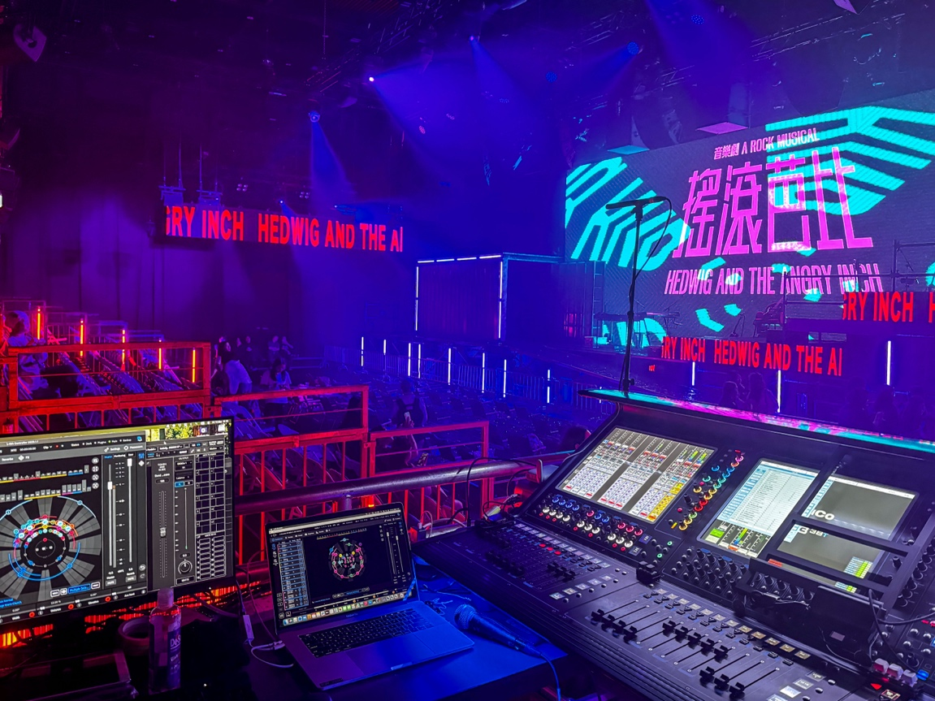

HONG KONG, CHINA – October 2026 – The Box at Freespace, in Hong Kong’s West Kowloon Cultural District, is the largest black box theatre in the city and the least fixed. It holds 950 standing or 450 seated, and it is built to be taken apart and rebuilt for whatever arrives next, with a permanent L-Acoustics L-ISA system that can be redrawn around each production. In May the room became a rock club for 13 performances of Hedwig and the Angry Inch, the first Cantonese staging of the cult musical, presented by WestK Performing Arts and directed by Ivanhoe Lam. Jordan Cheng translated the script and lyrics into Cantonese and plays Hedwig, the genderqueer rock singer working small clubs while the ex-lover who stole her songs fills stadiums

Every night opened with a vinyl warm-up DJ set and closed with a full after-party, with an intimate and heartfelt musical in between. Holding all three in one continuous evening fell to sound designer Can Ha, one of Hong Kong theatre’s most experienced practitioners, who brings two decades of work with composer Leon Ko and a run of L-ISA productions behind her, among them The Impossible Trial at the Xiqu Centre Grand Theatre.

Ha had designed the same show in the same room a year earlier and came back to rebuild it anew this year. She worked with L-Acoustics Application Engineer Daniel Lee, and with Nancy Lam, Technical Manager at Freespace, whose programming has given The Box its reputation for never feeling the same way twice.

Three L-ISA Listening Zones Cover the Full Width of the Room
For Hedwig the stage sits at the wide end of The Box, which puts roughly 300 people across the width of the room rather than in a line back from the stage: a raked seated block in the centre, with standing audience on both flanks. In the 2025 run the whole audience was treated as a single L-ISA zone, and the flanks heard a diluted version of the 360-degree image that the centre heard in full.

The fix was L-ISA Sound Spaces, which lets one spatial mix be rendered independently into more than one listening area. Working with Ha, Daniel Lee designed a configuration that would allow her to duplicate the room’s design into three zones driven from a single control, each with its own surround ring: centre for the seated block, left and right for the standing flanks, with every guest hearing the same spatial mix.

Two changes in the room made the zones work. The Kiva II hangs, previously out at the room’s outer edges, moved inboard between the main hangs, pulling the image back towards the centre for the standing audience. Additional X8 went in between the zones so each flank could be covered by its own surround ring. The design was modelled and validated in L-Acoustics Soundvision before load-in.

“Hedwig is somewhere between a concert and a play, and L-ISA is how we move between the two,” says Ha. “When Hedwig is abandoned, we move the entire band from one side of the room to the other, and we use the L-ISA room engine to blur everything, so the audience feels what she is feeling rather than being told about it. On top of the surround changes, we had already made tweaks to the frontal system and subs. As a result, we managed to do away with the drum screen and the whole thing sounds alive in a way it didn’t before.”

L-Acoustics DJ Makes Its Asian Debut
The DJ sets were the other half of the evening. For the return, Ha brought in L-Acoustics DJ, the first deployment of the technology anywhere in Asia, with the DJs using the same L-ISA design as the musical. L-Acoustics DJ separates a stereo track into stems in real time, and with the L-Acoustics DJ controller, it allows the DJ to spatialise these stems, adding a new dimension to their performance.

The effect on the room was immediate. With every track immersive wherever people stood, the crowd stopped bunching around the booth and spread out across the whole space, drinks in hand, still inside the show. The DJs changed from night to night and ranged from young techno players to veterans spinning nostalgic Cantopop, and all of them took to the new technology. They arrived 20 minutes early for soundcheck and were playing with the controls within ten minutes, moving their music around the room with confidence in a way they couldn’t before.

“I think it's really fun to play with, and the app is easy to use,” says DJ, Just Bee. “I love the mix-and-match of the dynamic effects that make the music experience even more immersive.”

“We wanted the audience to enjoy themselves where they were and not have to move around to find the good spot,” says Nancy Lam, Technical Manager at Freespace. “Putting the DJ system inside L-ISA meant that when people were holding their drinks and walking around after the show, they were still inside it. They are part of the show, not watching it.”

L-ISA, A Series and X8 Build the Three Zones
The main system runs five hangs of two ARCS Focus and one ARCS Wide across the width of the stage, with two hangs of four L-Acoustics Kiva II between hangs one and two, and four and five, for imaging into the standing areas. Low end comes from two columns of three L-Acoustics SB18 in cardioid configuration at the centre, with two L-Acoustics KS28 under the stage.

The three listening zones are built from 38 L-Acoustics X8, split between the centre zone’s surrounds and overheads, the left and right surround rings, and front-fill across the front of the audience, each zone with different loudspeaker layout rendered independently with L-ISA Sound Spaces from a single L-ISA Soundscape. L-Acoustics 15 LA12Xi and 11 LA4Xi amplified controllers drive the system, with one L-ISA Processor and one L-ISA Processor II handling the spatial processing for the musical and both DJ sets. L-Acoustics Certified Provider, Rightway Audio Consultants, supported the venue’s system throughout.

A Venue That Is Never the Same Way Twice
L-Acoustics DJ was built for clubs and festival stages. Hedwig is the first production to use it as an extension of a musical, carrying the evening either side of the curtain, and it will not be the last.

“The DJs who had played the run last year told me this year felt more energetic and more even, and that the audio was surrounding them,” says Ha. “The Box is built to be adapted every time, and Hedwig used that for everything it was worth. L-ISA was the primary tool, and it made everyone feel part of Hedwig’s show rather than sitting inside a black box. Pairing it with L-Acoustics DJ pushed that further than I thought we could take it.”

“Audiences can come back to this venue again and again and have a completely different experience every time,” concludes Lam. “Putting L-ISA and L-Acoustics DJ together gave them a new experience they had not had before. It was a delight to watch them respond.”

About L-Acoustics
Since 1984, we have been continuously innovating to shape the future of sound.

Our European-designed solutions optimize Source, System, and Space—unleashing creative possibilities in content, perfecting audio technology, and harmonizing with venue acoustics to guarantee exceptional performance.

Our global team of over 1,000, with 20% dedicated to R&D, has pioneered breakthroughs like the V-DOSC line array, L-ISA immersive solutions, and the eco-conscious L Series—innovations that have both transformed our industry and transcended our auditory perceptions.

The world’s most demanding stages trust us: Adele's Las Vegas residency, the Philharmonie de Paris, the Zaha Hadid-designed Guangzhou Opera House, and over 13,000 premium venues worldwide. We’ve earned this trust by consistently delivering extraordinary audio in every venue and any space.

We are L-Acoustics. We connect humans through the best shared sound experiences.

