Technics Celebrates 55 Years of the SL-1200 Series with a New Limited Anniversary Edition

Global release planned for September 2026, followed by first showcasing to the public during DMC DJs Day Poland in Warsaw on 20 August

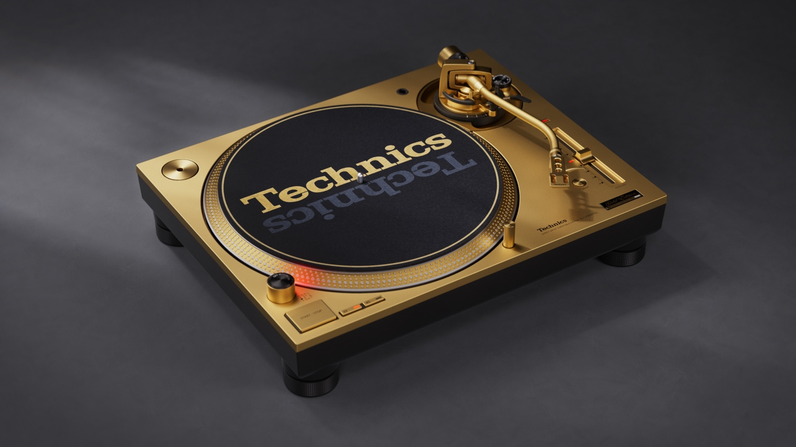

18th August 2026 – Today, Technics announces the forthcoming launch of the SL-1200 55th Anniversary Edition, a new special edition turntable created to celebrate 55 years of the iconic SL-1200 Series. Scheduled for global release in September 2026, the model pays tribute to a turntable lineage that has helped define DJ culture, shaped the evolution of club performance, and become one of the most recognisable instruments in modern music history.

The SL-1200 55th Anniversary Edition will be globally limited to 12,000 units. Each turntable will feature an individually engraved anniversary badge with its serial number, underlining the collectable character of this commemorative release.

Honouring the Legacy of DJ Culture

Designed to celebrate the timeless value of vinyl culture and DJ artistry, and the enduring power of truly engaging with music, the anniversary edition combines the unmistakable SL-1200 silhouette with refined gold coloured details. Reflecting the evolution of DJ culture into diverse spaces, the limited edition will be available in seven colourways, Gold, Blue, Red, Black, Green, White, Grey. With gold accents bringing a new level of visual expression to any DJ performance while honouring the iconic heritage of the SL-1200 Series.

Special design details include gold accents throughout, such as a gold anodised S-shaped aluminium tonearm, a platter with a gold coloured rim and strobe marks, matching gold knobs and buttons, a gold finished tonearm base, a commemorative anniversary badge, and a specially designed gold themed slip mat. Together, these details create a distinctive celebratory design that connects the craft of analogue performance with the enduring prestige of the SL-1200 name.

Inspired by the Hands, Ears, and Craft of DJs

With the SL-1200 55th Anniversary Edition, Technics celebrates the renewed energy surrounding analogue turntables and the performers who continue to make music a physical, hands-on art form. The launch is guided in the belief that, playing music with analogue turntables is once again becoming a movement. It is about performers relying on their skill and craftsmanship, rather than technology. Capturing the beat by ear, playing with hands, and filling the space with groove. We believe that the tactile experience of tangible music continues to connect and capture the hearts of people in a meaningful way. Technics is proud to be part of this legacy and the brand’s mission is to empower inspiring DJs and music lovers today and into the future.

The SL-1200: From Hi-Fi Innovation to DJ Legend

First introduced in 1972, the Technics SL-1200 was originally developed as a high-performance direct-drive turntable for demanding music lovers. Its rugged aluminium die-cast cabinet, high-torque motor, stable rotation, and rapid start-up performance made it exceptionally reliable in environments far beyond the living room.
The foundations of the SL-1200 story began with Technics’ pioneering direct-drive technology. In 1970, Technics introduced the SP-10, widely recognised as the world’s first direct-drive turntable. By connecting the motor directly to the platter, the system reduced speed fluctuations associated with belt or idler designs and established a new standard for rotational stability. The SL-1100 followed in 1971, combining direct drive with an integrated tonearm and compact construction, before the SL-1200 arrived in 1972 as the model that would become a global reference point for club and DJ use.
As disco, hip-hop, and club culture expanded in the 1970s, DJs discovered that the SL-1200’s torque, durability, pitch control, strobe markings, and resistance to vibration gave them new creative freedom. The turntable helped make beat-matching, cueing, scratching, and hands-on performance more precise and dependable. Over time, the SL-1200 became more than audio equipment: it became a musical instrument and a de facto standard for DJs around the world.

The 1979 SL-1200MK2 further strengthened this legacy with quartz-controlled direct drive and a layout that became synonymous with professional DJ performance. Its robust construction and intuitive operation helped shape decades of club culture, turntablism, and electronic music. The SL-1200 Series remains one of the rare products whose influence extends from hi-fi engineering to the language of performance itself.

Leading Edge Technology

The Technics SL-1200 55th Anniversary Edition will technologically be based on the proven and rock-solid MK7 platform. As such, it will carry the iron-coreless direct drive with single-stator/single-rotor with digital control for ultimate speed stability and fast start-up time. Speed can be adjusted with a pitch of up to +/- 16% via the classical vertical pitch fader. The aluminium S-shaped tonearm, a classic Technics feature – ensures precise tracking of the vinyl grooves, while its adjustable height allows the usage of a wider variety of pickup cartridges. The Reverse Play mode adds extra creativity to the DJ’s play styles.

Availability

The Technics SL-1200 55th Anniversary Edition is planned for global release in September 2026 It was unveiled today through a special DJ set, featuring globally acclaimed DJ ¥ØU$UK€ ¥UK1MAT$U (YOUSUKE YUKIMATSU), via the YouTube channel of Resident Advisor and the first public appearance will be during DMC DJs Day Poland at Fabryka Norblina in Warsaw on 20 August.

Further product details, final market availability, and regional pricing will be shared closer to launch.

