L-Acoustics A10 Covers Meetings and Live Music Under the Five-Metre Ceiling of Bali’s Secret Garden Spring
PT Gracia Auvindo won a three-way tender at the new Kuta lifestyle complex with a Soundvision model that showed the owners the coverage, the rigging and the power draw before a single box was ordered
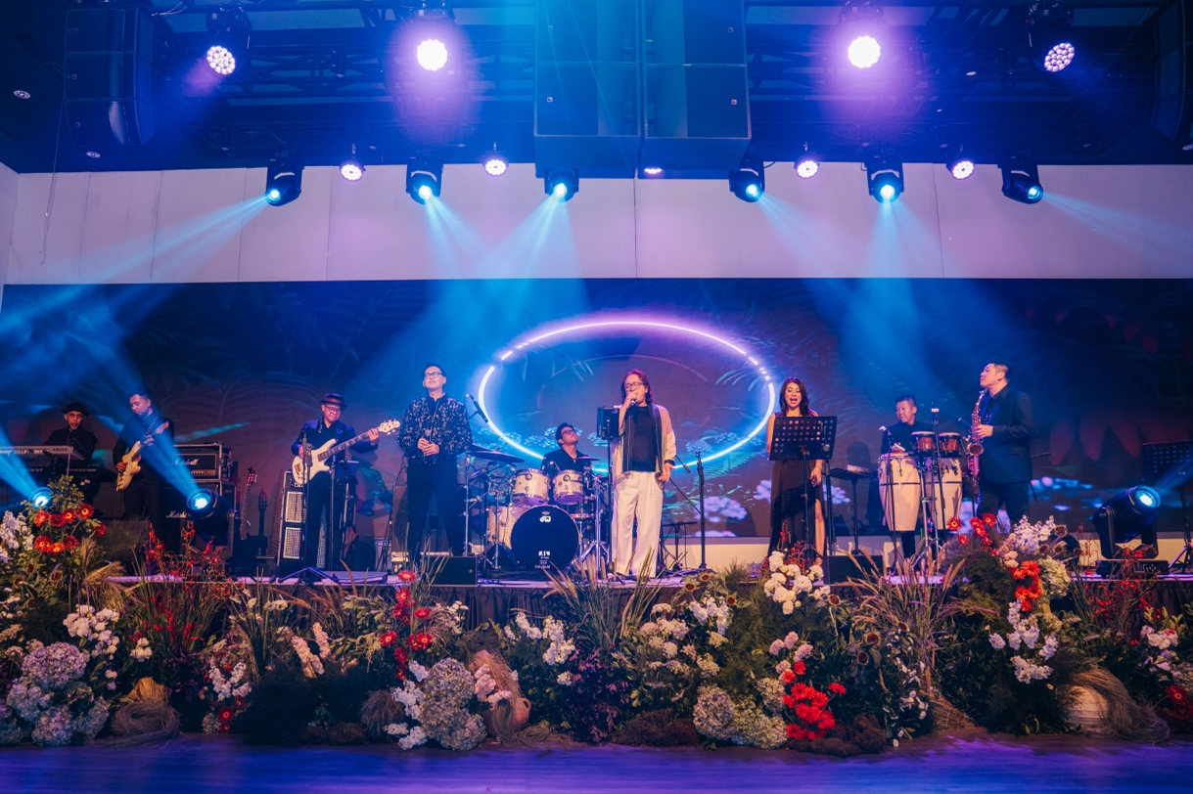
KUTA, Bali, Indonesia – September 2026 – Secret Garden Spring is a lifestyle complex that opened in March 2026 on Sunset Road, the corridor running from central Kuta up through Seminyak. Across three stories it gathers beauty retail and perfume-making workshops, a spa, fine dining, a coffee house, a cigar lounge and a transit lounge for travellers between flights, and its owners expect it to draw more than 600,000 visitors a year.
The complex is the newest venture from Secret Garden Group, the Balinese company behind the Secret Garden beauty and fragrance brand and Secret Garden Village, the 35,000-square-metre edu-tourism destination in the Bedugul highlands. On the top floor of the new building, above the retail and dining concourse, sits the Ambassador Lounge.
The Ambassador Lounge is the group's events venue in south Bali, seating between 350 and 400 guests depending on configuration and available for public hire. Folding partitions can divide it into three smaller meeting rooms, but as a single open space it was conceived from the outset to work equally well for corporate meetings and conferences as for live performance. That dual purpose set the brief for the L-Acoustics system serving the full room: one installation with the clarity to carry speech and presentation, and the headroom to carry a band.
The room itself made that brief harder than it sounds. The Ambassador Lounge measures 27 metres long by 19 metres wide, but its ceiling is only five metres high, and structural beams run through the space. LED screens along the presentation wall had to stay unobstructed for both conference content and live shows. Very little of the volume that a designer would normally use to get a system above an audience was available.
Soundvision Wins a Three-Way Tender
Secret Garden Spring’s owners ran a competitive tender, inviting three audio contractors to present proposals. Jakarta-based L-Acoustics Parter, PT Gracia Auvindo, invited the client to its Jakarta office to hear a system rather than read about one, then went considerably further than a demonstration.
The team rebuilt the Ambassador Lounge inside L-Acoustics Soundvision from the venue’s own architectural drawings, beams included and used the model to answer questions that usually go unanswered until a system is already on site. Alongside loudspeaker coverage, the model showed the owners the rigging mechanics for a five-metre ceiling and the electrical consumption the system would draw. For a client weighing three bids, that turned an audio proposal into something closer to a building document.
“It’s a very powerful use of the software,” says Hendra Halim, Application Director at PT Gracia Auvindo. “We can simulate the room and show the client exactly how the installation will look, with the power consumption and everything else explained within it.”
“Being able to show them exactly how it would look and perform on screen, before a single box had arrived on site, was what gave them the confidence to choose us,” Halim adds. PT Gracia Auvindo won the contract.
A10i Focus and A10i Wide Above the LED Screens
The answer to the low ceiling was a compact professional sound system built around L-Acoustics A10. Each side carries a hang of two A10 Focus and one A10 Wide, with four KS21i flown centrally and four X6i handling front-fill. Three LA4X amplified controllers power the system. The A10 enclosures are mounted above the LED screens, which keeps the screens clear for presentations and performance alike and puts the arrays as high in the five metres as the structure allows.
Speech and Music from a Single Installation
Since opening, the Ambassador Lounge has run both halves of its brief on the same system, and the response from the owners and from the venue’s first audiences has been consistent.
“The system itself is easy to work with, and the owners were thrilled from the very first event,” Halim concludes. “They told us they didn’t expect a room this size to sound this good, and we consider that a job really well done.”
For more information on Secret Garden Spring, please visit https://secretgardenspring.co.id/. More information on PT Gracia Auvindo can be found at www.graciaauvindo.com. Please visit L-Acoustics at www.l-acoustics.com.

About L-Acoustics
Since 1984, we have been continuously innovating to shape the future of sound.

Our European-designed solutions optimize Source, System, and Space—unleashing creative possibilities in content, perfecting audio technology, and harmonizing with venue acoustics to guarantee exceptional performance.

Our global team of over 1,000, with 20% dedicated to R&D, has pioneered breakthroughs like the V-DOSC line array, L-ISA immersive solutions, and the eco-conscious L Series—innovations that have both transformed our industry and transcended our auditory perceptions.

The world’s most demanding stages trust us: Adele's Las Vegas residency, the Philharmonie de Paris, the Zaha Hadid-designed Guangzhou Opera House, and over 13,000 premium venues worldwide. We’ve earned this trust by consistently delivering extraordinary audio in every venue and any space.

We are L-Acoustics. We connect humans through the best shared sound experiences.

