Casino de Espinho Raises the Stakes with L-Acoustics L2 in the Salão Atlântico

SLS replaces the Salão Atlântico’s PA with flown L2 and L2D, holding clarity, coverage and impact across every layout the 550-capacity hall books

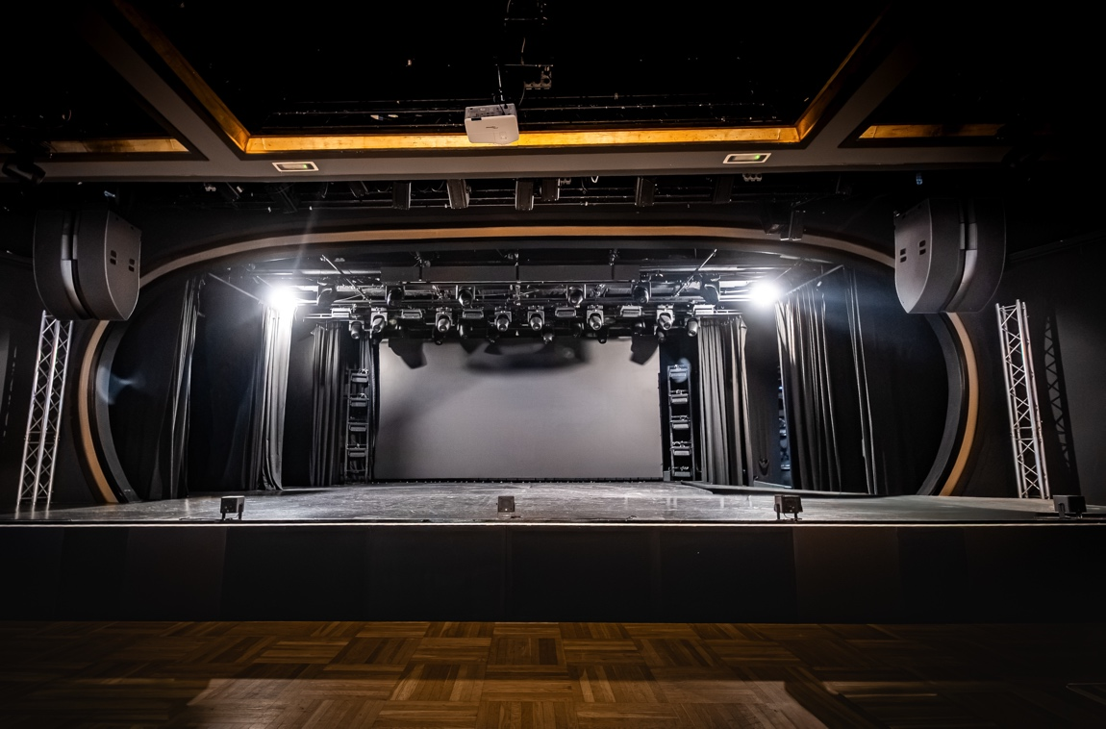

ESPINHO, PORTUGAL – October 2026 – The gridded streets of the Portuguese town of Espinho were laid out in the 19th century, after railway access turned a quiet fishing village into one of the country’s original seaside resorts. By the early 1900s the town had six casinos. The tradition continues on Rua 19, its main thoroughfare, where Casino de Espinho has been one of the region’s entertainment landmarks since 1974. Its showpiece is the Salão Atlântico, a 550-capacity hall that hosts international headliners, gala banquets and conferences, with fashion shows, comedy nights, festivals and private functions in between.

L2 and L2D Raise the House Standard in Every Layout
Keeping that calendar full means satisfying promoters, producers and corporate clients who each arrive with different expectations, in a room that is reconfigured between almost every booking. When the casino set out to raise the Salão Atlântico’s technical standard, the brief was to replace the PA outright and come back with greater clarity and speech intelligibility, uniform coverage and stronger impact, in every layout the hall can be set to.

The casino brought in L-Acoustics Certified Provider SLS, whose record with L-Acoustics systems in technically demanding venues and whose Soundvision expertise won it the project. SLS presented the proposal in January and had the system installed and commissioned by its own technical team in February.

“The Salão Atlântico earns its keep through its versatility,” says Pedro Santos, Sales Manager (Northern region), SLS. “It has to be ready for anything, and the sound has to perform in any one of a variety of layouts. Raising the technical standard of the room mattered to the clients who already trust us with their events, and it opens the door to new, more ambitious productions.”

“The main challenge was achieving uniform coverage in a multi-purpose venue with a variety of seating layouts and event configurations,” furthers Santos.

One L2D Hang Per Side, Modelled in Soundvision
The hall changes shape constantly, and the system had to sound the same in all of it. L2D covers the whole room from a single compact flown array each side of the stage, with uniform horizontal and vertical coverage that holds wherever the seating lands. Fewer enclosures also means a cleaner installation and open sightlines to the stage. SLS modelled the design in Soundvision, testing splay angles and rigging heights and validating SPL uniformity and speech intelligibility across every seat before a box was hung.

“Using Soundvision, we optimised the positioning of the L2 system to ensure consistent coverage across every audience area while carefully managing the interaction between the loudspeaker system, the room geometry, and its acoustic characteristics,” explains Santos.

One L-Acoustics L2D flies left and right of the stage as the main system. Four L-Acoustics KS28 subwoofers sit in a central ground stack along the stage front, and five L-Acoustics 5XT front-fills line the stage edge for the nearest tables. L-Acoustics LA7.16i, LA12X and LA2Xi amplified controllers drive the system, with a P1 processor at the head of a native Milan-AVB network that keeps latency ultra-low and calls for no format converters.

A Predictable L2 System from One Booking to the Next
Predictability is what the room trades on. Layouts change constantly, so the system has to be quick to reset and sound the same once it is. The casino’s technical team stayed involved through the whole implementation and moved to the new workflow quickly. Engineers and performers have singled out clarity, consistency of coverage and low-frequency impact, while management has picked out versatility and reliability across the full range of events the hall books. The platform scales as production demands grow.

About L-Acoustics
Since 1984, we have been continuously innovating to shape the future of sound.

Our European-designed solutions optimize Source, System, and Space—unleashing creative possibilities in content, perfecting audio technology, and harmonizing with venue acoustics to guarantee exceptional performance.

Our global team of over 1,000, with 20% dedicated to R&D, has pioneered breakthroughs like the V-DOSC line array, L-ISA immersive solutions, and the eco-conscious L Series—innovations that have both transformed our industry and transcended our auditory perceptions.

The world’s most demanding stages trust us: Adele's Las Vegas residency, the Philharmonie de Paris, the Zaha Hadid-designed Guangzhou Opera House, and over 13,000 premium venues worldwide. We’ve earned this trust by consistently delivering extraordinary audio in every venue and any space.

We are L-Acoustics. We connect humans through the best shared sound experiences.

