PSB Debuts the iQ Series: True All-in-One Streaming Speakers
  - A fresh new line of BluOS-enabled bookshelf speakers starting at €999, with the next-generation of Class-D amplification and seven high-quality finishes.
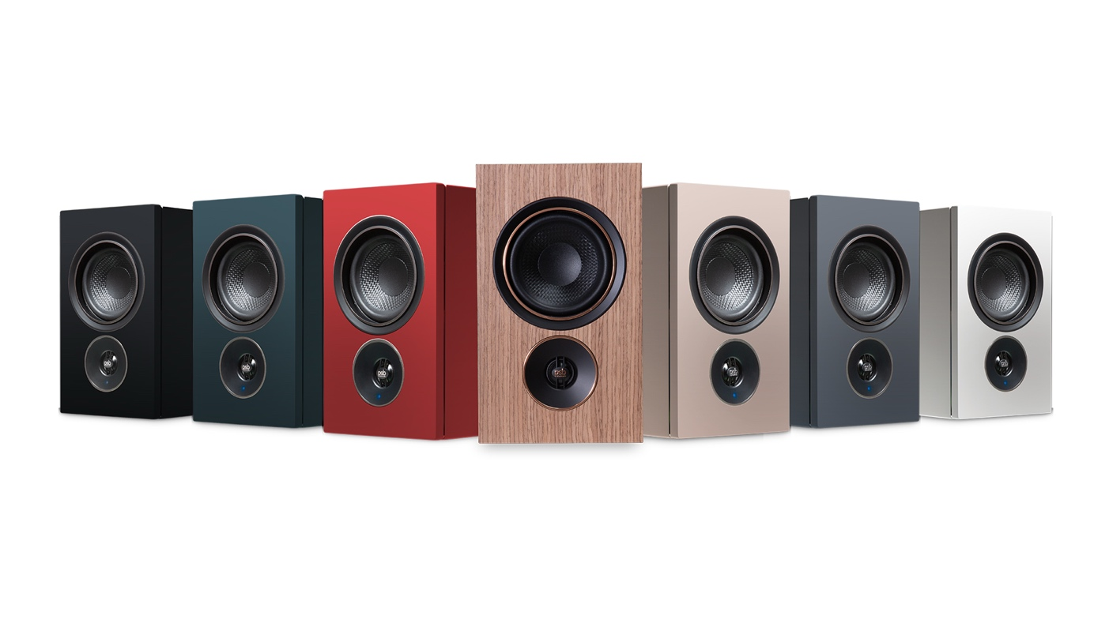
PICKERING, CANADA, JUNE 23, 2026 – PSB Speakers, the Canadian loudspeaker manufacturer with over fifty years of acoustic research and design, today announces the iQ series, a new generation of all-in-one streaming speakers designed to deliver high-fidelity sound without the complexity of traditional stereo systems. The iQ Series launches with two models: the iQ1, an introduction to PSB’s line of streaming speakers, and the iQ2, a true wireless stereo system in a choice of seven premium finishes, including a premium Walnut Veneer.

Built from the same acoustic platform introduced in PSB’s award-winning Alpha iQ, the new iQ Series elevates the all-in-one design with a new TI Burr Brown™ amplifier platform, cloth fabric grilles, and more refined finishes across the line. Both the iQ1 and iQ2 deliver the full BluOS experience, letting you listen to music, podcasts, and radio stations from more than 20 streaming services, and multi-room to other BluOS enabled speakers and audio systems throughout the home. An audiophile-grade DAC ensures audio is delivered in rich detail, supporting high-resolution playback up to 24-bit/192kHz.

“With the new iQ series, we’re expanding what PSB represents for listeners today. There is a growing segment of customers that want true high-fidelity sound without the complexity of traditional separates, and iQ is our answer to that shift,” said Mack Tommy, Product Manager at PSB Speakers. “It brings together PSB’s acoustic legacy with a more accessible, design-forward, and all-in-one approach—making it easier than ever to experience PSB performance in everyday spaces.”
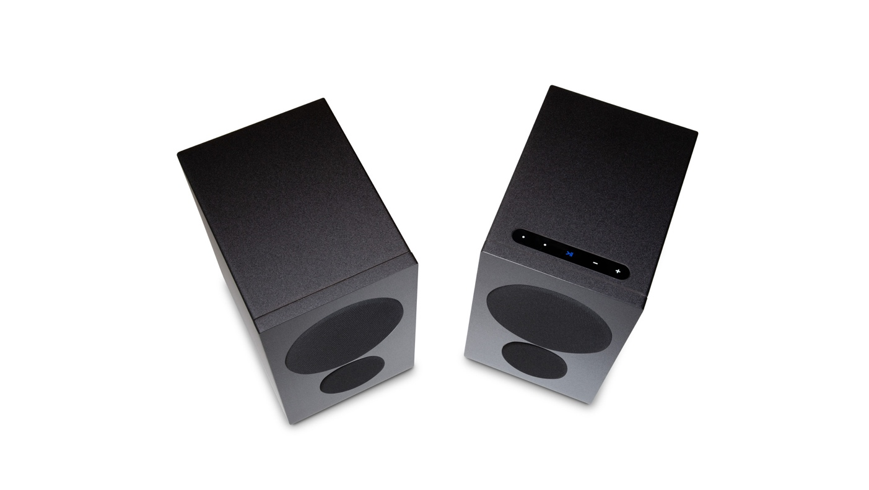
PSB iQ1 Black – Above (with Grille)

iQ1: Designed for Better Listening
The iQ1 brings PSB’s signature sound into a streaming powered speaker that every listener can enjoy. A wired stereo cable connects the primary and secondary speakers together, keeping both channels in perfect sync and achieving the best audio performance. The iQ1 is available at a suggested retail price of €999 EUR and £899 GBP in a choice of durable Black or White vinyl finishes.

iQ2: True Wireless Stereo in Seven Finishes
The iQ2 uses a low-latency wireless link to stereo pair the left and right speakers together without audio delays or interruptions. It is available in seven high-quality finishes including four new colours—Ember Red, Boreal Green, Granite Grey, Sandstone Beige, and a premium Walnut Veneer with copper-finished accents. A fingerprint-resistant coating is also applied through the finishing process to keep the cabinets clean with daily use. The iQ2 starts at a suggested retail price of €1,299 EUR and £1,199 GBP for colour finishes, and €1,399 EUR and £1,299 for the Walnut Veneer.

Shared Acoustic Platform
Both iQ models share a 4-inch polypropylene mid-bass driver with a steel basket and rubber surround, and a 0.75-inch aluminium dome tweeter with a neodymium magnet and ferrofluid damping. A new TI Burr Brown Class-D amplifier delivers 270 watts of total system power, with a 90-watt dedicated amplifier for each woofer. The iQ1 pairs its tweeters to a shared two-channel amplifier delivering 45 watts per channel, while iQ2 uses independent 45-watt amplifiers for each tweeter. A high-quality DSP crossover, tuned bass ports, and an optimized low frequency extension allow the iQ1 and iQ2 to deliver deeper, more powerful bass for their size.

“Every aspect of the iQ Series was engineered to deliver real stereo performance from a simplified system,” said Matt Simmonds, VP of Product Development at PSB Speakers. “From the new amplifier platform to the DSP tuning and driver integration, we focused on maximizing output, clarity, and control within a compact form factor. The result is a system that performs well beyond its size while maintaining the accuracy and balance that define PSB.”
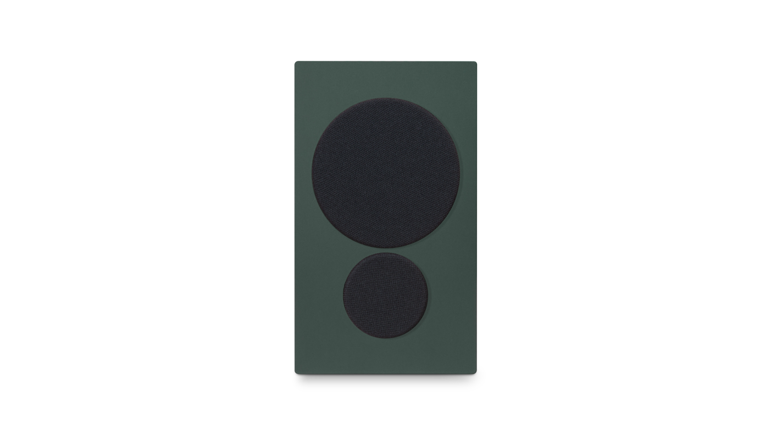
PSB iQ2 Boreal Green – Front (with Grille)

A World of Music
BluOS brings a premium multi-room streaming experience to the iQ series, allowing listeners to enjoy, music, podcasts, and internet radio with the highest quality sound. With access to over 20 popular streaming services like Amazon Music, Deezer, Qobuz, Tidal and TuneIn, along with personal music libraries and playlists, BluOS puts everything in one place. Easily manage and control your music from any room with the BluOS Controller App, which lets you also pair the iQ series with other BluOS enabled speakers and audio systems for multi-room music. Apple AirPlay 2, Spotify Connect, TIDAL Connect, and Bluetooth with aptX™ Adaptive add the flexibility to stream more music from more apps.

Well Connected
Both iQ models provide the flexibility to enjoy all home audio with a built-in MM phono preamp for turntables, RCA and optical inputs, and HDMI eARC for TV, movies, and gaming. The iQ1 and iQ2 are also outfitted with a convenient USB-C audio input for connecting other devices such as a laptop, phone, or mobile music player. A subwoofer output with DSP-enabled low-pass and high-pass filters lets the iQ series pair perfectly with a powered subwoofer for even deeper bass.

Smart and Simple
The iQ Series is experienced through the power of the BluOS Controller App, available for Android, iOS, macOS, and Windows. Browse music, playlists, podcasts and radio stations, with seamless control from any device. Top panel touch controls on the primary speakers provide quick and easy access to volume, playback, and two custom presets for favorite stations, playlists, or streaming services. Through BluOS, the iQ Series can be seamlessly integrated with popular smart home control systems including Control4, Crestron, Nice, RTI, and URC.
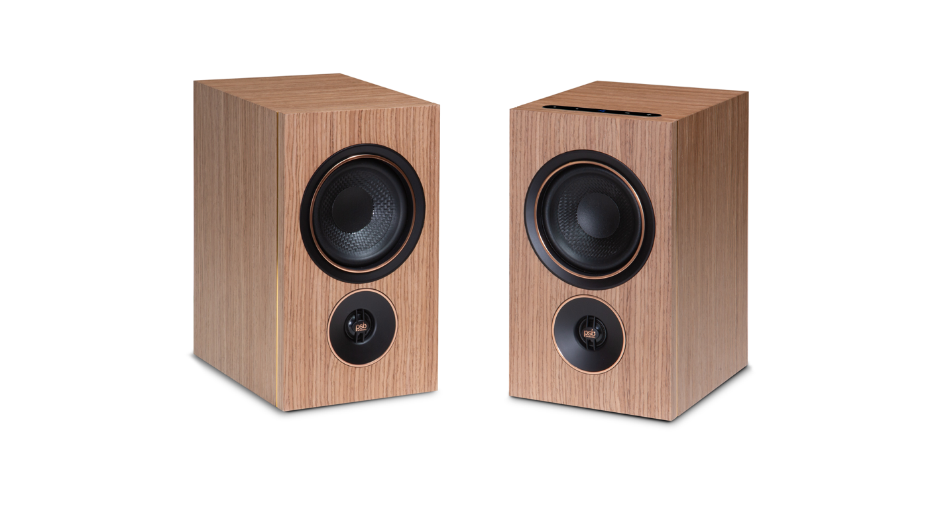
PSB iQ2 Walnut Veneer – Front (No Grille)

Features & Specs
 | iQ1 | iQ2
System Type | Powered stereo pair (wired) | Powered stereo pair (wireless)
Amplification | 270 watts total per pair | 270 watts total per pair
Drivers | 4” mid-bass driver, 0.75” aluminium dome tweeter | 4” mid-bass driver, 0.75” aluminium dome tweeter
Stereo Connection | Wired | Wireless
Music Streaming | BluOS, Apple AirPlay 2, Spotify Connect, Tidal Connect, and Qobuz Connect | BluOS, Apple AirPlay 2, Spotify Connect, Tidal Connect, and Qobuz Connect
Max Resolution | 24-bit / 192 kHz | 24-bit / 192 kHz
Connectivity | HDMI eARC, RCA (phono/line), optical, USB-C, USB-A | HDMI eARC, RCA (phono/line), optical, USB-C, USB-A
Wireless | Wi-Fi, Ethernet, Bluetooth aptX Adaptive | Wi-Fi, Ethernet, Bluetooth aptX Adaptive
Subwoofer Output | Yes | Yes
Finishes | Black, White | Black, White, Ember Red, Boreal Green, Granite Grey, Sandstone Beige, Premium Walnut Veneer

Pricing & Availability
- The iQ2 will be available in all finishes starting June 23, 2026, at €1,299 EUR and £1,199 GBP, through PSB dealers, authorized online retailers, and psbspeakers.com. Premium Walnut will be available in November 2026 for €1,399 EUR and £1,299 GBP.
- The iQ1 will be available in Black and White for €999 EUR and £899 GBP starting August 10, 2026, through authorized PSB retailers and psbspeakers.com.
- Global pricing and availability will vary by country. For information on international pricing and availability, contact an authorized PSB distributor.

For more information on the iQ series, visit psbspeakers.com/iq. Download the full press kit here including high-resolution images and product details.

About PSB Speakers
Since 1972, Founder and Chief Designer, Paul Barton, has been cementing his legacy as an expert in designing and building high-fidelity speakers that incorporate scientific principles in psychoacoustics. More than 50 years later and now a strategic part of Lenbrook International’s global portfolio, PSB Speakers’ products are sold in more than 70 markets where the brand sets the standard for “True to Nature” sound and is critically acclaimed for its value-driven and non-fatiguing speaker design. With an expansive suite of products that include audiophile speakers, ANC headphones, powerful and musical subwoofers, and a family of installed speaker solutions, PSB Speakers is designed and built to bring life to recorded music at world class levels.

psbspeakers.com
@psbspeakers

Media Contact
media@psbspeakers.com

