  - Technics introduces the SL-1210MKX - a new flagship professional direct-drive DJ turntable engineered for club and touring environments

Built for the Real World. Refined by Real DJs: New upper-line professional direct-drive turntable delivers enhanced vibration resistance, greater pitch precision and expanded creative control for demanding performance environments.

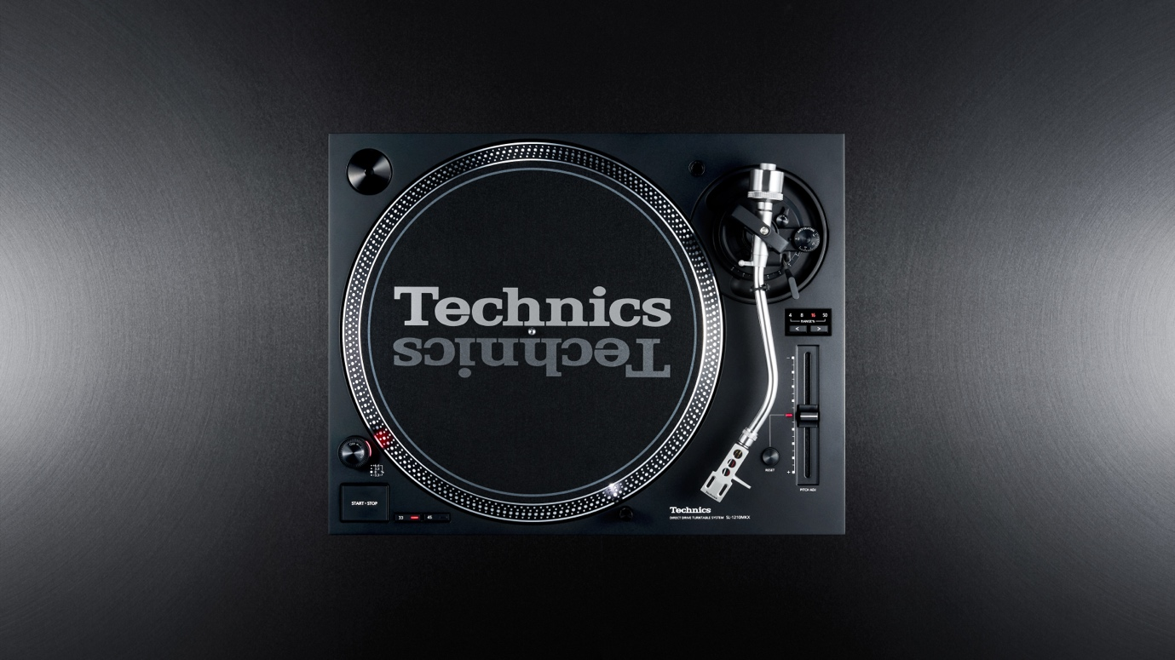

Amsterdam, 21st October 2026 – Technics today announces the SL-1210MKX, a new professional direct-drive DJ turntable that opens the next chapter in the long and influential history of the SL-1200 Series. Developed with direct input from working DJs and Sound Engineers to deliver greater stability, enhanced pitch precision and expanded creative freedom in demanding club, festival and live performances environments.

Positioned above the SL-1210MK7, the new model represents the next evolution of the iconic SL-1200 Series. Built upon real world testing and professional feedback, the SL-1210 MKX is designed to address the challenges DJs face in high pressure performance settings where powerful sound systems, deep bass, structural vibration and extended operating periods place exceptional demands on equipment.

As vinyl performance continues to evolve across clubs, festivals and specialist performance disciplines, professionals DJs increasingly demand greater resistance to feedback, precise pitch control, dependable operation and the freedom to develop new performance techniques. The SL-1210MKX has been created in response to those needs.

‘The SL-1200 Series has earned its reputation through decades of real-world performance in clubs, on stage and in studios around the world,” said Stefanie Baron, Manager Technics DJ Channel Europe, Panasonic Consumer Europe (PCEU). “With the SL-1210MKX, we wanted to build on that legacy by working closely with professional DJs and sound technicians to better understand the challenges they face. The result is a turntable that delivers even greater stability, precision and creative freedom while staying true to the qualities that have made the SL-1200 an industry standard for more than five decades.’

Engineered for demanding professional environments
A significantly heavier, optimally balanced chassis provides greater resistance to external vibration, while newly designed isolation feet have been engineered to combine effective feedback isolation with the stability required for confident scratching and performance use.

The result is a turntable designed to remain stable in bass-heavy environments without compromising the direct, controlled feel that scratch and performance DJs require. The reduced risk of acoustic feedback allows us to maintain higher sound pressure levels and more offensive EQ settings without compromise.

Extended pitch control for precision and expression
For the first time in the history of the SL-1200 Series, the SL-1210MKX introduces a dedicated ±4% pitch range. The narrower range provides DJs finer resolution and more precise adjustment, supporting accurate beatmatching and subtle tempo correction when tracks have closely matched BPM values. Alongside the standard pitch settings, a new ±50% range greatly extends the available tempo variation, opening new possibilities for creative mixing, turntablism and advanced performance techniques.

Further refinements include a quieter reset switch inspired by earlier SL-1200 models, the proven Technics coreless direct-drive motor with adjustable start-up torque and brake speed, 78 rpm playback and reverse functionality. A polished silver tonearm and elegant black finish underline the model’s premium character while paying tribute to the iconic SL-1200MK2.

Beyond these headline upgrades, the SL-1210MKX incorporates numerous subtle improvements developed with the precision, care and uncompromising attention to detail associated with Japanese engineering.

Made for the professional DJ ecosystem
The SL-1210MKX is created for headline and touring vinyl DJs, club and festival DJs, and performance and scratch specialists who demand the highest levels of performance from their equipment. It is equally suited to nightclubs and music venues with permanent DJ installations, rental and backline companies, and professional DJ service providers. By meeting the technical-rider expectations of influential artists, the SL-1210MKX is designed to support demand across the wider DJ ecosystem.

Above all, it is intended for users who place stability, durability, precision and expressive freedom, and who expect their turntable to perform consistently wherever their work takes them.

55 years of the SL-1200 Series
Technics celebrates 55 years of the SL-1200 Series and a legacy built together with generations of DJs and vinyl lovers. First introduced in 1972 as a high-performance direct-drive turntable, the SL-1200 quickly became far more than audio equipment. Its torque, rotational stability, durability and hands-on control gave DJs the freedom to shape disco, hip-hop, house, techno, turntablism and the wider evolution of club culture.

The 1979 SL-1200MK2 strengthened this position through quartz-controlled direct drive and the iconic professional layout that became a worldwide booth standard. The SL-1210MKX carries that story forward: an upper-line evolution designed to honor more than five decades of analogue performance while setting a new professional standard for the future.

The “X” stands for Extreme and Expert—reflecting both its demanding operating environment and the people for whom it has been created.

Public unveiling at Amsterdam Dance Event
The Technics SL-1210MKX will be unveiled publicly at 12:10 CET on Wednesday, 21 October 2026 at Pacific in Amsterdam, during the 30th anniversary edition of Amsterdam Dance Event. Further launch activities will follow including participation at the Paris Audio Video Show and the Poland Audio Video Show.

Availability and pricing
The SL-1210MKX will be available from January 2027 at selected Technics retailers at an RRP of € 1.499,- | GBP £ 1.299,-.

—ENDS—

About Technics

The Technics brand was established in the same era in 1965. Beginning with the Technics 1 speaker, the brand has gone on to develop revolutionary audio products and technologies, including amps, players, and tuners. In particular, the direct-drive turntable was an industry gamechanger, laying the foundation for today’s DJ and club music scenes. Today, in a diverse music scene that favors both analogue and digital audio, Technics continues to lead the market as a comprehensive audio brand.

For more information please see: technics.com or follow technics.global on Facebook or @technics_global on Instagram.

