Shure IntelliMix™ Bar Pro, Built for Human and AI Collaboration, Shipping Now
Certified for Microsoft Teams, the all-in-one conferencing solution brings medium and large rooms the clean audio and video that reliable AI requires

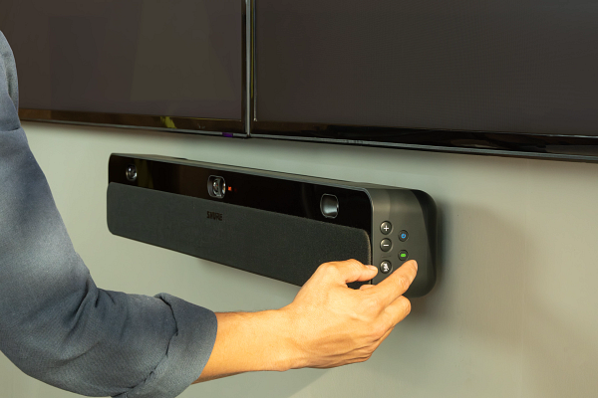

NILES, September 29, 2026 — Inconsistent audio and video quality remains a barrier to the accurate transcriptions, summaries and insights that inform critical business decisions. Shure recently announced the general availability of the IntelliMix™ Bar Pro, a Certified for Microsoft Teams all-in-one collaboration bar and touch panel for medium and large rooms designed to deliver the clean, reliable data that powers AI-driven collaboration.
“Every transcript, summary, and AI-generated insight begins with what your room’s devices can hear and see. When the inputs are clean, confidence in the outputs increases, and this becomes even more important when collaborating with AI agents,” said Sam Sabet, Chief Technology Officer at Shure. “Modern teams need trustworthy outputs to make the right strategic decisions. The IntelliMix Bar Pro delivers the trusted audio and video performance that powers those outputs in medium and large rooms, where enterprise AI has the most to gain, and the least room for error.”
The IntelliMix Bar Pro combines IntelliMix View™ AI video framing technology with onboard IntelliMix™ audio processing to capture speech, facial expressions, and non-verbal cues throughout the room, including those sitting nearest and at the end of the table. This allows AI tools to produce more accurate transcriptions to support more reliable AI insights and agentic services, reducing misunderstandings and enabling meeting participants to make faster, more confident decisions.
“Presence and clarity are the foundation of effective collaboration. When people are fully engaged and can be clearly heard, seen, and understood, organizations create the context that drives better decisions," said Craig Durr, Founder and Chief Analyst, The Collab Collective. "Shure plays a critical role in enabling that experience, helping transform meeting interactions into reliable, contextual data. That foundation strengthens the AI intelligence layer and helps organizations move from conversation to action.”
Why AI Requires Higher-Quality Audio and Video Inputs
As AI-driven features have become common place in the meeting environment, IT teams are increasingly focused on the importance of consistent audio and video quality for productive outcomes, particularly in larger rooms, where performance has traditionally required integrated AV systems. The Android-based IntelliMix Bar Pro addresses this challenge by delivering enterprise-grade performance from a single device, reducing system complexity while improving AI collaboration from the point of origin.
Onboard IntelliMix audio processing isolates voices and minimizes background noise. Meanwhile, IntelliMix View AI video framing keeps participants clearly visible, enabling reliable AI outcomes and consistent meeting experiences across locations.
“For IT teams, success isn’t just delivering reliable AI outcomes in one room. It’s delivering them consistently across every room,” said Susy Liem, Vice President, Collaboration and Conferencing at Shure. “Shure is working closely with Microsoft to deliver and expand a portfolio with certified options for every space. We’re giving IT teams an enterprise-ready solution that simplifies deployment while delivering the data clarity needed to unlock the full value of Microsoft Teams, Copilot, and Facilitator.”
Built for Secure, Scalable Microsoft Teams Deployments
Built on Microsoft Device Ecosystem Platform (MDEP), Microsoft’s enterprise-grade extension of the Android operating system, the IntelliMix Bar Pro is designed for enterprise environments where security, manageability, and long-term stability are essential. Being Certified for Microsoft Teams assures the solution meets Microsoft’s performance requirements and ensures compatibility with the platform, helping organizations reduce deployment risk and create a future-ready AI-powered workplace.
IT teams can securely manage, control and update IntelliMix Bar Pro remotely using ShureCloud and other enterprise IoT systems like Pro Management Portal and ServiceNow, streamlining support and maintenance across multiple locations.
“The IntelliMix Bar Pro brings high-quality audio and video performance organizations need to get the most from Microsoft Teams Rooms and tools like Copilot and Facilitator,” said Albert Kooiman, General Manager, Teams Partner Engineering and Customer Enablement at Microsoft. “When communication is transcribed clearly, and diarized by Microsoft Teams, AI-powered experiences can be more accurate, useful, and effective. Together, we're helping customers build more connected, more intelligent and more productive businesses worldwide.”
To learn more about the IntelliMix Bar Pro contact your Shure Sales representative or visit www.shure.com/imxbpk.

*Please contact your local Shure representative to get more details on availability of the Try Before You Buy Program in your market.

About Shure
Shure (www.shure.com) has been helping people sound extraordinary for more than 100 years. Founded in 1925, we are a leading global manufacturer of audio and collaboration technology, known for our commitment to quality, performance, and durability. We make microphones, wireless microphones, conference room solutions, earphones and headphones, in-ear monitors, and more.

From the biggest broadcast events and live performances to critical business meetings and university lectures, to your home office or studio, you can always rely on Shure.

Shure is headquartered just outside of Chicago in Niles, Illinois, in the United States. We have more than 30 locations around the world, and our products are sold in over 120 countries.

###

