Maranatha Community Church Installs Africa’s First Permanent L-Acoustics L-ISA System

DWR Distribution designs an immersive A Series system for the church’s new 5,500-seat auditorium in Kempton Park, South Africa

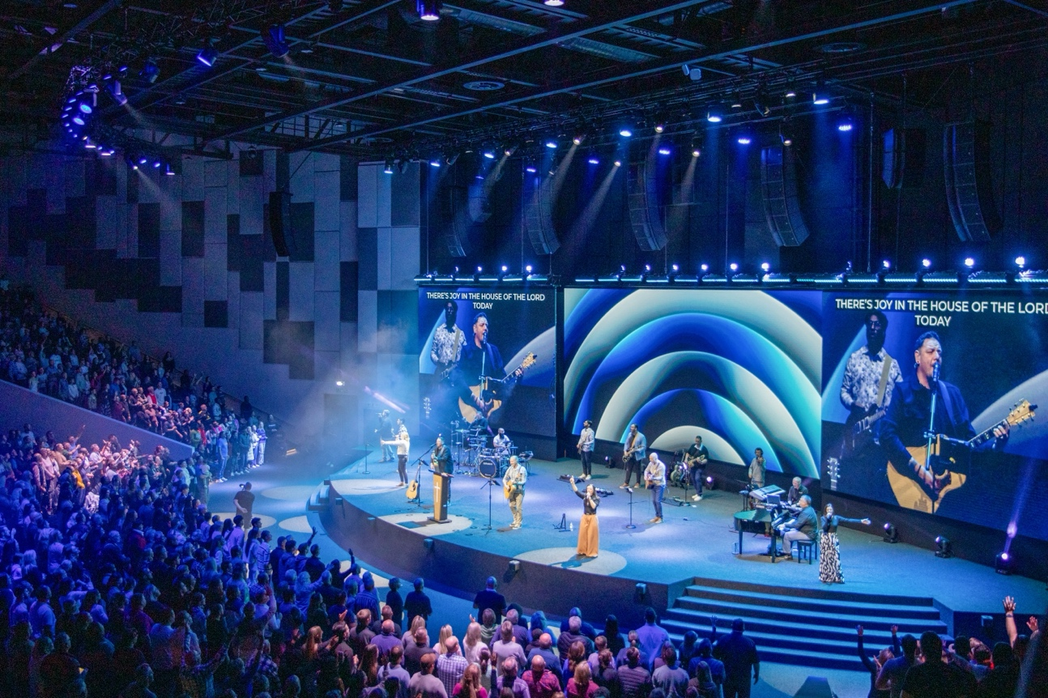

Kempton Park, SOUTH AFRICA – October 2026 – Maranatha Community Church has opened its new 5,500-seat campus in the Riverfields precinct of Kempton Park, north east of Johannesburg, with the first permanent L-Acoustics L-ISA hyperreal sound system in Africa. Supplied and installed by DWR Distribution, L-Acoustics Certified Provider Distributor for South Africa, the system is built entirely on A Series loudspeakers: a five-array L-ISA Scene System, cardioid KS28 subwoofers, and Spatial fills that carry the immersive image to the seats beneath the balcony.

The new auditorium nearly doubles the capacity of the church’s previous 3,000-seat home and adds a balcony, with a section of seating beneath it. Project consultant Robert Grobler, a South African lighting designer and member of the church since 2007, led the installation with DWR, the church’s technical partner of long standing.

“There was no fixed brief when the project began,” Grobler says. “They wanted a system with enough power. People worship here, and it gets loud. L-ISA wasn’t even on the table at first. It was just about finding something that could cover the whole room properly.”

Soundvision Modelling and a Live Demo Settle the Design
Over close to two years, DWR put three or four sound and lighting concepts to the church, simpler stereo options among them. Every concept was modelled in L-Acoustics Soundvision before it reached the church, including L-ISA, which needs a defined set of criteria to be met in a room to perform well. “We modelled L-ISA in the room before we proposed the concept to the church,” says Richard Smith of DWR.

The decision came once the church heard it. DWR took the pastors to a Jonathan Roxmouth concert at Montecasino, where Multi-Media had deployed L-ISA. “Once they’d heard it for themselves, there was no turning back,” Smith says.

“With stereo you get a wall of fairly generic sound coming at you,” says Pastor Mark Bradshaw, who oversees music and training at the church. “With L-ISA, if the drums are on the left, the sound comes from the left. What you see is what you hear, and that separation makes everything clearer, and easier on the ear.”

A Series Delivers Immersive Sound on a Stereo Budget
A venue of this size would normally call for a large stereo line array. Because L-ISA sends individual instruments and voices to separate arrays rather than every channel to one left-right pair, no single array has to work as hard. “Instead of needing a large K Series system, you can use A15s,” says Smith. “In the end, Maranatha’s investment came out comparable to a conventional system, with a far more capable result.”

Bradshaw puts it more simply: “I assumed it would be out of our budget. It wasn’t.”

Five A15i Arrays, Cardioid KS28 and Spatial Fills Under the Balcony
The L-ISA Scene System comprises five A15i arrays of six A15i Focus each, widened by an Extension of two further arrays of six A15i Focus. Eight KS28 subwoofers fly centrally above the stage in a cardioid configuration.

“Each console channel is sent directly to the L-ISA Processor II, which delivers unique signals to each array for precise sound localisation,” Smith explains. “Areas outside the immersive zone are typically covered by mono downmixes for front fills, out-fills and delays.”

At Maranatha, those zones are covered by two A15i out-fill arrays, each combining two A15i Focus with one A15i Wide, two A10i Focus as delays, and 10 5XT as mono front-fill. The seats beneath the balcony are the exception. There, 20 X6i are configured as L-ISA Spatial fills, so that section hears the same immersive image as the main listening area.

Amplification comes from two LA12X, six LA7.16i and one LA4X. “By using the new LA7.16i, we managed to feed each speaker with its own amplifier channel,” says Smith. “That gives us tremendous flexibility and processing power.”

Precision in the Design and the Rig
L-Acoustics Application Engineer Adriaan van der Walt designed the system with Smith, completing the design roughly a year before the doors opened, then returned to calibrate it and hand it over. DWR’s Jaco Beukes and Kyle Freemantle formed part of the installation team. “The real complexity sits in the L-ISA controller, where the routing and positioning angles have to be exact,” says Freemantle. “Getting the rigging precisely right was hard work, but genuinely enjoyable.”

“The information exchange from the initial design through to verifying speaker positions and angles on site was meticulous,” van der Walt adds. “Hats off to them.”

Every Musician Heard
For the worship team, the difference was immediate. “We have a great team, and every musician, every vocalist, wants to be heard. That’s why you become a musician in the first place,” Bradshaw says. “Now they’re heard, because there’s space for them.”

Members of the congregation now come up after services to say how clear everything sounded, and van der Walt sees that as the beginning. “This is the starting point for the venue crew,” he says. “L-ISA is new to them, but once they’ve had training they’ll find ways to use the system none of us has thought of yet.”

About L-Acoustics
Since 1984, we have been continuously innovating to shape the future of sound.

Our European-designed solutions optimize Source, System, and Space—unleashing creative possibilities in content, perfecting audio technology, and harmonizing with venue acoustics to guarantee exceptional performance.

Our global team of over 1,000, with 20% dedicated to R&D, has pioneered breakthroughs like the V-DOSC line array, L-ISA immersive solutions, and the eco-conscious L Series—innovations that have both transformed our industry and transcended our auditory perceptions.

The world’s most demanding stages trust us: Adele's Las Vegas residency, the Philharmonie de Paris, the Zaha Hadid-designed Guangzhou Opera House, and over 13,000 premium venues worldwide. We’ve earned this trust by consistently delivering extraordinary audio in every venue and any space.

We are L-Acoustics. We connect humans through the best shared sound experiences.

