NAD Expands Its Classic Series with the C 359S and C 569 CD
  - A re-engineered Class AB amplifier with BluOS built-in, joined by a CD player designed to reveal more from every disc.
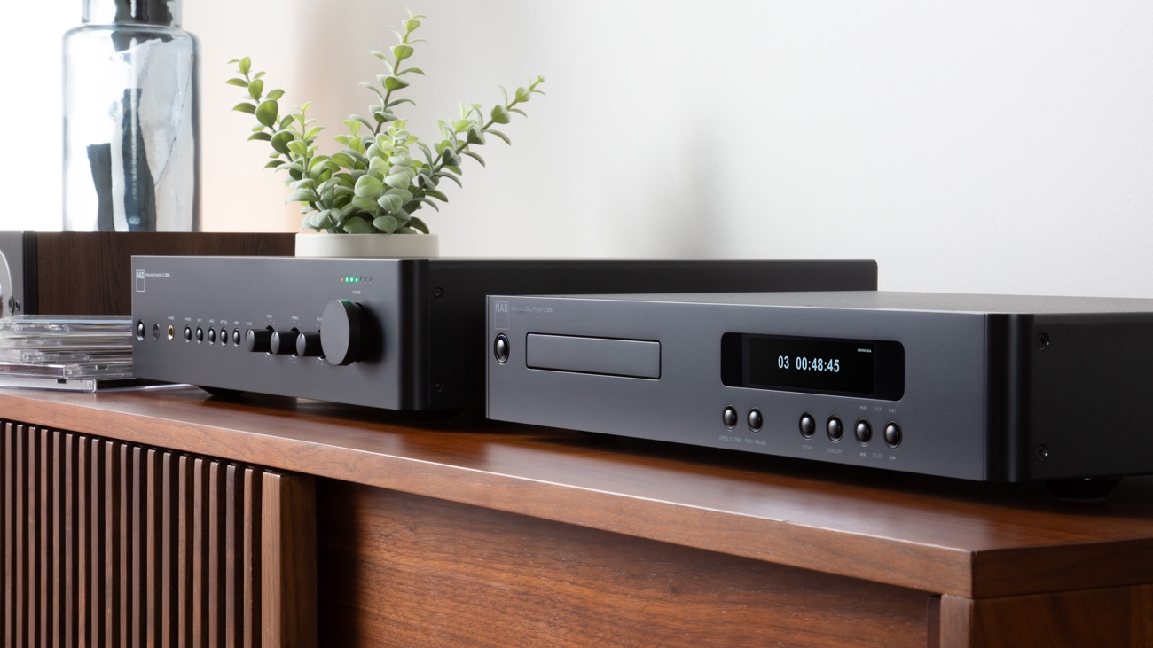

TORONTO, CANADA, OCTOBER 15, 2026 – NAD ELECTRONICS, a leading manufacturer of high-performance audio components for more than five decades, today introduced two new additions to its acclaimed Classic Series, the C 359S Integrated Amplifier and the C 569 CD Player. Both stay true to the principles that have defined NAD since its earliest designs: captivating musical performance, real-world power, simple functionality and genuine value.

The C 359S brings the traditional experience of a NAD integrated amplifier into a modern design, pairing a re-engineered Class AB amplifier with built-in BluOS® streaming, HDMI eARC and sophisticated subwoofer integration. The C 569 is a dedicated high-performance CD player that uses NAD’s Dynamic Digital Headroom (DDH) and QRONO d2a technologies to draw greater depth, detail and presence from the CDs listeners love.

“Audio enthusiasts today want a hi-fi system that is simple to live with but makes no compromises on sound quality,” said Morten Nielsen, NAD Product Manager. “The C 359S and C 569 are built for that listener. They look and feel like the NAD components people have trusted for decades, but under the hood they are entirely modern. You press play, and the engineering gets out of the way of the music.”
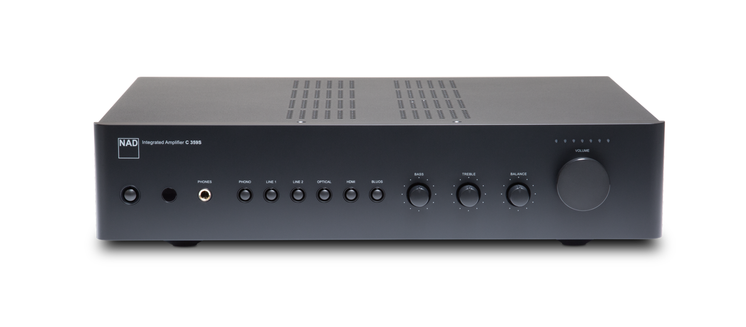
NAD C 359S Integrated Amplifier (Front)
C 359S: Re-Engineered Class AB for Today

At NAD, engineers have never believed that one amplifier technology is right for every product. Throughout its rich history, the company has chosen circuit topologies and power-supply technologies according to the requirements of each design, and it continues to use Class D extensively across its range. For the C 359S, Class AB is the right choice. What sets it apart is how it has been implemented.

Instead of the large transformer and linear power supply traditionally associated with Class AB, the C 359S uses a high-current, low-noise switch mode power supply derived from NAD’s flagship Class D amplifier platform. Modern multi-layer circuit architecture separates power conversion, signal processing and amplification, with carefully controlled grounding, current paths and signal routing that minimize unwanted interaction between the amplifier’s analogue, digital, and network functions. The result is a remarkably quiet, responsive amplifier delivering 2 x 70 watts of continuous power into 8 ohms, with the ability to handle demanding loudspeakers without compromise.

Simple to Use Without Limitations

Many amplifiers rely on large displays and layered menus, but the C 359S takes a different path. Physical buttons, knob controls and an included IR remote provide simple and intuitive operation, keeping the focus on the music experience.

Behind those familiar controls sits BluOS, built-in for high-resolution streaming and multi-room audio without a separate streamer. It’s a complete modern music system with HDMI eARC for TV sound, aptX™ HD Bluetooth for wireless listening, and a phono input for turntables.

The C 359S also treats the subwoofer as an integral part of the system. Optional high-pass filtering redirects deep bass to the subwoofer, easing the load on the main speakers and amplifier to improve clarity, imaging and headroom in a 2.1-channel setup.
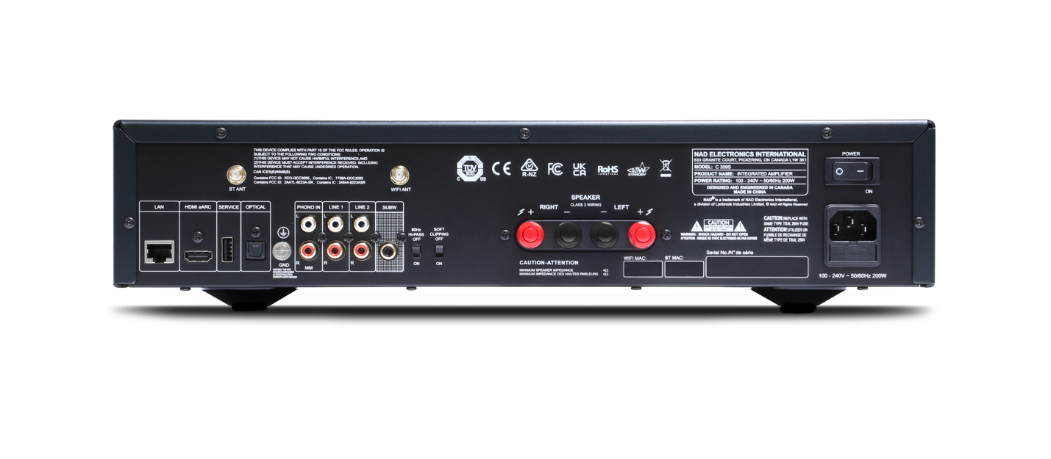C 359S Key Features
NAD C 359S Integrated Amplifier (Rear)

- Re-engineered Class AB amplification: 2 x 70 watts continuous into 8 ohms for confident real-world drive.
- High-current, low-noise switch mode power supply: Adopted from NAD’s flagship Class D amplifiers in the NAD MASTERS Series.
- Modern multi-layer circuit architecture: Separating power conversion, signal processing, and amplification for lower noise.
- Bulit-in BluOS: High-resolution streaming, internet radio, network music libraries and multi-room playback.
- HDMI eARC and Bluetooth: TV sound and wireless listening in a two-channel audio system.
- Phono, analogue and optical: For turntables, CD players, tuners and other traditional sources.
- Subwoofer output with optional high-pass filtering: Cleaner, more capable 2.1-channel system.
- Direct and tactile controls: Physical buttons, rotary dials, included IR remote and dedicated headphone output.

NAD C 569: Hear More from Every Disc

Joining NAD’s CD Player line between the entry-level C 538 and flagship C 589, the C 569 is built for music lovers whose collections deserve to be heard properly. Guided by NAD’s “Music First” design approach, it favours musicality, tonal balance and clarity over exaggerated detail or specs, delivering playback that is naturally engaging, even across long listening sessions.

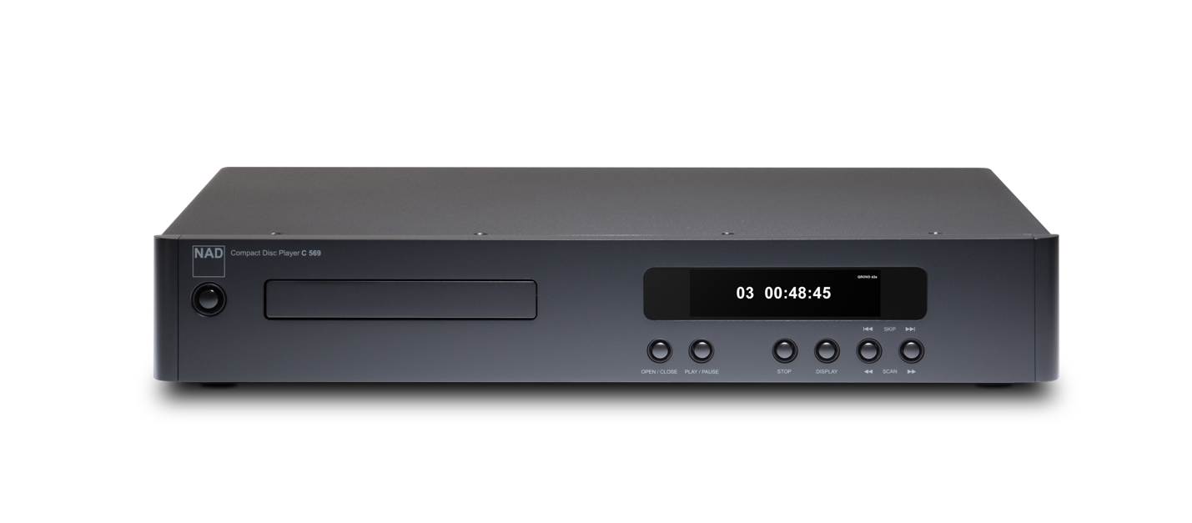
NAD C 569 CD Player (Front)

At its core are two key digital technologies. NAD’s proprietary Dynamic Digital Headroom (DDH) eliminates inter-sample clipping, allowing percussion and transients to hit harder and cleaner without the harshness of digital distortion. QRONO d2a refines timing and resolution, enhancing playback of both PCM and MQA encoded music for greater musical realism.

These technologies are supported by a carefully implemented ESS SABRE® DAC, improved op-amps and a refined power supply, chosen to lower noise and preserve low-level detail, while a high-quality transport ensures smooth, reliable operation. With analogue and digital outputs, the compact C 569 can serve as a complete source or as a transport for an external DAC, and it makes a natural partner for the C 359S.

C 569 Key Features

- A “Music First” Design: Natural, engaging and detailed CD playback that never sounds analytical.
- NAD Dynamic Digital Headroom (DDH): Eliminates inter-sample clipping for cleaner, harder-hitting transients.
- QRONO d2a: Refines timing and resolution for PCM and MQA encoded music.
- ESS SABRE® DAC: Supported by improved op-amps and a refined power supply.
- Analogue and digital outputs: Use as a complete source or as a transport with an external DAC.
- Simple operation: Intuitive front-panel controls, clear display and supplied remote.
- Compact and understated: Designed to fit easily into any system or room.

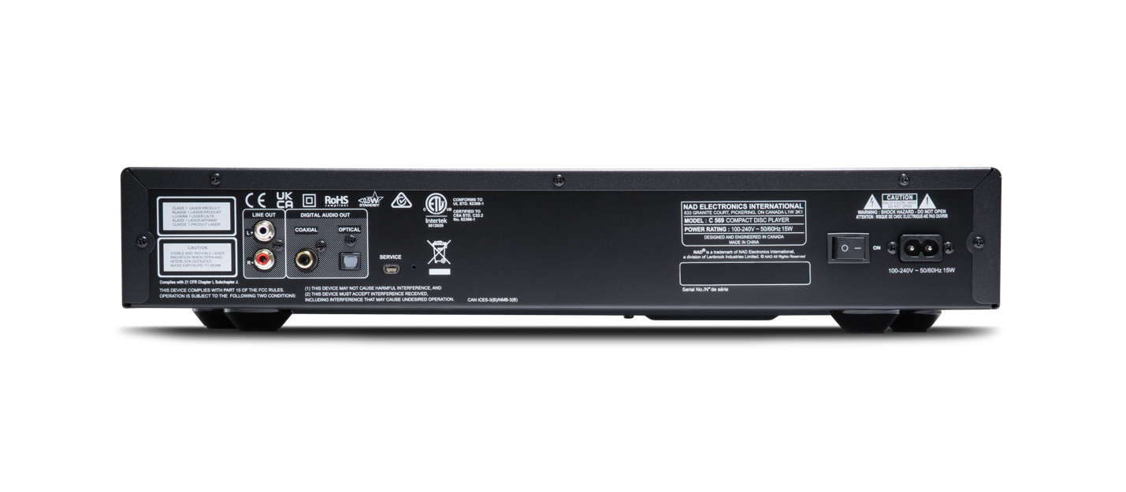
NAD C 569 CD Player (Rear)
Pricing & Availability

- The NAD C 359S Integrated Amplifier is available today from authorized NAD dealers at £1,099 in the U.K. and €1,199 across Europe.
- The NAD C 569 CD Player will be available late November from authorized NAD dealers, online at NADelectronics.com and Amazon at £749 and €949.
- C 359S production information, photography, and technical specs available here.
- C 569 product information, photography, and technical specs available here.

