L-Acoustics L-ISA Marks Europe’s First House of Worship Installation at Grace Family Church, Switzerland
Swiss partners SDS, Soundrig AG, Stagelight and Impact Atelier thread a five-hang A15i system around a fabric dome, a landmark chandelier and front projection, turning a like-for-like replacement into an immersive church sound system
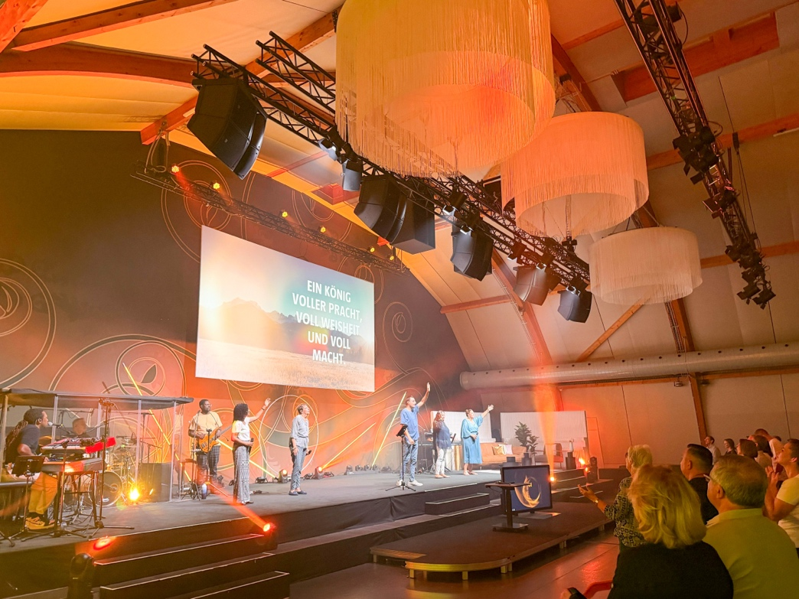
BUBIKON, Switzerland – September 2026 – Grace Family Church sits in the Zürich Oberland, half an hour south-east of Zürich. Its sanctuary is a tensile fabric membrane structure, rising in a rounded, vaulted profile from a 24 by 26 metre floor plan to a height of eight metres, and the congregation calls it the Church Dome. Up to 350 people fill it for the main Sunday service at 10am, and again for the church’s Worship Nights. The church was founded and is led by senior pastor Erich Engler, alongside pastor Susanne Engler and pastors Samuel Spörri and Roberto Vitali, and Engler’s grace-centred preaching has built a following that reaches well beyond Bubikon.
The system hanging in that room was approaching 20 years old and had reached the end of its life. The brief the church put to Swiss L-Acoustics distribution partner SDS was straightforward: replace it like for like, one loudspeaker left and one right. The site visit complicated that. From the positions the old system occupied, no left/right pair could give the room the imaging the church wanted for music or for the spoken word, so any replacement would have to hang somewhere else. That changed what was on the table. If the loudspeakers were moving anyway, there was no longer a reason for there to be only two of them.
A Demo in Winterthur, then a 1:1 L-ISA Design Inside the Church Dome
SDS came to the project through Soundrig AG, the consultancy already advising the church. The conversation opened with a listening session at the SDS Auditorium in Winterthur, and over the months that followed it turned towards L-ISA. What drew the church was localisation. In a room used for the spoken word as much as for music, the congregation should hear a voice coming from the person speaking, and an instrument from where it is being played, rather than from a loudspeaker off to one side. L-ISA does that for speech and for music alike. A second demonstration was staged 1:1 inside the Church Dome, the proposed design in the actual room, so the congregation could hear what it was being asked to buy. By the time the specification was agreed, the immersive system was no longer something SDS was proposing but something the church was asking for, and Grace Family Church became the first L-ISA installation in a house of worship in Europe.
L-ISA Meets a Domed Ceiling, a Chandelier and Front Projection
A full L-ISA design brought its own obstacles. “The domed roof and a striking chandelier were certainly a standout feature that made the installation and design unique,” Roger Sommer, company owner at Soundrig AG says. “We also had to design the L-ISA configuration around the front lighting and front projection.” The building envelope, on the other hand, turned out to be the one thing the architecture gave back. “The building shell is remarkably well insulated, so the amount of ambient noise getting in is surprisingly low,” Michael Graf at Stagelight says.
Soundvision Threads Five A15i Hangs Between the Sightlines
Soundvision did the coverage and SPL work, and on this project it also did the negotiating. “It calculated the optimal loudspeaker positions and SPL distribution, but it was also a huge help for placing the loudspeakers virtually within the building and finding the best compromise between sightlines, the projector’s field of view and the front spotlights,” Graf says. Modelling the room also gave the church a realistic picture of what it was buying, which is what carried the decision inside the congregation.
The final L-ISA Scene System comprises five hangs of one A15i Wide over one A15i Focus. Low end comes from two centre flown hangs of two KS21i each, and an X8 flown per side covers the lateral areas at the front of the room. One L-ISA Processor II handles the object processing and a single LA7.16i amplified controller drives all 16 enclosures.
Milan-AVB Carries L-ISA Audio to the LA7.16i
Audio runs from a Yamaha Rivage console over MADI into the L-ISA Processor II, with Milan-AVB carrying it onward to the LA7.16i. The same project renewed the venue’s audio network, planned and delivered by Michael Graf, systems engineer at integrator Impact Atelier and an experienced L-ISA user, who took on the switch and console integration. The church reports a clear improvement in overall stability as a result, and adds that the object-based nature of L-ISA could open the door to working more closely with the venue’s lighting in future.
Five Days, One Sunday Service to the Following Friday
Both ends of the install window were set by the church’s own diary. Work began on a Sunday evening, straight after the last service of the day, and had to be finished by the following Friday evening in time for that week’s Worship Night, rehearsals included. Rigging and PA installation were handled by Roger Sommer and his team at Soundrig AG, who stayed with the project from the first demo through to handover. “The support from Christian Schmid and the L-ISA application team was great from day one,” Patric Schafroth, Sales and Application Engineer at SDS says.
A System a Volunteer Team Can Run on a Sunday Morning
Grace Family Church is not a commercial venue, and the system is operated week to week by a team of semi-professional volunteers. “Set against the almost endless possibilities the system offers, the basic functions are kept as clear as possible, so getting started isn’t overly difficult,” This Hochstrasser, Head of Audio at Grace Church comments. First feedback has been strong, though the church is candid that it will take months of Sundays to draw on everything the system can do.
Stagelight sees room for the building to do more. “It’s equipped for whatever comes next, whether that’s their own events or renting out the space,” Hochstrasser says.
“It integrates very well into the building and is visually a win compared to a classic line array hang,” expands Hochstrasser. “Feedback from every side has been enormously positive.” Asked what it would say to another church weighing the same decision, the answer is unhesitating. “Definitely go and listen for yourself, and let experienced experts accompany you.”

About L-Acoustics
Since 1984, we have been continuously innovating to shape the future of sound.

Our European-designed solutions optimize Source, System, and Space—unleashing creative possibilities in content, perfecting audio technology, and harmonizing with venue acoustics to guarantee exceptional performance.

Our global team of over 1,000, with 20% dedicated to R&D, has pioneered breakthroughs like the V-DOSC line array, L-ISA immersive solutions, and the eco-conscious L Series—innovations that have both transformed our industry and transcended our auditory perceptions.

The world’s most demanding stages trust us: Adele's Las Vegas residency, the Philharmonie de Paris, the Zaha Hadid-designed Guangzhou Opera House, and over 13,000 premium venues worldwide. We’ve earned this trust by consistently delivering extraordinary audio in every venue and any space.

We are L-Acoustics. We connect humans through the best shared sound experiences.

Media assets available at: https://medialibrary.l-acoustics.com/bRgxHraZE

