Technics announces special DJ Set by ¥ØU$UK€ ¥UK1MAT$U to celebrate the 55th Anniversary of the SL-1200 Series

Global Premiere starts at 06:00 PM CEST on August 18, 2026

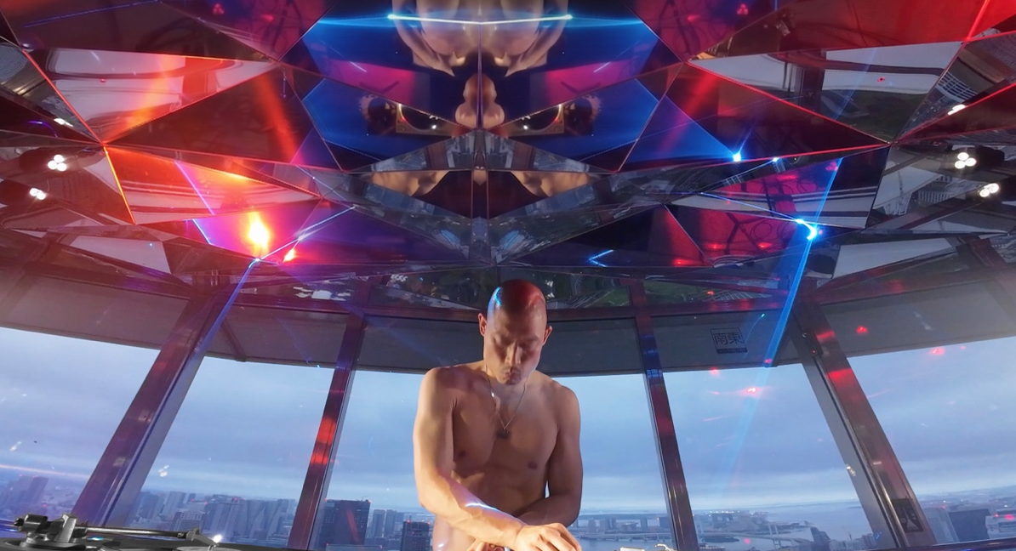

6th August 2026 - Technics is pleased to announce a special vinyl DJ set featuring globally acclaimed DJ ¥ØU$UK€ ¥UK1MAT$U played at Tokyo’s iconic landmark Tokyo Tower, in celebration of the upcoming 55th anniversary of the legendary SL-1200 Series in 2027.

The performance will premiere globally on August 18, 2026, on RA Live, via the YouTube channel of Resident Advisor, one of the world's leading electronic music platforms.

The YouTube link included in this announcement will direct users to RA's official YouTube channel, where the video will be published. Once the scheduled start time arrives, the DJ set will be premiered on RA Live.

RA Official YouTube Channel Link: www.youtube.com/residentadvisor
Since its debut in 1972, following the launch of the world's first direct-drive turntable, the SP-10, the Technics SL-1200 Series has helped shape and support vinyl-based DJ culture through its exceptional rotational stability, precision, and durability. Growing alongside DJs and club culture around the world, the SL-1200 remains the industry standard and continues to be trusted by professional DJs across generations.

For this project, Technics has partnered with ¥ØU$UK€ ¥UK1MAT$U, one of the most innovative and internationally celebrated DJs of his generation. Renowned for his distinctive artistic approach and boundary-pushing style, he has performed at major festivals and clubs worldwide, including Coachella, and is widely regarded as one of the defining figures of contemporary DJ culture. For this special performance, ¥ØU$UK€ ¥UK1MAT$U delivers an exclusive all-vinyl DJ set.

Filmed on the Top Deck of Tokyo Tower, located 250 meters above ground, in collaboration with DOMMUNE, Japan's renowned music and culture streaming platform, the project embodies the 55th anniversary theme, "THE LEGEND KEEPS SPINNING". Through this performance, Technics celebrates the enduring legacy of DJ culture, vinyl records, and analog music while expressing its commitment to carrying these values forward for future generations.

RA Live: ¥ØU$UK€ ¥UK1MAT$U @ Technics SL-1200 Series 55th anniversary

Premiere Date & Time: August 18, 2026
06:00 PM CEST (Berlin) | 05:00 PM BST (London)
Platform: Resident Advisor
Format: Free YouTube Premiere
YouTube Premiere: Link to be announced


¥ØU$UK€ ¥UK1MAT$U (YOUSUKE YUKIMATSU)

A DJ from Osaka based in Tokyo. As a pioneer of a contemporary alternative mixing style that transcends mainstream and underground dance music, blending mass appeal with experimentation, he has grown into one of the world's top DJs, drawing diverse audiences into a whirlwind of ecstasy.

He rose to prominence through energetic activities in Japan's club scene, including appearances at his own FUTURE TERROR parties and his flagship event Zone Unknown. His New Year's Eve photo shoot at Shibuya WWW and his overwhelming physicality and experimental approach delivering unknown DJ experiences sent shockwaves worldwide. Starting with his appearance at Berlin's Atonal, he performed at major EU electronic music festivals and clubs like Berghain. He participated in the TRANCE installation/performance at Beijing's Asian Dope Boys. His first compilation album, ‘Midnight is Comin’', released by Singapore's Midnight Shift, showcased his selector side by featuring numerous Japanese artists. His 2025 Boiler Room release approached 5 million views in one month, hit 10 million in six months, and now exceeds 19 million views. Beyond electronic dance music such as Ultra and EDC, he continues to take the world by storm with DJS at the world’s premier international festivals, including Coachella, Primavera and Lollapalooza.

Coachella 2026 https://youtu.be/IP9v-2nEA2E?si=ZfjZ_OUd3yZ6l0nO
Boiler Room: Tokyo https://youtu.be/T1tcUfUhR5U?si=G9Y8ugjFFLBfYFii
Instagram https://www.instagram.com/yousukeyukimatsu/
SoundCloud https://soundcloud.com/yousukeyukimatsu
X https://x.com/kesuyotsumakiyu
RA Podcast https://ra.co/podcast/849
Midnight Is Comin’ Album Review | Pitchfork
https://pitchfork.com/reviews/albums/yousuke-yukimatsu-midnight-is-comin/


Technics Direct Drive Turntable System SL-1200 Series

Celebrating its 55th anniversary in 2027, the SL-1200 Series is Technics' iconic line of direct-drive turntables, first introduced in 1972. Recognized for exceptional rotational accuracy, reliability, and durability, the series has earned the trust of audiophiles and professional DJs alike. Beyond its technical excellence, the SL-1200 helped pioneer new forms of DJ expression, including scratching and other performance techniques that contributed to the development of modern DJ culture around the world.

Continuously evolving in response to the needs of DJs and music communities worldwide, the series has achieved cumulative shipments of more than 3.5 million units and remains one of the world’s most iconic and respected turntable series ever created. Today, it continues to be loved by DJs, collectors, and music enthusiasts across the globe.

Technics Official Web: SL-1200 History Site
https://www.technics.com/global/home/technics-dj/history.html

About DOMMUNE

Founded in 2010 by Naohiro Ukawa, DOMMUNE is Japan's pioneering live streaming platform dedicated to music, art, and culture. Renowned for its high-quality programming and large global audience, it has become a unique cultural platform, welcoming leading artists, musicians, and creatives from around the world whenever they visit Japan.

Over the past 15 years, DOMMUNE has streamed approximately 5,000 programs, totaling more than 10,000 hours of content and over 200 terabytes of archived material, reaching a cumulative audience of more than 200 million viewers. Today, DOMMUNE operates its flagship studio, SUPER DOMMUNE, located on the 9th floor of Shibuya PARCO in Tokyo.

About Technics

The Technics brand was established in 1965. Beginning with the Technics 1 speaker, the brand has gone on to develop revolutionary audio products and technologies, including amps, players, and tuners. In particular, the direct-drive turntable was an industry gamechanger, laying the foundation for today’s DJ and club music scenes. Today, in a diverse music scene that favours both analogue and digital audio, Technics continues to lead the market as a comprehensive audio brand.

For more information please see: technics.com or follow technics.global on Facebook or @technics_global on Instagram.

