NAD Electronics M33 V2 Awarded EISA Smart Amplifier 2026-2027
  - Reference streaming amplifier honoured by the world’s leading audio experts for exceptional innovation, performance, and versatility.
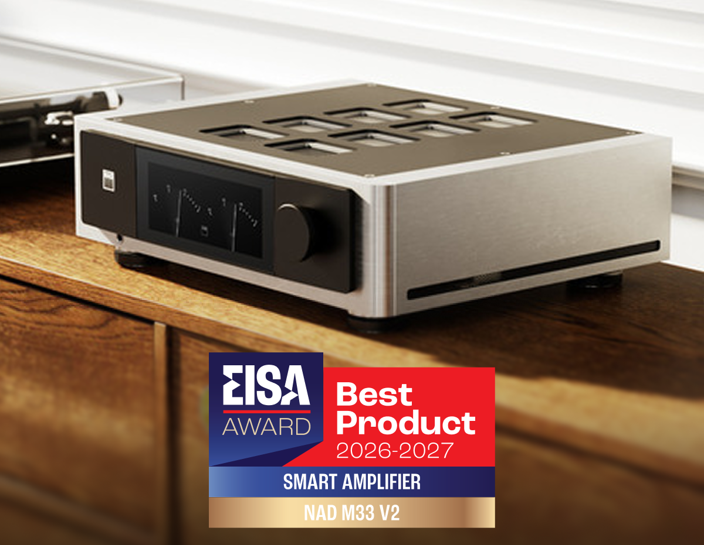

TORONTO, CANADA, AUGUST 24, 2026 – NAD Electronics, a leading manufacturer of premium high-performance audio components, is proud to announce that its flagship NAD Masters M33 V2 BluOS Streaming Amplifier has received the prestigious EISA Smart Amplifier 2026-2027 Award from the Expert Imaging and Sound Association (EISA).

Presented annually by a panel of expert journalists, editors, and reviewers representing the world’s most respected hi-fi and consumer electronics publications, EISA Awards recognize the finest products in their category based on innovation, performance, design, and overall value.

In awarding the NAD Masters M33 V2 its highest honour in the Smart Amplifier category, the EISA judges praised NAD’s ability to substantially improve upon an already award-winning platform through meaningful technological innovation and uncompromising performance. The judges highlighted the amplifier’s latest generation Purifi Eigentakt™ amplification, ESS’s most advanced ADC, Lenbrook Media Group's proprietary FOQUS and QRONO technologies, BluOS® streaming, Dirac Live Room Correction and Bass Control, and comprehensive connectivity options.

Official EISA Award Citation

“Improving the EISA Award-winning M33 was no small task, yet the M33 V2 is far more than a routine update. Replacing the original Purifi Eigentakt class-D amplifier modules with the latest-generation versions further reduces already-low distortion while delivering more than 200Wpc into 8 ohms and 380Wpc into 4 ohms. A redesigned DAC stage incorporating proprietary QRONO and FOQUS technologies improves timing accuracy and detail. BluOS delivers intuitive streaming and multiroom capabilities, while Dirac Live with Dirac Live Bass Control provides room correction and the integration of up to two subwoofers. Connectivity includes HDMI eARC, balanced XLR inputs, an MM/MC phono stage, and extensive smart-home compatibility, making it easy to see why the EISA judges consider the M33 V2 the smartest integrated amplifier around.”

“We are honoured that the NAD Masters M33 V2 has been recognized by EISA as the Smart Amplifier of the Year,” said Spencer Chrislu, Product Manager for NAD Masters. “This honour reaffirms that our vision to bring end-to-end timing precision yields superior results for music lovers. The combination of technologies like FOQUS, QRONO, ESS ADC, Purifi Eigentakt, and Dirac Live, bolsters our technical designs around jitter, streaming latency, and other innovations to deliver extraordinary musical realism while remaining intuitive, flexible, and future-ready.

The NAD M33 V2 represents a significant evolution of NAD’s audio architecture and amplifier platform. The latest research in audio points to a lack of impulse clarity due to timing misalignment as one of the remaining frontiers in addressing listening distortion. The product’s architecture was redesigned from input to output, applying the most advanced technologies and circuitry designs to eliminate this form of distortion, creating a state-of-the-art streaming amplifier that performs with speed, deftness, and finesse, handling even the most challenging musical passages with ease.

The EISA Smart Amplifier 2026-2027 award demonstrates NAD’s long tradition of recognition from the world’s respected hi-fi journalists, and their commitment to delivering exceptional performance and innovation across multiple product categories.

For full high-resolution images, product information, and press materials, download the NAD EISA Awards 2026-2027 toolkit here.

About NAD Electronics
Founded in 1972 and now sold in over 80 countries, NAD Electronics is renowned for its
award-winning line of high-quality components for audio, home theatre and custom
installation applications. Since the beginning, NAD’s commitment to four core values –
innovation, simplicity, performance, and value – have earned it a cult-like
following that catapulted it to becoming a household name amongst audiophiles and
music lovers alike. To this day, the brand continues to design and manufacture some of
the most acclaimed and affordable hi-fi components that include modern features and
technologies meant to appeal to a new generation of audiophiles. Visit nadelectronics.com for more.

contacts
Scott Wicks
Marketing and Communications
media@nadelectronics.com

US Media Relations
Adam Sohmer
OLEX Communications
adam@olexcommunications.co.uk

UK Media Relations
Steve Dalton
OLEX Communications
steve@olexcommunications.co.uk

Links
Website: https://nadelectronics.com
Facebook: https://www.facebook.com/nadelectronics
LinkedIn: https://www.linkedin.com/company/nad-electronics/
Instagram: https://www.instagram.com/nadelectronics/
X: https://x.com/nadelectronics

