SHURE INTRODUCES NEXT GENERATION OF THE MV6 USB GAMING MICROPHONE: SMARTER AUDIO FOR GAMERS

With smart presets and two colourways, gamers, streamers, and creators can fine-tune their sound and their setup
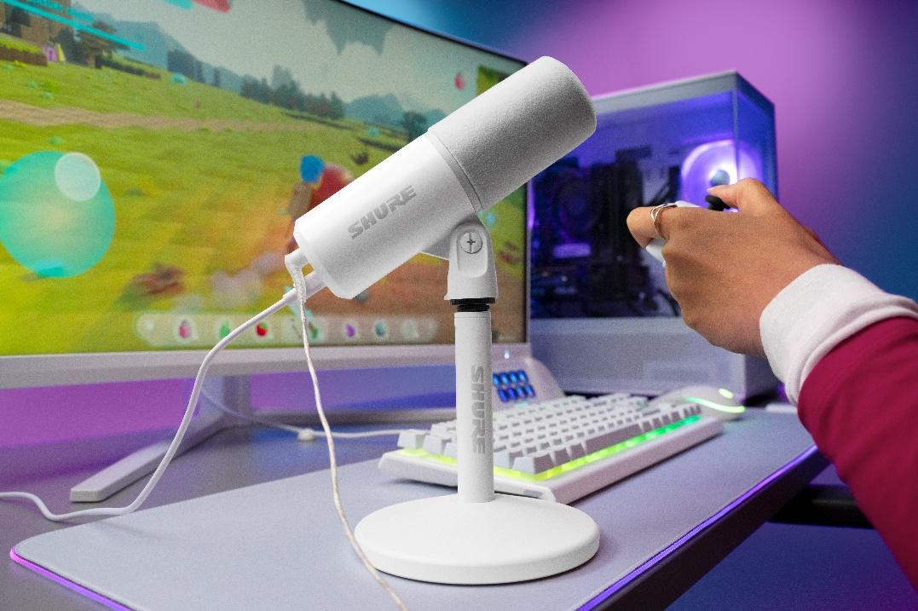
NILES, IL, 30th September 2026 — Today, Shure announced the launch of the MV6 USB Gaming Microphone Gen 2, including a new white variant, the latest evolution of its digital MOTIV microphone portfolio. Following the success of the original MV6, the MV6 Gen 2 incorporates feedback from gamers, streamers, and creators to deliver a more customisable audio experience while maintaining an accessible price point.
Engineered specifically for PC gaming, streaming and content creation, the MV6 Gen 2 brings Shure's professional broadcast technology to more creators, including those purchasing their first dedicated microphone and looking to elevate their sound beyond a headset.
New for Gen 2, the enhanced MV6 gives gamers, streamers, and creators more control over the intelligent processing that made the original so powerful. Built around Shure’s Voice Isolation Technology, the mic now adds adjustable Auto Level Mode and an adjustable Real-Time Denoiser to more effectively manage sudden volume changes and background noise during gameplay and streaming. The result is personalized audio that stays clear and consistent, helping users stay focused on their game while providing greater freedom to position the microphone where it works best for their setup and on-camera presence.
"Gamers and streamers aren't audio engineers, and they shouldn't have to be to sound great," said T Banks, Product Manager at Shure. "They whisper during tense strategic moments, shout during victories, and stream from environments ranging from quiet bedrooms to noisy shared spaces. With the MV6 Gen 2, the audio intelligence sits inside the microphone’s hardware itself. The mic does the heavy lifting of managing volume spikes and erasing background room noise, directly out-of-the-box."
Built for Gaming, Streaming and Creating
The MV6 Gen 2 is designed for the realities of gaming, streaming, and content creation, from sudden volume changes and background noise to setups that move across PCs, tablets, and phones. Users can fine-tune audio settings in the free MOTIV desktop, tablet, and mobile apps, then save them directly to the microphone for consistent sound when switching between compatible devices.

Core upgrades and smart features include:
- Two Colourways: Available in black and new all-white finishes. Both options ship with a matching desktop stand and USB-C cable. The white model features color-matched flocked foam with a velvety finish for a clean, unified desk aesthetic.
- Adjustable Auto Level Mode: Whether users whisper through a stealth mission or shout after a clutch victory, Auto Level Mode keeps their voice at a steady, consistent volume. Users can now choose how loud their voice sits in the mix and how quickly the mic reacts. A slower setting delivers a smooth, podcast-style sound, while a faster one catches sudden gaming moments without clipping or dropouts.
- Adjustable Real-time Denoiser: A new slider lets users control how much of their room comes through on stream. Slide it up to cut out background noise like fans, keyboards, or roommates, or ease it back to keep a more natural, open sound in the mix.
- Customisable EQ: A 5-band equalizer lets users design their signature tone, on top of simple Dark, Natural and Bright options.
- Built-in Digital Popper Stopper: On-board virtual pop filtering mechanically and digitally suppresses harsh sounds.
- Three Presets: The mic offers quick presets for Speech, Singing, and Instrument applications.
The MV6 Gen 2 now ships with a longer 2-meter USB-C cable to support more flexible positioning and complex desk layouts. The included desktop stand has an isolation base to minimize desk bumps and vibrations, while a universal 5/8-inch thread makes it easy to unmount the microphone and attach it to any standard boom arm. A 3.5mm headphone jack lets users hear their mic and game audio exactly as their audience does, with no delay, and a tap-to-mute hardware button with a colour-changing LED indicator enables instant, silent muting.

From Play to Everyday. MV6 Gen 2 Does It All.
With Shure’s immediately recognizable design and audio quality, the MV6 Gen 2 can take users from late-night Discord raids to morning business presentations. The MV6 Gen 2 is compatible with PC, Mac, and Android devices via a single USB-C cable. It is also MFi Certified by Apple for use with iPhone and iPad.
Pricing & Availability
The Shure MV6 Gen 2 is available beginning September 30, 2026 for $169 (MSRP) at shure.com and authorised retailers. Shure MOTIV apps will support MV6 Gen 2 from launch.
For more information, visit https://www.shure.com/mv6.
About Shure
Shure (www.shure.com) has been helping people sound extraordinary for more than 100 years. Founded in 1925, we are a leading global manufacturer of audio and collaboration technology, known for our commitment to quality, performance, and durability. We make microphones, wireless microphones, conference room solutions, earphones and headphones, in-ear monitors, and more.

From the biggest broadcast events and live performances, to critical business meetings and university lectures, to your home office or studio, you can always rely on Shure.

Shure is headquartered just outside of Chicago in Niles, Illinois, in the United States. We have more than 30 locations around the world, and our products are sold in over 120 countries.

