Panasonic Expands Hi-Fi Line-up with New SC-PMX112 and SC-PM302 Systems

Internet radio and a choice of premium connected audio and compact everyday listening, with both available from October 2026.




Germany, Wiesbaden - October 2026

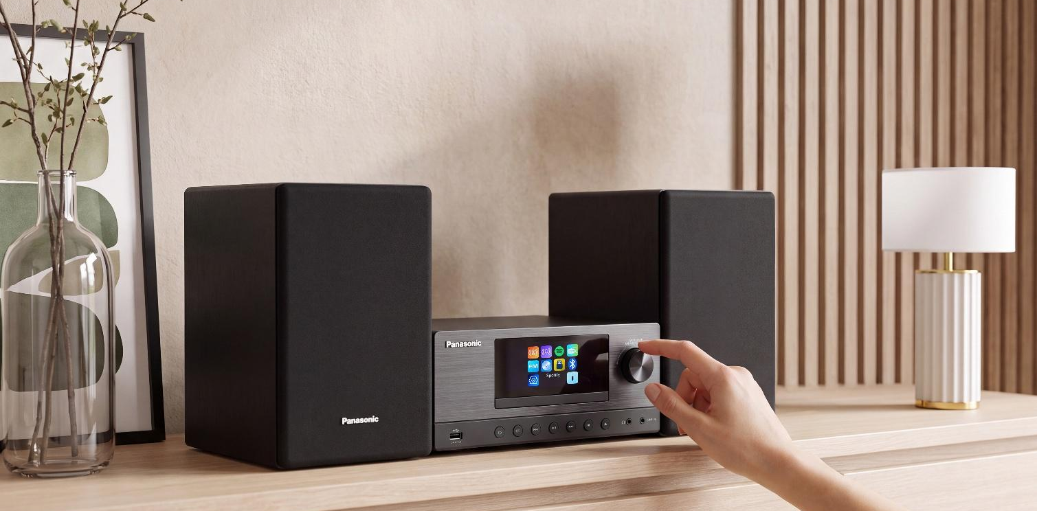

- Two new Hi-Fi systems designed for different listening needs
- Premium SC-PMX112 with a powerful 2-way speaker system
- Internet radio and Spotify Connect on the SC-PMX112
- SC-PMX112 with 180 W
- Bluetooth® wireless streaming on both systems
- CD, USB, DAB+ and FM radio playback
- Compact SC-PM302 with 60 W RMS stereo sound
- Wooden speaker cabinets and colour TFT displays
- Remote controls and local-language menu support

Panasonic announces two new Hi-Fi systems offering a choice of connected home audio and compact everyday listening. The SC-PMX112 leads the new line up with Internet radio, Spotify Connect and a broad range of digital and physical music sources. The compact SC-PM302 provides a more accessible option, combing 60W RMS stereo sound with CD and USB playback, Bluetooth ®, DAB+ and FM radio in a space saving design.

Available from October 2026, the two models are designed to give listeners the flexibility to choose the system that best suits their home and listening preferences, from those seeking enhanced sound performance and broader connectivity to those that seek an easy and enjoyable solution for main living room audio system to music in bedrooms, kitchens and home offices.

SC-PMX112: Connected Hi-Fi with Powerful Detailed Sound

The SC-PMX112 features a 2-way speaker system with 13 cm full-range drivers, dedicated tweeters and bass reflex ports. This combination delivers clear vocals, detailed high frequencies and powerful bass, creating a balanced listening experience across a wide variety of music. Five preset EQ modes allow the sound to be adjusted to suit different listening preferences.

The speakers are housed in wooden cabinets that support the system’s refined sound and give the SC-PMX112 a more substantial presence in the home. Detachable speaker grilles and cables provide additional flexibility when setting up the system.

Dual-band Wi-Fi provides access to Spotify Connect and internet radio, opening a wide choice of music, radio stations and podcasts. Bluetooth® enables straightforward wireless streaming from a compatible smartphone or tablet.

Alongside its wireless features, the SC-PMX112 supports CD and USB playback, DAB+ digital radio and FM radio, giving listeners the flexibility to move between streaming, radio and physical music collections.

The system also offers a range of connections for other home entertainment devices. An optical input can be used to connect a compatible television or other digital audio source, while a 3.5 mm line input supports additional analogue devices. A USB-A port supports playback and charging, with dedicated headphone and subwoofer outputs providing further listening and system-expansion options.

SC-PM302: Compact Hi-Fi for Flexible Everyday Listening

For listeners looking for a more compact option, the SC-PM302 delivers 60 W RMS stereo sound through a pair of 10 cm full-range speakers housed in wooden enclosures, provide balanced audio across a wide range of music genres.

Its space saving format makes the SC-PM302 well suited for a range of rooms around the home including bedrooms, kitchens, living rooms and home offices, while five preset EQ modes allow listeners to tailor the sound to their personal preferences.

Despite its compact design, the SC-PM302 offers a broad choice of listening options, including Bluetooth® streaming, CD and USB playback, DAB+ digital radio and FM radio.

Designed to Feel at Home

Both systems combine clean, minimalist styling with wooden speaker cabinets and colour TFT displays, allowing them to blend naturally into contemporary living spaces.

The SC-PMX112 features a large 2.8-inch colour TFT display providing a clear overview of music sources, stations and settings. The compact SC-PM302 features an easy-to-read 2.4-inch colour TFT display for straightforward navigation and everyday operation.

Both models are supplied with remote controls and offer 17 European language menu support, while detachable AC cables provide greater flexibility when positioning the systems in the home.

Integrated clock, alarm and sleep functions on the SC-PMX112 provide additional everyday convenience, allowing listeners to wake to a favourite radio station or set the system to switch off automatically at the end of the day.

Availability and Pricing

The Panasonic SC-PMX112 will be released in October 2026 at a recommended retail price of £269.99. The SC-PM302 will also be available from October at a guide price of £119.99. Both systems will be available directly from Panasonic and from major electrical retailers.

—ENDS—


About the Panasonic Group

Founded in 1918, the Panasonic Group is a global leader developing innovative technologies and solutions with wide-ranging applications in the consumer electronics, devices, B2B solutions, heating and cooling, electrical equipment and lighting, and energy sectors worldwide. The Panasonic Group consists of Panasonic Holdings Corporation, seven operating companies and affiliates both within Japan and overseas. Panasonic Holdings Corporation reported consolidated net sales of 46.0 billion euros (8,048.7 billion yen) for the year ended March 31, 2026. To learn more about the Panasonic Group, please visit: https://holdings.panasonic/global/


Create Today. Enrich Tomorrow.

Holistic Wellbeing for People, Society, and the Planet - Our goal is to bring balance to People, Society and the Planet through our innovative solutions & products, promoting overall wellbeing for everyone by creating a healthier, simpler and more balanced way of living.

Find out more >


Panasonic Group Environmental Initiatives

The Panasonic Group has set forth its long-term environmental vision, "Panasonic GREEN IMPACT," with the aim of achieving both a better life and a sustainable global environment for all. Under PGI, Panasonic Group strives towards achieving virtually net zero CO2 emissions from its own operations by 2030, and aims to create an impact of more than 300 million tons (*1) of reduced and avoided CO2, which is equivalent to about 1 percent of the current global total of approximately 31.7 billion tons (*2) by 2050. The group also works on business activities to realize a circular economy in which resource efficiency contributes to decarbonization and reduces the consumption of limited natural resources.

*1: CO2 Emission factor based on 2020
*2: 31.7 billion tons of energy-derived CO 2 emissions in 2020 (Source: IEA)

PANASONIC GREEN IMPACT - ABOUT US - PANASONIC HOLDINGS

