L-Acoustics A15 Wide Carries Moyo Drymades from Beachfront Wellness to Late-Night DJ Sets

L-Acoustics Certified Partner Prosound delivers a complete DJ sound system built on A Series and X Series for the Tulum-inspired beach club on Albania’s Ionian coast

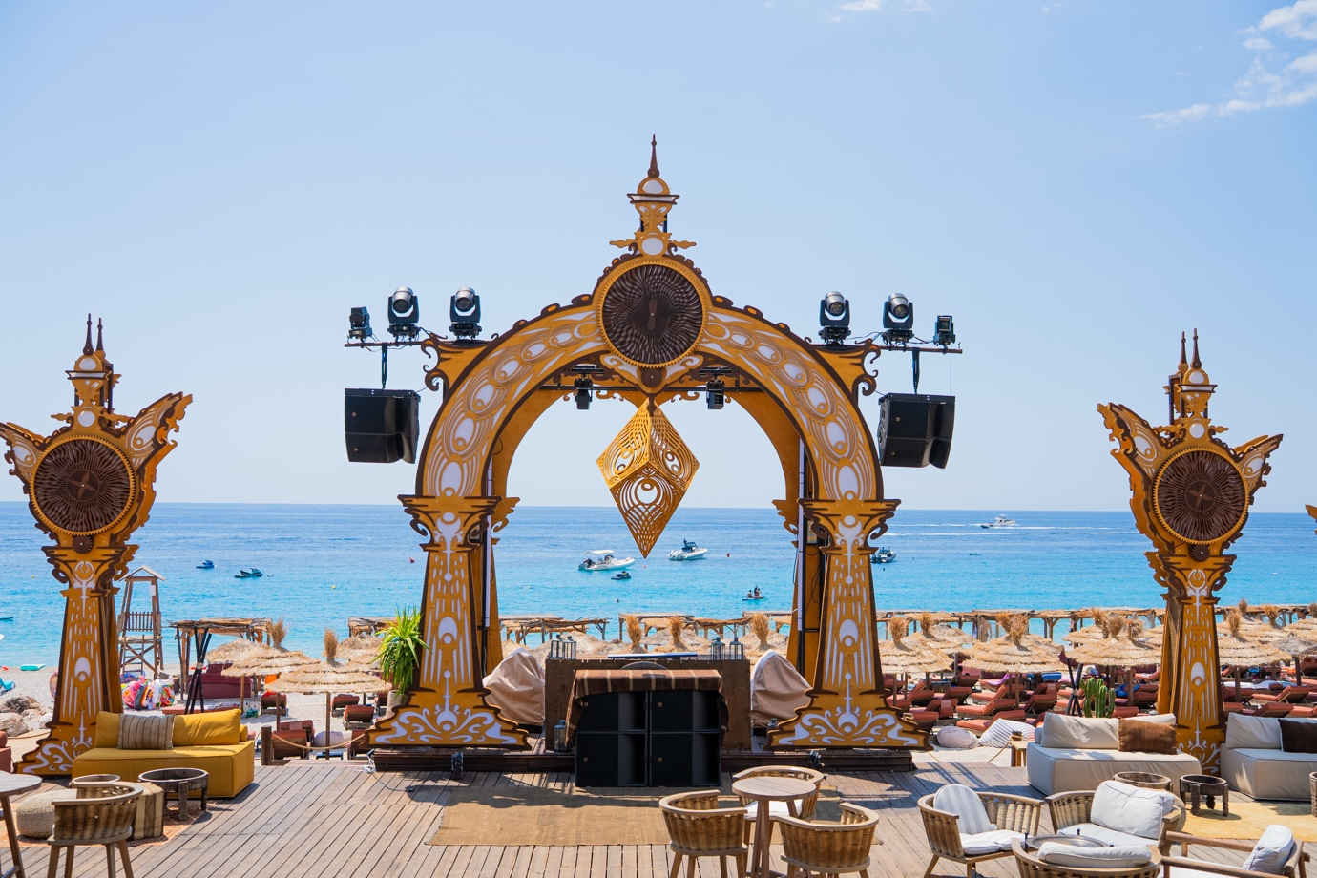

DHËRMI, ALBANIA – September 2026 – Drymades is the beach the Albanian Riviera is becoming known for: a long curve of ivory pebbles, clear Ionian water and pine slopes running down to the sand. Moyo Drymades sits directly on it. Part restaurant, part wellness retreat, part beach club, Moyo spends its days as a place to eat, swim and slow down, then turns its beachfront over to international DJ sets, live performances and large-scale events after dark. Getting there has never been easier: since the Llogara tunnel opened in summer 2024, the coastal drive from Vlora to Palasë takes seven minutes rather than 30, and Moyo has become one of the busiest destinations on the Riviera.

That double life set the brief for Moyo’s audio upgrade. One system had to sit low, warm and unobtrusive across the restaurant, loungers and wellness areas through the middle of the day, then find full-range weight and headroom for a Saturday night on the same stretch of sand, on an open-air site with almost no walls to contain it and salt air working on it all year round. A complete L-Acoustics system, designed and installed by L-Acoustics Certified Partner Prosound, now does both.

A15 Wide and KS21 for Two Very Different Registers
Prosound is an Albania-based systems integrator with a track record in premium hospitality, entertainment and large-scale event audio. The company supported Moyo from acoustic design through to installation, commissioning and system optimisation, with Endrit Veleshnja leading the system design and Henri Balla the installation.

“Moyo wanted powerful, impactful low frequencies, excellent definition across the entire frequency spectrum and consistent coverage throughout the venue,” says Endrit Veleshnja, project lead at Prosound. “The system needed to perform equally well for background music and DJ programming throughout the week before stepping up to substantially higher SPL and headroom demands during Moyo’s weekend events.”

Definition does as much work at 11am as it does at midnight. At daytime levels, competing with the sea rather than with a crowd, the clarity and natural warmth of the A15 Wide coverage lets lunch service, conversation and the wellness programme share the beach without the music being pushed to make itself heard.

IP55 Enclosures for Sea Spray and Salt Air
Moyo’s second constraint is the site itself. The club is on the sand, open to the sky, with very little between the loudspeakers and the water.

“The system had to withstand years of exposure to sea spray, salt air, humidity and rain,” says Veleshnja. “Weather resistance came as standard rather than as something we had to engineer around. A15 Wide, KS21 and SB18 IIi are rated IP55, and that gave us the protection and the reliability a coastal site demands with no compromise on audio performance.”

Soundvision Aims Eight X12 One by One
Moyo is not a neat rectangle of a room. Dancefloor, dining, lounge and perimeter areas all had to be covered at once, from positions dictated by a beach rather than by a building.

“Soundvision enabled us to model SPL distribution, system angles and audience areas across all of Moyo’s different spaces before committing to a position on site,” Veleshnja adds. “The finished project file aims each of the eight X12 at its own site and azimuth angle, tailored fixture by fixture to the shape of the venue rather than repeated around it. That let us balance the main dancefloor against the out-fill and front-fill zones, and catch coverage inconsistencies on screen rather than by ear once the system was live.”

From Dancefloor to Perimeter: A15 Wide, KS21, X12 and SB18 IIi
The main system centres on two hangs of two L-Acoustics A15 Wide, flown either side of the performance area, with four KS21 subwoofers split two per side groundstacked below. The A Series delivers the definition and the directivity the brief called for while carrying the low-frequency impact Moyo wanted for its electronic programming, and KS21 supplies the headroom to push that impact across an open-air site with nothing to help contain it.

Coverage extends out to eight X12 working as satellite and fill loudspeakers across the dining, lounge and perimeter areas, alongside six SB18 IIi that keep low-frequency energy consistent well beyond the main dancefloor. In the DJ booth, two X15 HiQ and two SB18 IIi sit either side of the console.

Two LA12X and three LA4X amplified controllers power and process the system from purpose-built enclosures that Prosound designed to keep them clear of rain, direct moisture and the beach environment, while preserving the ventilation and thermal headroom amplified controllers need and keeping them accessible for routine servicing.

A Reference Point for the Albanian Riviera
Since the system went live, Prosound reports that Moyo Drymades has become a reference point for audio quality on the Albanian Riviera. Feedback from visiting engineers, artists and production teams keeps returning to the same point: the low end arrives with real physical weight while the mid and high frequencies stay fully intact, at any hour of the day.

“We engineered headroom into the system for the big nights while keeping the directional control that everyday programming depends on, so the venue can move between registers without affecting coverage at either end,” says Veleshnja. “We’re delighted with the final result, and with the equipment, system design and optimisation that made it possible.”

“Guests notice the new system the moment the first track drops,” says Tatu, resident DJ, Moyo Drymades. “The power and the clarity we now have on this beach are exactly what we set out to build, and they are part of what keeps people coming back.”

For more information on Moyo Drymades, please visit www.moyo.al. More information on Prosound can be found at www.prosound-sales.al.

About L-Acoustics
Since 1984, we have been continuously innovating to shape the future of sound.

Our European-designed solutions optimize Source, System, and Space—unleashing creative possibilities in content, perfecting audio technology, and harmonizing with venue acoustics to guarantee exceptional performance.

Our global team of over 1,000, with 20% dedicated to R&D, has pioneered breakthroughs like the V-DOSC line array, L-ISA immersive solutions, and the eco-conscious L Series—innovations that have both transformed our industry and transcended our auditory perceptions.

The world’s most demanding stages trust us: Adele's Las Vegas residency, the Philharmonie de Paris, the Zaha Hadid-designed Guangzhou Opera House, and over 13,000 premium venues worldwide. We’ve earned this trust by consistently delivering extraordinary audio in every venue and any space.

We are L-Acoustics. We connect humans through the best shared sound experiences.

