Jikei Gakuen Joint Graduation Ceremony Turns to L-Acoustics K3 and Kiva II for Both Speech and Live Music

Sonic Wave and L-Acoustics Certified Provider Bestec Audio deploy a compact, full-bandwidth professional sound system at Sheraton Grande Tokyo Bay

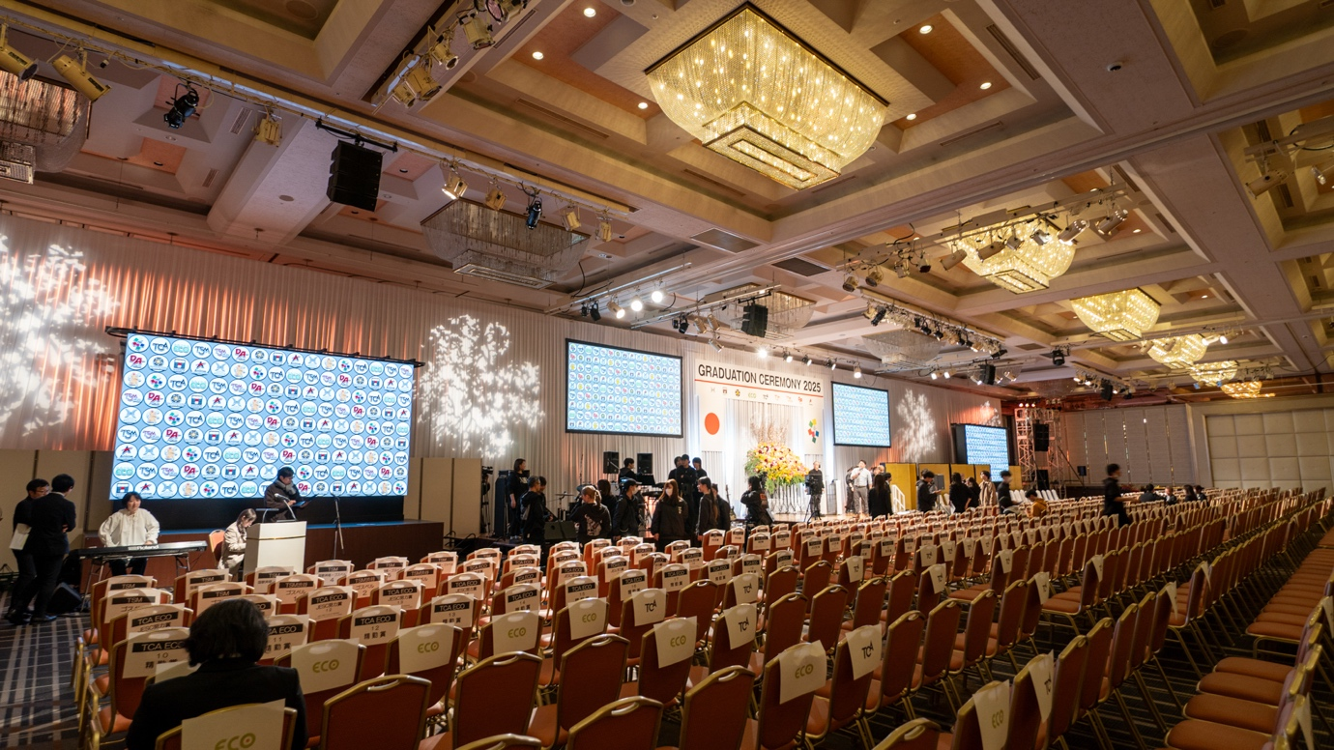

MAIHAMA, JAPAN – October 2026 – Every spring, the Jikei Gakuen group holds a joint graduation ceremony for its schools across the Tokyo area. This year, nine of those schools gathered around 1,400 students, families and staff at the Sheraton Grande Tokyo Bay Hotel in Maihama, Chiba Prefecture, for a single day that paired the formal proceedings, including the reading of every graduate’s name with live music performed by the schools’ own teaching staff, among them keyboardist Mickie Yoshino.

The ceremony filled The Club Fuji, the hotel’s grand ballroom, which covers more than 1,600 square metres and measures 32.0 metres deep by 50.5 metres wide beneath a 6.2-metre ceiling. A room considerably wider than it is deep asks a great deal of a main system working from a stage at front centre, where two hangs will cover the left and right of the audience comfortably but can leave the middle of the room without clear sound. With addresses, the reading of every name and a live band all on the same programme, the system had to hold intelligibility and musical weight in equal measure.

Sonic Wave, the audio company that has handled the ceremony’s sound for several years, knew both the room and the brief. “The star of a ceremony like this is, above all, the voice: the MC and everyone who speaks from the stage,” says Sonic Wave Director Kohei Harashima, who also teaches sound part-time at the Kasai campus of the Tokyo School of Music & Dance College.

K3 and KS21 Bring Full Bandwidth to the Main System
New for 2026 was the main system. Sonic Wave specified four L-Acoustics K3 per side with three KS21 subwoofers, configured cardioid to keep low-frequency energy forward in the room and away from the surfaces behind the hangs. K3 was the enclosure that allowed a single main hang to serve both halves of the programme, offering full bandwidth from a compact box so that the spoken word and the live performance were carried by the same system.

“This joint graduation ceremony is held at this scale every year,” says Mr Harashima. “We had been using Kiva II as in-fill for about two years, but this was the first time we used K3 and KS21 as the main system.”

Kiva II In-Fill Covers the Centre Within the Ceiling’s Weight Limit
Covering the middle of The Club Fuji fell to in-fill, and where it could be placed was decided by the ballroom itself. “Because the room is so wide, we use in-fill to stop the sound dropping out in the centre,” says Mr Harashima. “There is no floor space to stack anything, so the in-fill has to be flown, and the venue’s ceiling battens have a weight limit. That is where the light weight Kiva II comes in handy.”

Kiva II was familiar ground. Sonic Wave has worked with L-Acoustics systems for years and with Kiva II in particular, and had used it as the in-fill for this ceremony previously. The company runs its projects with a small and experienced crew, and a system compact enough to travel in a van and light enough for one or two people to rig is central to the way it works; in day-to-day production the team selects its subwoofers from SB15m or SB18 according to the scale of the room.

Soundvision Settles the Design Ahead of a One-Day Load-In
With every in-fill position in the air and a single day to prepare the room, Sonic Wave modelled the deployment in L-Acoustics Soundvision and came to site with the loudspeaker settings already prepared. “Being able to set the loudspeakers up in advance in Soundvision, before we get to site, is a big advantage in our work,” says Mr Harashima.

The final deployment comprised four L-Acoustics K3 and three cardioid-configured KS21 subwoofers per side as the main system. Four arrays of four Kiva II provided in-fill, flown from the ballroom’s overhead battens, while 12XT coaxial enclosures handled out-fill and stage monitoring for the live performances.

K3 and Kiva II Set the Benchmark for Next Year’s Ceremony
The joint graduation ceremony returns to The Club Fuji each year, and each edition becomes the reference point for the one that follows. “Using K3, I felt the vocal quality went up a grade on the system we had been using,” says Mr Harashima. “And combining the main system with Kiva II meant we could cover the whole room with even sound. The live performances by the teaching staff sounded great.”

“L-Acoustics has very high potential as a loudspeaker, so I want to go on using it,” says Mr Harashima. “And when they introduce new technology, I always look forward to adopting it.” He names L-Acoustics Source Intelligence in particular: “I would really like to try it.”

For more information on the Jikei Gakuen group, please visit www.jikeicom.jp. More information on Bestec Audio can be found at www.bestecaudio.com.

Please visit L-Acoustics at: www.l-acoustics.com

About L-Acoustics
Since 1984, we have been continuously innovating to shape the future of sound.

Our European-designed solutions optimize Source, System, and Space—unleashing creative possibilities in content, perfecting audio technology, and harmonizing with venue acoustics to guarantee exceptional performance.

Our global team of over 1,000, with 20% dedicated to R&D, has pioneered breakthroughs like the V-DOSC line array, L-ISA immersive solutions, and the eco-conscious L Series—innovations that have both transformed our industry and transcended our auditory perceptions.

The world’s most demanding stages trust us: Adele's Las Vegas residency, the Philharmonie de Paris, the Zaha Hadid-designed Guangzhou Opera House, and over 13,000 premium venues worldwide. We’ve earned this trust by consistently delivering extraordinary audio in every venue and any space.

We are L-Acoustics. We connect humans through the best shared sound experiences.

