Igatpurihillstrek&tourism

Bhandardara Camping Itinerary

Duration: 1 Day 1 Night
Location: Bhandardara

Cost Includes:

Meals:
- 1 Evening snacks
- 1 Dinner
- 1 Morning breakfast
Activities:
- Camping
- Outdoor dining
- Stargazing

Cost Excludes:

- Mineral water and all kinds of extra meals
- Any medical/emergency evacuation if required
- Any kind of cost not mentioned in the inclusions above

Itinerary:
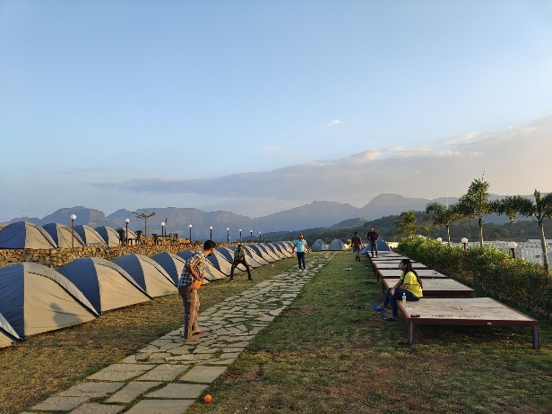
Day 1:
- 04:30 PM: Arrive in Bhandardara and unwind.

- 05:30 PM: Enjoy the sunset accompanied by delightful evening snacks.

- 07:00 PM: Indulge in bonfire and music.
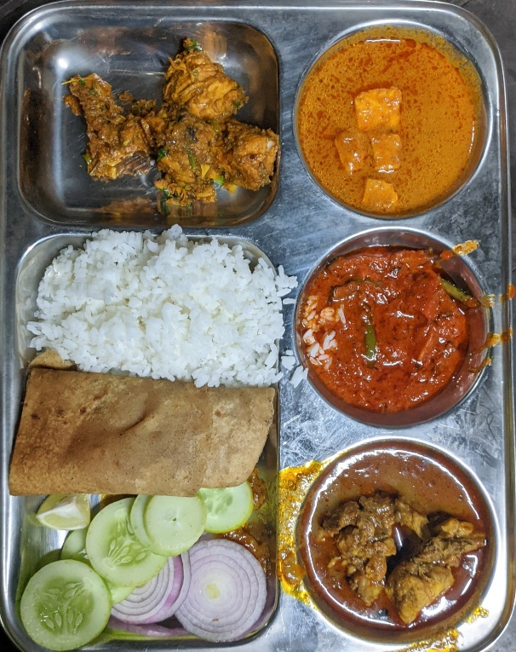
- 09:00 PM: Savor a delightful camping dinner.

- 11:30 PM: Retreat for the night.

Day 2:

- 06:30 AM: Wake up and prepare for the day.

- 07:30 AM: Delight in a leisurely morning breakfast.

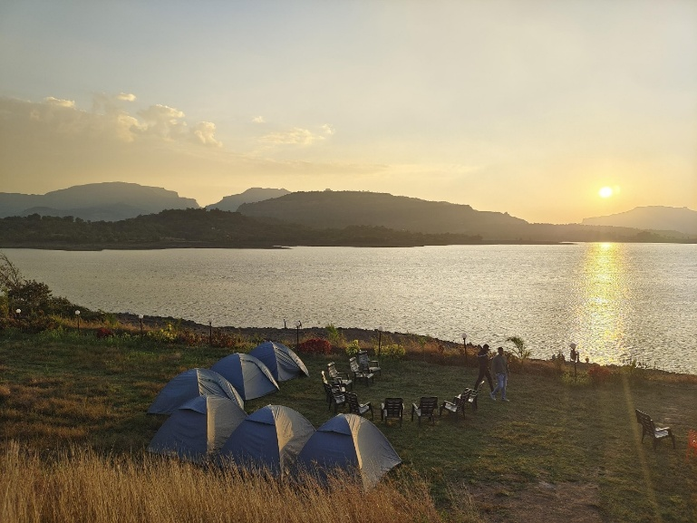
- 08:30 AM: Depart for Sandhan valley

- 09:30 AM: Arrive at the valley and explore

- 01:30 PM: Depart for Mumbai.

- 05:30 PM: Arrive at Mumbai ( we’ll have Lunch at Dhaba on Our way to Mumbai)

Things to Carry:

ID proof

Sanitizer, masks, and personal medicines

2-3 liters of water

Good shoes and an extra pair of socks

Cap and bag cover

Warm clothes/shawl, towel, napkin, extra pair of clothes

Eatables like fruits and dry fruits for munching during the trek and to avoid dehydration

Haversack to put in all the things

Notes:

Avoid wearing expensive items like gold & silver ornaments and tight clothes like jeans.

Do not wear sandals or chappals (carry them in a bag).

Avoid any unnecessary risks during the expedition.

Smoking, consuming tobacco/alcohol is strictly prohibited during the trek.
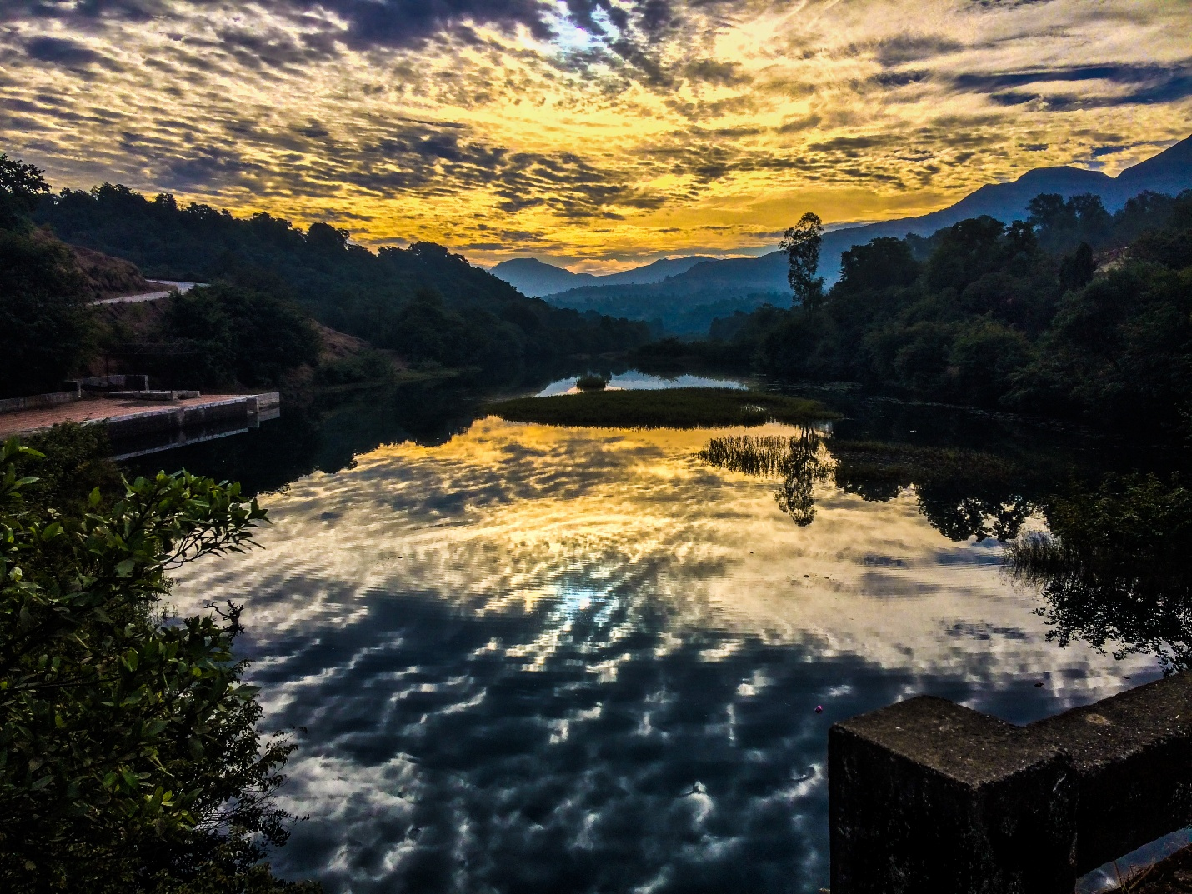
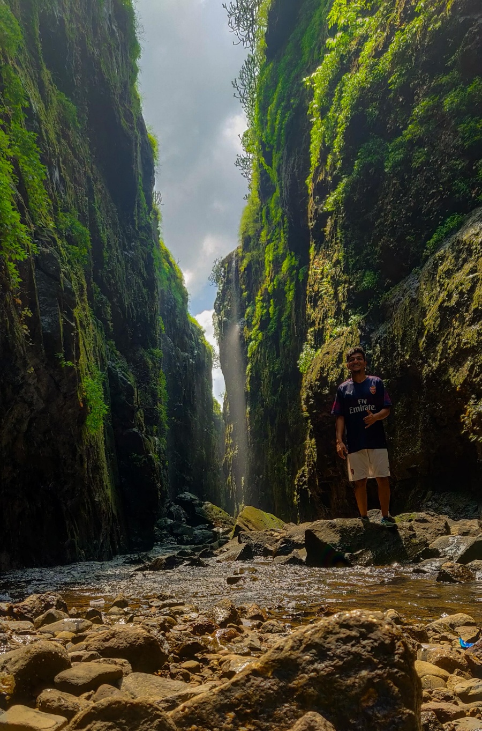
Follow the code of conduct, keep the place neat & clean, and do not litter.

