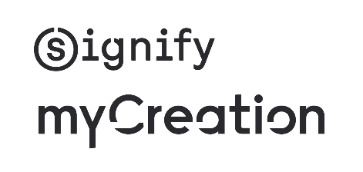
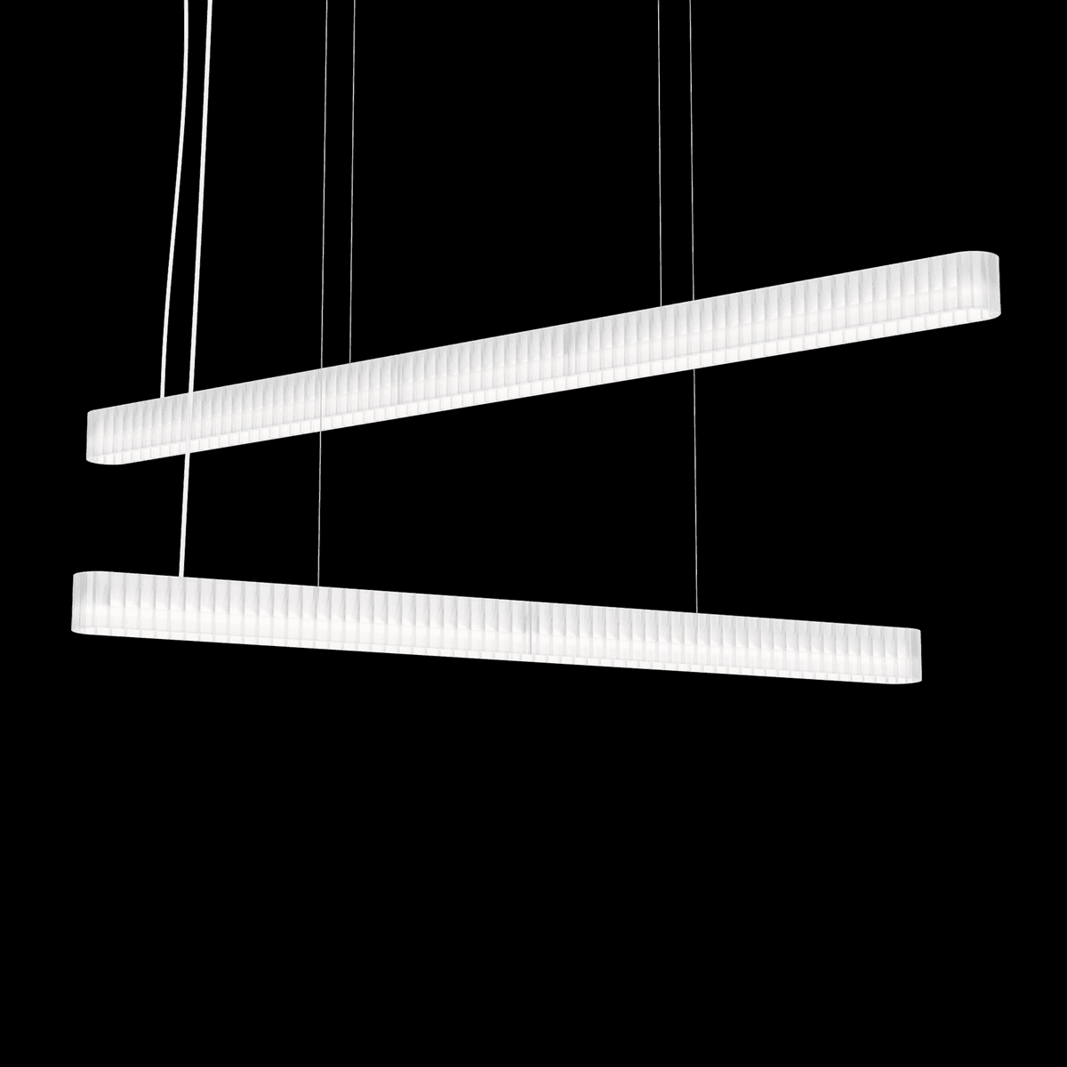Puzzle
Description
Puzzle blends performance, sustainability, and a bold visual language into one striking modular concept. The pendant luminaire features a shadow-free glowing light effect, smart system readiness, and modern aesthetics.
USP
- Pendant mounting options with driver in canopy for concrete & wooden ceilings and driver on ceiling for false ceilings
- Continuous glowing light effect through transparent body
- Various light recipes: 3000K, 4000K, CRI 90+
- Office compliant
- Heat resistant & impact resistant PET-G material for housing
- Printed with mass-balanced 50% recycled copolyester materials
- Driver options: PSU (Non Dimming) / DIA (Dali Interact Dimming) / WIA (Wireless Interact dimming) / SIA (Sensor ready driver)
- Interact ready
- Integrated sensor option for presence detection and daylight control
- EPD document available (Environmental Product Declaration)
- Disassembly instructions available
The Projector complies with the following standards:
- CE marked
- RoHS
Specifications:
- Efficacy up to 152 lm/W
- CRI90, Color temperature: 3000K / 4000K
- Lumen: 4000 and 5000
- Lumen maintenance: 72,000hrs to L80 @ 25°C Ta
- Driver Failure Rate <1% @ 5,000 hrs
- IP20 / IK02
- Electrical Class II
- Ambient range: +10°C to +35°C
- Glow wire test 650°C
- 5-year warranty
- Binning: CRI90 SDCM<2
Schematic light drawing
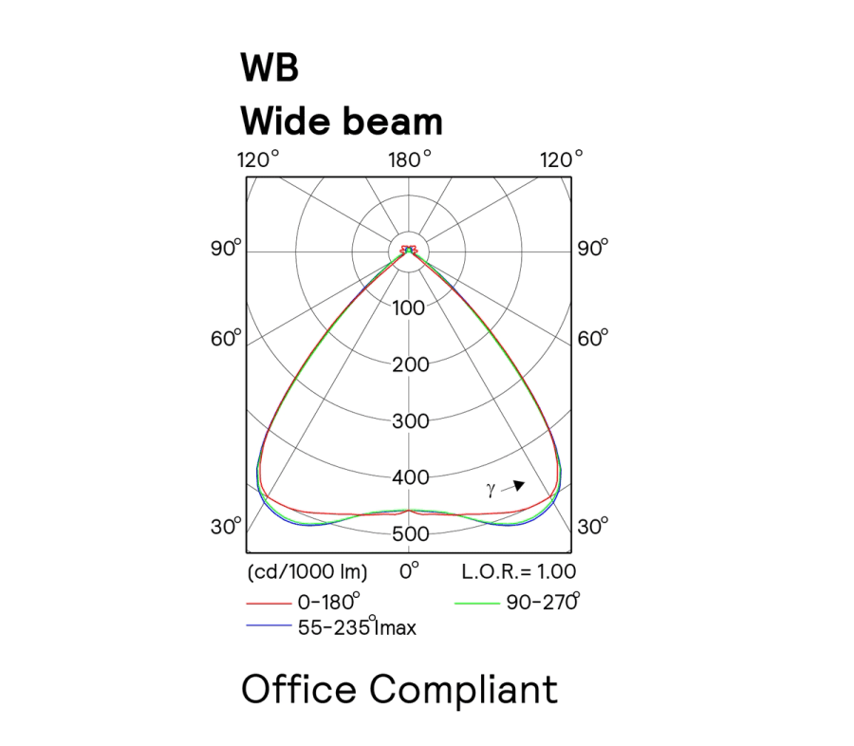

Dimensional drawing

