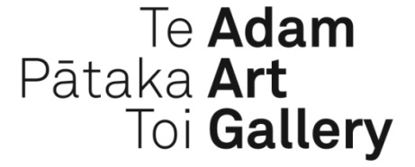

PUBLIC PROGRAMME

Drawing Is/Not Building: Roland Snooks, Sarah Treadwell, Simon Twose
Living Cities 2011-: an exhibition by Richard Frater

Lecture: Behavioral Formation and Composite Prototypes
6pm Wednesday 22 April
LT 1 Ground Floor, School of Architecture
Vivian Street
Melbourne-based architect Roland Snooks will speak about the generative design processes and robotic fabrication techniques he is developing that are opening up a new set of architectural possibilities and implications for form, structure and ornament. Snooks is a founding partner of Kokkugia and director of Studio Roland Snooks and senior lecturer at RMIT University where he directs the Architectural Robotics Lab. He has taught and presented widely in the USA, Europe and Australia.

Floor Talk
4.30pm Friday 24 April
Adam Art Gallery
Join Roland Snooks, Sarah Treadwell and Simon Twose for a tour of Drawing Is/Not Building and stay on to attend the opening of the Adam Art Gallery’s new exhibitions at 6pm.

Artist’s Talk
2.00pm Saturday 25 April
Adam Art Gallery
Join Richard Frater at the Adam Art Gallery for an artist’s talk.

Film Screenings
Adam Art Gallery
Come along for a casual drink and an opportunity to view films chosen by each architect as a complement to their work in Drawing Is/Not Building.

Tron directed by Steven Lisberger
Thursday 21 May, 6pm

Pink and White Terraces directed by Nova Paul
Sea, Sight, Site directed by Louise Stevenson
Friday 5 June, 6pm

The Five Obstructions directed by Lars von Trier
Thursday 7 May, 6pm

Roundtable Discussion
2-4pm Saturday 30 May
Adam Art Gallery
A discussion moderated by Simon Twose about the issues raised by the exhibition Drawing Is/Not Building, which will feed into the publication documenting the project.

