BPK Timesheet Policy v1.00
Policy Scope: Internal |  |  | Custom Policy
Version | Authored by | Reviewed by | Approved by | Next Review Date | Change(s)
1.00 | President | Vice-President  Policy Officer | 2024 Executive team | March 2025 | Policy newly created due to the introduction of staff timesheets.

PURPOSE

The purpose of this timesheet policy is to create a standard timesheet procedure for accurate payroll and recordkeeping. The timesheet policy will contain the scope of the policy, general information for employees, and the complete procedures that employees must comply with.

POLICY STATEMENT

Values
Batman Park Kindergarten believes in honesty, responsibility, and efficiency. Our timesheet policy reflects these values:
- Honesty: We record our work hours accurately to show our true contributions.
- Responsibility: We take ownership of our time and duties by filling out our timesheets on time.
- Efficiency: We use the timesheet system to manage time effectively, ensuring smooth operations.
- Respect: We value everyone's time and efforts by being accurate in our timesheet entries.
- Continuous Improvement: We're always looking to make our timesheet process better to serve our team and company.
Scope
This timekeeping policy applies to company employees who are employed on a full-time or part-time basis, for the purpose of recording hours of work, including regular, additional hours and leave.

TIMESHEET PROCESS

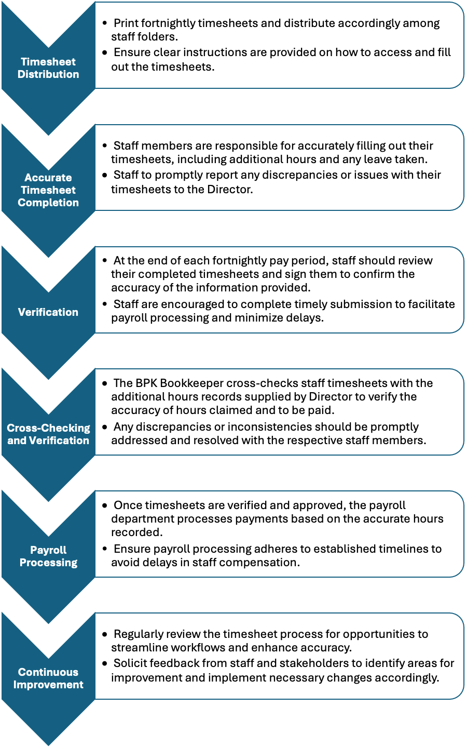

RESPONSIBILITIES | Approved provider and persons with management or control | Nominated supervisor and persons in day-to-day charge | Administration Officer or Bookkeeper | Early childhood teacher, educators and all other staff
Print fortnightly timesheets and distribute accordingly among staff folders. |  |  | ✔
Ensure clear instructions are provided on how to access and fill out the timesheets. | ✔ | ✔
Accurately filling out timesheets, including additional hours and any leave taken. |  |  |  | ✔
Promptly report any discrepancies or issues with personal timesheets to the Director. |  |  |  | ✔
At the end of each fortnightly pay period, staff review their completed timesheets and sign them to confirm the accuracy of the information provided. |  |  |  | ✔
Staff are encouraged to complete timely submission to facilitate payroll processing and minimize delays. |  | ✔ |  | ✔
Cross-check staff timesheets with the additional hours records supplied by Director to verify the accuracy of hours claimed and to be paid. |  |  | ✔
Any discrepancies or inconsistencies should be promptly addressed and resolved with the respective staff members. |  | ✔ | ✔
Once timesheets are verified and approved, the payroll department processes payments based on the accurate hours recorded. |  |  | ✔
Ensure payroll processing adheres to established timelines to avoid delays in staff compensation. |  |  | ✔
Regularly review the timesheet process for opportunities to streamline workflows and enhance accuracy. | ✔ | ✔ | ✔
Solicit feedback from staff and stakeholders to identify areas for improvement and implement necessary changes accordingly. | ✔ | ✔ | ✔ | ✔

Background
At Batman Park Kindergarten, we recognize the importance of effective policy and accurate record-keeping in the smooth operation of our kindergarten. Through recent process reviews, we identified an opportunity to enhance our payroll processing and promote transparency and accountability among staff by introducing timesheets. The Committee of Management executive team, in collaboration with the center Director and Administration Officer, collectively recognized the importance of implementing timesheets as an essential component of our commitment to continuous improvement.

It's important to note that timesheets must be signed by relevant staff to ensure timely processing of payments. Failure to sign timesheets will result in payment delays.

Definitions
- Normal hours - An hour of work in the employee's workday that the Approved Provider and/or Director has authorized and is contractually agreed to.

- Workday - A full workday consists of a predetermined number of hours within the company's operating hours. Standard business hours for sessional Kindergarten are 7.00am - 6.00pm, Monday through to Friday.

- Additional Hours - Additional hours refer to any working hours that fall outside the specified hours outlined in the Letter of Employment. These hours must be authorized by the Director or Teacher in Charge to ensure compliance with our policies.

- Sick Pay - The wages employees receive when they’re on sick leave.

- Annual leave - Employees are entitled to annual paid leave during the year. Their annual leave is paid at the normal hourly rate with annual leave loading of 17.5% applied.

- Overtime - An employee will be paid overtime for all authorised work performed outside the ordinary spread of hours or in excess of 38 hours per week.

- Allowances - An employee will be paid overtime for all authorised work performed outside the ordinary spread of hours or in excess of 38 hours per week.

Sources and Related Policies

Sources
- Early Learning Association Australia - VECTEA 2020 chrome-extension://efaidnbmnnnibpcajpcglclefindmkaj/https://elaa.org.au/wp-content/uploads/2021/09/FWC-Version-VECTEA-2020-2021-FWCA-3620.pdf
- Fair Work Ombudsman; Timesheet Template - www.fairwork.gov.au

Related Policies
- BPK Staffing Policy
- Privacy and Confidentiality
- Staff Grievances and Dispute Resolution
- Staff Recruitment
- Determining Responsible Person
- Code of Conduct

Evaluation
In order to assess whether the values and purposes of the policy have been achieved, the approved provider will:
- regularly seek feedback from everyone affected by the policy regarding its effectiveness
- monitor the implementation, compliance, complaints and incidents in relation to this policy and ensure satisfactory resolutions have been achieved
- keep the policy up to date with current legislation, research, policy and best practice
- revise the policy and procedures as part of the service’s policy review cycle, or as required
- notifying all stakeholders affected by this policy at least 14 days before making any significant changes to this policy or its procedures, unless a lesser period is necessary due to risk (Regulation 172 (2)).

Attachments
- Example Timesheet
- Process for repeated timesheet violations
- Process for timesheet submission: sick leave or leave

Authorisation
This policy was adopted by the Approved Provider of Batman Park Kindergarten in March 2024.

Review date: MARCH 2025

Attachment 1 - Example Timesheet
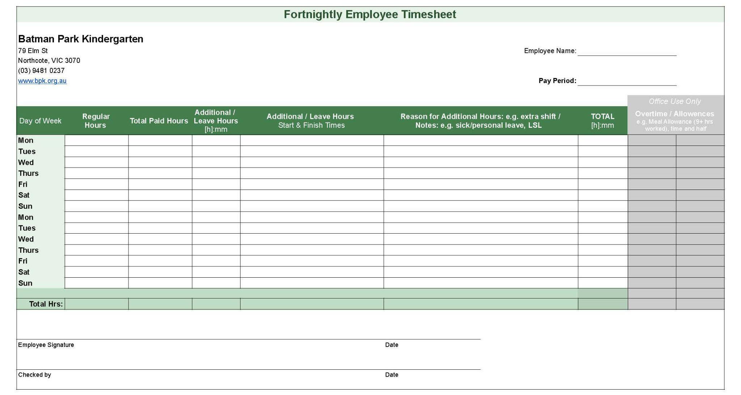

Attachment 2 - Process for repeated timesheet violations

In cases of repeated violations of our timesheet policy, we follow a progressive approach to address the issue:

Informal discussions: Initially, we'll engage in informal discussions to address any issues or misunderstandings regarding timesheet submissions. This provides an opportunity for open dialogue and resolution.

Formal oral warnings: If the issue persists after informal discussions, formal oral warnings will be issued. This serves as a clear indication that the matter requires immediate attention and correction.

Written warnings: Should the problem continue despite previous interventions, written warnings will be issued to document the issue formally. This ensures clarity and accountability moving forward.

Performance counseling initiated: When repeated timekeeping violations persist despite prior warnings, performance counseling will be initiated. This process will follow due diligence to address the underlying issues effectively.

It's important to note that our goal is not punitive action but rather to ensure compliance with company policies and maintain a productive and respectful work environment. We encourage open communication and cooperation to address any issues related to timesheet compliance effectively.

Attachment 3 - Process for timesheet submission; sick leave or leave

Notification: When an employee is unable to work due to sickness or planned leave, they must notify Batman Park Kindergarten’s Director or person in charge as soon as possible. This notification should include the expected duration of the absence.
Timesheet Adjustment: The employee should adjust their timesheet to reflect the sick leave or planned leave period accurately. This involves entering the appropriate leave category (e.g., sick leave, annual leave) in the “Reasons for leave / Notes” section, for the duration of their absence.
Submission Deadline: The employee should aim to submit their timesheet as per the fortnightly deadline, even when on sick leave and in particular for planned leave. If possible, they should submit their adjusted timesheet before their absence begins. However, if this is not possible, Batman Park Kindergarten will pay the employee their regular hours and any additional hours worked should be logged upon return and will be paid in the following pay cycle.
Approval Process: The Bookkeeper will review the adjusted timesheet and cross-check with Directors log. They will verify the accuracy of the leave entry and approve the timesheet accordingly before making additional hours payment.
Record Keeping: Once approved, the adjusted timesheet should be appropriately filed for record-keeping purposes. This ensures that accurate records of employee attendance and leave are maintained.
Communication: Throughout the process, clear communication between the employee, Director and Bookkeeper is essential. Any questions or concerns regarding timesheet submission during sick leave or planned leave should be addressed promptly to ensure a smooth process.

