Dear all new children and parents
It is a pleasure to welcome you to xxx kindergarten, and we look forward to getting to know you.
At xxx kindergarten, we use an adaptation model where we invite you to song and music gatherings before the actual start begins in August. We aim to meet all new parents, or other caregivers for a series of singing sessions before the summer vacation. We will sing together, move, get to know each other and play together.

You can read more about Solvangmodellen (in norwegian) here.
Other Singing kindergartens that practice the Solvang model, or a variation of it, have achieved good results and established a safe and good relationship with both children and parents before the actual start in the fall. This has led to more confident children, parents, and staff when the adaptation process in kindergarten begins.
Singing and music help us get to know each other in a sensory, emotional, and joyful way. Songs and rhyme that are familiar create extra security for the child.
This spring, we will offer 4 gatherings (see details below).
We ask you to give us feedback on the following:
- Which gatherings can you attend? Also, let us know if none of the dates are suitable.
- Write down and send us a song or rhyme/rule that you like to use together at home.

The song or rhyme you submit will be "my song" for the child, which he/she will also bring with them at the kindergarten start later in August. This will create security and recognition for your child. The leaders for the gatherings will be the department head (avdelingsleder), [insert name], and the toddler educators (førskolelærere) [insert name]. We all have extensive experience from kindergarten life.

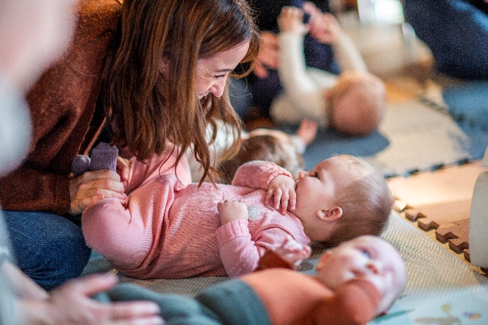

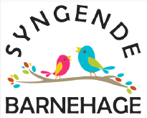
[Name of the kindergarten] is a Syngende barnehage/Singing kindergarten, and we encourage you to visit https://www.musikkfralivetsbegynnelse.no/syngende-barnehage where you can read about what this entails (in norwegian). On the website, there are great pictures and clips from Solvang Singing kindergarten, which is the originator of the Solvang model itself.

THE SINGING GATHERINGS will be on [DAY] at 9:30 - 10:30 a.m. and will take place at [ROOM NAME]
1st gathering; [DATE+PLACE], you will meet the department head and pedagogical leaders from the toddler departments.
2nd gathering; [DATE+PLACE], together with the department head and pedagogical leaders from the toddler departments.
3rd gathering; [DATE+PLACE], from this time, you will be divided into groups in the department you will attend from the fall.
4th gathering; [DATE], in the department you will attend from the fall.
Remember to give us feedback via email [email address], or on mobile [insert number], by [deadline/date] and answer:
- whether you will attend all or some of the gatherings
- which song or rhyme you would like to use that is associated with your child

WELCOME TO THE SINGING GATHERING - We look forward to meeting you all!
Songful regards from
[Names of all participants from the kindergarten]

[insert picture or logo from kindergarten]

RESPONSE SLIP (COPY AND PASTE INTO THE EMAIL TO [EMAIL ADDRESS])
We will attend the 1st gathering _________________________________ (check)
We will attend the 2nd gathering_________________________________ (check)
We will attend the 3rd gathering_________________________________ (check)
We will attend the 4th gathering_________________________________ (check)
We would like to bring the following song/rhyme, which the child enjoys:
__________________________________________________________________________

