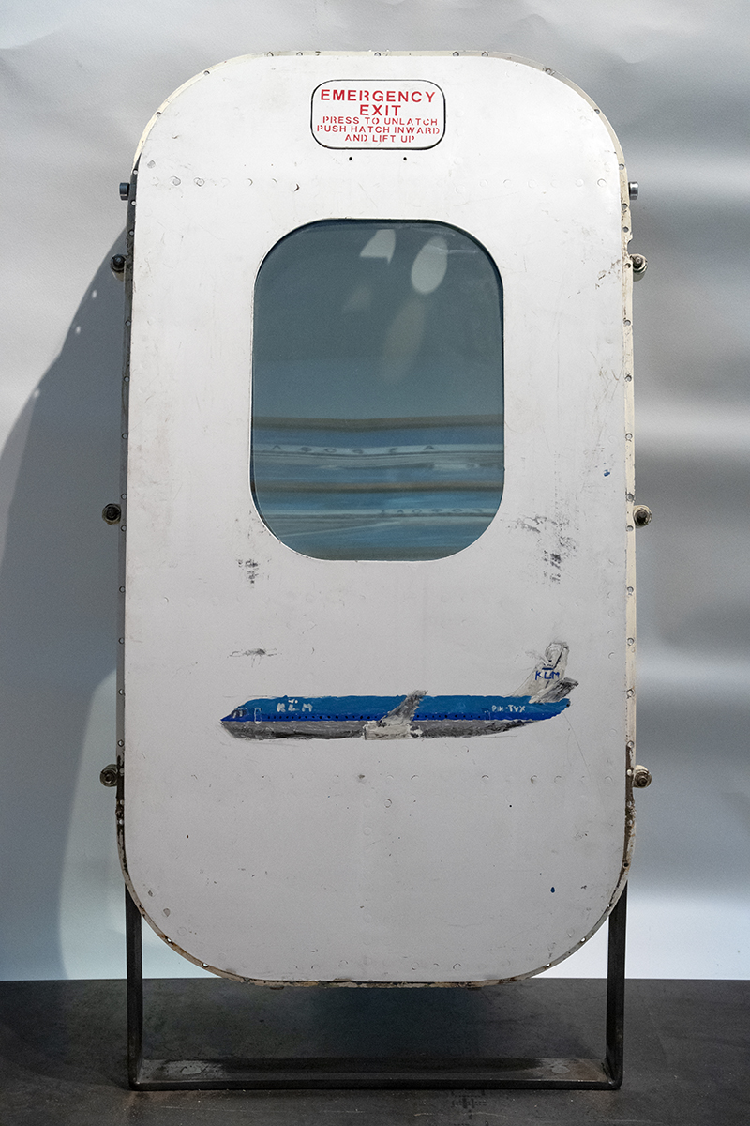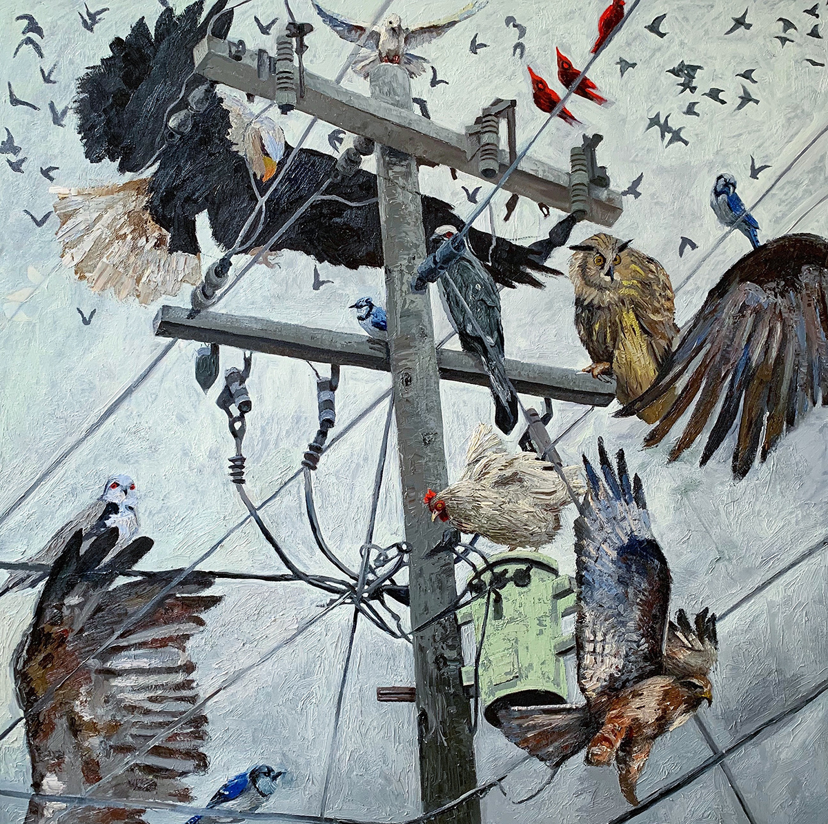
September 6, 2019

Press Release
Tripoli Gallery
P.O. Box 49
Sagaponack, NY 11962

T. 631 377 3715
E. info@tripoligallery.com

East Hampton Airport, Hangar 11
Vahakn Arslanian
DC-8 Jet (Side 1), 2013
nail polish on airplane emergency exit door

Lauren West
Flappable, 2019
oil on canvas
48 x 48 inches (121.9 x 121.9 cm)

Hosted by Gianpaolo de Felice
200 Daniels Hole Road, East Hampton, NY 11937
Private Viewings Available by Appointment

HANGAR
Vahakn Arslanian & Lauren West
On View by Appointment: September 7th – October 7th, 2019
Opening Reception: Saturday, September 7th, 1 - 7pm

East Hampton, NY – Tripoli Gallery is pleased to present Hangar, a pop-up exhibition featuring artists Vahakn Arslanian and Lauren West. Hosted by Gianpaolo de Felice in Hangar 11 at the East Hampton Airport, the exhibition will be available for private viewings from September 7th through October 7th, 2019. An opening reception for the artists will be held on Saturday, September 7th from 1 to 7pm, in Hangar 11 at the East Hampton Airport, 200 Daniels Hole Road, East Hampton, NY 11937.

Visual artwork is most often defined by its physical presence–its gravitational pull to the ground–while the idea of flight is less tethered to the Earth. Flight has always been imbued with wonder, from the natural creatures that fly as a means of survival to the human-made machines that travel vast distances over lands and oceans. For artists Vahakn Arslanian and Lauren West, winged creatures and vehicles manifest in their work in a variety of ways. From the delicate membraned wings of bees, to the thick feathered wings of birds, to the sharp angled blades of a jet-engine fan, subjects of flight are composed of similar mechanisms yet encased in captivating and unique forms.

Working between painting and sculpture, Vahakn Arslanian uses materials such as oil paint on canvas, graphite, and nail polish on paper in found frames. His work often depicts airplanes, birds, and candles, all subjects of movement and energy. Arslanian uses spare airplane windows and doors as frames and surfaces for painting, frequently shattering the glass inside of them. The cracked glass creates a scattering of light within his works, as in DC-8 Jet, 2013, where the luminous effect is intensified by the use of nail polish on paper to illustrate a plane behind the glass on each side of an airplane cockpit window. Many paintings in one artwork, another example of the artist’s double-sided works is a jet-engine fan painted in nail polish with a unique commercial airplane on each of the fan’s angled blades–both front and back–revealing a new plane when viewed from different perspectives.

Painting in oil, Lauren West’s canvases are composed of richly layered colors that map out scenes often suggesting biblical stories as well as apocalyptic occurrences. The humor in her work is a result of the incredible assortment of animals and objects combined in each painting, even UFOs appear, such as in Lunar Love, 2019, where past and future converge between medieval battle weapons and alien flying objects. Flappable, 2019, presents a balancing act between West’s avian subjects choreographed around a telephone pole. An unusual gathering of birds including an eagle and an owl, cardinals and blue jays, a chicken and a dove, hover and land on a telephone pole, its wires and transformer. Impasto brushstrokes heighten the physicality of her painted subjects as they strive to take their places within the painting’s edges, in between taut wires and textured sky.

For press inquiries or further information, please contact info@tripoligallery.com or call 631.377.3715.

Vahakn Arslanian (b. 1975, Antwerp, Belgium) was raised in New York City and began painting and working with glass at an early age. Deaf from birth and fascinated by the chaotic beauty of shattered glass, Vahakn found in his art both a route for his imaginative vision and a means of exploring the equilibrium between destruction and creation. His work frequently employs glass—sometimes broken, sometimes intact—as well as found or acquired objects like antique window sashes and hardware, massive airliner cockpit windows, lightbulbs, and even jet-engine fans. The images he places in and on the spaces thus created depict his vision of beauty and absurdity: a bird with a subway car for a beak, a candle with too many flames, a flock of tiny Boeing jets converging on the vortex at the center of a shattered window. Vahakn Arslanian’s work has been shown at multiple solo exhibitions in London, Antwerp, Geneva, St. Barthélemy, and his native New York City, as well as in numerous group exhibitions, including the St. Moritz Art Masters. His collaboration with Julian Schnabel, “The Ones You Didn’t Write—The Maybach Car,” was displayed on the Grand Canal during the Venice Biennale.

Lauren West (b. 1989, Oxford, MS) is a visual artist from Oxford, Mississippi who now resides in New York City. She received her MFA degree from The New York Academy of Art after obtaining a BFA from the University of Mississippi. West’s paintings deal with the wild combination of animals, Southern imagery in the United States, humor, and existentialism. The majority of the work consists of a half fantastical, half realist approach to oil paint which often depicts beasts coming to grips with their own impermanence. She enjoys creating characters in worlds that don’t mind leaning into the cheesy wonderment of what it all means. Perseverance is an important element within these characters while they are seen continuing onward despite noticing their own mortality. The result can be described as comically hopeful and bittersweet. Lauren West has exhibited in Mississippi at the University of Mississippi Museum in Oxford, and in New York at Right Behind the New Museum, ChaShaMa, and The New York Academy of Art, among others.

